Hare Krishna
Prasadam, Sweets & Savories Vertical
Detailed Business Plan

Hare Krishna Golden Temple (ISKCON), Banjara Hills, Hyderabad
Prepared for: Temple management, Production (Prabhu) and DMTT
Source: Prasadam Revenue Generation Plan meeting, 26 September 2026
v1.0 draft, 26 September 2026

Figures marked [ESTIMATE] are planning assumptions. Replace them with the 6–12 month order data before committing budget.

Contents
1. Executive summary
2. Background and meeting insights
3. Vision, mission and positioning
4. Market research
5. Competitive landscape and SWOT
6. Target audiences
7. Business models and revenue streams
8. New business ideas
9. Products, gift tiers and packaging
10. Pricing strategy and unit economics
11. Marketing and sales plan
12. Operations plan
13. Organisation and roles
14. Roadmap
15. Hero campaign calendar
16. Financial plan
17. Risks and mitigation
18. KPIs and ROI tracking
19. Immediate action items and open questions
20. Mind map and flowcharts
21. Sources

1. Executive summary
The idea. Temple-made satvik sweets and savories, from the house of Radha Krishna, sold through every circle the temple already reaches: counters, restaurant, corporate gifting, white-label, catering, communities, e-commerce and, later, QSRs and exports.
Why us, why now. Temple visitors, donors, company owners, institutions and online followers already trust the ISKCON name. Janmashtami 2026 counters sold out at about ₹6 lakh with limited stalls. Three companies asked for Dasara gift boxes that we could not supply. A group has asked for 50,000 meals. Demand is real; what has been missing is a production owner, a sales kit and a system. That now exists: the temple production lead handles the kitchen, and Mukunda Dasa with the DMTT handles marketing, technology and sales.
The model. Run two price segments: a competitive mass tier for volume that keeps the kitchen busy and covers fixed costs, and a premium tier for margin. Sell through 14 revenue streams, starting with those needing little capital (internal supply, festival stalls, corporate and white-label gifting), then e-commerce, communities and catering, and later a dedicated unit, QSRs and exports.
The numbers. Year 1 (Oct 2026–Sep 2027) target gross revenue about ₹2.2 crore, rising to about ₹4.5 crore in Year 2 and ₹7.5 crore in Year 3 [ESTIMATE]. Year-1 incremental opex about ₹67 lakh and small capex under ₹30 lakh. No large building investment until demand is proven.
The ask. Approve the plan in the decision meeting (target 5 Oct 2026), finish the 2-week foundation sprint (data, samples, pricing, sales kit, one hire), and use Dasara and Diwali 2026 as the pilot.

Objectives at a glance
# | Objective | Measure
O1 | Launch the vertical with a ready sales kit | Catalogue, prices, samples and packaging ready by 10 Oct 2026
O2 | Win Dasara/Diwali corporate orders | ≥ 5,000 gift boxes and ≥ 10 corporate/institution clients by 8 Nov 2026 [ESTIMATE]
O3 | Stabilise internal supply | 100% of internal prasadam orders placed with in-house production by Nov 2026
O4 | Go online | Shopify + Amazon live with ≥ 12 SKUs by 31 Jan 2027
O5 | 10× festival counters | Janmashtami 2027 counter sales ≥ ₹60 lakh (10× 2026) as stretch; ₹30 lakh base
O6 | Prove ROI | Monthly DMTT ROI report from Nov 2026; vertical cash-positive by month 6
O7 | Year-1 revenue | ₹2.2 crore gross revenue Oct 2026–Sep 2027 [ESTIMATE]

2. Background and meeting insights
This plan is built from the Prasadam Revenue Generation Plan meeting, 26 September 2026 (audio recording, transcript and summary). Every point raised is captured below, grouped by theme, so nothing is lost.

Why now
- Mukunda Dasa is already driving revenue generation for the temple from several sources (gift items, e-commerce); prasadam is one of them.
- "Already we are late. If not today, tomorrow we have to start." Target to be doing this at scale within one year at most.
- First-mover advantage: no temple in the Bangalore group of temples has done this at large scale yet; the market is untapped.
- Earlier attempts (with Vasudha, with T-Hub and Justdial.com founders and government networks) stalled because margins did not work and nobody owned production. Now a dedicated production lead (Prabhu) is in place, so the missing piece is solved.
- Division of labour: "You take care of production. We take care of marketing and technology."
- A devotee must own the vision for 5–10 years and keep driving it.

Brand advantage
- When customers hear it is from ISKCON, customer acquisition is easy; people trust the name.
- Competing small shops often use chemicals and artificial colours; buyers do not trust them.
- Positioning: 'from the house of Radha Krishna', satvik, pure, without preservatives. People will pay for that.
- Strong SEO and digital presence: anyone searching for ISKCON Hyderabad finds our pages first.
- Proposal discussed to move email addresses to an iskconhyderabad.org-style domain for brand consistency.
- Brand-building stunt idea: an India Book of Records / world-record attempt (e.g. via the 'Mandal Yatra' platform) for a large-quantity preparation, used on social media and the website.

Existing assets to reuse
- Huge databases, networks and warm contacts who have already contributed to the temple.
- Existing system for dispatching prasadam to online donors all over India; other departments already copy this system.
- Existing human resources, spaces, vendor list and negotiated rates.
- Existing e-commerce experience: Shopify, order management, fastest-courier comparison.
- Subhadra Radha Devi Mataji has shipped around 15,000 parcels via Amazon across the country and knows fastest shipping.
- AI engineers and data scientists in the team; cross-sell databases; SMS, WhatsApp, RCS, Google Ads, Meta Ads and organic marketing.
- A new kitchen was recently inaugurated.
- Wooden gift boxes are already available in the storeroom; see-through plastic boxes already in use.
- Personal network in the trade: Mukunda Dasa's cousins run a large sweets business in Malaysia and have supplied bahumana sweets before; family has long experience in this business.

Named contacts and circles
- MNR group: 42 institutions (schools, colleges: medical, engineering, commerce, arts). Staff and student gifting at Dasara.
- Steel/foundry company owners with ~10,000 employees across Karnataka, AP, Telangana, Kerala, Tamil Nadu.
- T-Hub mentors, directors, CEOs, founders.
- Event-management firms, e.g. Naukaran Entertainment (Kavitaji); high-profile Dasara Dandiya events attended by prominent people.
- Telangana Chamber of Commerce (president is close); member companies registered on its platform.
- Rotary, Round Table, Alpha Circle, BNI.
- Institute of Company Secretaries and chartered accountants, Hyderabad chapter (president, secretary).
- About 100 gated communities with weekend flea markets; organisers have given free stalls before.
- About 100 companies currently in touch; outbound selling is possible with manpower.
- Chinmaya Mission Bhagavad Gita recitation event asked for 50,000 meals over two days: an order we should not lose.
- Big donors (e.g. from large showrooms) phone asking for 5 kg of namkeen in the rainy season.
- Three companies have asked us for gift boxes, calendars and Dasara gifts; we could not serve them yet ("my heart is paining").
- A partner has offered network, funds and execution for 100 restaurants / 100 QSRs in Hyderabad under the brand (KFC-style popularity).

Festival counters evidence
- Janmashtami 2026: almost all prasadam counters sold out; around ₹6 lakh sales. Target: 10 times more.
- A family member of the production lead watched the corner stall for four hours; continuous crowds.
- Mahalaya (Pitru Paksha) brings many people for service; last year ~200 lakh-level participation was mentioned. Put sweets and savories stalls there too.
- One stall causes queues of 10–50 people and others walk away; put many stalls in a row.
- Place stalls where footfall is: entrance, exit (especially the darshan exit queue), Goshala walking path, staircases, garden, near benches and the waterfall, from Goshala entrance to Samskara hall.
- A counter in a garden where people do not gather is of no use; traffic goes out through the exit.
- Permanent pagodas that can be closed in rain and opened otherwise; costing was requested earlier but not done.
- The restaurant should take over the entire lawn on festival days: chairs, round tables, full-length counters, sweets and savories in a full row.
- Answer to 'the temple is becoming commercial': this is passive selling. We are not pushing; people choose to approach a stall.
- Shelf-stable stock is the hedge: if festival sales fall short, sell the balance online / via Instagram with a small discount.

Pricing and unit economics
- Two options: premium price for limited premium customers (limited staff, high revenue per order), or competitive price for huge volumes.
- Illustration used: 1 lakh orders per month at a small ticket making ₹10 lakh, versus 10,000 premium orders.
- Premium alone cannot cover capex, rent, electricity and salaries; it is a niche and hard to push.
- Decision: run two segments. The mass segment keeps the kitchen running (rotation, maintenance); premium adds margin.
- Very attractive packaging wins the market.
- Big brands have entered (a well-known brand now sells a full range of laddus and products), which proves the market.
- Prabhu will give good costing for mass and premium items; we help Prabhu grow so he gets volume-based better pricing.
- Jaggery is costlier than sugar; sugar is acceptable. Prefer jaggery-based where price allows; pick whichever gives the better price.
- Namkeen for diabetics, who cannot eat sweets.

Production and capacity
- Production lead currently has 4 people; will add people directly for good orders.
- Internal demand exists daily: donor campaigns, Culture Connect, the corporate relations department, the new Virpaksha campaign (daily donors).
- Weekly minimum order with one fixed delivery day (4 deliveries a month) so the kitchen can plan.
- Festival months (hero campaigns) communicated in advance through the system with quantities from the calendar.
- An exclusive cook for our orders if we commit volume.
- Last Krishna-related order was received and prepared quickly even at the last minute.
- Procurement rule: stop giving prasadam orders to anyone else; order only from the internal production lead.
- Infrastructure can be established if needed; later, a separate building outside the temple can be converted into a unit, as other temples do.
- Catering needs heavy capex and infrastructure; plan it as its own vertical.
- A pantry/service area exists near the restaurant; cooking happens in the main kitchen.

Products
- Criterion one: shelf life of 15–20 days.
- Kaja (including square kaja), khara (savoury) and sweet items.
- Groundnut chikki; black til and white til chikkis.
- Puri unde (puffed-rice balls) with jaggery, coconut and elaichi; poha puffed-rice variant for health-conscious buyers.
- Laddus and a 250 g weekly new item in a see-through box, which had very good response.
- Namkeens / mixtures.
- Pickles, papads, masala powders, sambar powder: another vertical.
- Dry fruits for gifting.
- Samples shown of small machines (e.g. a small red machine) for making items.

Governance and ROI
- Track from DMTT how much effort, time and energy was spent and how much revenue was generated for the temple.
- If someone asks 'you spent this much, what did we get back?', the ROI must be clearly visible.
- Budget for prasadam must be stated per department: LLP, Culture Connect, online donors.
- Approval path: production lead discusses with his reporting manager; then one meeting of Mukunda Dasa, the production lead and the manager to finalise.

Learning visits and long-term vision
- Visit ISKCON Mysore (prasadam there is very good) and Ahmedabad; spend a day with those devotees. Introductions available.
- Tech-platform thinking: Zomato, Swiggy, Zerodha, Amazon own little but scale through technology. Our scale will also come from technology.
- Long-term: 100 employees, export to different countries, 100 QSRs.
- Other related ideas raised: dairy products and ghee; temple advertising projects; education company in 150 languages; Krishna-conscious games; audio/video in 50 languages (outside this plan's scope but share the same DMTT capability).

3. Vision, mission and positioning
Vision. Make prasadam, sweets and savories one of the organisation's biggest verticals: first in Hyderabad, then across South India and all of India, and eventually in export markets. Profits fund our own kitchen, our own staff and machinery, and the temple's service to society.
Mission. Offer pure, satvik, preservative-free prasadam, prepared with devotion and offered to Sri Sri Radha Krishna, to every audience we already touch: visitors, donors, devotees, companies, institutions, communities and online buyers. Production is done by the temple kitchen; marketing, technology and sales are done by the DMTT; every rupee and hour is tracked for ROI.

Positioning statement
For families, companies and devotees who want sweets they can trust, our prasadam is the only satvik, preservative-free range prepared in a temple kitchen and offered to Sri Sri Radha Krishna, backed by the decades-old goodwill of ISKCON. Unlike local shops using colours and chemicals, every pack is pure, and every purchase supports the temple's service.

Brand pillars
- Purity: satvik (no onion, garlic, eggs), no preservatives, no artificial colours.
- Devotion: prepared with care and offered to the Deity first.
- Trust: the ISKCON / Hare Krishna name and a long record in Hyderabad.
- Service: proceeds support temple activities and food-for-all programmes.
- Delight: attractive packaging that makes a gift feel special.

Guiding principles
- Passive selling, not pushing: stalls where people are; people choose to buy.
- Start with what we have (kitchen, network, systems); invest only after demand is proven.
- Technology is the scale engine (like Zomato, Swiggy, Amazon): data, e-commerce, automation.
- Every rupee and every hour is tracked; ROI must be visible to anyone who asks.
- Quality and food safety are never traded for volume.

4. Market research
Desk research carried out on 26 September 2026. Figures are from third-party reports and should be treated as indicative.
Topic | Finding | Source
India packaged sweets market | ₹8,431 crore in 2025, forecast ₹30,506 crore by 2034 (≈16% CAGR). Boxes are the largest packaging format (49%). | IMARC Group
India namkeen market | Expected to grow by USD 4.89 billion between 2025 and 2030 at ≈10.2% CAGR; Tier-II/III retail expansion is a driver. | Technavio
Corporate gifting | India's corporate gifting market could cross ₹27,000 crore by 2030, with organised players taking nearly half. | Chococraft industry note
Diwali gifting mix | About 58% of Diwali gifts in 2025 were for corporate celebrations and 42% personal. | Outlook India / MyFlowerTree report
Premiumisation | Consumers increasingly prefer premium packaged sweets, curated hampers and customised assortments. | Mordor Intelligence
GST 2.0 | From 22 Sept 2025, pre-packaged and labelled namkeen, bhujia and mixtures moved from 12% to 5% GST; sweets are at 5%. Lower tax helps the mass segment. | Upstox / GST Council 56th meeting
FSSAI licence thresholds | From 1 April 2026 Basic Registration covers turnover up to ₹1.5 crore (was ₹12 lakh); Central Licence threshold raised from ₹20 crore to ₹50 crore; State Licence in between. | Mondaq / FSSAI order of 13 March 2026
Labelling | Pre-packaged sweets must show date of manufacture and best-before date. The best-before display for loose sweets on trays is now voluntary (recommended anyway). | FSSAI / Free Press Journal
Temple precedent | ISKCON Govinda's (Bangalore) runs an online store with same-day delivery slots for sweets, snacks, bakery, thalis and catering. | iskcongovindas.in
Local competition | Hyderabad incumbents: G Pulla Reddy (since 1948, pure ghee, gifting page), Almond House (ships worldwide), Vellanki Foods, Dadu's, Pista House, Olive Mithai, Godavari Vantillu. | Brand sites / IndiaShopping

What this means for us
- The packaged-sweets market is growing about 16% a year and boxes are the leading format, which suits gift boxes.
- Corporate buyers drive most festival gifting; our owner-level network is the fastest route to them.
- The GST cut to 5% on packaged namkeen lowers consumer prices and supports the mass tier.
- Under the April 2026 FSSAI thresholds, Year-1 turnover below ₹1.5 crore could fall under Basic Registration, but turnover of ₹2 crore or more needs a State Licence. Plan for a State Licence from the start.
- Hyderabad has strong heritage brands but none with a temple and satvik story at scale, which leaves a clear gap.
- Other ISKCON temples (e.g. Govinda's Bangalore) prove that temple food can be sold online with same-day delivery.

5. Competitive landscape and SWOT
Competitor | Profile | Tier | Our edge
G Pulla Reddy Sweets | Heritage pure-ghee brand; strong gifting and online | Premium | Temple sanctity + satvik + cause; prasadam is offered to the Deity
Almond House | Premium dry-fruit sweets, global shipping | Premium | Price flexibility (mass tier), institutional network
Vellanki Foods / Godavari Vantillu | Andhra traditional snacks, pickles, powders; online | Mid | Brand trust, festival footfall, donor base
Pista House / Dadu's / Olive Mithai | Retail chains, festival boxes | Mid–Premium | No-chemical, no-colour promise; spiritual story
Online gifting platforms | Aggregators (IGP, FNP, etc.) curate hampers | Mid | Direct relationships with company owners; white-label
Other temple Govinda's | ISKCON Bangalore, Jaipur, Ahmedabad stores | Mid | Not competitors but partners and benchmarks; Hyderabad has no scale player
Big national brands | Haldiram's, Bikaji, and new entrants selling laddus | Mass–Mid | Freshness, devotion, local connect; competitive pricing on mass tier

SWOT analysis
Strengths  • ISKCON / Hare Krishna brand trust built over decades  • Satvik, preservative-free, offered-to-Deity positioning  • Warm network: company owners, chambers, BNI, Rotary, institutions  • Large donor databases and top SEO ranking  • Existing dispatch system, Shopify skills, negotiated vendor rates  • Proven festival demand (Janmashtami sold out)  • In-house AI, data and marketing team (DMTT) | Weaknesses  • Kitchen capacity: 4 people today  • No dedicated packaging, design and pricing kit yet  • No historical cost/demand data compiled  • Limited cold chain and storage  • Production and marketing in different reporting lines  • Premium-only pricing would not cover fixed costs
Opportunities  • Dasara, Diwali, New Year, Sankranti corporate gifting  • White-label for companies' staff and clients  • 100 gated communities, weekend flea markets  • Large event catering (e.g. 50,000 meals)  • E-commerce pan-India; diaspora / export (Malaysia, Europe)  • QSR franchise with an interested partner  • GST cut to 5% on namkeen; growing packaged-sweets market (≈16% CAGR) | Threats  • Established Hyderabad sweet brands and national players  • Perception that the temple is 'commercialising' prasadam  • Food-safety incident damaging brand reputation  • Trademark/brand-use questions on the ISKCON name  • Ingredient price swings (ghee, jaggery, nuts)  • Festival demand volatility and weather

6. Target audiences
Mukunda Dasa's model: different audiences, different circles and different products for each audience. Circle 1 comes to us; circle 2 is the B2B network we go to; circle 3 is the open public; circle 4 is digital; circle 5 is scale.

Temple visitors and festival crowds (Circle 1: those who come to us)
Who: Daily visitors, weekend families, festival crowds (Janmashtami, Mahalaya, Ratha Yatra, Gaura Purnima, etc.)
Needs: Quick purchase, prasadam to take home, meals on the lawn
Our offer: Restaurant, lawn food court, multiple festival stalls, take-home packs, 250 g see-through boxes
Channel: Stalls at entrance/exit/Goshala path, restaurant, QR menus, UPI
Price point: Mass tier ₹30–₹250

Donors and life members (Circle 1: those who come to us)
Who: Online donors across India, big donors, sponsors, Virpaksha daily donors
Needs: Blessed prasadam at home; gifts for family and staff
Our offer: Donor prasadam packs, bahumana boxes, 5 kg namkeen tins, festival hampers
Channel: Existing donor dispatch system, WhatsApp, donor-care calls
Price point: Mid to premium

Internal departments (Circle 1: those who come to us)
Who: Culture Connect, LLP, online donor team, corporate relations, campaigns
Needs: Reliable weekly supply at an agreed rate
Our offer: Weekly standing order, one fixed delivery day, festival top-ups
Channel: Internal order form in the system; monthly budget per department
Price point: Internal transfer price (cost + agreed margin)

Corporate companies (Circle 2: those we go to (B2B))
Who: Owners/HR/admin of firms with 500–10,000+ staff (steel, IT, pharma, real estate, T-Hub startups)
Needs: Festival gifts for staff and clients, on time, branded, within budget
Our offer: Own-brand gift boxes (3 tiers) and white-label boxes with company branding; samples, menu, price list
Channel: Owner-level meetings (Mukunda Dasa + production rep), chamber and BNI referrals, LinkedIn, email
Price point: ₹250–₹2,500 per box; volume slabs

Educational institutions (Circle 2: those we go to (B2B))
Who: MNR group (42 institutions) and other school/college chains
Needs: Gifts for staff and students; event snacks
Our offer: Low-ticket student packs, staff boxes, event catering
Channel: Chairman relationships; academic-calendar planning
Price point: Mass tier with bulk slabs

Associations and professional networks (Circle 2: those we go to (B2B))
Who: Telangana Chamber of Commerce, BNI, Rotary, Round Table, Alpha Circle, ICSI/ICAI Hyderabad chapters
Needs: Member gifts, event hampers, meeting snacks
Our offer: Co-branded hampers, member discount codes, event snack boxes
Channel: Presidents/secretaries, chapter meetings, newsletters
Price point: Mid tier

Event management companies (Circle 2: those we go to (B2B))
Who: Firms running Dandiya, weddings, corporate events (e.g. Naukaran Entertainment)
Needs: Return gifts, event food counters
Our offer: Return-gift boxes, live counters, catering
Channel: Partner commission / referral fee
Price point: Mid tier

Gated communities (Circle 3: open public (B2C outside))
Who: ~100 gated communities with weekend flea markets
Needs: Tasty, pure snacks; festival supplies
Our offer: Weekend stall with top sellers, pre-order for festivals, community WhatsApp group
Channel: Flea-market organisers (free stalls offered before), RWA committees
Price point: Mass tier

Life-event families (open circle) (Circle 3: open public (B2C outside))
Who: Families holding house-warming, naming ceremony, birthdays, weddings, car/vehicle puja, shop openings, shraddha
Needs: Prasadam packs, return gifts, satvik catering
Our offer: Occasion packs, catering menus, bulk sweets
Channel: Google Ads, Instagram, referrals, temple ceremony desk
Price point: Mid tier

Online shoppers across India (Circle 4: digital)
Who: Social-media followers, NRIs sending gifts home, health-conscious buyers
Needs: Trusted, pure, shelf-stable sweets delivered fast
Our offer: Shopify store + Amazon; subscriptions; diabetic-friendly namkeen; jaggery range
Channel: Meta Ads, Google Ads, WhatsApp, RCS, SMS, SEO, influencers
Price point: Mid tier + shipping

Health-conscious and diabetic buyers (Circle 4: digital)
Who: Buyers avoiding refined sugar, chemicals and colours
Needs: Jaggery-based, low-sugar, millet, poha puffed rice
Our offer: 'Satvik Wellness' sub-range; namkeen for diabetics
Channel: Content marketing, doctors/yoga communities
Price point: Premium

Institutional bulk / large gatherings (Circle 5: scale)
Who: Spiritual/cultural organisations (e.g. Chinmaya Mission 50,000 meals), government and corporate events
Needs: Very large volumes, on time, hygienic
Our offer: Bulk meal packets, prasadam packs, catering
Channel: Direct leadership contact; tender responses
Price point: Per-plate contract

QSR and restaurant diners (Circle 5: scale)
Who: Urban young families and office-goers wanting pure veg fast food
Needs: Fast, affordable, pure veg
Our offer: Satvik QSR outlets (franchise with partner), later fine dine
Channel: Franchise partner, food-delivery apps
Price point: ₹99–₹399 meals

Export and diaspora (Circle 5: scale)
Who: Indian diaspora (Malaysia, Europe, USA, Middle East), ISKCON temples abroad, Indian grocery stores
Needs: Authentic long-shelf-life sweets, pickles, powders
Our offer: Export-grade packaged range
Channel: Family business in Malaysia, European contacts, APEDA, Amazon Global
Price point: Export pricing

7. Business models and revenue streams
ID | Stream | Phase | Capex | Margin
R1 | Internal supply to departments | Phase 0–1 | Low | Low–Medium
R2 | Festival stalls and counters | Phase 1 onward | Medium (pagodas) | High
R3 | Temple restaurant and lawn food court | Phase 1–3 | Medium | Medium
R4 | Corporate gifting (own brand) | Phase 1 onward | Low (packaging) | High
R5 | White-label / co-branded gifting | Phase 1 onward | Low | High
R6 | Daily snacking (365-day retail) | Phase 1–2 | Low | Medium
R7 | E-commerce (own store + marketplaces) | Phase 2 | Low | Medium
R8 | Catering and bulk meals | Phase 2–4 | High (at scale) | Medium
R9 | Gated community flea markets | Phase 2 | Low | Medium
R10 | Outbound B2B and life-event sales | Phase 2–3 | Low | Medium
R11 | Pickles, papads and powders | Phase 3 | Low–Medium | Medium–High
R12 | QSR and fine-dine restaurants | Phase 4–5 | Partner-funded | Royalty 4–8% [ESTIMATE]
R13 | Exports and diaspora | Phase 5 | Medium | Medium–High
R14 | Donor and sponsor packs | Phase 1 onward | Low | Medium

R1. Internal supply to departments
What: Weekly standing orders to Culture Connect, LLP, online donors dispatch, corporate relations and campaigns, with one fixed delivery day and festival top-ups.
Why: Guaranteed base load for the kitchen from day one; replaces outside vendors.
How: Order-trend analysis (6–12 months) → minimum weekly quantity per department → internal price list → order form in the system.
KPIs: Weekly order fulfilment %, on-time %, internal cost saved vs outside vendors

R2. Festival stalls and counters
What: Rows of stalls at high-footfall points on festival days; permanent rain-proof pagodas; restaurant takes the entire lawn.
Why: Proven: Janmashtami 2026 sold out at ≈₹6 lakh with limited counters. Target 10×.
How: Footfall map → stall layout (entrance, exit queue, Goshala path, staircases, garden, waterfall, Samskara) → UPI + POS → stock plan from calendar → leftovers go online.
KPIs: Sales per festival, sales per stall per hour, stock-out time, leftover %

R3. Temple restaurant and lawn food court
What: Restaurant as the daily anchor; on festival days full-length counters, chairs and round tables across the lawn.
Why: Captures every visitor; 365-day revenue.
How: Menu engineering, QR ordering, festival lawn SOP, rental furniture contracts.
KPIs: Daily covers, average bill, festival-day revenue

R4. Corporate gifting (own brand)
What: Dasara, Diwali, New Year, Sankranti and other gift boxes in three tiers, with dry fruits and sweets; samples, menu, price list.
Why: About 58% of Diwali gifting is corporate; our network reaches owners directly; three companies have already asked.
How: Gift catalogue + samples → owner meetings (Mukunda Dasa with production rep) → PO with 50% advance → production calendar → dispatch.
KPIs: Boxes sold, average order value, repeat clients, advance collected

R5. White-label / co-branded gifting
What: Same boxes with the client's logo and message (sticker or printed sleeve), so their brand travels with our prasadam.
Why: Companies are already paying some vendor; the owner prefers a trusted source.
How: Brand-sticker template, MOQ per design, proof approval, 10–15 day lead time.
KPIs: White-label orders, lead time, design approval cycle

R6. Daily snacking (365-day retail)
What: Sweets and savories unconnected to festivals: chikkis, kaja, khara, namkeen, puri unde, laddus, 250 g weekly specials.
Why: Evergreen demand; rotation keeps the kitchen busy.
How: Top-10 SKU list, standard pack sizes, shelf-life testing, temple shop + restaurant + online.
KPIs: Units per SKU per week, sell-through, returns/spoilage

R7. E-commerce (own store + marketplaces)
What: Shopify store and Amazon listing for shelf-stable items, pan-India shipping, subscriptions, donor bundles.
Why: Scale through technology; reuse donor dispatch and Amazon experience (≈15,000 parcels).
How: Catalogue & photography → Shopify + payment + courier aggregator → Amazon → ads funnel → WhatsApp retargeting.
KPIs: Orders/month, CAC, ROAS, repeat rate, delivery TAT

R8. Catering and bulk meals
What: Satvik catering for house programmes, life events, corporate and institutional events; bulk meal packets (e.g. 50,000 meals).
Why: Strong demand; many requests already; high visibility for the brand.
How: Start with drop-off catering from existing kitchen; partner kitchens for very large orders; later dedicated catering unit.
KPIs: Events/month, plates served, per-plate margin, feedback score

R9. Gated community flea markets
What: Weekend stalls in ~100 gated communities, pre-orders for festivals, community WhatsApp groups.
Why: Access already exists; organisers have given free stalls.
How: Mobile stall kit, 2-person team, route calendar, lead capture for donor/preaching programmes.
KPIs: Events/month, sales/event, leads captured

R10. Outbound B2B and life-event sales
What: Sell to companies, event managers and families for openings, naming ceremonies, birthdays, weddings, vehicle pujas.
Why: The open 'public circle' beyond our own contacts.
How: Sales executive, CRM pipeline, Google Ads for 'satvik catering Hyderabad', referral fees for event planners.
KPIs: Leads, conversion %, revenue per salesperson

R11. Pickles, papads and powders
What: Masala powders, sambar powder, pickles, papads: very long shelf life, ideal for online and export.
Why: Adjacent vertical with low spoilage; strong Andhra/Telangana demand.
How: Recipe standardisation, lab testing, FSSAI labelling, co-packer if needed.
KPIs: SKUs live, online share, export enquiries

R12. QSR and fine-dine restaurants
What: Satvik quick-service outlets under the brand via the interested franchise partner; vision of 100 QSRs in Hyderabad; later fine dine.
Why: Partner offers network, funds and execution; pure-veg QSR is under-served.
How: Brand licence agreement, central kitchen, 1–3 pilot outlets, SOPs, then scale.
KPIs: Outlets live, royalty income, food-safety audit scores

R13. Exports and diaspora
What: Long-shelf-life range for diaspora markets and temples abroad.
Why: Family business in Malaysia; European contacts; ISKCON global network.
How: Central FSSAI licence + IEC + APEDA; export partner; destination-country labelling.
KPIs: Countries served, export revenue

R14. Donor and sponsor packs
What: Bahumana gift boxes for big donors, sponsor prasadam for festivals, 5 kg namkeen tins in monsoon.
Why: Deepens donor relationships; big donors already ask.
How: Donor-care team offers packs with campaigns; sponsorship tiers include prasadam.
KPIs: Packs sent, donor retention uplift

8. New business ideas
Additional ideas that build on the meeting and on the research. Each can be tested cheaply before scaling.
Idea | Description
Satvik Subscription Box | Monthly box of 4–6 seasonal sweets and savories delivered to homes and offices; donor-exclusive pricing.
Festival Pre-order App/Page | Pre-book Janmashtami/Diwali boxes online; pick up at a dedicated counter to avoid queues; stock planned from pre-orders.
Corporate 'Prasadam Friday' | Weekly snack trays for company pantries on a subscription contract.
Student and hostel packs | Low-ticket packs for MNR and other institutions during exams and festivals.
Diabetic-friendly namkeen line | Clearly labelled low-sugar/no-sugar range for donors who cannot eat sweets.
Jaggery & millet wellness range | Premium health range (jaggery chikki, millet laddu, poha puffed-rice unde).
Occasion kits | House-warming, naming ceremony, vehicle puja, shraddha and wedding return-gift kits.
Monsoon namkeen tins | 5 kg tins for big donors and showrooms in the rainy season.
World-record event | Largest laddu / largest chikki / most prasadam packets in a day for PR (India Book of Records).
Live-kitchen experiences | Weekend 'make your own laddu' workshops for families and corporate teams.
Temple-to-desk vending | Branded shelf-stable snack racks in corporate offices and co-working spaces.
Instagram flash sales | Clear post-festival leftover stock with limited-time offers.
Referral programme for event planners | Commission for every catering or return-gift order referred.
Sponsor-a-box | Donors sponsor prasadam boxes distributed to the needy on festivals (cause marketing).
Travelling prasadam (Yatra tie-in) | Shelf-stable packs for yatris on the temple's pilgrimage tours (links to the Yatra department).
NRI gifting portal | Order from abroad, delivered to family in India for festivals.

9. Products, gift tiers and packaging
First criterion: shelf life of at least 15–20 days. Shelf-life figures are typical and must be confirmed by lab tests on our own recipes and packs.
Product | Category | Shelf life (days) | Tier | Sweetener | Packs | Notes
Groundnut chikki | Sweet – brittle | 60–90 | Mass | Jaggery | 100 g, 200 g, 500 g | Top shelf-life item; ideal for online and gifting
Til chikki (black & white) | Sweet – brittle | 60–90 | Mass/Premium | Jaggery | 100 g, 200 g | Sankranti hero product
Dry-fruit chikki | Sweet – brittle | 45–60 | Premium | Jaggery/Sugar | 200 g, gift tin | Corporate gifting
Puri unde (puffed-rice balls) | Sweet – laddu | 20–30 | Mass | Jaggery, coconut, elaichi | 6-pc, 12-pc | Karnataka favourite; light, healthy
Poha puffed-rice unde | Sweet – laddu | 20–30 | Wellness | Jaggery | 6-pc | For health-conscious buyers
Kaja / square kaja | Sweet – fried | 15–20 | Mass | Sugar syrup | 250 g, 500 g | Andhra classic
Besan / boondi laddu | Sweet – laddu | 10–15 | Mass/Premium | Sugar, ghee | 250 g, 500 g, 1 kg | Festival and temple staple
Dry-fruit laddu | Sweet – laddu | 20–30 | Premium | Dates/jaggery | 250 g, gift box | No added sugar option
Mysore pak | Sweet – ghee | 15–20 | Premium | Sugar, ghee | 250 g, 500 g | Gift box star
Khara / mixture namkeen | Savory | 30–45 | Mass | — | 200 g, 500 g, 5 kg tin | Diabetic-friendly choice
Chakli / murukku | Savory | 30–45 | Mass | — | 200 g, 400 g | All-season
Ribbon pakoda / chekkalu | Savory | 30–45 | Mass | — | 200 g | Telangana favourite
Roasted/spiced nuts | Savory | 60–90 | Premium | — | 150 g tins | Gift boxes
Masala powders & sambar powder | Pantry | 180+ | Mid | — | 100 g, 250 g | Pickles/powders vertical
Pickles | Pantry | 180+ | Mid | — | 250 g, 500 g | Satvik (no onion/garlic) differentiator
Papads | Pantry | 180+ | Mass | — | 200 g | Long shelf life
Dry fruits assortment | Gifting | 90+ | Premium | — | Gift boxes | Wooden box option
Weekly special (250 g box) | Rotating | 7–20 | Mass | Varies | 250 g see-through | Already tested with very good response

Gift box tiers
Tier | Price | Contents | Best for
Seva box | ₹250–₹450 | 3 items (chikki, namkeen, laddu) in a see-through or card box with brand sticker | Staff gifting at scale, students, communities
Utsav box | ₹600–₹1,200 | 5–6 items including a premium sweet and dry fruits in a printed rigid box | Employees, association members, donors
Vaikuntha box | ₹1,500–₹3,000+ | Wooden box, dry fruits, premium sweets, small Deity picture / Gita card | Clients, VIPs, directors, big donors
White-label add-on | +₹15–₹60 per box | Client logo sticker/sleeve, greeting card, custom message | Any tier, MOQ applies

Packaging
- See-through plastic boxes (already in use) for counters and the 250 g weekly item; move to food-grade PET with tamper seal.
- Branded stickers: temple brand + FSSAI number + MFD/best-before + ingredients + veg mark; client stickers for white-label.
- Printed rigid boxes for the Utsav tier; wooden boxes (stock in storeroom) for the Vaikuntha tier.
- Gift sleeve with a short story card: 'Prepared with devotion and offered to Sri Sri Radha Krishna'.
- Tins for 5 kg namkeen and premium nuts.
- Eco option: kraft paper boxes and cloth bags for premium buyers; reduce single-use plastic over time.
- Every pack carries a QR code to the online store and to donation pages (cross-sell).

10. Pricing strategy and unit economics
Premium only means limited customers, limited business and no cover for capex, rent, power and salaries. Competitive only means thin margins. Run both.
Tier | Logic | Used for
Mass / competitive tier | Priced at or slightly below local shop prices; high volume; keeps the kitchen running and covers fixed costs (rent, salaries, power). | Counters, communities, internal supply, student packs
Premium tier | Premium ingredients (pure ghee, dry fruits, jaggery), premium packaging; limited volumes, high margin. | Corporate VIP boxes, donors, online wellness range
Internal transfer price | Cost + agreed small margin; fixed for a quarter; budget per department. | Culture Connect, LLP, online donors
Volume slabs (B2B) | e.g. 100–499 boxes list price; 500–1,999 −5%; 2,000+ −8% [ESTIMATE]; 50% advance, balance before dispatch. | Corporate and institutional orders
Festival pricing | Fixed MRP; combos for quick checkout (₹100/₹200/₹500) to reduce queues. | Festival stalls

Illustrative unit economics [ESTIMATE]
Item | MRP | Net of 5% GST | Ingredients | Packaging | Labour & overhead | Gross profit | GM %
Seva box (₹350) | ₹350 | ₹333 | ₹140 | ₹35 | ₹50 | ₹108 | 32%
Utsav box (₹900) | ₹900 | ₹857 | ₹360 | ₹90 | ₹110 | ₹297 | 35%
Vaikuntha box (₹2,000) | ₹2000 | ₹1905 | ₹850 | ₹300 | ₹200 | ₹555 | 29%
Chikki 200 g (₹80) | ₹80 | ₹76 | ₹32 | ₹8 | ₹12 | ₹24 | 32%
Namkeen 500 g (₹180) | ₹180 | ₹171 | ₹75 | ₹12 | ₹25 | ₹59 | 35%
Festival combo (₹200) | ₹200 | ₹190 | ₹80 | ₹12 | ₹28 | ₹70 | 37%

Replace with actual costing sheets from production (task 3.3).

11. Marketing and sales plan
Lever | Plan
Brand story | 'From the house of Radha Krishna': satvik, pure, no preservatives, no artificial colours, offered to the Deity, profits support temple service.
Databases | Segment donor, visitor, event and corporate databases; AI scoring to find likely buyers (DMTT data scientists).
WhatsApp / SMS / RCS | Festival broadcast calendars, catalogue links, one-tap reorder, community groups for gated societies.
Google Ads | Search: 'Diwali gift boxes Hyderabad', 'corporate gifts Hyderabad', 'satvik catering', 'pure ghee sweets online'.
Meta Ads & Instagram | Reels of prasadam preparation, Deity offering, festival crowds; flash sales for leftovers; retargeting.
SEO & content | Leverage existing top ranking; product pages, recipes, 'why satvik' articles; Google Business Profile for the food court.
Owner-level selling | Personal meetings with company owners via chambers, BNI, Rotary, T-Hub; sample box + catalogue + price list.
Events & PR | Record attempts, Dandiya tie-ups, stalls at chamber and BNI events; press on 'temple kitchen goes online'.
On-campus visibility | Signage and QR codes at darshan exit, Goshala, waterfall, restaurant; 'take prasadam home' messaging.
Cross-sell | QR on every pack to store and donation pages; prasadam with donation receipts; yatra packs.

Customer funnel
Stage | Activities
Awareness | Festival crowds, social reels, SEO, chamber/BNI events
Interest | Catalogue on WhatsApp, website product pages, sample boxes
Consideration | Owner meeting, price list, white-label mock-up, reviews
Purchase | Online checkout / PO with advance / UPI at stall
Delivery & delight | On-time dispatch, story card, feedback call
Repeat & referral | Festival calendar reminders, subscription, referral rewards

Corporate gifting sales process
- List target companies from chamber, BNI, Rotary, T-Hub, donor and MNR contacts; rank by staff size.
- Warm introduction by Mukunda Dasa; meeting with owner/HR with sample box, catalogue and price list.
- Offer own-brand or white-label; share mock-up within 48 hours.
- Quote with volume slab, delivery date and 50% advance.
- Confirm PO, lock production slot, approve sticker proof.
- Dispatch with story card; feedback call; set reminder for next festival.

Festival stall playbook
- Map footfall: entrance, darshan exit queue, Goshala walking path, staircases, garden, waterfall and benches, Goshala entrance to Samskara hall.
- Put stalls in a row (several counters) instead of one crowded counter; separate queues for combos.
- Pre-packed combos (₹100/₹200/₹500) for fast checkout; UPI QR at every counter.
- Runners restock hourly; stock-out alerts on WhatsApp group.
- Restaurant expands across the lawn with rented chairs and round tables on festival days.
- Leftover shelf-stable stock goes online within 48 hours with a small discount.

12. Operations plan
Area | Plan
Kitchen & production | Start in the existing/new kitchen with 4 staff + 1 hire now; add seasonal staff for hero campaigns; exclusive cook once weekly volume is committed; later a dedicated unit (converted building outside the temple).
Standard recipes | Written recipes and yield sheets for every SKU so taste and cost stay constant; batch records.
Shelf-life & quality | Lab shelf-life test per SKU before online launch; moisture-proof packing; first-in-first-out; batch codes.
Procurement | Use negotiated temple vendor rates; bulk-buy ghee, jaggery, groundnut, dry fruits before festival season; two suppliers per key item.
Storage | Dry store with racks, pest control and temperature/humidity monitoring; separate finished-goods store.
Order management | One system for all orders (internal, B2B, online, festival): Shopify/ERP + production calendar; weekly minimum orders; festival forecasts from the calendar.
Fulfilment | Reuse donor-dispatch set-up; courier aggregator for fastest partner; own vehicle for Hyderabad B2B; Amazon for marketplace.
Festival stall SOP | Layout map, stall kit (pagoda, table, POS, UPI QR, signage), cash-handling rules, hourly restocking runners, stock-out alerts.
Compliance | FSSAI registration/licence matched to turnover, labelling (MFD, best-before, ingredients, veg mark, FSSAI no.), GST 5%, trade licence, fire NOC, staff medical checks, water testing.
Finance & ROI (DMTT) | Separate cost centre; track revenue, ingredient cost, packaging, salaries, marketing, hours spent by each team; monthly P&L and ROI dashboard.

Compliance checklist
- FSSAI State Licence (manufacturing) sized to expected turnover; add e-commerce and off-site stall coverage.
- Labels: product name, ingredients, allergens (nuts, milk, sesame), net weight, MRP, MFD, best-before, batch, FSSAI logo and number, veg mark, customer-care contact.
- Voluntary best-before boards on loose sweets at counters.
- GST registration; 5% GST on sweets and packaged namkeen (check HSN for each SKU).
- Legal metrology for pre-packed goods; trade licence; fire NOC; pest control; water testing; staff medical fitness.
- Written approval for use of the temple / ISKCON name and logo on commercial packs.

13. Organisation and roles
Role | Person | Responsibility
Executive sponsor | Temple leadership | Approves budget, brand use and major decisions
Vertical lead – marketing, sales & technology | Mukunda Dasa | Vision, network, marketing, e-commerce, DMTT reporting
Production lead | Prabhu (production) | Recipes, costing, samples, capacity, kitchen team
Production manager (reporting line) | Production lead's manager | Approves production commitments and resources
E-commerce & logistics advisor | Subhadra Radha Devi Mataji | Shopify/Amazon, fastest shipping
Corporate sales representative | To be assigned by Mukunda Dasa | Joins owner meetings; manages B2B pipeline
Order coordinator (new hire) | To hire now | Order confirmations, internal orders, production calendar
Design & packaging | DMTT designer | Catalogue, boxes, stickers, white-label mock-ups
Data & AI | DMTT data scientists | Demand analysis, targeting, ROI dashboard
Finance | Accounts team | Cost centre, GST, P&L, ROI
Quality & compliance | To assign | FSSAI, labelling, hygiene audits

14. Roadmap

Phase 0 – Foundation · 26 Sep – 10 Oct 2026 (2 weeks)
Goal: Data, decisions and a ready-to-sell kit
- Share order confirmation details requested by production
- Analyse 6–12 months of prasadam purchases and order volumes
- Estimate weekly minimum and festival peak demand
- Budget per department (LLP, Culture Connect, online donors)
- Final product list, quantities and samples from production
- Costing and two-tier pricing (mass and premium)
- Hire one additional production/order person
- Gift catalogue, menu, price list, sample boxes, sticker templates
- Decision meeting: Mukunda Dasa + production lead + his manager
- Set up DMTT cost centre and ROI tracking sheet
- Check FSSAI licence scope and brand-use approval

Phase 1 – Pilot: Dasara & Diwali · 11 Oct – 30 Nov 2026
Goal: Prove corporate gifting, stalls and internal supply
- Owner meetings with 20+ companies, MNR, chambers, BNI
- Serve the three companies that already asked
- White-label boxes for first clients
- Mahalaya / Pitru Paksha and Dasara stalls in multiple locations
- Diwali gift box production and dispatch
- Weekly standing internal orders live
- Leftover stock sold online / Instagram
- Post-pilot review: sales, margin, hours, lessons

Phase 2 – Launch channels · Dec 2026 – Mar 2027
Goal: Year-round revenue and digital sales
- Shopify store + Amazon listing for shelf-stable range
- Shelf-life lab tests and full FSSAI labelling
- New Year, Sankranti (til chikki), Vaikuntha Ekadashi, Gita Jayanti campaigns
- Gated community weekend stalls (start 10, grow to 30)
- Catering pilot: house programmes and small events
- Satvik subscription box beta
- CRM and B2B sales executive

Phase 3 – Scale in Hyderabad · Apr – Sep 2027
Goal: 10× festival sales and new product lines
- Permanent rain-proof pagodas; lawn food-court SOP
- Pickles, papads and powders line
- Janmashtami 2027 target: 10× 2026 counter sales
- Catering scale-up; partner kitchens for 50,000-meal orders
- Learning visits: ISKCON Mysore and Ahmedabad
- Year-1 review and Year-2 budget

Phase 4 – Dedicated unit & QSR pilot · Oct 2027 – Sep 2028 (Year 2)
Goal: Own capacity, machinery and first outlets
- Dedicated production unit (converted building), machinery
- State/Central FSSAI licence as turnover grows
- Brand licence agreement with QSR partner; 1–3 pilot outlets
- Pan-India e-commerce push; corporate contracts across South India
- Team of ~25–40

Phase 5 – National & export · Year 3–5 (2028–2031)
Goal: A national vertical with exports
- Scale QSRs towards the 100-outlet Hyderabad vision
- Export via Malaysia and Europe contacts; APEDA/IEC
- Replicate model with other temples
- ~100 employees

15. Hero campaign calendar
Dates are approximate; confirm against the temple Panchang each year.
Festival | When | Opportunity | Demand
Mahalaya / Pitru Paksha | 26 Sep – 10 Oct 2026 | Stalls for devotees doing service; prasadam packs | Medium
Navaratri & Dasara (Vijayadashami) | 11 – 20 Oct 2026 | Corporate & institution gifting, Dandiya tie-ups | Very high
Deepavali | 8 Nov 2026 | Gift boxes, white-label, donors | Very high
Kartika month / Damodara | Oct – Nov 2026 | Lamp-offering visitors; stalls | High
Gita Jayanti | Dec 2026 | Gita + prasadam gift packs | Medium
New Year | 1 Jan 2027 | Corporate new-year gifting | High
Vaikuntha Ekadashi | Dec 2026 / Jan 2027 | Huge footfall; stalls | Very high
Makara Sankranti | 14 Jan 2027 | Til chikki, sweets, gifting | High
Gaura Purnima / Holi | Mar 2027 | Stalls, festival feast | Medium
Ugadi & Sri Rama Navami | Mar – Apr 2027 | Ugadi packs, gifting | Medium
Narasimha Chaturdashi | May 2027 | Stalls | Medium
Ratha Yatra | Jun – Jul 2027 | Street stalls along the route | High
Sri Krishna Janmashtami | Aug/Sep 2027 | 10× target on counters, online pre-orders | Very high
Ganesh Chaturthi | Sep 2027 | Laddu/modak demand, gifting | High

16. Financial plan [ESTIMATE]
Stream | Y1 ₹L | Y2 ₹L | Y3 ₹L | GM % | Basis
Internal supply (R1) | 36 | 47 | 56 | 25% | ₹3 L/month average across departments
Festival stalls (R2) | 45 | 81 | 122 | 50% | Janmashtami 2027 ₹30 L (5× first year) + other festivals ₹15 L
Restaurant & lawn uplift (R3) | 18 | 27 | 38 | 35% | Incremental ₹1.5 L/month
Corporate gifting – own brand (R4) | 30 | 66 | 119 | 40% | Diwali/Dasara 5,000 boxes × ₹450 + New Year/Sankranti
White-label gifting (R5) | 12 | 30 | 54 | 40% | 8–10 clients
Daily snacking retail (R6) | 15 | 27 | 43 | 40% | Top-10 SKUs via shop and counters
E-commerce (R7) | 18 | 54 | 108 | 30% | Ramp ₹0.5 L → ₹3 L/month
Catering & bulk meals (R8) | 20 | 50 | 100 | 25% | Events + 1 large order
Gated communities (R9) | 10 | 20 | 30 | 40% | 10→30 communities, ₹12k–₹15k per event
Outbound B2B & life events (R10) | 8 | 20 | 40 | 35% | Sales executive from Phase 2
Pickles, papads, powders (R11) | 4 | 12 | 24 | 40% | Launch Phase 3
Donor & sponsor packs (R14) | 8 | 12 | 16 | 35% | Bahumana, monsoon tins
QSR royalty (R12) | 0 | 0 | 0 | 100% | Year 2 pilots; Year 3 royalty modelled separately
Total | 224 | 446 | 749 | 37% | Year 3 excludes QSR royalty

Year-1 incremental operating costs
Item | ₹ lakh | Note
Additional staff salaries | 24 | 1 order coordinator now + seasonal cooks + sales exec (Phase 2)
Marketing (ads, content, samples) | 12 | ≈5% of revenue
Packaging design & moulds | 3 | One-time catalogue, dies, stickers
Pagodas & stall kits | 6 | Rain-proof pagodas, tables, signage, POS
Technology (Shopify, apps, POS, CRM) | 3 | Subscriptions and integrations
Utilities & kitchen overheads (allocated) | 8 | Power, gas, water, maintenance
Compliance, testing, licences | 2 | Shelf-life tests, FSSAI, audits
Logistics not charged to customers | 5 | Free-shipping offers, B2B deliveries
Contingency | 4 | ≈5%
Total | 67

Year-1 summary
- Gross revenue: about ₹224 lakh.
- Gross profit after ingredients, packaging and direct labour: about ₹82 lakh (37%).
- Incremental operating costs: about ₹67 lakh.
- Net contribution to the temple: about ₹15 lakh in Year 1, before capex.
- Break-even: the vertical should be cash-positive in the Dasara–Diwali pilot because gifting orders take 50% advance.

Capital expenditure (staged, only after demand is proven)
Item | Estimate | When
Small machines (chikki cutter, laddu maker, sealing, packing) | ₹8–15 L | Phase 2–3
Permanent pagodas (8–12 units) | ₹6–12 L | Phase 3
Storage racks, dehumidifier, weighing & labelling | ₹3–5 L | Phase 2
Dedicated production unit fit-out | ₹50 L–1.5 Cr | Phase 4 (only after demand is proven)
Delivery vehicle | ₹8–12 L | Phase 3–4

Funding
- Phase 0–1: funded from existing kitchen budget plus 50% customer advances on B2B orders.
- Phase 2–3: reinvest vertical surplus; sponsors/donors for pagodas and machines.
- Phase 4+: surplus plus partner capital (QSR partner has offered funds); CSR support where appropriate.

17. Risks and mitigation
ID | Risk | L | I | Score | Mitigation | Owner
R-01 | Kitchen cannot meet Diwali peak volume | 4 | 5 | 20 | Forecast from order data; seasonal staff; cap orders by capacity; 50% advance; partner kitchens on standby | Production lead
R-02 | Premium-only pricing fails to cover fixed costs | 3 | 4 | 12 | Two-tier model; mass tier for volume; monthly margin review | Mukunda Dasa
R-03 | Food-safety incident harms temple reputation | 2 | 5 | 10 | FSSAI compliance, hygiene SOPs, batch codes, shelf-life tests, staff medical checks, recall plan | Quality
R-04 | Use of the ISKCON name on commercial packaging questioned | 3 | 4 | 12 | Written approval from temple leadership / group legal; consistent brand guidelines; consider a sub-brand | Sponsor
R-05 | Perception that prasadam is being commercialised | 3 | 3 | 9 | Passive selling, devotional messaging, transparent use of proceeds, prasadam offered first | Mukunda Dasa
R-06 | Ingredient price spikes (ghee, jaggery, nuts) | 4 | 3 | 12 | Forward-buy before season, two suppliers, sugar/jaggery flexibility, price validity clauses | Production lead
R-07 | Festival sales below plan; leftover stock | 3 | 3 | 9 | Shelf-stable SKUs, pre-orders, online/Instagram clearance | DMTT
R-08 | Late B2B deliveries during peak | 3 | 4 | 12 | Production calendar, cut-off dates, dispatch buffer, own vehicle | Order coordinator
R-09 | Staff overload across departments | 4 | 3 | 12 | Dedicated hires; clear RACI; hours tracked in DMTT | Prod. manager
R-10 | Online shipping damage/spoilage | 3 | 3 | 9 | Moisture-proof packs, tested courier partners, only shelf-stable items online | E-commerce advisor
R-11 | Rain disrupts festival stalls | 3 | 3 | 9 | Rain-proof pagodas; indoor fallback locations | Facilities
R-12 | Cash/stock leakage at stalls | 2 | 3 | 6 | UPI-first, POS, stock reconciliation per shift | Finance
R-13 | QSR partner quality not aligned with temple standards | 3 | 5 | 15 | Strict brand licence, audits, satvik SOPs, exit clauses | Sponsor
R-14 | Regulatory changes (FSSAI, GST) | 2 | 2 | 4 | Quarterly compliance review | Finance

18. KPIs and ROI tracking
Tracked by DMTT so that 'you spent this much; what did we get back?' always has a clear answer.
KPI | Definition | Unit | Frequency
Revenue | Monthly gross revenue by stream | ₹ lakh | Monthly
Gross margin | Revenue minus ingredients, packaging, direct labour | % | Monthly
ROI | (Contribution − DMTT & marketing cost) ÷ total invested cost | % | Monthly
Hours invested | Hours spent by DMTT, production, sales on the vertical | hours | Weekly
Festival sales | Sales per festival and per stall-hour | ₹ | Per event
Corporate pipeline | Leads, meetings, proposals, POs, boxes | count | Weekly
Online | Orders, conversion rate, CAC, ROAS, repeat rate | various | Weekly
Operations | On-time delivery %, order fill rate, spoilage % | % | Weekly
Quality | Complaints per 1,000 orders; audit score | count / score | Monthly
Customer | Rating, NPS, repeat B2B clients | score | Quarterly

ROI formula
ROI % = (Revenue − ingredients − packaging − direct labour − marketing − allocated overheads − value of hours invested) ÷ (total costs incl. capex depreciation) × 100.
Hours are logged weekly by each team (DMTT, production, sales) and valued at a standard hourly cost, so staff time is not treated as free.

19. Immediate action items and open questions
# | Action | Owner | Due
A1 | Provide the order confirmation information requested for prasadam orders | Production team (order coordinator) | 29 Sep 2026
A2 | Hire an additional person for prasadam production work | Production lead | 10 Oct 2026
A3 | Propose available budget and requested items to production for samples and planning | Mukunda Dasa's team | 30 Sep 2026
A4 | Analyse 6–12 months of prasadam purchases and order volumes; share regular and festival estimates | DMTT data | 3 Oct 2026
A5 | Prepare and send the detailed plan for the prasadam and sweets vertical | Mukunda Dasa | 30 Sep 2026 (this document)
A6 | Identify additional prasadam products with longer shelf life | Production lead | 4 Oct 2026
A7 | Prepare packaging and product presentation for bulk corporate gifting | DMTT designer + Production lead | 10 Oct 2026
A8 | Send a representative to support meetings with large company owners | Mukunda Dasa | 3 Oct 2026
A9 | Hold the finalisation meeting on products and quantities | Mukunda Dasa | 5 Oct 2026
A10 | Route all prasadam orders only to the internal production lead | All departments | Immediate
A11 | Get pagoda costing done | Facilities | 31 Oct 2026
A12 | Respond to the Chinmaya Mission 50,000-meal request | Mukunda Dasa | Immediate

Open questions for the decision meeting
- Final product list, quantities and weekly minimum per department?
- Budget allocated for prasadam per department (LLP, Culture Connect, online donors)?
- Pricing model split between premium and competitive tiers?
- Real production capacity per day now, with one more hire, and at peak with seasonal staff?
- Which infrastructure and staffing investments are justified before demand is validated?
- Brand name on packs: 'ISKCON Hyderabad', 'Hare Krishna Golden Temple', or a sub-brand?
- Which FSSAI licence covers commercial sale and e-commerce, and does it cover off-site stalls?
- Transfer-pricing and profit-sharing between production and marketing teams?
- Who owns catering for very large orders (50,000 meals) until a catering unit exists?

20. Mind map and flowcharts
The interactive, fully detailed mind map is in 03_Mind_Map.html.

Mind map overview
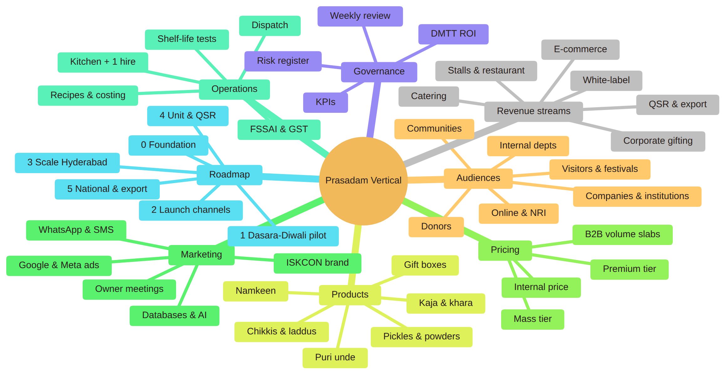

Order-to-delivery flow (all channels)
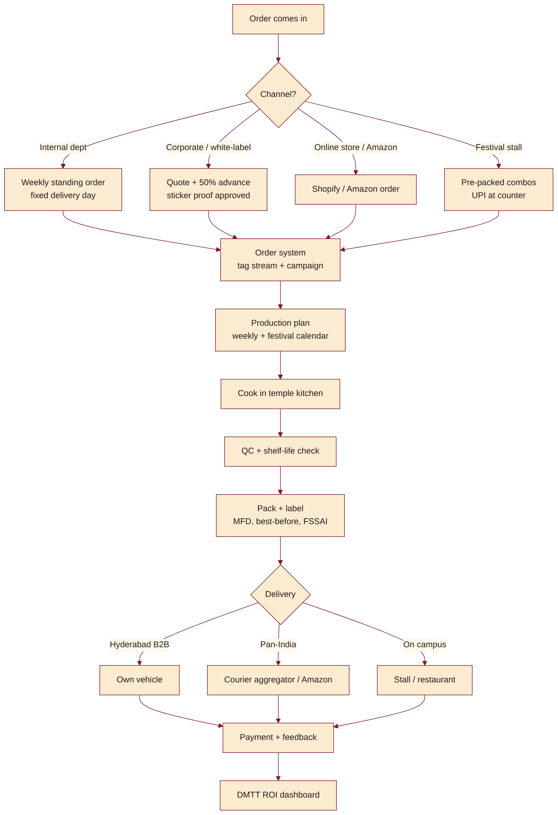

Corporate gifting sales flow
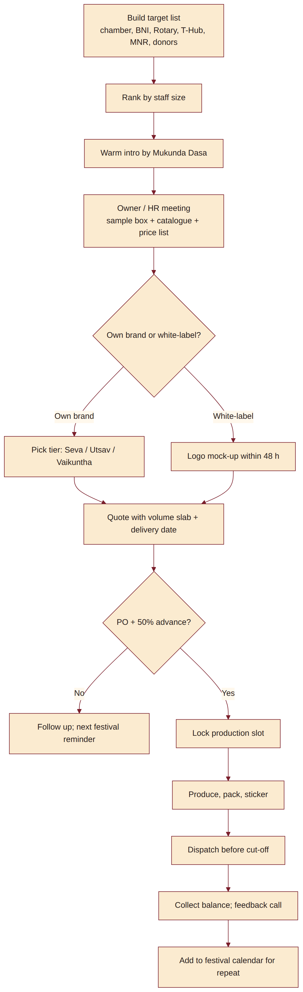

Festival stall operations
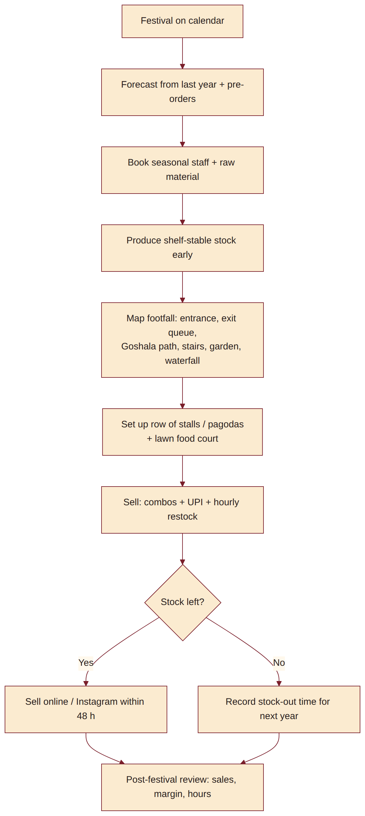

Decision and phase-gate flow
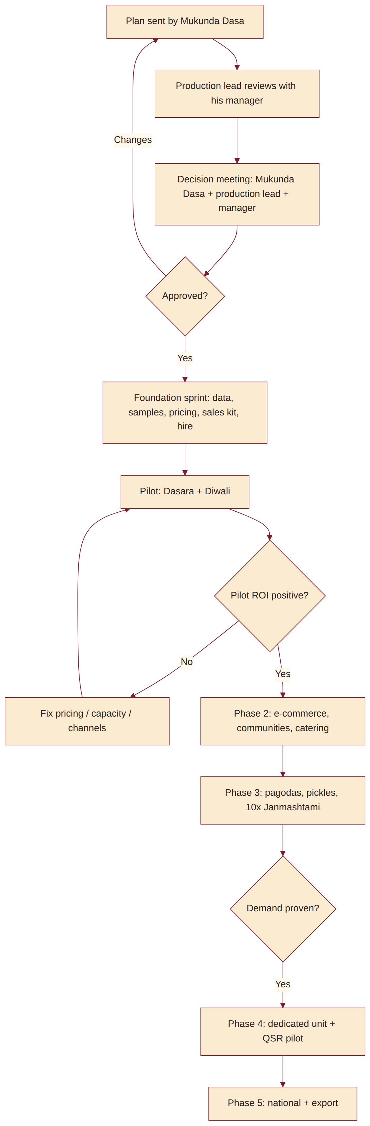

DMTT ROI tracking flow
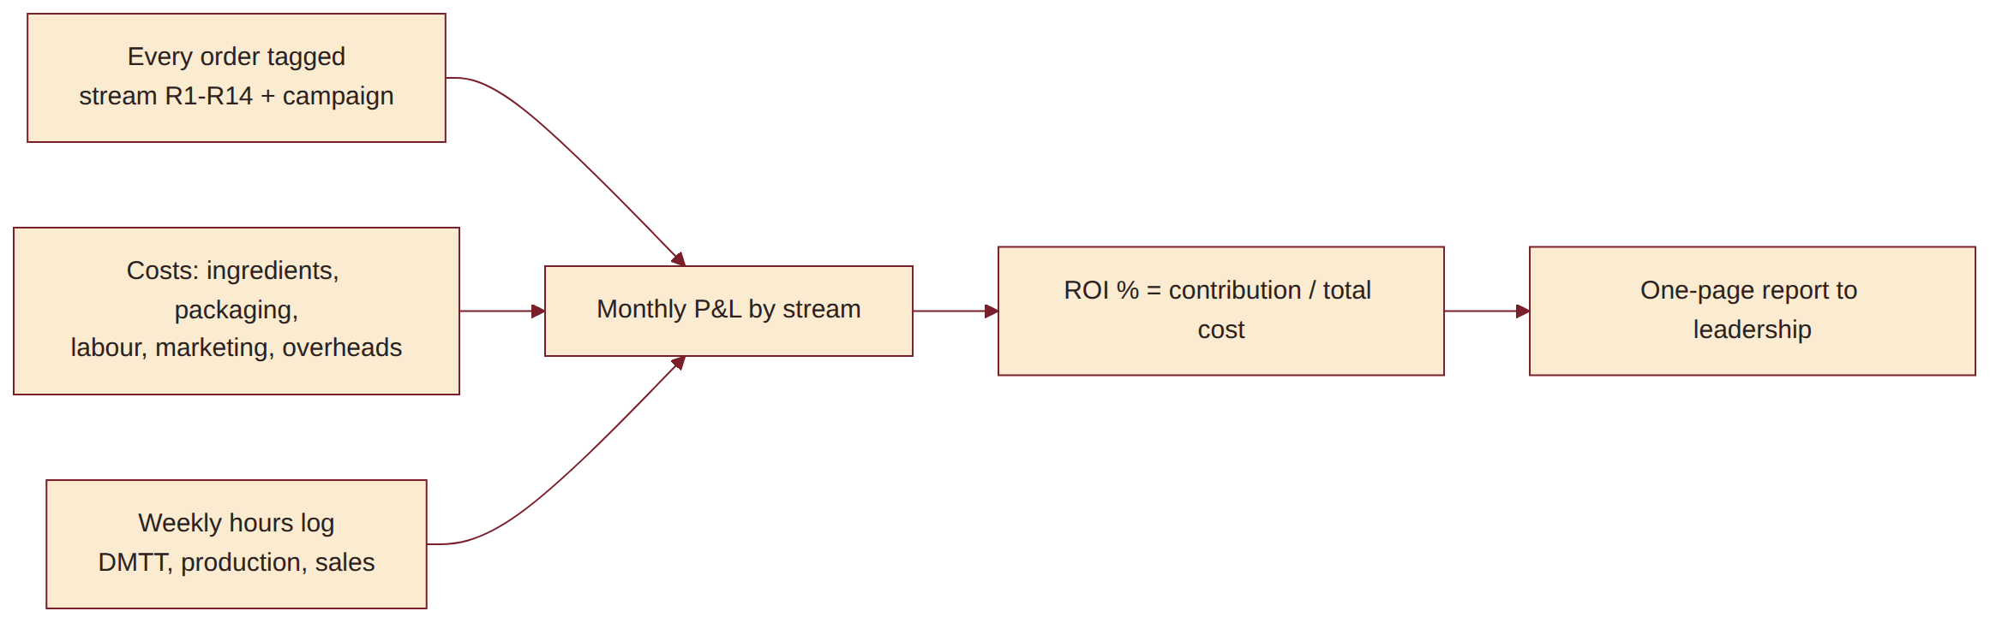

21. Sources
- India packaged sweets market: https://www.imarcgroup.com/india-packaged-sweets-market
- India namkeen market: https://www.technavio.com/report/namkeen-market-industry-in-india-analysis
- Corporate gifting: https://www.chococraft.in/blogs/corporate-gifts/corporate-gifting-industry-india-2025-2030
- Diwali gifting mix: https://www.outlookindia.com/xhub/featured-insights/diwali-gifting-report-2025-what-india-is-really-buying-for-the-festival-of-lights
- Premiumisation: https://www.mordorintelligence.com/industry-reports/india-sweets-market
- GST 2.0: https://upstox.com/news/personal-finance/latest-updates/gst-rate-cut-2025-namkeens-bhujia-and-other-pre-packaged-and-labelled-goods-to-get-cheaper-from-september-22/article-180743/
- FSSAI licence thresholds: https://www.mondaq.com/india/food-and-drugs-law/1801924/fssai-raises-turnover-limits-for-food-business-registration-and-licensing
- Labelling: https://www.freepressjournal.in/mumbai/fssai-removes-mandatory-best-before-date-requirement-for-non-packaged-sweets-fda-to-intensify-festival-season-inspections
- Temple precedent: https://iskcongovindas.in/
- Local competition: https://indiashopping.io/blogs/route-to-roots/famous-sweet-shops-in-hyderabad
- G Pulla Reddy gifting: https://gpullareddysweets.com/pages/gifting
- Almond House: https://almondhouse.com/
- Hare Krishna Golden Temple: https://hkmhyderabad.org/

