M24MCA1L206 Advanced Database Lab

LAB CYCLE

- An overview of relational database design using MySQL
To get neat Output

SET LINESIZE 200;
COLUMN column_name FORMAT A50 or 999;(varchar-A50/int -9999)
A → Stands for Alphanumeric (Character/String) format.
50 → Specifies the width (number of characters) to display for that column.

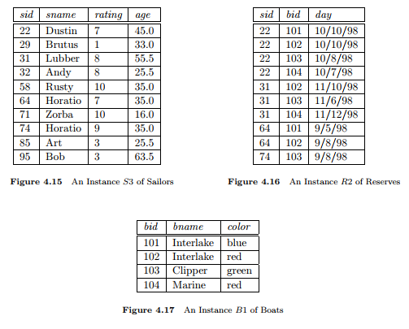

PROG 11: Union, Intersect and Minus(Set operations)
- Find the ids of sailors who have reserved a red boat or a green boat
- Find the names of sailors who have reserved boat 102.
- Find the name and the age of the youngest sailor
- Find the names of sailors who have reserved all boats.

PROG 12: Perform Nested Query operations
- Find the ids of sailors who have reserved a red boat or a green boat.
- Find the names of sailors who have reserved boat 102.

PROG 13: Execution of Join operations using the same table.
- Find the name and the age of the youngest sailor(Inner Join)
- Find the names of sailors who have reserved all boats.(Natural join)
- Find the ids of sailors who have reserved a red boat or a green boat(Left Join)
- Find the names of sailors who have reserved boat 102.(Right Join)
- Find the names of sailors who have reserved all boats.(Full outer join)

