Maura Cullen

W205 – 3 Summer Term

2017/7/17

Lab 6 Submission

## Topology file: tweetcount.clj

(ns tweetcount

(:use [streamparse.specs])

(:gen-class))

(defn tweetcount [options]

[

;; spout configuration

{"sentences-spout" (python-spout-spec

options

"spouts.sentences.Sentences"

["sentence"]

)

}

;; Bolts

{

;; bolt configuration 1

"parse-bolt" (python-bolt-spec

options

{"sentences-spout" :shuffle}

"bolts.parse.ParseTweet"

["aword"]

:p 2

)

;; bolt configuration 2

"tweetcounter-bolt" (python-bolt-spec

options

{"parse-bolt" :all}

"bolts.tweetcounter.TweetCounter"

["word","counts"]

)

}

]

)

## Screenshot of topology

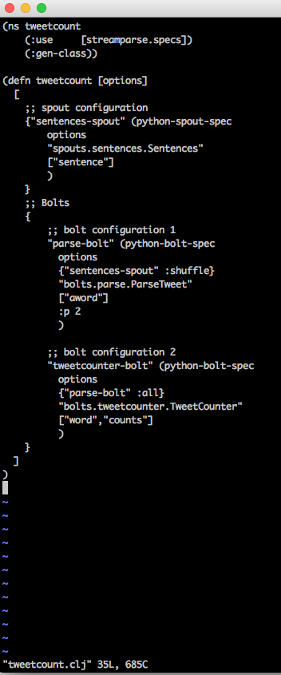

## Screenshot of Running Tweetcount

