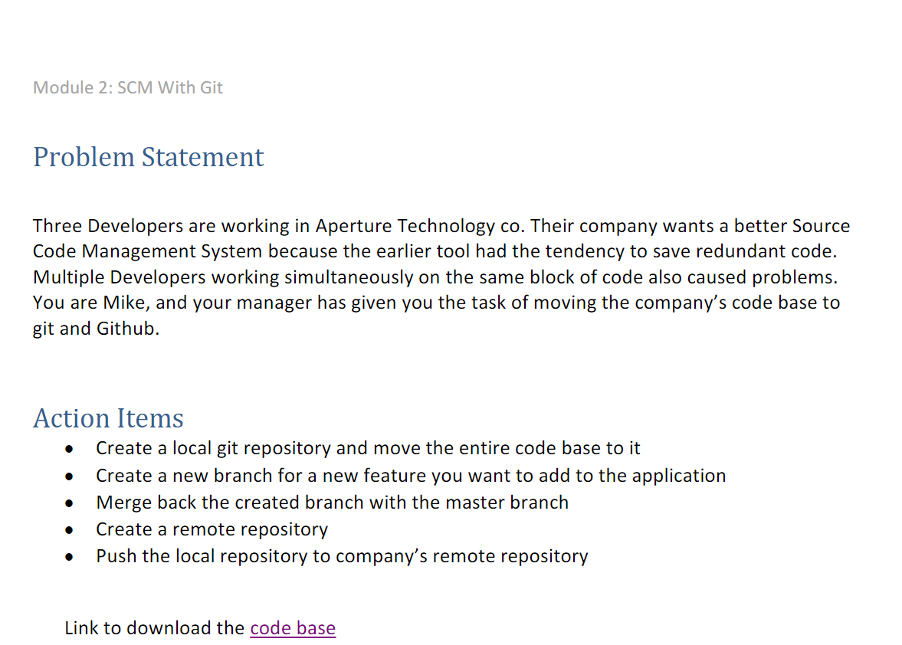

Configuring user name in terminal with git

git config --global user.name “mayukhdas053”

git config --global user.email [mayukhdas053@gmail.com](mailto:mayukhdas053@gmail.com)

git config –list and making repo

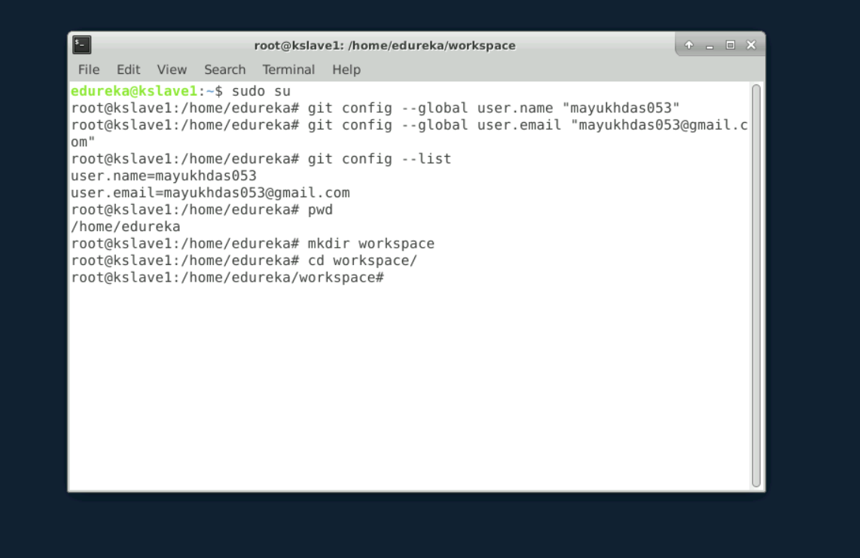

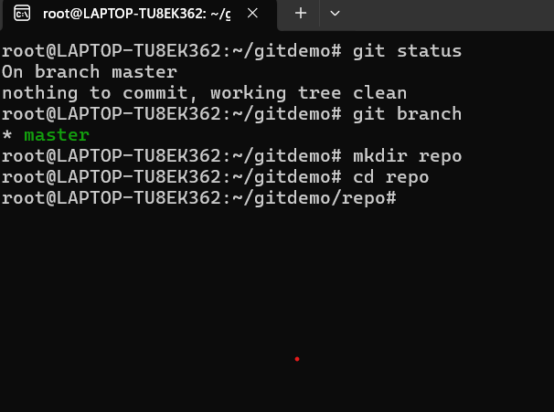

Setup the repo

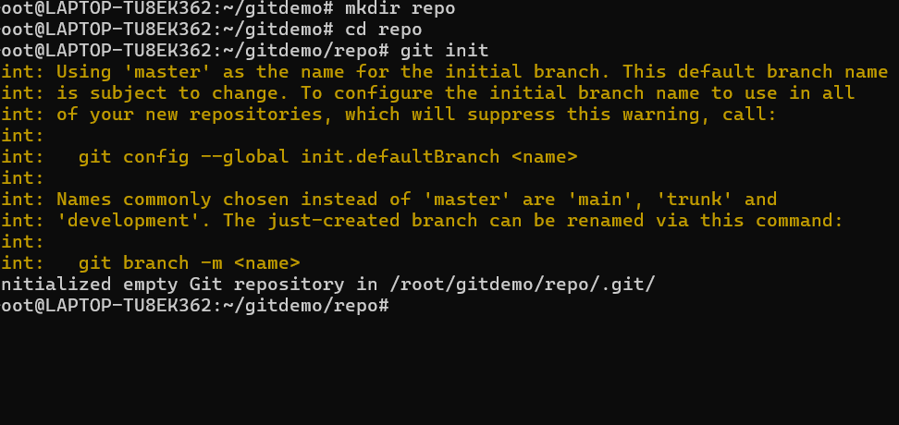

Code base downloaded



Added in new repository

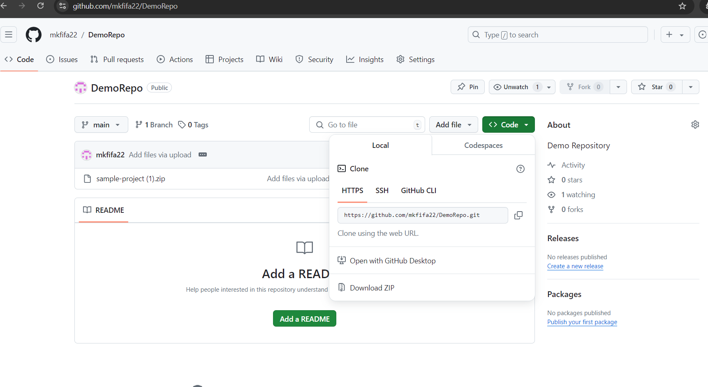

Created a new branch for a new feature you want to add to the application

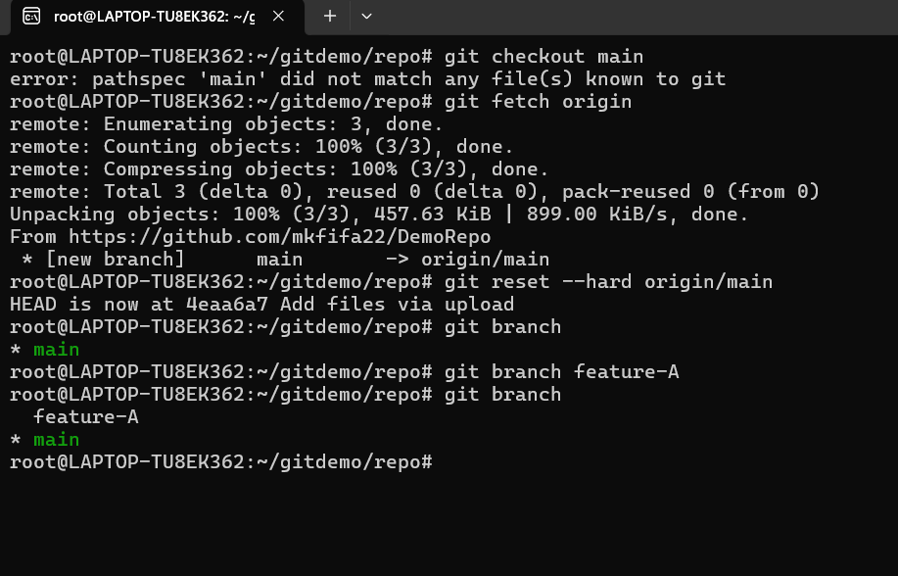

Merge back the created branch with the master branch

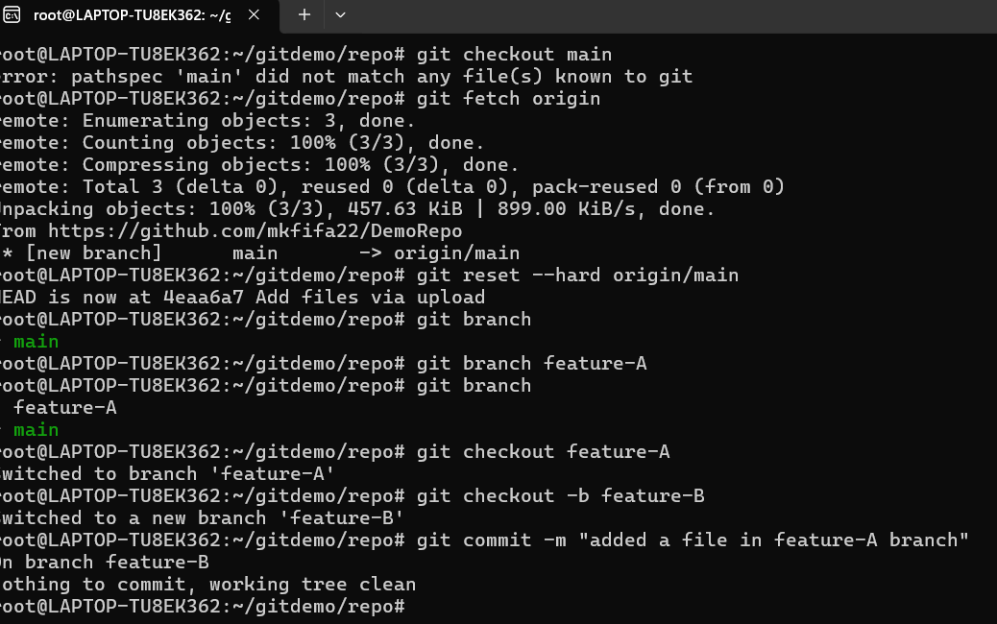

Check log – git log -3

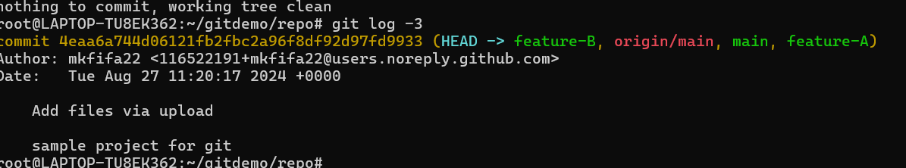

git merge feature-A

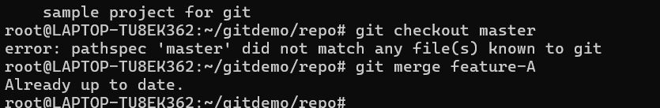

Office Repo created

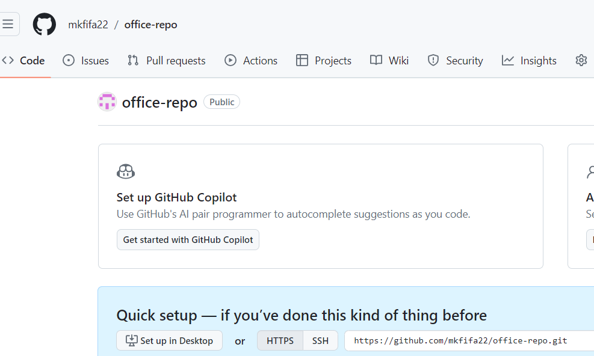

root@LAPTOP-TU8EK362:~/gitdemo/repo# git add .

root@LAPTOP-TU8EK362:~/gitdemo/repo# git commit -m "First commit"

On branch feature-B

nothing to commit, working tree clean

root@LAPTOP-TU8EK362:~/gitdemo/repo# git remote add origin <https://github.com/mkfifa22/office-repo.git>

echo "# kn" >> README.md

git init

git add README.md

git commit -m "first commit"

git branch -M main

git remote add origin https://github.com/mkfifa22/kn.git

git push -u origin main

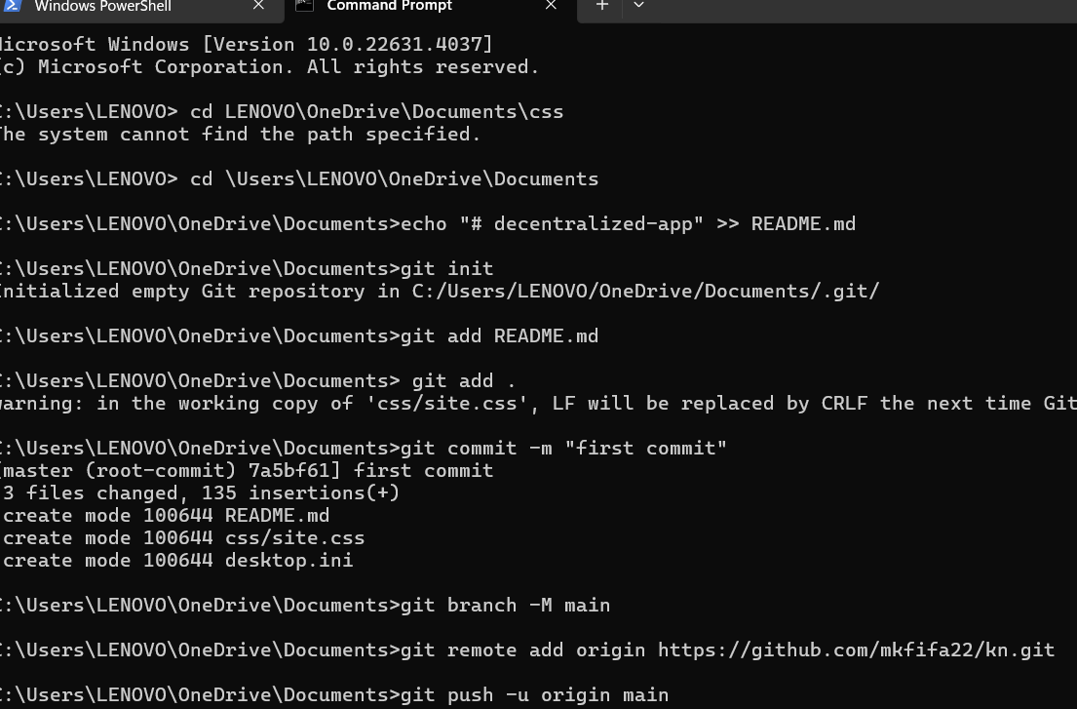

Moved to git hub

