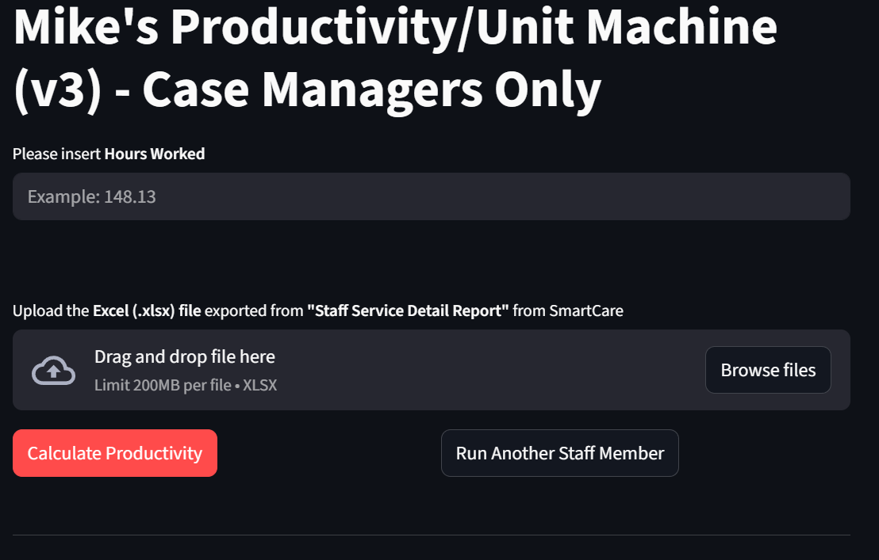
How to Run Mike’s Incredible Productivity App

🎯 Purpose of the App

Mike’s Incredible Productivity App is a web-based tool designed to analyze staff service data and automatically calculate minutes, units, and productivity percentages. The app eliminates manual calculations, reduces errors, and produces consistent, reliable productivity results for supervisory review and compliance tracking.

🔓 Step 1: Open the App
🌐 Open the app using the following link:
https://mkdemmers42-productivity-unit-master-v3-app-nhgt3n.streamlit.app
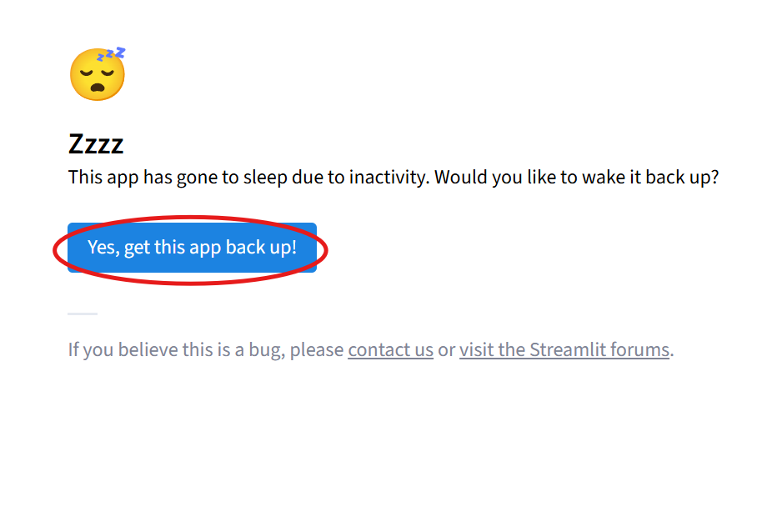
⚠️ Important Note:
The app may occasionally be “sleeping.” If prompted, select:

👉 Yes, get this app back up!
⏳ The system will automatically reboot/rebuild the app. This is normal and typically takes about one minute.
✅ Once the app loads, keep this browser tab open.

⏱️ Step 2: Open UKG and Obtain Hours Worked
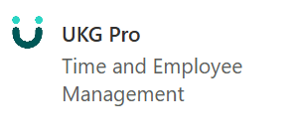
1️⃣ Open UKG and log in.

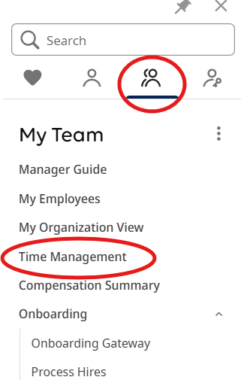
2️⃣ Navigate to Your Team and select Time Management.
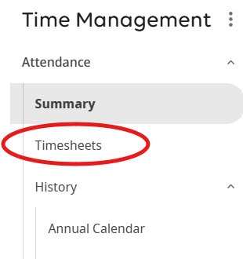
3️⃣ Select Timesheets.
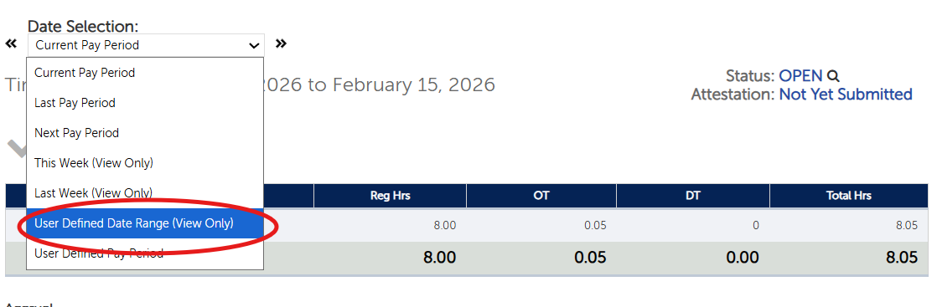
4️⃣ Open the Date Selection drop-down menu and choose User Defined Date Range (View Only)
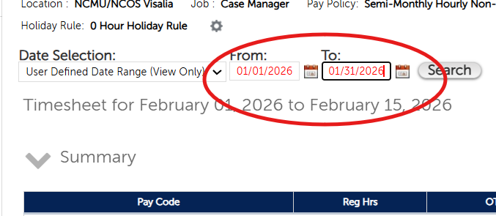
5️⃣ Enter the appropriate From and To dates, The select Search.
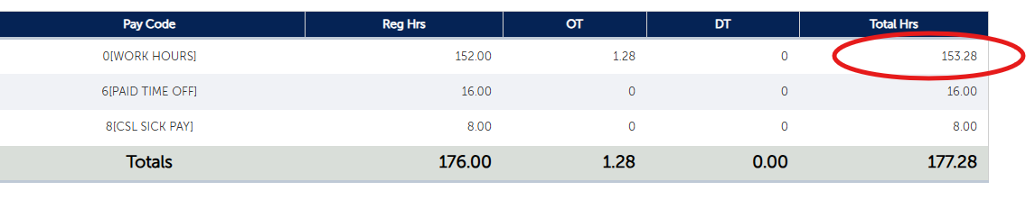
📊 The system will display the staff member’s worked hours for the selected date range.
⚠️ Important Note:
✔️ Use Hours Worked ONLY
❌ Do NOT include PTO, CSL, or combined totals.
✍️ Write this number down or keep it readily available.
🧾 Step 3: Open SmartCare and Run the Report
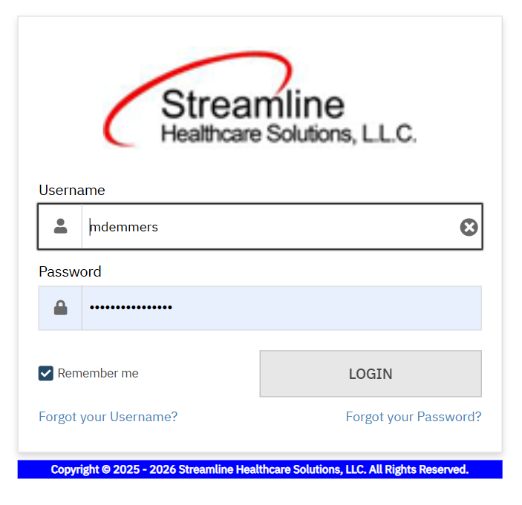
1️⃣ Open SmartCare and log in.
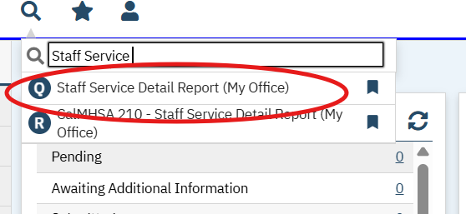
2️⃣ Using the spyglass 🔍 (search) icon, search for: Staff Service Detail Report
3️⃣ Select the report and allow it to fully load.

Once loaded:
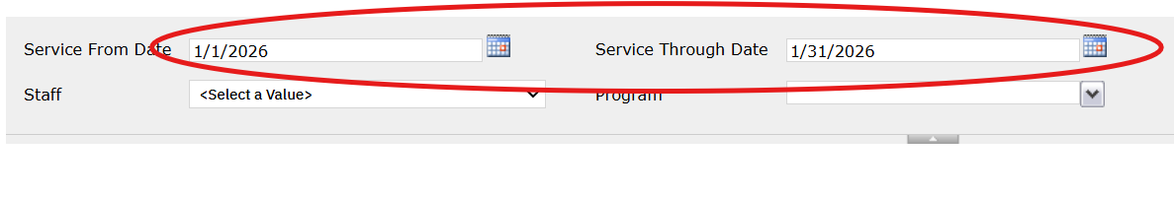
4️⃣ Enter the same date range used in UKG.
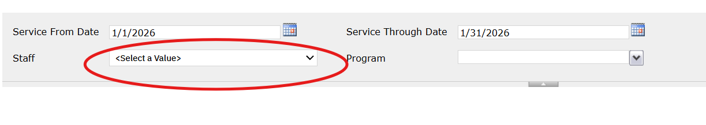
5️⃣ Select the staff member’s name from the Staff drop-down menu.
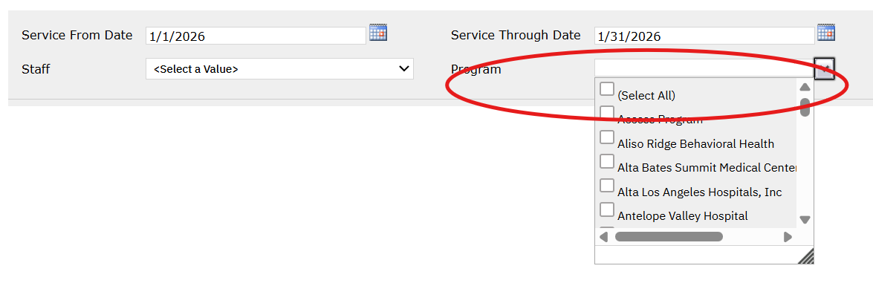
6️⃣ From the Program drop-down menu, select All Programs.
7️⃣ Select View Report.

📤 Export the report:
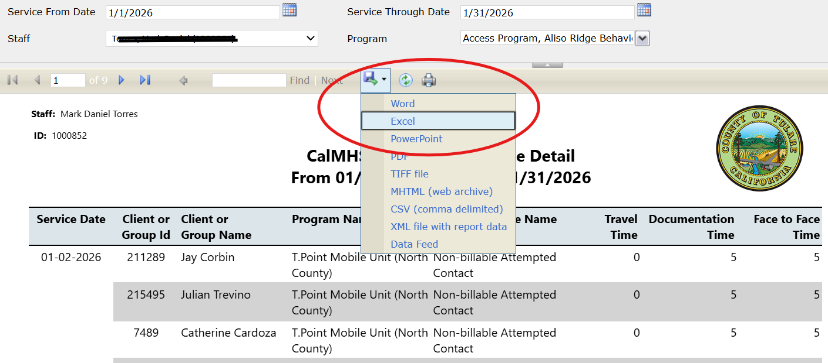
8️⃣ Select the Export drop-down menu and choose Excel.
📁 Side Note:
The file will download to your Downloads folder by default.
Access it via File Explorer → Downloads.

✨ Step 4: The Magic — Run the App
Now that all required information is ready:
1️⃣ Return to the browser tab where the app is open.
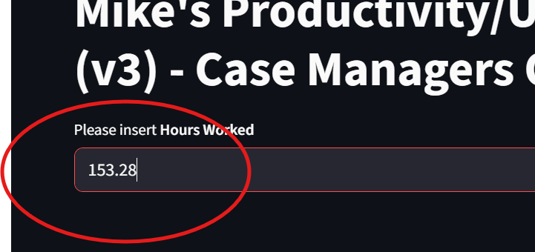
2️⃣ Enter the Hours Worked value.
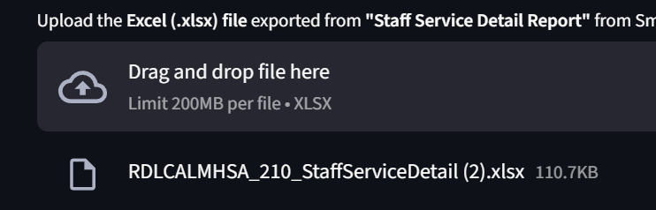
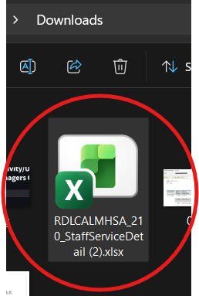
3️⃣ Drag and drop the downloaded Excel file into the app.

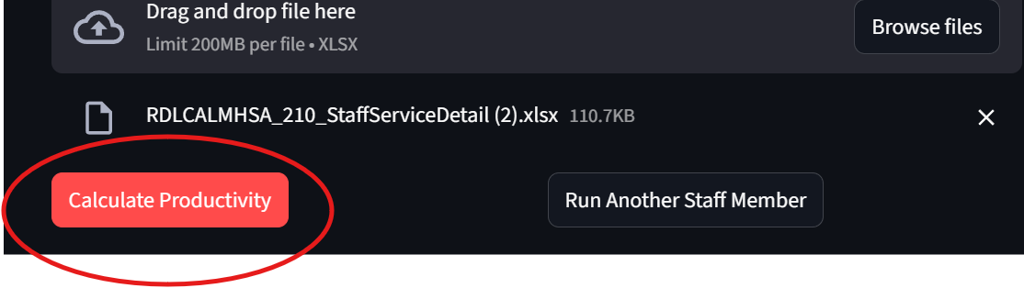
4️⃣ Select Calculate Productivity.

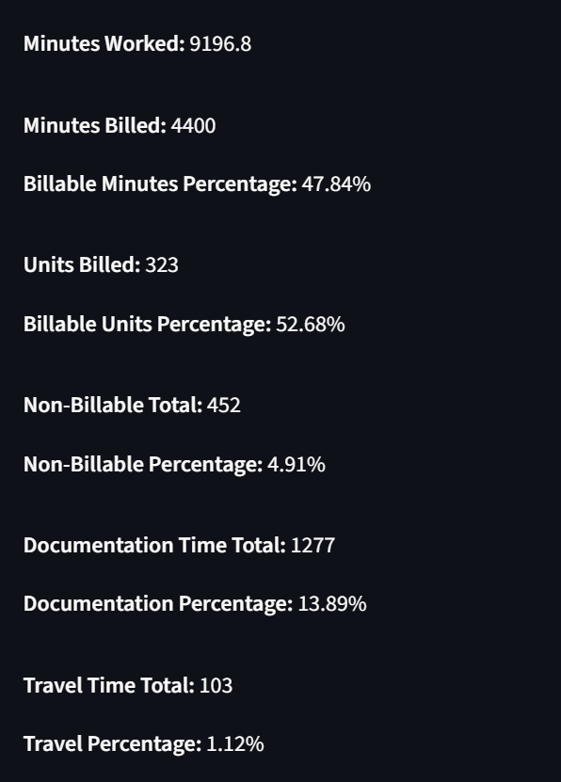
🎉 Boom! Your productivity results will immediately display.

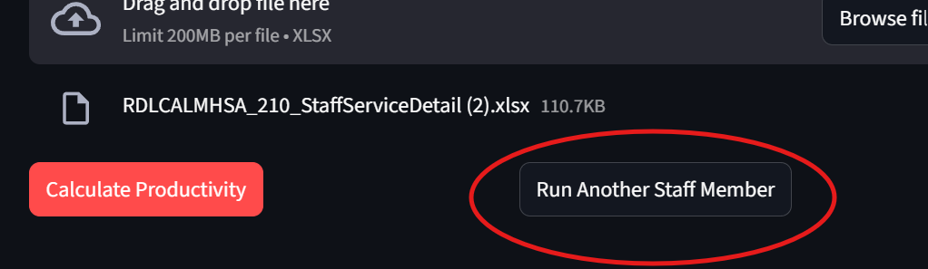
🔁 To run productivity for another staff member, select Run Again and repeat Steps 2–4.

I hope this tool makes your workflow faster, easier, and more accurate.
Thank you for using Mike’s Incredible Productivity App.

