Stat Blocks

Monsters
Monster | Part & Scene
The Horror | P2S1
Torment Demon 1(m) | P2S5 & P2S9
Torment Demon 2(cap) | P2S5 & P2S9
Statue of the Third Commander | P2S6
Basilisk Hatchling | P2S7
Deatheye Yslansh | P2S9
Excrucior Interfectus,  Avatar of Torment | -

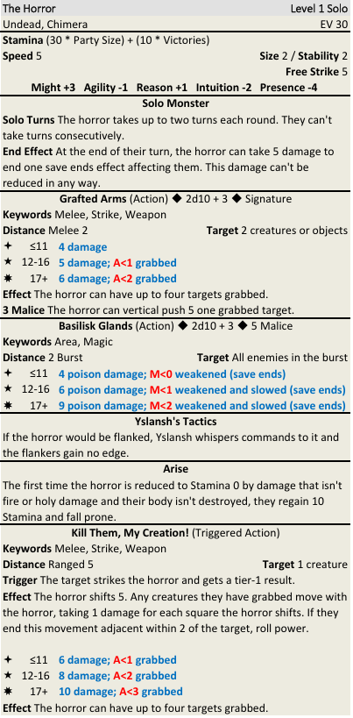

Retainers
Retainer | Part & Scene
Gwennyl Thorton | P1S3
Squire Qoroth | P2S3
Squire Bleddyn | P2S8

Dir. Note: These stat blocks are also in the Player Rewards document.

