**PROJECT IN DATA STRUCTURE AND ALGORITHM**

Group Members: Gamboa, Mark Arsenius S.

Elec, John Maynard

San Buenaventura, Jayson

Abella, Jasper

Lantican, Jessabeth

**Introduction**

This project is consisting of different sorting algorithms that is show through basic GUI programming using python. The user will see exactly like the picture shown below (figure 1). The program has various buttons that has a specific algorithm function that it will execute, depending on the user’s selection. The main idea is to present a algorithm option to the user. As shown below, by just one look, the user will automatically gain the intended instructions of the program when using it. We improvised the code that was suppose to be displayed via terminal, and imported it to a basic GUI. Running in GUI is a bit tricky due to different OS themes, so the color and style may vary on each OS like in Windows and Ubuntu.

**(Figure 1)**

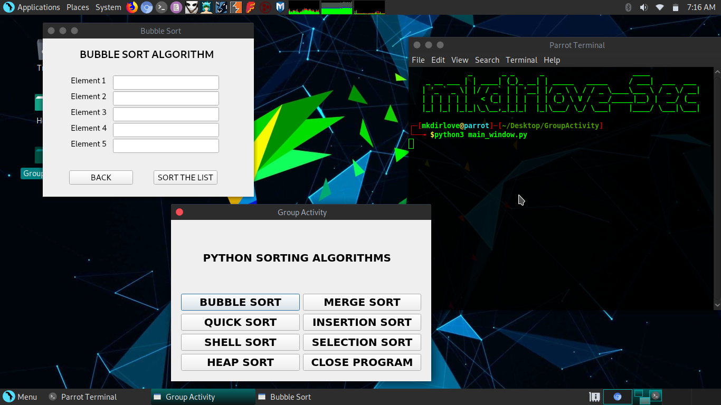**main_window.py**

The first windows that will appear when the program is launched. All the algorithm functions are displayed via buttons.

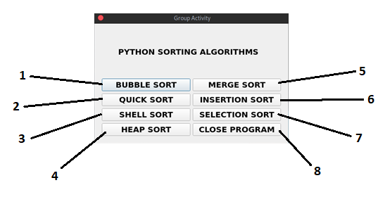**FUNCTIONS**

1. Bubble Sort **Button** - Display Bubble Sort Window.
2. Quick Sort **Button** - Display Quick Sort Window.
3. Shell Sort **Button** - Display Shell Sort Window.
4. Heap Sort **Button** - Display Heap Sort Window.
5. Merge Sort **Button** - Display Merge Sort Window.
6. Insertion Sort **Button** - Display Insertion Sort Window.
7. Selection Sort **Button** - Display Selection Sort Window.
8. Close Program **Button** - Close the program window.

**Example: A sample when a button is clicked**

The picture below is what will appear when a user clicks a button on the main menu. In this case, Bubble Sort Algorithm is shown in the picture. The user is required to input the **int** elements that will be sorted using Bubble Sort, (note: the program ONLY ACCEPTS INTEGER VARIABLE). As we can see, the program is limited to 5 elements of array. This window has various functions such as the “BACK” button which takes the user back to the main menu when he/she changes the desired algorithm. The “SORT THE LIST” button will execute the sorting algorithm that the user wants, another window will appear displaying the sorted list.

(Figure 2) bubble_sort.py

**Program Windows Walkthrough**

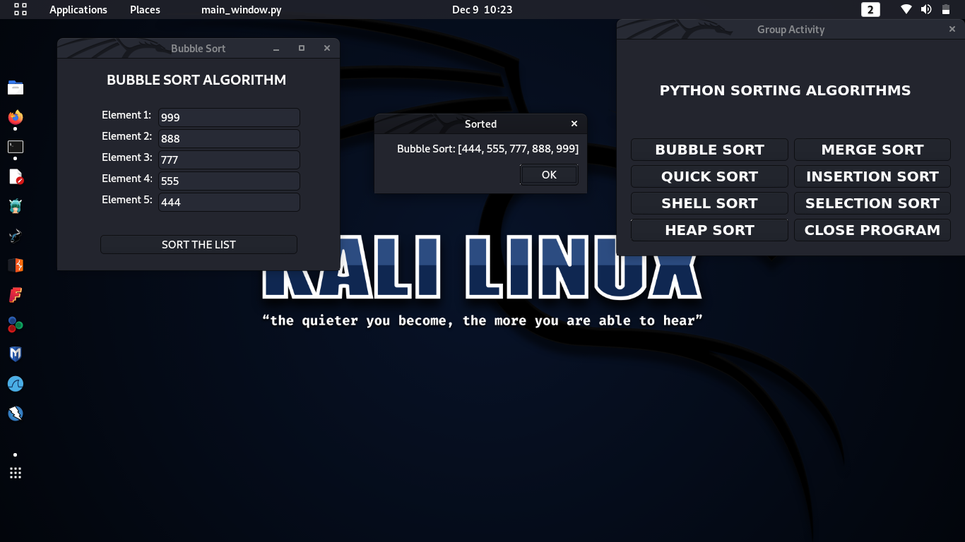Main Menu Bubble Sort Window

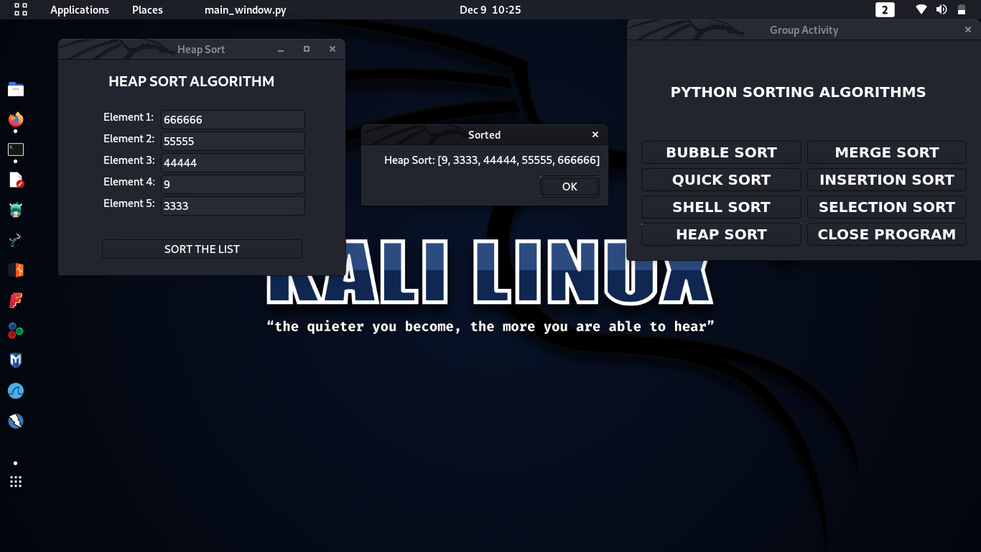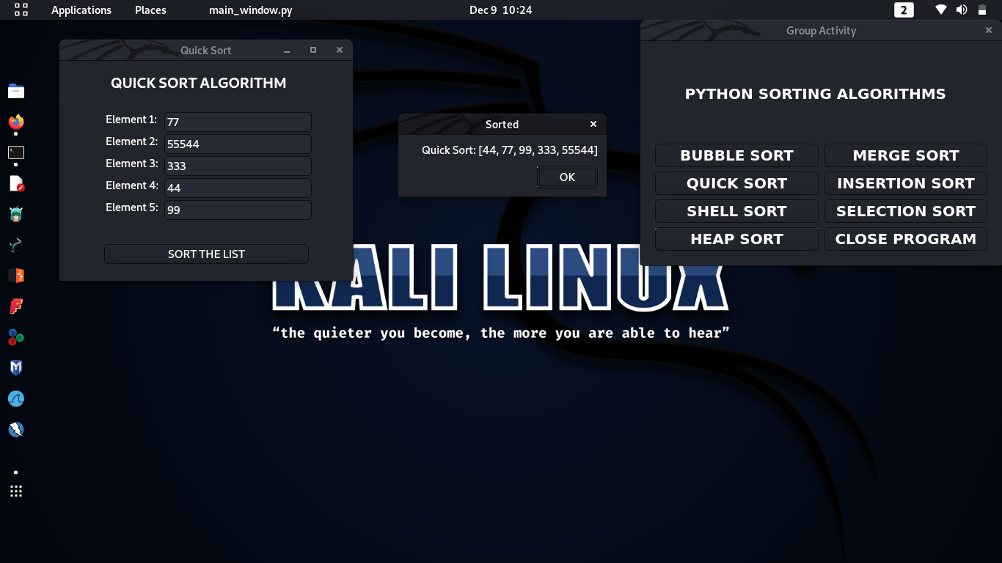Quick Sort Window Heap Sort Window

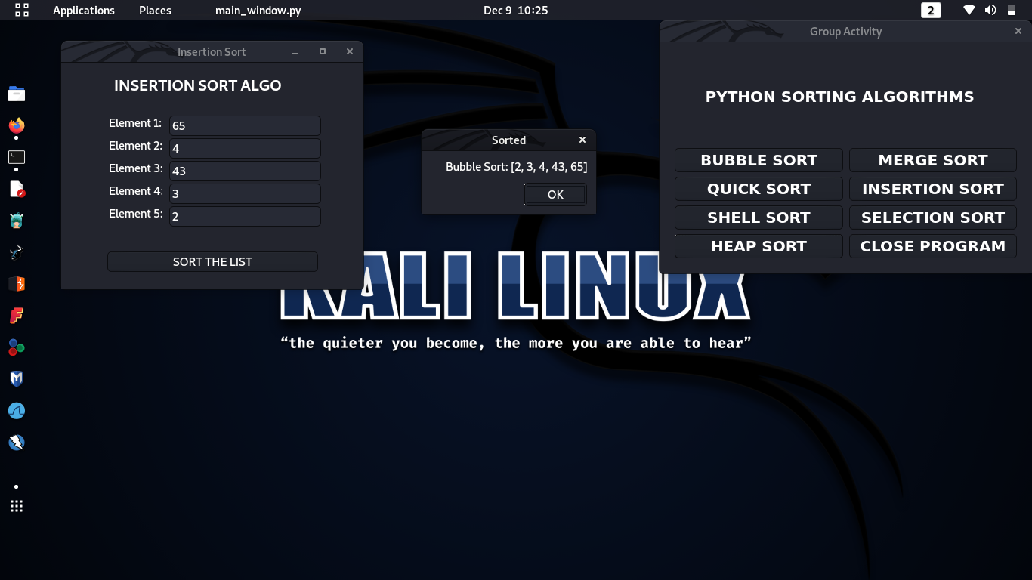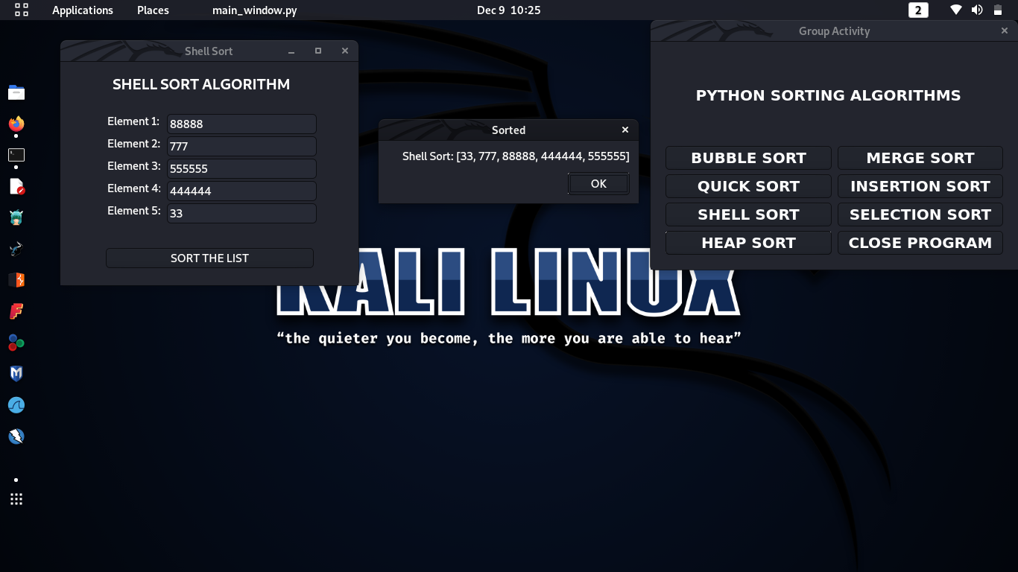Shell Sort Window Insertion Sort Window

Selection Sort Window Merge Sort Window

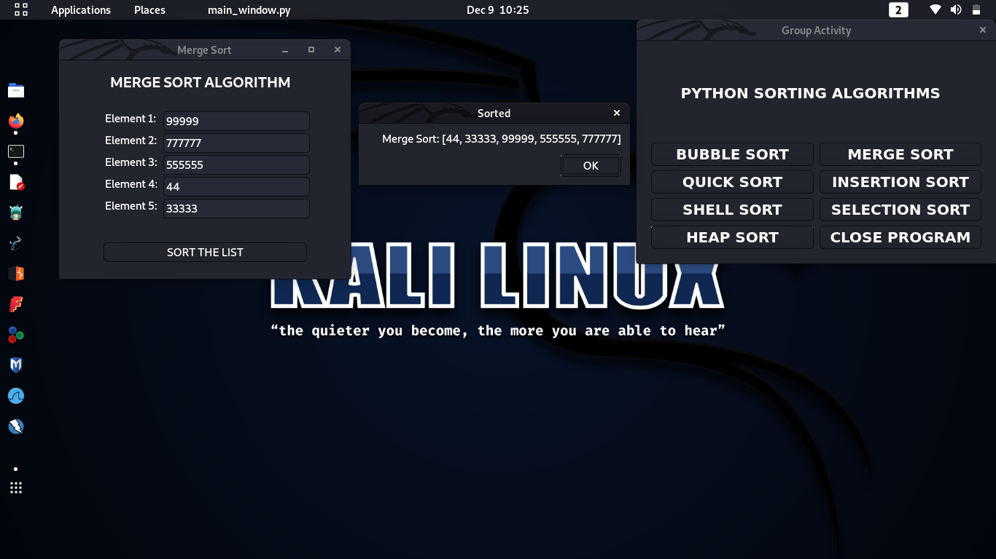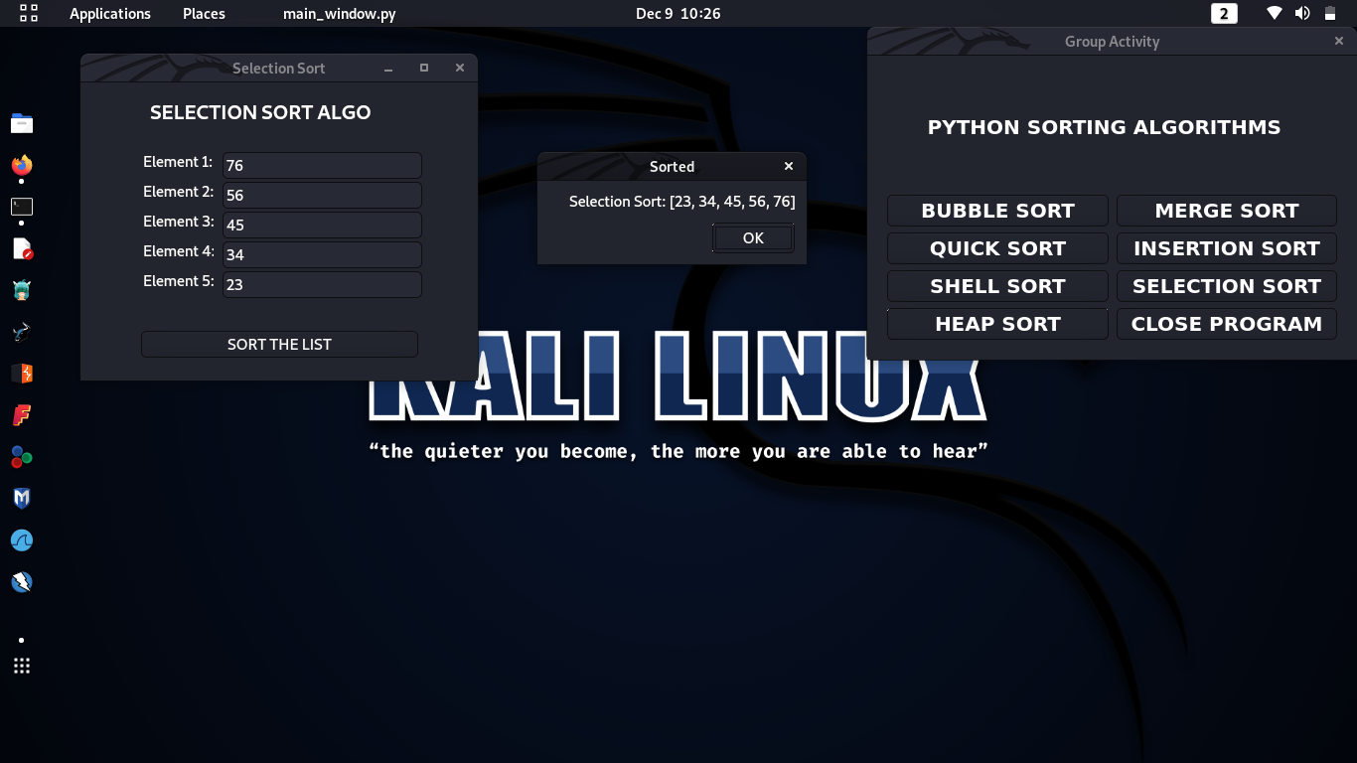

Output Window