NYC Airbnb Capstone — Team Pitch
BANA 5160 · Week 2 EDA Alignment
Brendan Meara, Jairam Manikandan, Francois Miaule, Rachael Chin, Manas Manu
Data: Inside Airbnb NYC · Full listings.csv + calendar.csv

1. Purpose of This Document
This document presents the first-pass EDA findings and viable courses of action as per our hypothesis.

2. What We're Working With
We have advisor approval to use the full Inside Airbnb NYC dataset — as opposed to the stripped-down Kaggle file (AB_NYC_2019.csv, 16 columns). Here is what we actually have:
File | Size | Key Fields
listings.csv | 73 MB · 30,259 listings · 90 columns | price, amenities, room_type, bedrooms, review_scores_*, host_listings_count, estimated_revenue_l365d, estimated_occupancy_l365d
calendar.csv | 369 MB · 365 days × all listings | date, available — availability patterns by month (note: no daily price in this version)
Snapshot date | June 14, 2026 | Current market, not historical Kaggle 2019 data
Scope | NYC only (all 5 boroughs) | Manhattan 45% · Brooklyn 35% · Queens 16% · Bronx 3% · SI 1%

Fields that matter for our hypothesis
- calculated_host_listings_count — host scale segmentation (0% null)
- estimated_revenue_l365d — our primary performance metric (71% populated; 29% have no price/booking data)
- estimated_occupancy_l365d — all listings have this (0% null)
- amenities — 0% null, but needs parsing from raw text list
- price — 28% null (only priced listings)
- review_scores_rating — 28% null
- bedrooms / bathrooms— 33–36% null (use accommodates as backup capacity proxy)
- instant_bookable — 100% null good candidate to drop from analysis.

3. What the Data Actually Says — First Pass EDA
Since our combined datasets have 100+ columns/ variables, we focused our analysis on the ones important to our hypothesis (listed above).
3.1 Market Structure
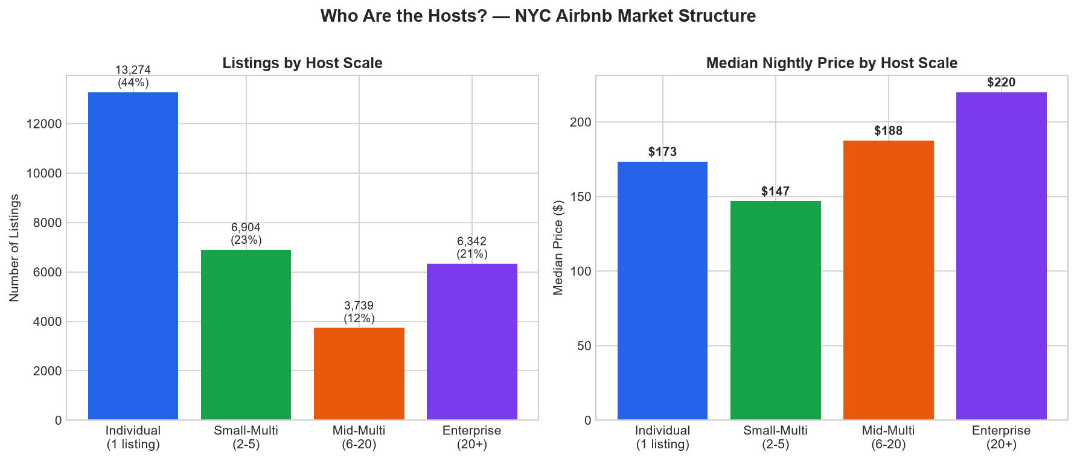
Figure 1. Host scale distribution and median nightly price by tier.
- 30,259 total listings across NYC
- Individual hosts (1 listing): 43.9% of market — median price $173/night
- Small-Multi (2–5 listings): 22.8% — median price $147/night
- Mid-Multi (6–20): 12.4% — median price $188/night
- Enterprise (20+ listings): 21.0% — median price $220/night
- Entire home/apt is 55.5% of listings at $223 median; Private room is 42% at $103 median
3.2 The Occupancy Gap
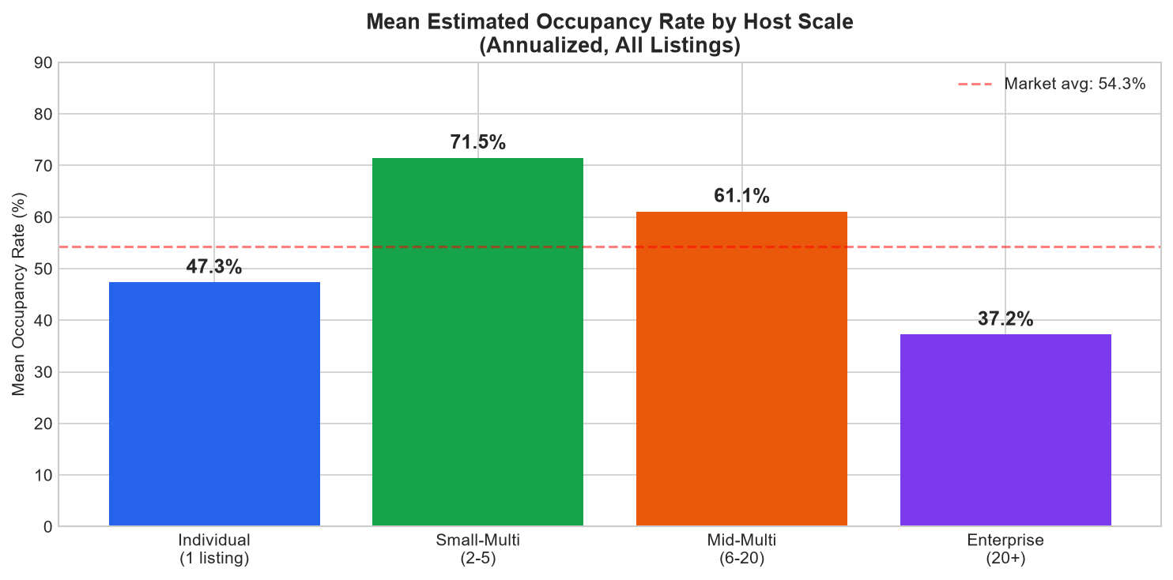
Figure 2. Mean estimated occupancy rate by host scale tier.
Key finding: Small-Multi operators (2–5 listings) have mean occupancy of 71.5% — nearly 25 points higher than individual hosts (47.3%). Enterprise operators (20+) have the lowest occupancy at 37.2%, despite pricing highest.

- Individual hosts: 47.3% mean occupancy
- Small-Multi (2–5): 71.5% — the market outperformer
- Mid-Multi (6–20): 61.1%
- Enterprise (20+): 37.2% — lowest occupancy despite highest prices
3.3 Quality Inversion
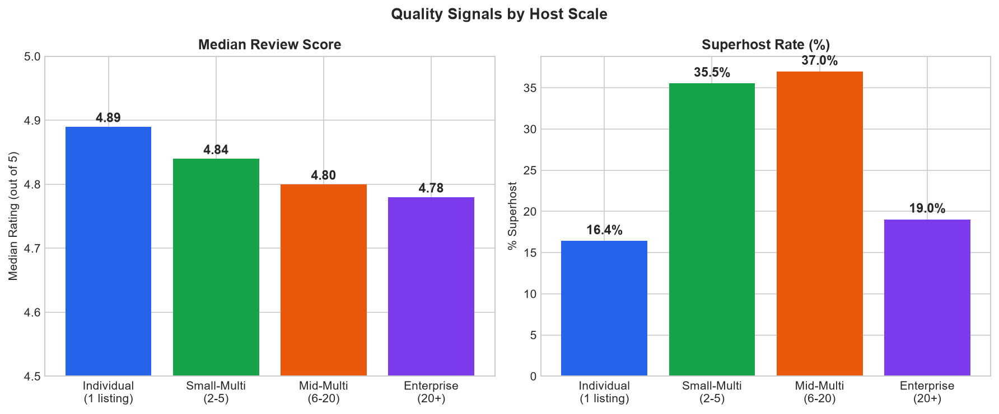
Figure 3. Median review score and superhost rate by host scale tier.
- Individual hosts score highest on reviews: median 4.89 vs Enterprise 4.78
- Superhost rate peaks at Small-Multi (35.5%) and Mid-Multi (37.0%)
- Individual superhost rate is only 16.4% — high quality but low recognition
- Enterprise has lower review scores and lower occupancy than individual hosts
3.4 The Mispricing Signal
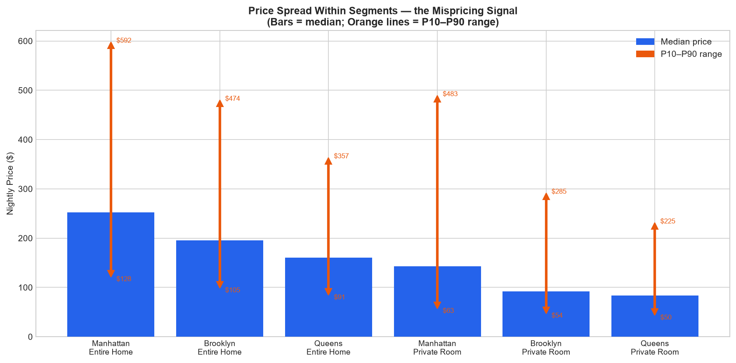
Figure 4. Price spread (P10–P90) within identical neighborhood × room type segments.
Within the same borough and room type, prices vary by a factor of 5–7x. Manhattan private rooms range from $84 (P10) to $550 (P90) — a CV of 1.81. This is not quality variation we can explain with the data we have. It is pricing noise — and the gap between a listing's actual price and its 'fair' price is the actionable signal.

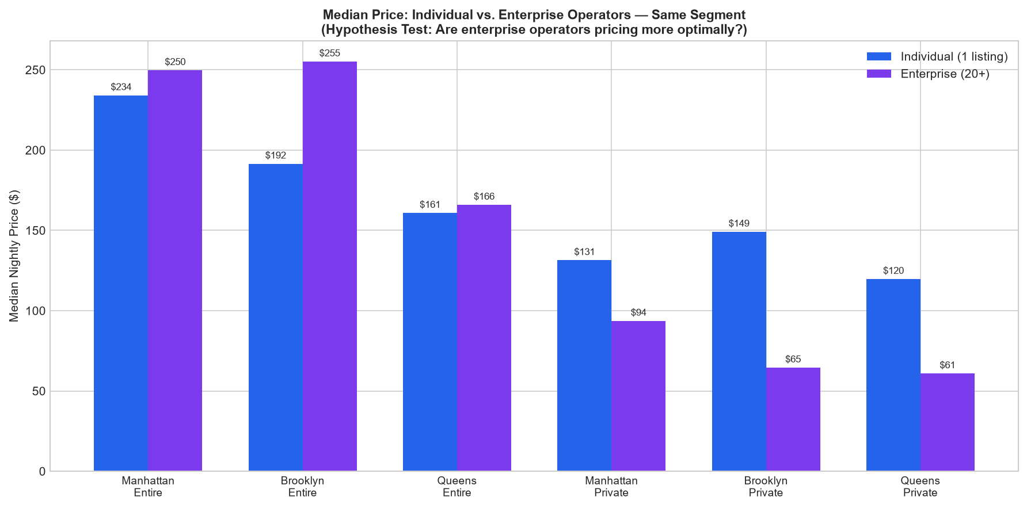
Figure 5. Median price: Individual (1 listing) vs. Enterprise (20+), matched by segment.
- Entire homes: Enterprise prices 4–31% higher than individuals in same borough
- Private rooms: Individual hosts price 26–57% higher than enterprise — opposite direction
- Enterprise operators appear to use volume/discount strategy on private rooms
- Individual hosts on private rooms may be overpriced relative to competition, hurting occupancy
3.5 Seasonal Availability Patterns
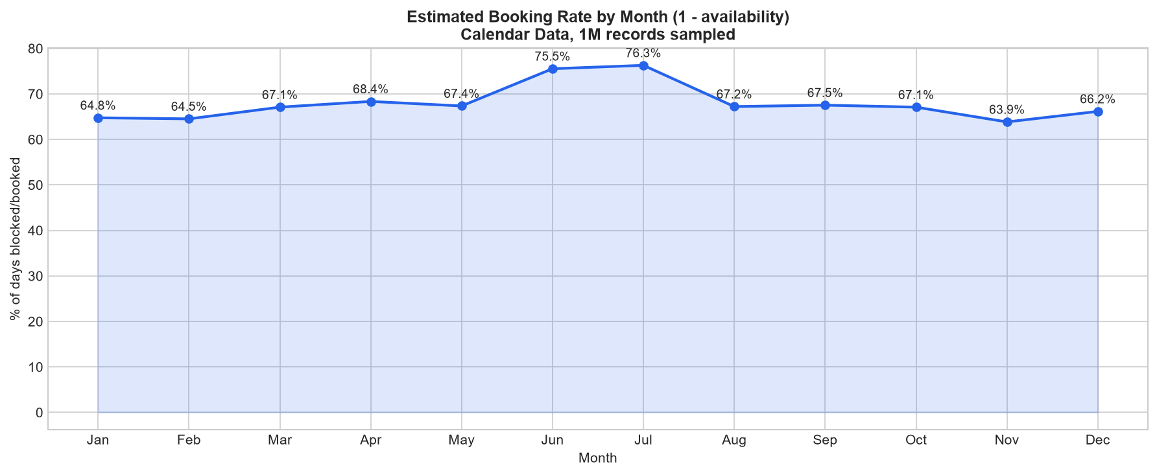
Figure 6. Estimated booking rate by month (1 − availability rate), 1M calendar records.
- Calendar file contains availability but not daily price (field absent in this export)
- Seasonal booking patterns visible — useful context for any seasonal pricing recommendations
- Pricing model will use listings.csv price field + availability_365 as demand proxy

3.6 Revenue, Amenities, Bedrooms/Bathrooms
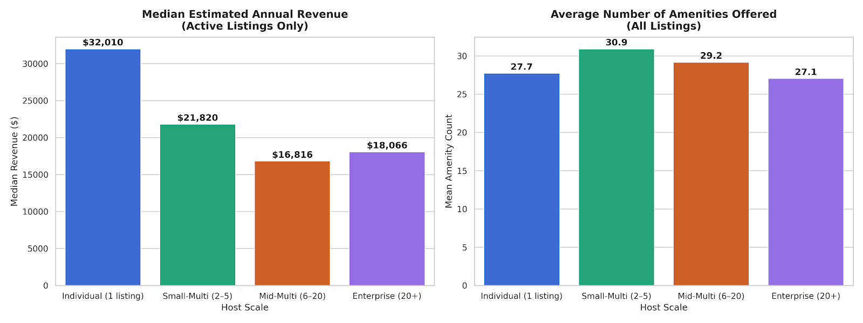
Figure 7. Median annual revenue (active listings) and average amenity counts by host scale.

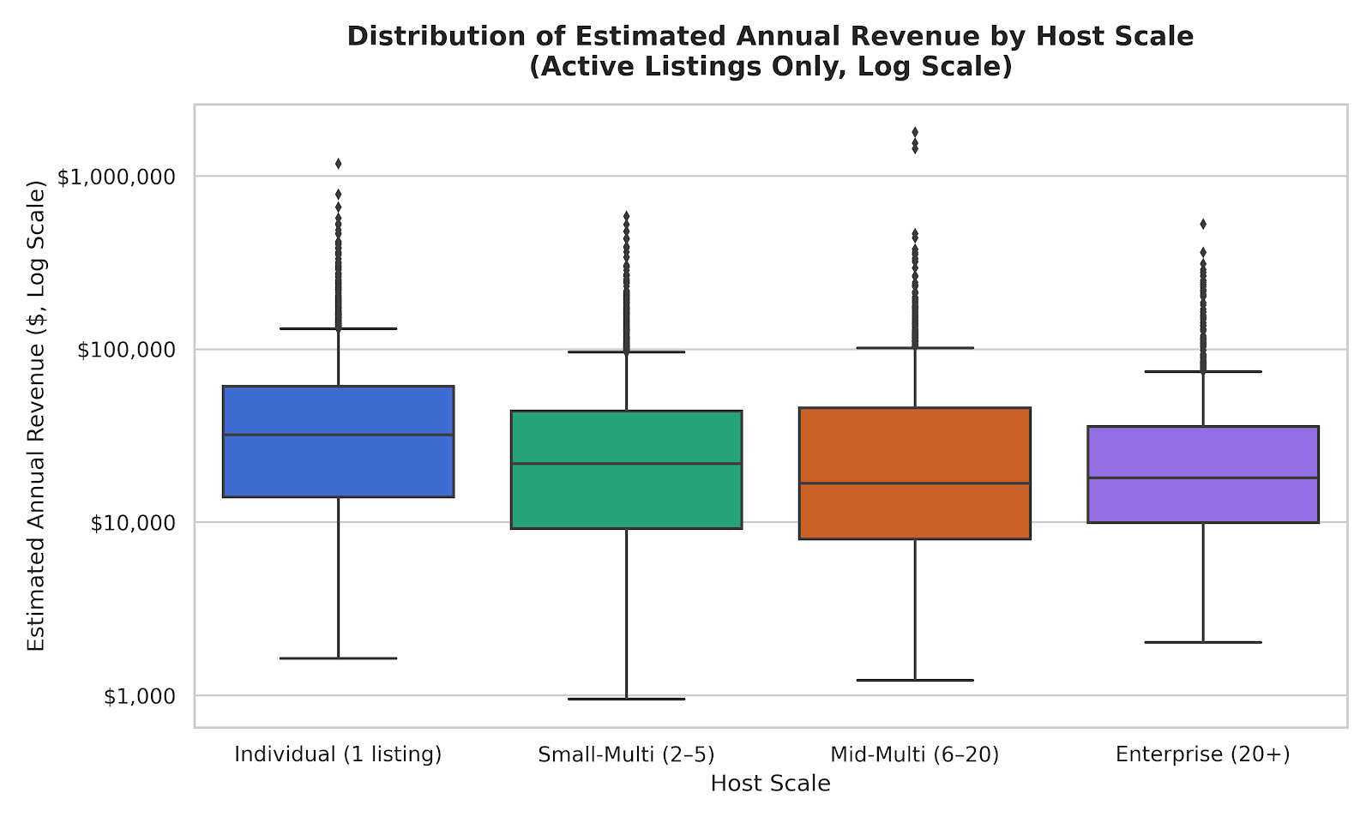
Figure 8. Distribution of estimated annual revenue across host scale segments (log scale).

Among active market listings (listings generating > $0 in trailing revenue), individual hosts capture the highest median annual yield at $$32,010, followed by Small-Multi operators at $21,820. Despite their premium nightly pricing strategy, Enterprise operators pull in a significantly lower median annual revenue of $18,066 due to their severe occupancy penalty (37.2%).
Small-Multi operators provide the highest average amenity count in the city at 30.9 items per listing, followed closely by Mid-Multi hosts at 29.2. Conversely, Enterprise operators provide the leanest amenity footprints, averaging just 27.1 items. This establishes a clear structural correlation between amenity density and superior occupancy rates.
When evaluating property layout limits, Enterprise operators intentionally select smaller physical blueprints, maintaining the lowest average capacity profile at 1.43 bedrooms and an accommodation threshold of 2.76 guests. Small-Multi hosts manage significantly larger spaces, averaging 1.70 bedrooms per listing.
Box plot:
Individual hosts make the highest median annual revenue $32,010 by keeping their occupancy balanced, whereas Enterprise hosts suffer a massive revenue penalty ($18,066 because they overprice their entire apartments and let them sit vacant)
There is also a presence of extreme outliers stretching into the $100,000to $1,000,000+ annual threshold.

4. Courses of Action — Group Vote Needed
Based on the EDA, there are multiple defensible directions.
Option A — The Mispricing Diagnostic
Core question: How far is any given listing priced from its 'fair value' given its segment, and what's the revenue impact of closing that gap?

- Hedonic pricing regression: predict price from room type, borough, capacity, amenity count, review scores
- Residual = mispricing signal. Positive residual = overpriced. Negative = underpriced.
- Output: a listing-level diagnostic — 'you are priced $X above/below comparables; estimated revenue impact is $Y/year'
- Simpler model, cleaner deliverable, lower execution risk
- Limitation: doesn't explain WHY the gap exists, just that it does
Option B — Individual vs. Small-Multi Benchmarking Tool
Core question: What specific practices separate Small-Multi operators (the occupancy leaders) from Individual hosts — and can we build a tool that shows an individual host exactly how to close that gap?

- Segment the market by host tier; characterize Small-Multi vs. Individual on pricing, occupancy, amenities, review velocity
- Build a matched-segment benchmark: for your listing's borough/room type/capacity, here is how the top-tier hosts are positioned
- Layer A's mispricing diagnostic underneath as the pricing recommendation mechanism
- Output: a host-facing benchmarking report — 'operators like you but higher-performing are doing X, Y, Z differently'

Option C (Recommended) – Hybrid Approach – Revenue Optimizer

Core question: What is the exact monetary value of an individual host's pricing error, and what specific operational and amenity changes must they make to match the efficiency of the market's top-performing operators?

Integrated Architecture: Employs the Hedonic Pricing Regression model to establish an objective asset-valuation engine, while evaluating the results directly against matched competitive cohorts.
Actionable Prescriptive Analytics: Pinpoints the exact pricing residual (the dollar value gap) and immediately explains the why by exposing the listing's operational and amenity deficiencies relative to high-occupancy Small-Multi hosts.
Output: A holistic commercial real estate audit — "Your listing is underpriced by $X/night relative to its intrinsic value, but to successfully capture that missing $Y/year in yield without hurting occupancy, you must close your operational feature gap by adding a dedicated workspace and enabling self-check-in."

5. Approach Summary
- Dataset: same listings.csv + calendar.csv
- EDA submission: same charts, same descriptive statistics
- Timeline: Week 2 EDA → Week 3 modeling → Week 4 dashboard → Week 5 delivery
- Team roles: Jai (data), Manas (modeling), Rachael (viz), Francois (insights), Brendan (PM/narrative)

Here is the brief summary of the exact methodology, models, and approaches we plan to use:

1. The Core Analytical Engine (Predicting Fair Value & Residuals)
To isolate the "Mispricing Diagnostic," we will build a statistical baseline to determine what a listing should charge based on its physical and spatial assets.
- Approach: Hedonic Price Modeling via Ordinary Least Squares (OLS) Regression or a Log-Linear Regression Model (to handle right-skewed pricing data).
- Independent Variables: room_type, neighbourhood_cleansed (neighborhood fixed effects), accommodates (capacity), bedrooms, beds, review_scores_rating, and our flattened top binary amenities.
- The Output: For each listing, the model yields a Residual = Actual Price - Predicted Price. This residual serves as our objective mispricing signal.

2. Feature Work & Parsing the Amenities Block (Resolving the 100+ Unique Fields)
- Approach: Top N Frequency Regular Expressions & Binary Hot-Encoding
- Method: We will write a python parsing script to aggregate the total count of all string elements across the entire NYC amenities column, extract the top 20 most frequent, high-impact business features (e.g., Wireless Internet, Air Conditioning, Self Check-in, Dedicated Workspace), and map them into simple binary (0 or 1) indicator columns.

3. Cleaning the Performance Proxy & Nulls (Handling the 29% Missing Revenue Data)
Because inactive or orphaned listings will skew our baseline pricing coefficients downward, we must rigorously define our target universe.
- Approach: Strict Rule-Based Filtering & Multi-Criteria Segmentation.
- Method: We will restrict our modeling and benchmarking exclusively to "Active Market Listings" by dropping rows that fail to meet a baseline market footprint. Our filtering rule will require: price > 0, availability_365 > 0, and number_of_reviews_ltm (at least one review in the last twelve months). This standardizes our target audience and eliminates data sparsity.

4. Matched-Segment Benchmarking (Structuring the Individual vs. Small-Multi Comparison)
- Approach: K-Nearest Neighbors (KNN) Distance Metric or Exact Cohort Stratification.
- Method: We will bucket listings into distinct operational cells based on exact matches of neighbourhood_group_cleansed x room_type x accommodates ranges. Within each matched cell, we will calculate the median occupancy (estimated_occupancy_l365d) and amenity saturation for the Small-Multi Host Cohort (calculated_host_listings_count between 2 and 5), providing the explicit operational roadmap an individual host needs to close their revenue gap.

5. Business Proposal /End User Target
The data shows a "Occupancy Gap" where Small-Multi operators drastically outperform individual hosts (71.5% vs 47.3% occupancy).
The Value Proposition: We are positioning this tool as a way to help individual hosts run their properties with the exact same algorithmic and operational efficiency as a property management firm.
The Business Model Framework: In our final narrative, we can pitch this under two commercial lenses:
- Direct-to-Consumer (SaaS): A premium subscription tool for independent hosts looking to maximize their yield.
- B2B Enterprise Integration: A value-add dashboard that Airbnb would provide to their individual host ecosystem to increase total marketplace transaction volume and improve overall inventory quality, ultimately helping revenue for Airbnb.

Open Questions for the Group
- Option A or B? Or a hybrid where B's benchmarking frames A's pricing diagnostic?
- Do we target individual hosts as the end user, or frame this as a tool a platform (e.g. Airbnb, a property manager) would offer?
- Amenities field needs real parsing work (100+ unique values). Who owns that and when?
- Revenue proxy: estimated_revenue_l365d has 29% nulls and many zeros. Do we filter to active listings only (has price + recent review) or model on full population?
- Calendar has no daily price. Does this change our seasonal pricing ambitions, or do we deprioritize that layer?

