Tyrosine-Amide Prodrugs of the Antiviral Therapeutic Cidofovir Exhibit Significantly-Improved Cellular Uptake, Antiviral Potency, and Reduced Renal Toxicity

Running title: Tyrosine-Amide Cidofovir Prodrugs increase bioavailability and potency compared to parent/CMX

Eric S. Simon1, Shyamala Ganesan1**†**, Dawn Reyna1, Matthew K. Doherty1, Caroll B. Hartline2, Emma A. Harden2, Kathy A. Keith2, Mark N. Prichard2, and Elke Lipka1* ***add Toth for 505-Adv***

*Corresponding author (Elke Lipka) 540 Avis Dr., Suite A Ann Arbor, MI 48108 Phone: 734-663-4233 ext. 236 Fax: 734-663-3607 [elipka@tsrlinc.com](mailto:elipka@tsrlinc.com)

1. TSRL, Inc., 540 Avis Dr., Suite A, Ann Arbor, Michigan 48108

2. Department of Pediatrics, University of Alabama School of Medicine, Birmingham, Alabama 35233

Currently at …

**Keywords: Cidofovir; antiviral; therapeutics; prodrug; DNA viruses; intracellular transport; intracellular metabolism; activation; herpes simplex virus; cytomegalovirus; varicella zoster virus; cowpox; adenovirus; analytical methods**

## Abstract

Cidofovir (CDV, Vistide®) is a nucleoside phosphonate that exhibits broad-spectrum antiviral activity against double-stranded DNA (dsDNA) viruses. It has a long intracellular half-life, allowing for prolonged intervals between doses compared to other therapies. However, it exhibits poor transmembrane permeability due to its high polarity and low lipophilicity. This results in poor oral absorption and cellular uptake that requires IV administration of the currently licensed product and limits its therapeutic effectiveness. Furthermore, its clinical utility is plagued by dose-limiting nephrotoxicity. To overcome these limitations, we conceived a prodrug strategy that links CDV via a phosphoester bond to a tyrosine amide aliphatic chain (lengths 12 and 16 respectively). The higher lipophilicity of the prodrugs and the length of the alkyl chain resulted in improved cellular uptake, as levels of prodrug measured in cells incubated with the C16 analog were approximately 10-fold higher than the levels measured after incubation with the C12 analog. This implies that the increased lipophilicity introduced by the pro-moieties also increased cellular uptake, which resulted in more intracellular conversion to the active form of CDV and enhanced antiviral potency. In comparison to CDV, the C12 and C16 prodrug analogs exhibited approximately 40- and 200-fold improvements in antiviral potency, respectively, against several dsDNA viruses in infected human foreskin fibroblasts (HFF). The C16 prodrug also demonstrated reduced kidney toxicity with improved oral bioavailability and efficacy *in vivo*, compared to CDV. However, the oral bioavailability was lower than that of CMX-001, a lipid-ester CDV prodrug, but the tyrosine amide prodrug strategy resulted in more even tissue distribution and reduced GI toxicity with oral administration. These results demonstrate that alkyl-Tyrosine prodrug moieties of CDV warrant further investigation to confirm these improved product features of an existing, effective antiviral drug.

## Introduction

Cidofovir (CDV, Vistide®), or (S)-3-hydroxy-2-(phosphonomethoxy)propyl cytosine ((S)-HPMPC), is an acyclic nucleoside phosphonate (ANP) that has broad-spectrum antiviral activity against double-stranded DNA (dsDNA) viruses (1). CDV is particularly active against herpesviruses and is indicated for treatment of AIDS-related cytomegalovirus (CMV) retinitis (2). The mechanism of activity for CDV (**1 in Figure 1**) against DNA viruses begins with its intracellular conversion to CDV diphosphate (CDV-PP) (**2 in Figure 1**), a potent inhibitor of viral DNA polymerase (3–5). CDV has a long intracellular half-life, which allows for periods of up to 2 weeks between doses in patients treated for CMV retinitis (6, 7). This is an advantage over other treatments for CMV retinitis, such as ganciclovir and foscarnet, which must be administered more frequently (daily) (6, 8). However, similar to ganciclovir, foscarnet, and other nucleoside phosphonate analogs, CDV exhibits poor absorption and oral bioavailability (9). This is attributed to its high polarity and low lipophilicity, the latter resulting from its intrinsic negative charges at physiological pH. Finally, most treatment options for CMV, including CDV, are plagued by adverse side effects, most notably dose-limiting nephrotoxicity (6, 9). Given the vulnerability of immunocompromised patients and other high-risk populations to CMV and other DNA viruses, treatment options with increased efficacy and reduced toxicity profiles are needed.

The limitations of CDV and other ANPs described above are primarily due to their hydrophilic nature, which results in poor transport characteristics across lipid bilayer membranes. Prodrug strategies that have been evaluated to date have attempted to mask the negative charge(s) with hydrophobic chemical moieties that are enzymatically cleavable upon intracellular permeation. The chemical strategies that have been explored are acycloxyalkyl (10), alkyloxyalkyl (11), S-acylthioethyl (SATE) (12), aryl (13), acyloxybenzyl phosphonate esters (14), cyclosaligenyl phosphonate esters (15), and phosphonamidate (16, 17) derivatives of ANPs. However, these approaches have yet to yield an approved oral therapeutic, either due to observed toxicity and/or because improvements in efficacy have not been substantial enough to warrant the time and expense for further development, with the possible exception of CMX-001 (Brincidofovir).

CMX-001 is a lipid-ester prodrug of CDV that increases oral bioavailability and reduces nephrotoxicity by lowering kidney exposure (18). The lipid moiety allows for increased cellular uptake and improved activity against a broad spectrum of dsDNA viruses (18–23). Unfortunately, dose-limiting GI toxicity has been observed with oral administration CMX-001, which may limit its use to IV administration in adult patients (24, 25). However, the improved oral bioavailability and efficacy observed with CMX-001 supports continued exploration of alternate prodrug moieties with similar efficacy and lower GI toxicity following oral administration.

In this work, we investigated prodrugs employing a phosphoester linkage of CDV to a tyrosine amide aliphatic chain (lengths 12 and 16, C12-Tyr-CDV and C16-Tyr-CDV, respectively) (**3 and 4 in Figure 1**). These two prodrugs were evaluated *in vitro* against several DNA viruses and compared to CDV and other standard therapeutics. The C12 and C16 prodrug analogs exhibited approximately one to two orders of magnitude improved antiviral activity. The relative increase of antiviral potency was found to correlate with increases in intracellular levels of the metabolites CDV and CDV-PP as well as alkyl chain length. Furthermore, though oral bioavailability remained low, orally dosed C16-Tyr-CDV was effective *in vivo* against murine CMV (mCMV) and human Adenovirus (Ad) with reduced kidney toxicity and improved biodistribution compared to CDV. These results warrant further investigation of CDV prodrug strategies that increase oral bioavailability with reduced GI toxicity, compared to CMX-001, for use as a broad-spectrum oral antiviral therapeutic.

## Materials and Methods

### Prodrug Synthesis and Theoretical Calculations.

The synthesis of the prodrugs was performed by contract research organizations (CRO) applying the synthetic route of McKenna et al (26). C16-Tyr-CDV was prepared by SRI International (Menlo Park, CA, USA) and C12-Tyr-CDV was prepared by ChemDiv (Khimki, Russia). Each of the CROs provided complete certificates of analysis upon delivery of the compounds, which are included as Supplemental Material.

The theoretical physicochemical properties of the synthesized prodrugs were calculated using the ACD/Percepta PhysChem Profiler of the ACD Chemsketch software package (version C30H41 build 87885).

### Cell Culture.

Primary Human foreskin ﬁbroblast (HFF) cells were prepared from human foreskin tissue obtained from the University of Alabama at Birmingham tissue procurement facility, with approval from its institutional review board. The tissue was incubated at 4°C for 4 h in cell culture medium consisting of minimum essential media (MEM) with Earle’s salts supplemented with 10% fetal bovine serum (FBS; HyClone, Inc., Logan, UT) and standard concentrations of L-glutamine, amphotericin B (Fungizone), and vancomycin. Tissue was then placed in phosphate-buffered saline (PBS), minced, rinsed to remove the red blood cells, and resuspended in trypsin-EDTA solution. The tissue suspension was incubated at 37°C and gently agitated to disperse the cells, which were then collected by centrifugation. Cells were resuspended in 4 mL of medium, placed in a 25-cm2 tissue culture ﬂask, and incubated at 37°C in a humidiﬁed CO2 incubator for 24 h. The medium was then replaced with fresh medium, and the cell growth was monitored daily until a conﬂuent cell monolayer was formed. The HFF cells were then expanded through serial passages in standard growth medium of MEM with Earle’s salts supplemented with 10% FBS, L-glutamine, penicillin, and gentamicin. The cells were routinely passaged and used for assays at or before passage 10.

### Antiviral Assays.

Antiviral and cytotoxicity data were obtained in a series of three to five separate experiments to provide an accurate estimate of antiviral activity and required statistical data. Every assay included positive and negative control compounds as well as uninfected controls to ensure the integrity of the experiment. The concurrent assessment of cytotoxicity was performed in each assay using the same number of cells and at equivalent levels of compound exposure so that accurate selective index (SI) values could be obtained.

The cytopathic effect (CPE) reduction assays were performed using HFF cells maintained in assay media consisting of MEM with Earle’s salts, 2% FBS and standard concentrations of L-glutamine, penicillin and gentamycin. Cells were seeded into 384-well microtiter plates and were subsequently incubated at 37˚C in a humidified 5% CO2 incubator for 24h to allow the formation of confluent monolayers. Dilutions of test compounds were prepared in the plates in a series of 5-fold dilutions in duplicate wells to yield final concentrations that range from 60 to 0.1 µM for cytotoxicity or from 10 to 0.003 µM for potency measurements. Monolayers were then infected at an MOI of 0.005 PFU/cell with HSV-2, CMV, VZCV, CPXV, or Ad5 or with infected HFF cells for VZV. Infected cells were then incubated further at 37˚C until 100% CPE was observed in the virus control wells. Cytopathology was determined by the addition of CellTiter-Glo reagent (Promega, Madison, WI) according to the manufacturer’s suggested protocol. Concentrations of test compounds sufficient to reduce CPE by 50% (EC50) were interpolated from the experimental data. Cytotoxicity was also determined with CellTiter-Glo and concentrations of the compounds that decreased cell viability by 50% (CC50) were also calculated from the data and selective index (SI) values were calculated as the CC50/EC50 as a measure of antiviral activity.

### *In vitro* Prodrug and Cidofovir Metabolism.

Stock solutions of CDV and the prodrugs C12- and C16-Tyr-CDV tyrosine amides were dissolved separately in DMSO (concentration of 200 µM). Each stock solution was diluted in growth medium to a final concentration of 1 µM (final DMSO concentration 0.5% v/v). Diluted solutions were incubated for 24 hours in a 37°C water bath with gentle shaking before use in metabolic studies.

HFF cells were revived from cryogenic storage with thawing at 37˚C in a water bath. The cells were then resuspended in growth medium and transferred aseptically to T-75 tissue culture flasks, which were then incubated at 37˚C in a CO2 incubator until confluence was achieved. The confluent cells were trypsinized and passaged at least twice into new T-75 tissue culture flasks before use. Cells were then seeded at a density of 6E+06 cells per T-75 flask and incubated at 37˚C in a CO2 incubator for 24 hours. The growth medium was then removed and 30 mL of each respective drug (corresponding to 30 nmol of total drug) or vehicle was added to dedicated T-75 flasks (triplicate). Each flask was then incubated at 37˚C with 5% CO2 for 72 hrs. The cells were examined under a phase contrast microscope every 24 hours to monitor for changes in cell morphology. At the end of 72 hours, the control flasks (vehicle) were trypsinized for cell counting, the drug solutions in each treatment flask were aspirated, and cells were rinsed twice with 40 mL of chilled saline. Then, 1 mL of chilled methanol:distilled water (70:30) was added to lyse and remove cells. The cell lysate were collected in a sterile vial, vortexed, and stored immediately at -80˚C.

Before LC-MS/MS analysis, each cellular lysate was thawed and centrifuged at 3,000 rpm for 5 minutes at 4˚C. The supernatant was aspirated and analyzed directly for CDV, CDV-PP and the respective prodrugs (if applicable) using optimized LC-MS/MS methods on a Shimadzu LCMS 8050 UPLC triple quadrupole mass spectrometer (Shimadzu, Kyoto, Japan). For all three methods, the vials containing the supernatant were transferred to an autosampler (4˚C) and 5 µL was injected to measure each component using the following LC-MS/MS conditions. All columns were installed within a column heater compartment and maintained at 60˚C. For CDV, the supernatant was injected on a C8 reversed-phase column (2.6 µm, 150 x 3 mm) (Phenomenex, Torrance, CA, USA) at a flow rate of 0.5 mL/min. Mobile phases consisted of (A) 6mM ammonium formate/0.1% formic acid in water and (B) methanol, with an initial composition at 10% B. The composition of mobile phase B increased linearly for 1 minute 90% B, where it was held constant for 1 minute. The composition returned to 10 % B for the duration of the run (3 minutes total). For CDV-PP, the same column, mobile phases and gradient was used, except mobile phase A did not contain formic acid. For the prodrugs, the supernatant was injected on a pentafluoro-phenyl column (2.6 µm, 50 x 2.1mm) (Phenomenex, Torrance, CA, USA) at a flow rate of 0.7 mL/min. Mobile phases consisted of (A) 6mM ammonium formate/0.1% formic acid in water and (B) methanol, with an initial composition at 70% B. The composition of mobile phase B increased linearly for 1 minute 95% B, where it was held constant for 1 minute. The composition returned to 70 % B for the duration of the run (3 minutes total). The prodrugs and CDV were detected using optimized multiple reaction monitoring (MRM) settings using positive mode electrospray ionization (ESI). CDV-PP was detected using negative ESI. The MRM transitions that were monitored were as follows: C16-Tyr-CDV tyrosine amide (666.5 → 262.1), C12-Tyr-CDV tyrosine amide (610.2 → 262.1), CDV (280.1 → 112.1) and CDV-PP (437.8 → 79.0). Concentrations of each component were calculated via extrapolation of their analytical signals (peak areas) onto an external calibration curve comprised of serially-diluted test compounds in blank cellular lysate. The calibration ranges for each component in the lysates were 0.008 to 1.502 µM (C16-Tyr-CDV), 0.008 to 1.640 µM (C12-Tyr-CDV), 0.018 to 1.791 µM (CDV) and 0.011 to 2.277 µM (CDV-PP) respectively.

### Animals and ethics statement

All studies were approved by the Institutional Animal Care and Use Committees at each institution (St. Louis University School of Medicine, University of Cincinnati, and TSRL, Inc.) and were conducted according to federal and institutional regulations. Animals were visually inspected, weighed, and determined to be free of abnormalities and illness upon receipt and at study initiation. Animals were group housed, or individually as required, in wire-bottom cages rested on a plastic pan, with sufficient bedding to cover the wire mesh, or in solid cages with Pure-o’Cel® bedding. Nestlets and/or cardboard Bio-tunnels were provided for enrichment.

### *Pharmacokinetics and Biodistribution*

The pharmacokinetics and biodistribution of C16-Tyr-CDV was determined following IV or oral administration of 14C-C16-Tyr-CDV in fasted male CFW mice (Charles River Laboratories), with 14C-CDV as a control. Dosing formulations for intravenous (IV) administration were prepared by dissolving unlabeled compound in 1% labrasol in 0.9% sodium chloride. The oral formulation was prepared by suspending unlabeled compound in 0.5% CMC. A sufficient volume of 14C-labeled compound dissolved in DMSO was added to each formulation resulting in a final concentration of 0.084 mg/ml Cidofovir, 0.2 mg/ml C16-Tyr-CDV, and 1.0 mg/ml C16-Tyr-CDV. Each formulation also had a specific activity of 10.0 µCi/ml and 10% DMSO content. Individual doses were calculated based on fasted body weights obtained on the day of dosing. IV doses were administered at a dose volume of 5.0 ml/kg and the oral dose at 10.0 ml/kg. Whole blood samples (50-150 µl per collection) were collected by tail vein nick from isoflurane-anesthetized animals in the 72-hour Cohorts at 1, 2, 4, 8, 24, 48, 72 hours post-dose using EDTA coated microcapillary tubes, which were then deposited into pre-weighed 20 ml scintillation vials. The vials were transferred to a -20°C freezer for storage until processing and analysis. At the terminal time points (8, 24 and 72 hours post-dose), spleen, kidney, liver, lung, skin, salivary glands, brain and small intestine (approximately 10 cm starting from the duodenum) were excised immediately following blood collection, rinsed with 0.9% sodium chloride, blotted dry, deposited into pre-weighed scintillation vials, and frozen at -20°C for further analysis.

For Liquid Scintillation Counting (LSC) quantitation, Solvable™ (Perkin Elmer) was added to each sample at a volume of 2.0ml/ml whole blood or 100mg trimmed tissue. Blood samples were incubated at 50-55°C for at least one hour, whereas tissues were dissolved at 50-55°C overnight. Once cooled to ambient temperature, 0.2 ml of 30% hydrogen peroxide/100 mg was added to tissue samples, which were then incubated at 50-55°C for at least 30 minutes (venting occasionally to relieve pressure), and cooled to ambient temperature. For blood samples, 0.2 ml of 0.1M EDTA-di-sodium/ml was added and immediately followed with the addition of 3.0 ml of 30% hydrogen peroxide/ml. Blood samples were left standing 15-30 minutes to complete the reaction, incubated for at least one hour at 50-55°C (vented occasionally to relieve pressure), and cooled to ambient temperature. Untreated whole blood and tissue samples were processed as described above for color quench, as well as untreated samples combined with dose formulation dilutions to determine the standard curve for the 14C isotope in each sample type. Using 24 well plates, 10 µl aliquots of each dose formulation, 200 µl aliquots of each tissue sample, 10 µl aliquots of dose formulation dilutions, 180 µl aliquots blank processed blood combined with 10 µl dose dilutions, and 200 µl aliquots of blank processed tissues combined with 10 µl dose dilutions, as well as single 180 µl aliquots of each blood sample were combined with 750µl Ultima Gold™ scintillation cocktail in each sample well and 3 blank wells. Plates were sealed, gently mixed, and placed in the TriLux MicroBeta liquid scintillation counter (Model 1450-024) for analysis. Plates were acclimated to the dark for at least 5 minutes, and counted for 20 minutes using 14C Protocol 10. These data were then used for pharmacokinetic parameter estimates calculated using WinNonLin Noncompartmental Analysis program, version 6.4.0.768.

### *In vivo* Efficacy

Studies to determine efficacy against mCMV were conducted at Cincinnati Children’s Hospital Medical Center. Female Balb/c mice were infected with 1x105 pfu of mCMV strain K181 via intra-peritoneal (IP) injection and treated with either vehicle (0.5% CMC) or 50 mg/kg/day C16-TYR-CDV by oral gavage or IP with 50 mg/kg/day Ganciclovir (GCV). Drug treatment started the day before the virus infection and continued twice daily for 2 days post infection. Mice were sacrificed at the end of the study (3 days post infection) and viral titers were determined from liver and spleen.

Studies to determine the efficacy of C16-Tyr-CDV against Adenovirus were performed at St. Louis University School of Medicine using previously described methods (Toth et al ). Briefly, female Syrian hamsters were immunosuppressed using cyclophosphamide (CP) administered IP starting with an induction dose of 140 mg/kg and then 100 mg/kg for all subsequent injections. The dosing schedules for each group (n=15) are shown in **Supplemental Table 1**. Hamsters were infected with 3x1010 pfu/kg of wild-type human Adenovirus type 6 (Ad6), strain tonsil 99 (ATCC). CDV was administered IP starting with an induction dose, followed by a three times weekly dosing schedule, while C16-Tyr-CDV was administered daily via oral gavage. For all drugs, the first dose was given one day before virus challenge (Day -1), and then continued for the duration of the study. Five hamsters were sacrificed to determine the liver virus titer 5 days post infection. All hamsters were observed and weighed daily. At necropsy, the blood and liver was collected. Virus was extracted from the liver and quantified by 50% Tissue Culture Infectious Dose (TCID50) assay in HEK-293 cells (18). Serum was assayed for liver transaminase levels.

### *In vivo* Prodrug Toxicity

Toxicity following multiple equimolar doses of C16-Tyr-CDV and CMX-001 for both the IV and oral routes was assessed. Jugular vein cannulated animals were obtained from Charles River and used for IV administration. Throughout the 7-day dosing period, cannulae were secured under Velcro® jackets to prevent the animals from compromising the cannulae. Cannulated animals were individually housed while non-cannulated animals were group housed. Non-cannulated animals were used for oral administration. Compounds were suspended in carboxymethylcellulose or dissolved in 1% labrasol in 0.9% sodium chloride for oral or IV administration, respectively, once daily for 7 days. Animals were observed daily for body weight change and clinical abnormalities. On Day 8, animals were euthanized, blood samples for clinical chemistry and hematology were obtained by cardiac puncture, and samples of kidney, liver, lung, small intestine, colon, spleen, heart, and skeletal muscle were processed for histopathology. Each whole blood sample was allocated between EDTA whole blood tubes (minimum 100µl/sample) and serum (minimum 700µl/sample) tubes and remained at ambient temperature until analysis at the University of Michigan Unit for Laboratory Animal Medicine *In Vivo* Animal Core (ULAM-IVAC). Samples were submitted to ULAM-IVAC within 8 hours post-collection for hematologic complete blood count (CBC) and blood chemistry analyses. A board-certified Veterinary Pathologist at Vet Pathology and IND Services (Novi, MI) conducted histopathology evaluations.

## RESULTS

### Longer-chain alkyl groups increase the lipophilicity of Tyrosine-amide prodrugs of Cidofovir.

Cidofovir, or CDV, exhibits low oral bioavailability and cellular uptake. This is due to its high hydrophilicity and low lipophilicity, with a calculated Log D at pH 7.4 (cLog D7.4) of -7.4. We hypothesized that masking one of the negative charges via phospho-esterification with a Tyr amide linker and incorporation of long-chain alkyl groups would improve the CLog D7.4 values.

The C12-Tyr-CDV and C16-Tyr-CDV prodrugs were synthesized at gram quantity scale with high purity. For C12-Tyr-CDV, 2.5 g was prepared in two batch lots with purities 95.7% and 98.2% respectively. For C16-Tyr-CDV, 0.822 g was prepared with 96.86% purity as determined via UV-HPLC (280 nm). Identification and structural confirmation were determined via 1H NMR, 31P NMR and mass spectrometry. The analytical results for C12-Tyr-CDV and C16-Tyr-CDV are summarized in CRO-provided certificates of analysis (Supplemental Materials).

The resulting cLog D7.4 values for C12-Tyr-CDV and C16-Tyr-CDV were -0.4 and 1.5 respectively, corresponding to increased lipophilicity of approximately 7 to 9 orders of magnitude compared to CDV.

### Tyr-CDV prodrugs Demonstrate improved *In vitro* Cellular Uptake and Metabolism.

To assess if the enhancement in lipophilicity translated into increased intracellular uptake and conversion to CDV-PP, we incubated uninfected HFF cells with CDV, C12-Tyr-CDV, C16-Tyr-CDV, or CMX-001 for 72 hours and measured the corresponding prodrug and metabolite concentrations (i.e. CDV and CDV-PP) from the cellular lysates. In the case of CDV incubation, the prodrug measurements were not applicable. In each incubation, 1 µM of test compound (corresponding to 30 nmol) was incubated with 6 X 106 cells. No signs of cell toxicity/morbidity were observed throughout the 72-hour incubation period with any of the test compounds.

As shown in **Figure 2**, we were unable to measure any metabolite levels in CDV-treated cells above the detection limit of 0.018 µM. However, in the lysates of cells incubated with the prodrugs, we observed the prodrug as well as significant levels of metabolites. Cellular uptake for the prodrugs was lowest for C12-Tyr-CDV (7.79 pmol/106 cells), but we were still able to detect conversion of the C12 analog to CDV and CDV-PP (4.09 pmol/106 cells and 3.25 pmol/106 cells, respectively). Cellular uptake for C16-Tyr-CDV was over 4-fold higher than the C12 analog resulting in over 10-fold higher intracellular conversion to CDV than the C12 analog. Additionally, we observed higher levels of CDV than prodrug following treatment with the C16 analog. Compared to C16-Tyr-CDV, treatment with CMX-001 resulted in almost twice as much uptake of the prodrug and higher levels of CDV. However, intracellular levels of CDV-PP were only 1.2 fold higher in cells treated with CMX-001 compared to C16-Tyr-CDV (41.64 pmol/106 cells and 33.95 pmol/106 cells, respectively).

### Tyr-CDV Prodrugs are more potent than CDV *in vitro*.

To determine if the enhanced cellular uptake and conversion resulted in improved antiviral activity, the parent compound, CDV, and the two prodrugs were evaluated *in vitro* against three herpesviruses (hCMV, HSV-2 and VZV) and two poxviruses (vaccinia and cowpox) in HFF cells. Cytotoxicity of the CDV prodrugs was assessed concurrently. As summarized in **Table 1**, both prodrugs exhibited significant improvement in antiviral activity over CDV. The C12 analog exhibited an average potency enhancement over CDV of about 40-fold (**Table 2**). The average is about 16-fold if HSV-2 is not included, which was particularly susceptible to the C12 analog. The C16 analog improved potency by 190-fold, on average. Generally, C16-Tyr-CDV provides about 2 orders of magnitude improved potency compared to 1 order of magnitude for C12-Tyr-CDV against dsDNA viruses, relative to CDV. For the poxviruses, the magnitude of the increase in potency from both prodrugs was roughly matched by their respective increases in cytotoxicity, resulting in selectivity index (SI) values in the range of about 6 to 10. Against the herpesviruses hCMV and VZV, the SI values were on the orders of approximately 100 to 1000-fold for C12-Tyr-CDV and C16-Tyr-CDV, respectively. We did not observe an increase in potency for C16-Tyr-CDV against HSV-2 compared to C12-Tyr-CDV, resulting in a narrower SI window than expected. The CC50 values of CDV were at or above the upper limit tested (60 µM). Based on the SI50 results, C16-Tyr-CDV was carried forward for evaluation *in vivo*.

### *In vivo* C16-Tyr-CDV distribution and pharmacokinetics

The pharmacokinetic profile and biodistribution of C16-Tyr-CDV was determined following IV and oral administration of 14C-C16-Tyr-CDV. As seen in **Table 3**, IV CDV had a lower AUC than IV C16-Tyr-CDV and oral C16-Tyr-CDV (222, 1390, and 760 ng*hr/mL, respectively). Oral C16-Tyr-CDV had the longest t1/2 at 38.2 hours. Oral bioavailability of C16-Tyr-CDV was 5.5%. Across all test groups, tissue levels exceeded blood levels. When administered via IV, C16-Tyr-CDV levels were highest in the liver and spleen at 24 hours (**SF. 2)**, whereas IV CDV was highest in the liver and kidneys. Oral administration resulted in a modified tissue distribution profile at 24 hours, compared to CDV, with lower exposure of the kidneys and higher levels in the liver and spleen (**Figure 4**). Oral administration of the prodrug initially resulted in the highest drug levels being present in the intestine at 8 hours, as expected, which dropped below the levels seen in the liver by 24 hours after treatment (**SF. 3**). At 72 hours, prodrug levels were highest in the liver, while levels in other tissues were between 10-100 ng/g.

### *In vivo* C16-Tyr-CDV efficacy

To determine the efficacy of C16-Tyr-CDV against dsDNA viruses *in vivo*, we treated mice infected with mCMV and immunosuppressed hamsters infected with Ad6. Against murine CMV *in vivo*, mice were treated with C16-Tyr-CDV, GCV, or a mock treatment (Labrasol) by oral gavage. Treatment started one day prior to infection with 1x105 pfu murine CMV, strain K181, and lasted through 2 days post infection. At 3 days post infection, the mice were euthanized and the spleen and liver harvested to determined viral titers by plaque reduction assays. The C16-Tyr-CDV prodrug was equally effective as GCV in reducing viral titers to undetectable levels, supporting our *in vitro* observations (**SF. 4**).

To determine the efficacy of C16-Tyr-CDV against Adenovirus, immunosuppressed hamsters were infected with 3x1010 pfu/kg Ad6 and treated with 1, 3, or 10 mg/kg oral C16-Tyr-CDV daily or IP CDV every other day. Dosing was initiated one day before virus challenge (Day -1), and then continued for the duration of the study (**Supplemental Table 1**). C16-Tyr-CDV treatment reversed body weight loss for Adenovirus-challenged hamsters in a dose-dependent manner (**SF 5A**).

At 5 days post challenge, 5/15 animals from each treatment group were sacrificed and the organs visually inspected for pathology. All untreated and 1 mg/kg C16-Tyr-CDV treated hamsters had yellow mottled livers with enlarged gall bladders, whereas 3 of 5 animals had such pathology in the 3 mg/kg C16-Tyr-CDV treatment group. No gross pathology was observed in the 10 mg/kg C16-Tyr-CDV or CDV treatment groups. Serum and liver samples were also collected 5 days post challenge and analyzed for transaminase levels and viral titers, respectively. Animals that were sacrificed between Days 5 and 8 were also included in serum and liver virus titer analyses. The serum alanine transaminase (ALT) levels were elevated for all the Ad6-infected, vehicle-treated hamsters, whereas CDV treatment effectively alleviated liver pathology and C16-Tyr-CDV treatment mitigated liver pathology in a dose-dependent manner (**Figure 5A**). **5**

### *In vivo* C16-Tyr-CDV toxicity

In order to determine the toxicity of C16-Tyr-CDV, rats were treated with multiple equimolar oral doses of C16-Tyr-CDV or CMX-001, or equimolar CDV IV, once daily for 7 days. As summarized in **Table 4**, treatment related clinical observations, tissue changes, and clinical pathology effects were the most severe in the CMX-001 group, with villus blunting and degenerative changes observed in the gastrointestinal tract. Weight loss was also marked in CMX-001 treatment group (**Figure 5**). Two of 4 animals were found dead or moribund and euthanized in the oral CMX-001 group. In contrast, orally administered C16-Tyr-CDV was well tolerated. CDV administered IV at 12.6 mg/kg was also well tolerated with clinical pathology similar to mock treatment controls.

## Discussion/CONCLUSIONS

### Tyrosine Amide Prodrugs of Cidofovir Increase *In vitro* Cellular Uptake and Conversion to Cidofovir diphosphate, thereby increasing potency.

One of the fundamental limitations of CDV is its high hydrophilicity and low lipophilicity. Consequently, CDV exhibits low oral bioavailability and cellular uptake. We engineered tyrosine amide prodrugs of CDV to increase oral bioavailability and cellular uptake by masking one of the negative charges via phospho-esterification with the Tyr amide linker and with the incorporation of long-chain alkyl groups. The cLog D7.4 values for C12-Tyr-CDV and C16-Tyr-CDV were -0.4 and 1.5 respectively, corresponding to increased lipophilicity of approximately 7 to 9 orders of magnitude compared to CDV. This enhancement in lipophilicity translated into increased intracellular uptake. While we were unable to measure any metabolite levels in CDV-treated cells above the detection limit of 0.018 µM, in cells incubated with the prodrugs we observed significant levels of metabolites, as well as prodrug. This implies that the lipophilic tyrosine amide pro-moieties are effective in facilitating improved intracellular uptake. This also implies that the enzymatic machinery is present intracellularly to cleave and release CDV from the pro-moieties, as well as for phosphorylating the parent compound to CDV-PP.

Interestingly, the levels of metabolites measured in cells incubated with the C16 analog were approximately 10-fold higher than the levels measured after incubation with the C12 analog, which exhibits some correlation with the relative antiviral activity of the two prodrugs (**Table 2**). This supports the hypothesis that the poor cellular uptake of CDV is partially responsible for its limited effectiveness as an antiviral therapeutic. Our results show that this can be remedied using the Tyr amide prodrug approach to increase lipophilicity, and therefore increased uptake. The higher intracellular levels of CDV than prodrug observed for the C16 analog may also indicate that the C16-Tyr-CDV analog coverts to CDV at a higher rate than CMX-001 once inside the cell, but the resulting levels of CDV-PP were nearly equivalent for CMX-001 and C16-Tyr-CDV. , where it can exert its intracellular antiviral activity after enzymatic release and conversion to CDV-PP

The increased uptake of the prodrugs and the resulting intracellular levels of CDV-PP translated into a significant improvement in antiviral activity when compared to CDV. Generally, our prodrugs, as well as CDV, exhibited higher potency *in vitro* against the herpesviruses than the poxviruses. On average, the C16 analog exhibited almost 200-fold improved antiviral activity compared to CDV, while the C12 analog exhibited an average of almost 40-fold improvement (**Table 2**). As stated above, this difference in activity appears to reflect the difference in cellular uptake and conversion observed for the C12 and C16 analogs. This translated into *in vivo* efficacy for the C16-Tyr-CDV prodrug, as well. In the mCMV model, we demonstrated that oral administration was as effective as ganciclovir in reducing mCMV viral load to undetectable levels. C16-tyr-CDV was also effective against Ad6 in immunosuppressed female Syrian Hamsters in a dose-dependent manner, where the orally administered prodrug was as effective as IP CDV at reducing liver damage and viral load.

While the oral bioavailability of C16-Tyr-CDV remains low compared to CMX-001, our prodrug was still effective when administered orally and appears to distribute differently in the body than CMX-001. The biodistribution following a single oral dose of 5 mg/kg radio-labeled CMX-001 was described by Quenelle et al. (19). As expected, the highest levels of CMX-001 were in the intestine at 24 hours, which may explain some of the observed GI toxicity seen in clinical trials. The levels of CMX-001 seen in the lung, liver, kidney and spleen ranged from 0.1µg – 10µg equivalents per gram tissue, while remaining tissues had moderate to low levels of drug, excluding the brain and spinal cord. However, CMX-001 was detected (10-20 ng equivalents/g) in the spinal cord, brain, and cerebrospinal fluid of mice treated with 10 mg/kg CMX-001. Following a single oral dose of 10 mg/kg radio-labeled C16-Tyr-CDV, we also observed the highest levels in the intestine 8 hours after dosing, but at 24 hours the highest levels of drug were in the liver (**SF 4**). Unlike CMX-001, we observed over 100 ng/g tissue in the brain at 24 hours at an equivalent dose. By 72 hours, C16-Tyr-CDV appeared to be evenly distributed throughout the tissues, with highest levels still in the liver, and at concentrations above the reported EC50 values for Ad5, CMV, and VZV. As the liver is an area of higher CMV replication, the observed drug levels in the liver may be advantageous therapeutically. Additionally, oral C16-Tyr-CDV appears to result in less toxicity, especially in the intestine, when compared to either oral or IV administration of CMX-001, based on weight change and clinical and histopathological evaluation (**Table 3**).

### Conclusions

The goal of this research was to improve upon the oral bioavailability, toxicity, and potency of CDV against DNA viruses using a tyrosine-amide prodrug strategy. We were successful in avoiding CDV-associated nephrotoxicity while demonstrating improved efficacy compared to CDV, especially following oral administration. However, while we were able demonstrate oral efficacy compared to CDV, our compound showed less bioavailability than CMX-001. In spite of the lower oral availability, we also demonstrated superior biodistribution of our prodrug, compared with CMX-001, which may result in reduced GI toxicity. These results warrant further investigation of similar prodrug strategies as broad-spectrum antiviral therapies against dsDNA viruses with lower GI toxicity following oral administration as an alternative to CMX-001.

## Tables

Table 1. Antiviral activity (EC50) and corresponding cytotoxicity (CC50) for each test compound against multiple DNA viruses (n=3 each). *indicates equivalent replicate measurements. NC, not calculated.

|  |  |  |  |  |  |  |  |  |
| --- | --- | --- | --- | --- | --- | --- | --- | --- |
|  | Antiviral Activity, EC50 (µM) | | | | | | Cytotoxicity CC50 (µM) | SI Range |
| Compound | **HCMV** | **HSV-2** | **VZV** | **Vaccinia** | **Cowpox** | **Ad5** | **HFF** | **CC50/EC50** |
| CDV | 0.6 ± 0.3 | 31.6 ± 16.0 | 0.5 ± 0.6 | 22.5 ± 11.4 | 23.9 ± 8.5 | 2.98 ± 2.2 | ≥ 60 | NC |
| C12-CDV | 0.05 ± 0* | 0.2 ± 0.2 | 0.015 ± 0* | 1.6 ± 1.4 | 2.6 ± 1.8 | 0.152 | 15.6 ± 17.7 | 6 - 215.5 |
| C16-CDV | 0.001 ± 0* | 0.2 ± 0.1 | 0.004 ± 0* | 0.2 ± 0.1 | 0.3 ± 0.2 | 0.03 ± 0.01 | 1.22 ± 0.8 | 4 - 300 |

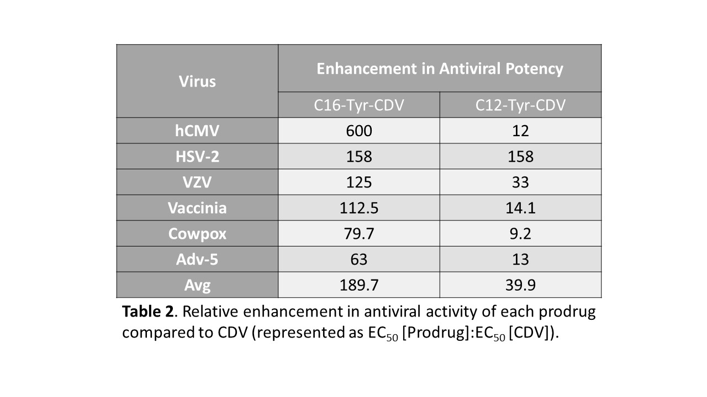

Table 2. Relative enhancement in antiviral activity of each prodrug compared to CDV (represented as EC50 [Prodrug]:EC50 [CDV]).

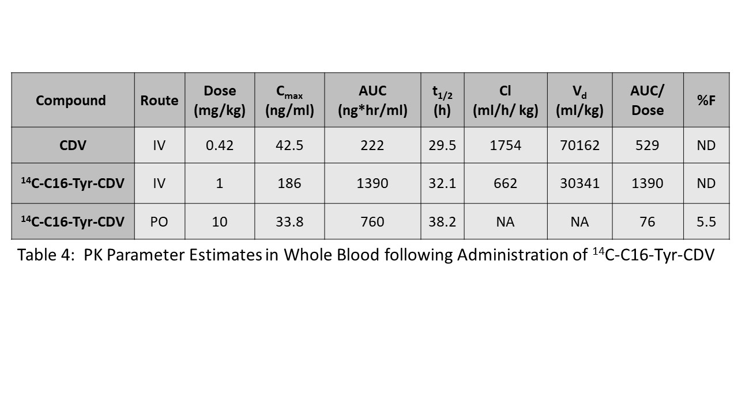

Table 3. PK Parameter Estimates in Whole Blood following Administration of 14C-C16-Tyr-CDV

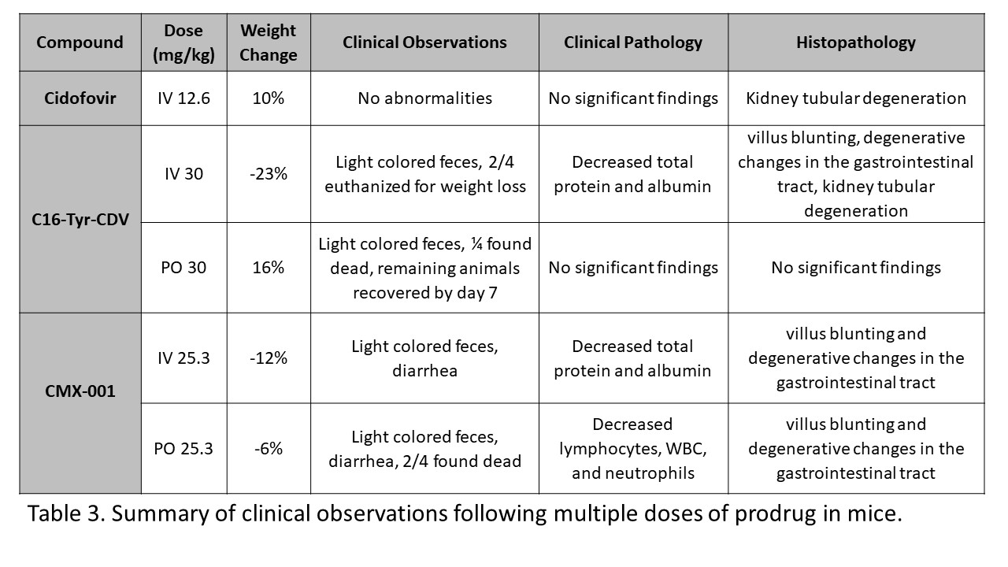

Table 4. Exploratory Multiple-dose Toxicity of C16-Tyr-CDV vs. Cidofovir and CMX-001 in rats

Supplemental Table 1. Experiemental design for C16-Tyr-CDV efficacy against human Adenovirus type 6 in immunosuppressed Syrian hamsters.

|  |  |  |  |  |  |  |  |
| --- | --- | --- | --- | --- | --- | --- | --- |
| **#** | **Groups** | **Ad6** | **Drug Dose** | **n** | **Work Performed** | | |
| **Day 5** | **Day 14** | **Daily** |
| **1** | **Virus vehicle**  **+**  **Drug vehicle** | no | none | 5  +  10 | Sacrifice 5 animals, gross pathology, serum transaminase levels | Sacrifice 10 animals, gross pathology serum transaminase levels | Observation, Body Weight |
| **2** | **Virus vehicle**  **+**  **C16-Tyr-CDV** | no | 10 mg/kg q.d. | 5  +  10 |
| **3** | **Virus vehicle**  **+**  **CDV** | no | 37 mg/kg followed by 20 mg/kg 3X weekly | 5  +  10 |
| **4** | **Virus**  **+**  **Drug vehicle** | yes | none | 5  +  10 | Sacrifice 5 animals, gross pathology, Ad titer in liver, serum transaminase levels | Sacrifice 10 animals, gross pathology, Ad titer in liver, serum transaminase levels |
| **5** | **Ad6**  **+**  **C16-Tyr-CDV** | yes | 10 mg/kg q.d. | 5  +  10 |
| **6** | **Ad6**  **+**  **C16-Tyr-CDV** | yes | 3 mg/kg q.d. | 5  +  10 |
| **7** | **Ad6**  **+**  **C16-Tyr-CDV** | yes | 1 mg/kg q.d. | 5  +  10 |
| **8** | **Ad6**  **+**  **CDV** | yes | 37 mg/kg followed by 20 mg/kg 3X weekly | 5  +  10 |

## Figures

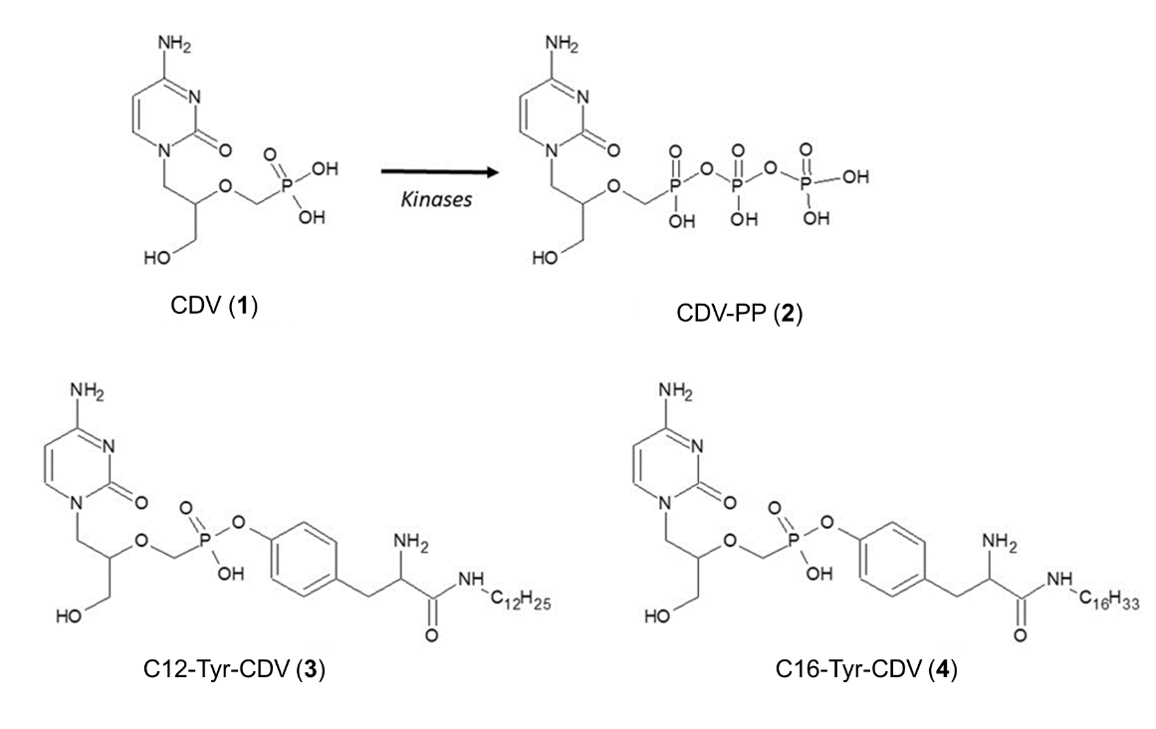

**Figure 1. Structures of Cidofovir (CDV, 1), its kinase-activated antiviral metabolite CDV-PP (2) and the synthetic tyrosine amide prodrugs (3) and (4) of CDV respectively.**

Figure 2.

**Figure 2. Intracellular metabolite levels per 1 X106 HFF cells after 72 hour incubation with CDV, C12-Tyr-CDV, C16-Tyr-CDV, and CMX-001 respectively.**

Figure 3. Distribution

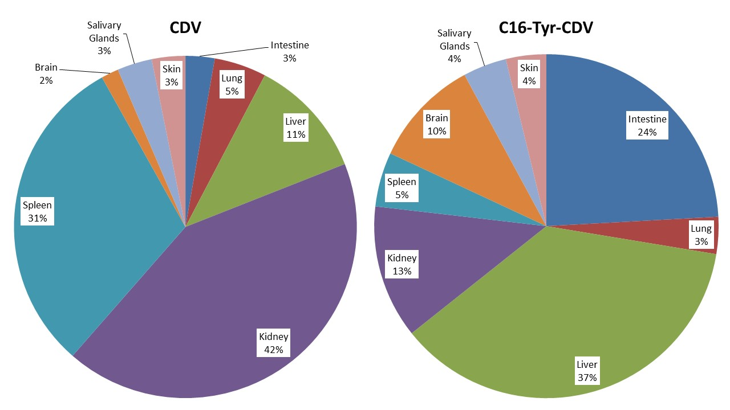

**Figure 3. Distribution of 14C-labeled CDV (IV) or C16-Tyr-CDV (PO) 24 hours after dosing.**

Figure 4

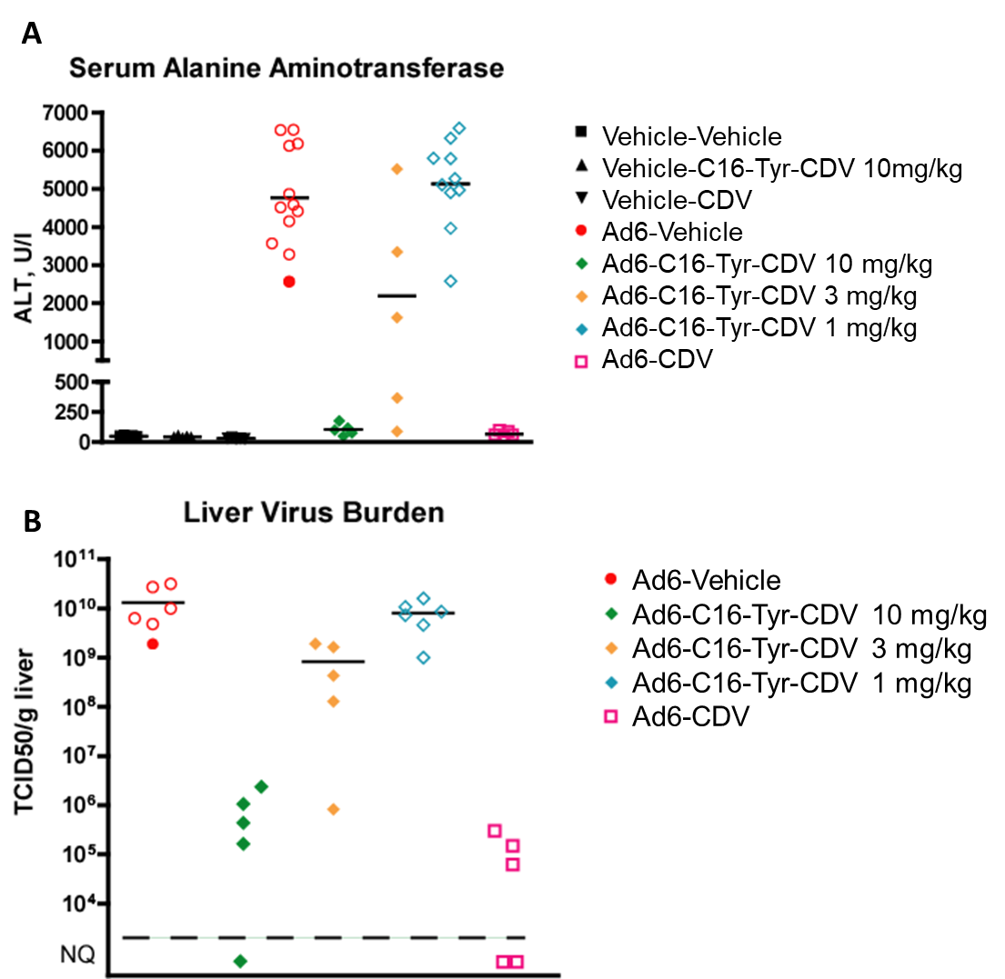

**Figure 4 . C16-Tyr-CDV is effective against Ad6 infection in immunosuppressed Syrian hamsters.** Each symbol represents the value from an individual animal; the horizontal bar signifies the mean. Empty symbols for the Ad6-Vehicle and Ad6-C16-Tyr-CDV 1 mg/kg groups indicate that the sample was collected from a moribund animal sacrificed ahead of schedule. A) Serum AST. Ad6-Vehicle v. Ad6-C16-Tyr-CDV 1 mg/kg p=0.3734; Ad6-Vehicle v. Ad6-C16-Tyr-CDV 3 mg/kg p=0.0399; Ad6-Vehicle v. Ad6-C16-Tyr-CDV 10 mg/kg p=0.0019; Ad6-Vehicle v. Ad6-CDV 20 mg/kg p=0.0019 (Mann-Whitney U-test). B) Liver virus titers. Ad6-Vehicle v. Ad6-C16-Tyr-CDV 1 mg/kg p=0.6991; Ad6-Vehicle v. Ad6-C16-Tyr-CDV 3 mg/kg p=0.0087; Ad6-Vehicle v. Ad6-C16-Tyr-CDV 10 mg/kg p=0.0043; Ad6-Vehicle v. Ad6-CDV 20 mg/kg p=0.0043 (Mann-Whitney U-test; for the purposes of statistical calculations, a value of 6.05x104 TCID50/g was assumed for all not quantifiable samples); NQ: not quantifiable (below the quantification threshold of 6.05x104 TCID50/g).

Figure 5. Tox body weight percent change

**Figure 5. Mean Body Weight Percent Change in rats treated with multiple doses of C16-Tyr-CDV, CMX-001, or CDV.**

Supplemental figure 1. (If more than reference to patent needed) synthesis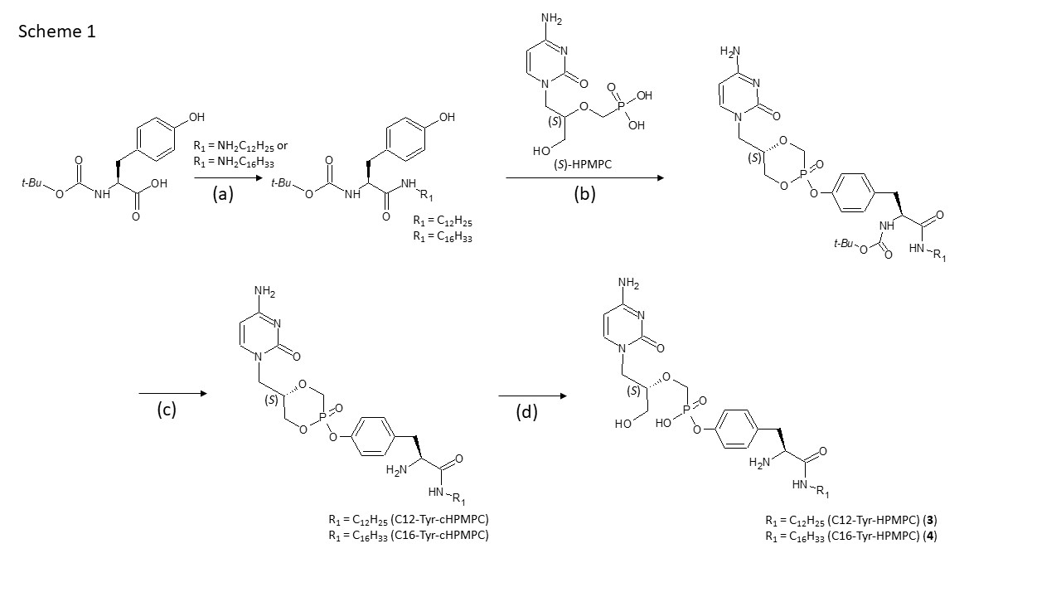

SuppFigure 1. Sythesis

SF2

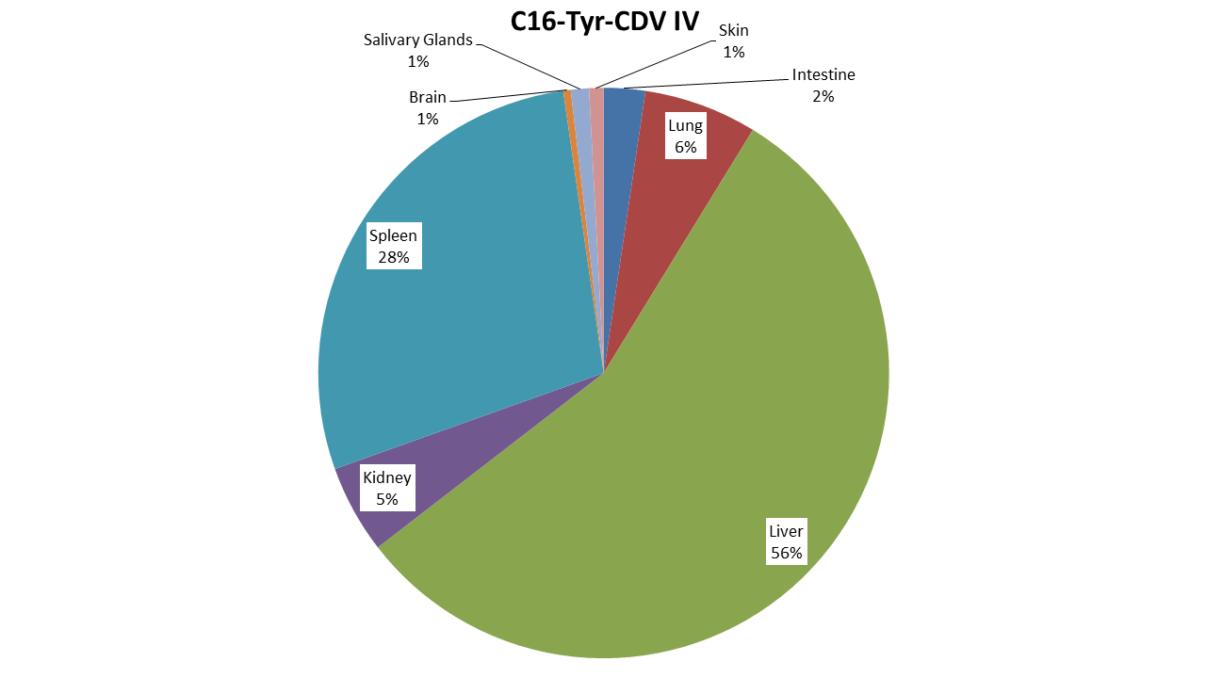

SuppFigure 2. Distribution of C14 labeled C16-Tyr-CDV (IV) 24 hours after dosing.

SF3

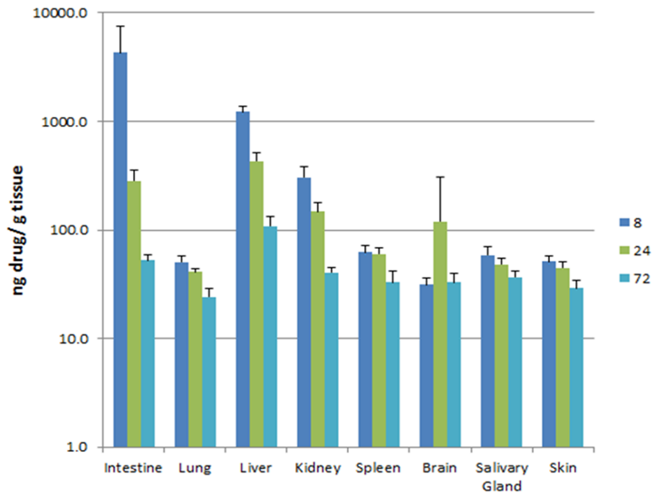

SuppFigure 3. Distribution of C14-labeled C16-Tyr-CDV at 8, 24, and 72 hours following a single 10 mg/kg dose.

SF 4

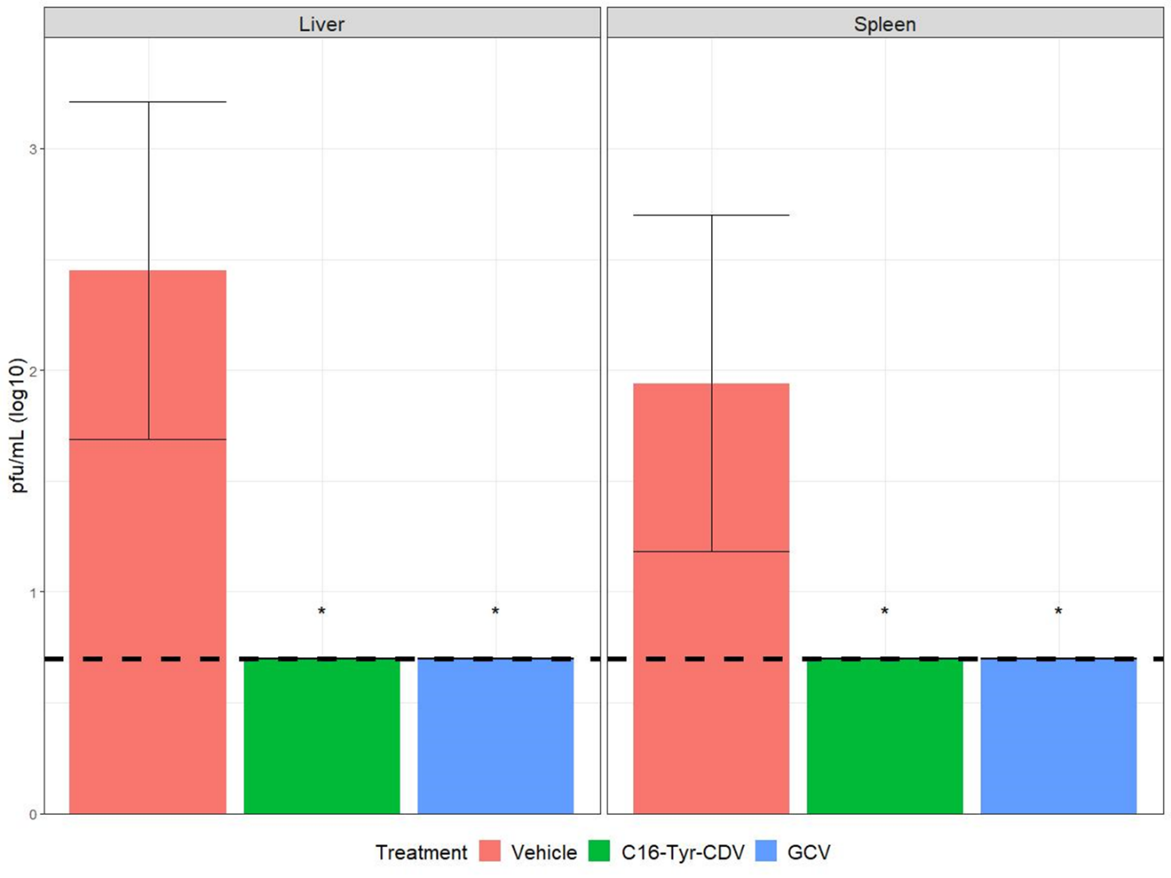

SuppFigure 4. C16-Tyr-CDV inhibits mCMV replication in the liver (left) and spleen (right) as well as gancyclovir. Dashed line represents the limit of detection. * p ≤ 0.0015.

SF5

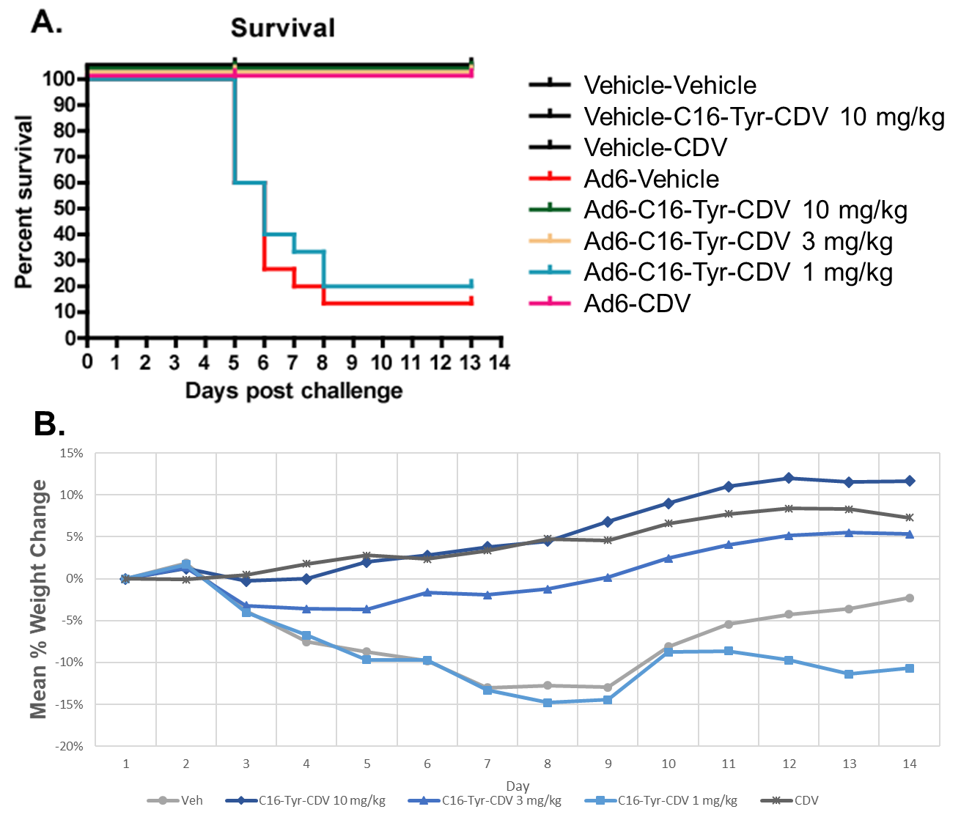

SuppFigure 5. C16-Tyr-CDV reverses Ad6-induced mortality and morbidity. A. Survival. Vehicle v. C16-Tyr-CDV 1 mg/kg p=0.5894; Vehicle v. C16-Tyr-CDV 3 mg/kg, C16-Tyr-CDV 10 mg/kg, or CDV 20 mg/kg p<0.0001 (Log rank). B. Mean percent weight change.

## REFERENCES

1. De Clercq E. 1996. Therapeutic potential of Cidofovir (HPMPC, Vistide) for the treatment of DNA virus (i.e. herpes-, papova-, pox- and adenovirus) infections. Verh K Acad Geneeskd Belg 58:19–47; discussion 47-49.

2. Plosker GL, Noble S. 1999. Cidofovir: a review of its use in cytomegalovirus retinitis in patients with AIDS. Drugs 58:325–345.

3. Cihlar T, Chen MS. 1996. Identification of enzymes catalyzing two-step phosphorylation of cidofovir and the effect of cytomegalovirus infection on their activities in host cells. Mol Pharmacol 50:1502–1510.

4. Ho HT, Woods KL, Bronson JJ, De Boeck H, Martin JC, Hitchcock MJ. 1992. Intracellular metabolism of the antiherpes agent (S)-1-[3-hydroxy-2-(phosphonylmethoxy)propyl]cytosine. Mol Pharmacol 41:197–202.

5. Xiong X, Smith JL, Kim C, Huang E, Chen MS. 1996. Kinetic analysis of the interaction of cidofovir diphosphate with human cytomegalovirus DNA polymerase. Biochemical Pharmacology 51:1563–1567.

6. Jacobson MA. 1997. Treatment of Cytomegalovirus Retinitis in Patients with the Acquired Immunodeficiency Syndrome. New England Journal of Medicine 337:105–114.

7. Lalezari JP. 1997. Intravenous Cidofovir for Peripheral Cytomegalovirus Retinitis in Patients with AIDS: A Randomized, Controlled Trial. Annals of Internal Medicine 126:257.

8. 1992. Mortality in Patients with the Acquired Immunodeficiency Syndrome Treated with either Foscarnet or Ganciclovir for Cytomegalovirus Retinitis. N 326:213–220.

9. Cundy KC. 1999. Clinical Pharmacokinetics of the Antiviral Nucleotide Analogues Cidofovir and Adefovir. Clin Pharmacokinet 36:127–143.

10. Starrett JE, Tortolani DR, Hitchcock MJM, Martin JC, Mansuri MM. 1992. Synthesis and in vitro evaluation of a phosphonate prodrug: bis(pivaloyloxymethyl) 9-(2-phosphonylmethoxyethyl)adenine. Antiviral Research 19:267–273.

11. Hostetler KY. 2009. Alkoxyalkyl prodrugs of acyclic nucleoside phosphonates enhance oral antiviral activity and reduce toxicity: Current state of the art. Antiviral Research 82:A84–A98.

12. Peyrottes S. 2004. SATE Pronucleotide Approaches: An Overview. Mini Reviews in Medicinal Chemistry 4.

13. Oliyai R, Shaw JP, Sueoka-Lennen CM, Cundy KC, Arimilli MN, Jones RJ, Lee WA. 1999. Aryl ester prodrugs of cyclic HPMPC. I: Physicochemical characterization and in vitro biological stability. Pharm Res 16:1687–1693.

14. Jessen HJ, Schulz T, Balzarini J, Meier C. 2008. Bioreversible Protection of Nucleoside Diphosphates. Angewandte Chemie International Edition 47:8719–8722.

15. Meier C, Görbig U, Müller C, Balzarini J. 2005. *cyclo* Sal-PMEA and *c* *yclo* Amb-PMEA: Potentially New Phosphonate Prodrugs Based on the *cyclo* Sal-Pronucleotide Approach. Journal of Medicinal Chemistry 48:8079–8086.

16. Mehellou Y, Balzarini J, McGuigan C. 2009. Aryloxy Phosphoramidate Triesters: a Technology for Delivering Monophosphorylated Nucleosides and Sugars into Cells. ChemMedChem 4:1779–1791.

17. Cahard D. 2004. Aryloxy Phosphoramidate Triesters as Pro-Tides. Mini Reviews in Medicinal Chemistry 4.

18. Toth K, Spencer JF, Dhar D, Sagartz JE, Buller RML, Painter GR, Wold WSM. 2008. Hexadecyloxypropyl-cidofovir, CMX001, prevents adenovirus-induced mortality in a permissive, immunosuppressed animal model. Proceedings of the National Academy of Sciences 105:7293–7297.

19. Quenelle DC, Lampert B, Collins DJ, Rice TL, Painter GR, Kern ER. 2010. Efficacy of CMX001 Against Herpes Simplex Virus Infections in Mice and Correlations with Drug Distribution Studies. J Infect Dis 202:1492–1499.

20. El-Haddad D, El Chaer F, Vanichanan J, Shah DP, Ariza-Heredia EJ, Mulanovich VE, Gulbis AM, Shpall EJ, Chemaly RF. 2016. Brincidofovir (CMX-001) for refractory and resistant CMV and HSV infections in immunocompromised cancer patients: A single-center experience. Antiviral Res 134:58–62.

21. Florescu DF, Pergam SA, Neely MN, Qiu F, Johnston C, Way S, Sande J, Lewinsohn DA, Guzman-Cottrill JA, Graham ML, Papanicolaou G, Kurtzberg J, Rigdon J, Painter W, Mommeja-Marin H, Lanier R, Anderson M, van der Horst C. 2012. Safety and efficacy of CMX001 as salvage therapy for severe adenovirus infections in immunocompromised patients. Biol Blood Marrow Transplant 18:731–738.

22. Florescu DF, Keck MA. 2014. Development of CMX001 (Brincidofovir) for the treatment of serious diseases or conditions caused by dsDNA viruses. Expert Rev Anti Infect Ther 12:1171–1178.

23. Camargo JF, Morris MI, Abbo LM, Simkins J, Saneeymehri S, Alencar MC, Lekakis LJ, Komanduri KV. 2016. The use of brincidofovir for the treatment of mixed dsDNA viral infection. J Clin Virol 83:1–4.

24. Detweiler CJ, Mueller SB, Sung AD, Saullo JL, Prasad VK, Cardona DM. 2018. Brincidofovir (CMX001) Toxicity Associated With Epithelial Apoptosis and Crypt Drop Out in a Hematopoietic Cell Transplant Patient: Challenges in Distinguishing Drug Toxicity From GVHD. J Pediatr Hematol Oncol 40:5.

25. Painter W, Robertson A, Trost LC, Godkin S, Lampert B, Painter G. 2012. First Pharmacokinetic and Safety Study in Humans of the Novel Lipid Antiviral Conjugate CMX001, a Broad-Spectrum Oral Drug Active against Double-Stranded DNA Viruses. Antimicrobial Agents and Chemotherapy 56:2726–2734.

26. McKenna CE, Kashemirov BA, Krylov IS, Zakharova VM. January 2017. Method to improve antiviral activity of nucleotide analogue drugs. US9550803B2.