

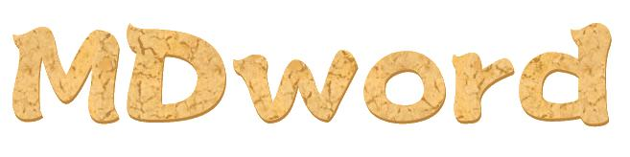

Replace image by md5:

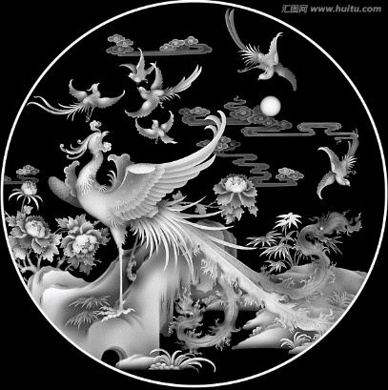

|  |  |
| --- | --- |
| Id | image |
| 0 |  |
| 1 |  |
| 2 |  |
| 3 |  |
| 4 |  |



This is text.





This is text2.

