image space hold



Replace image by md5:

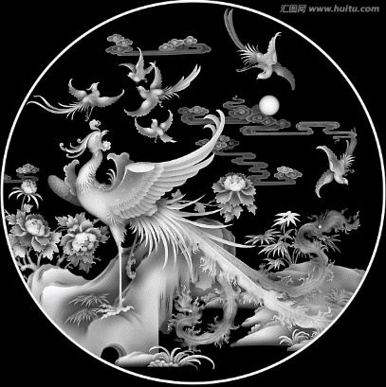

|  |  |
| --- | --- |
| Id | image |
| 1 |  |

111