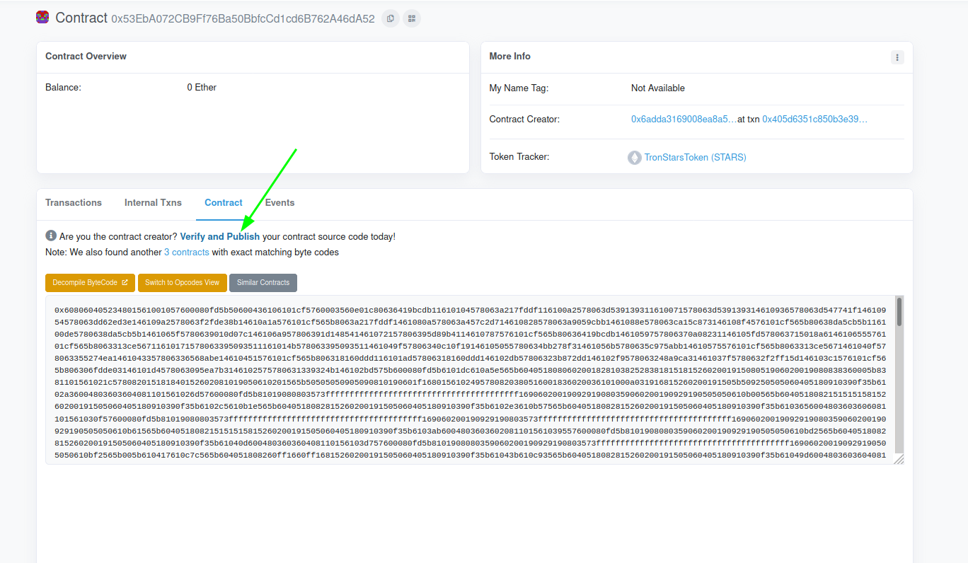
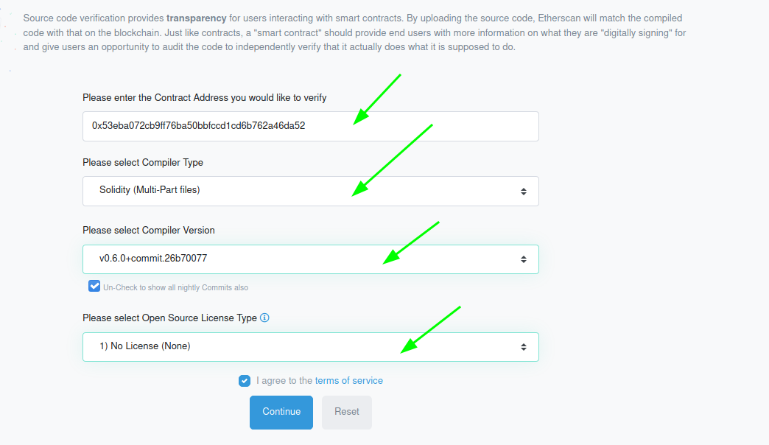
Go to https://abi.hashex.org/#
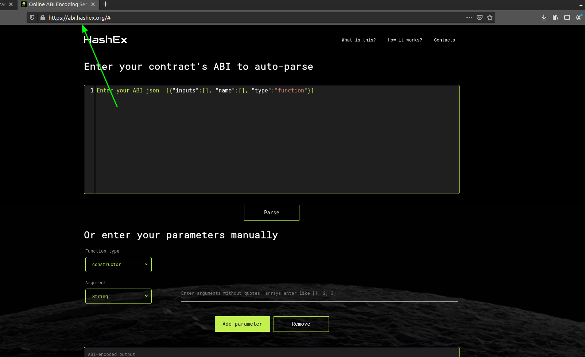
Copy ABI contract Investment pool
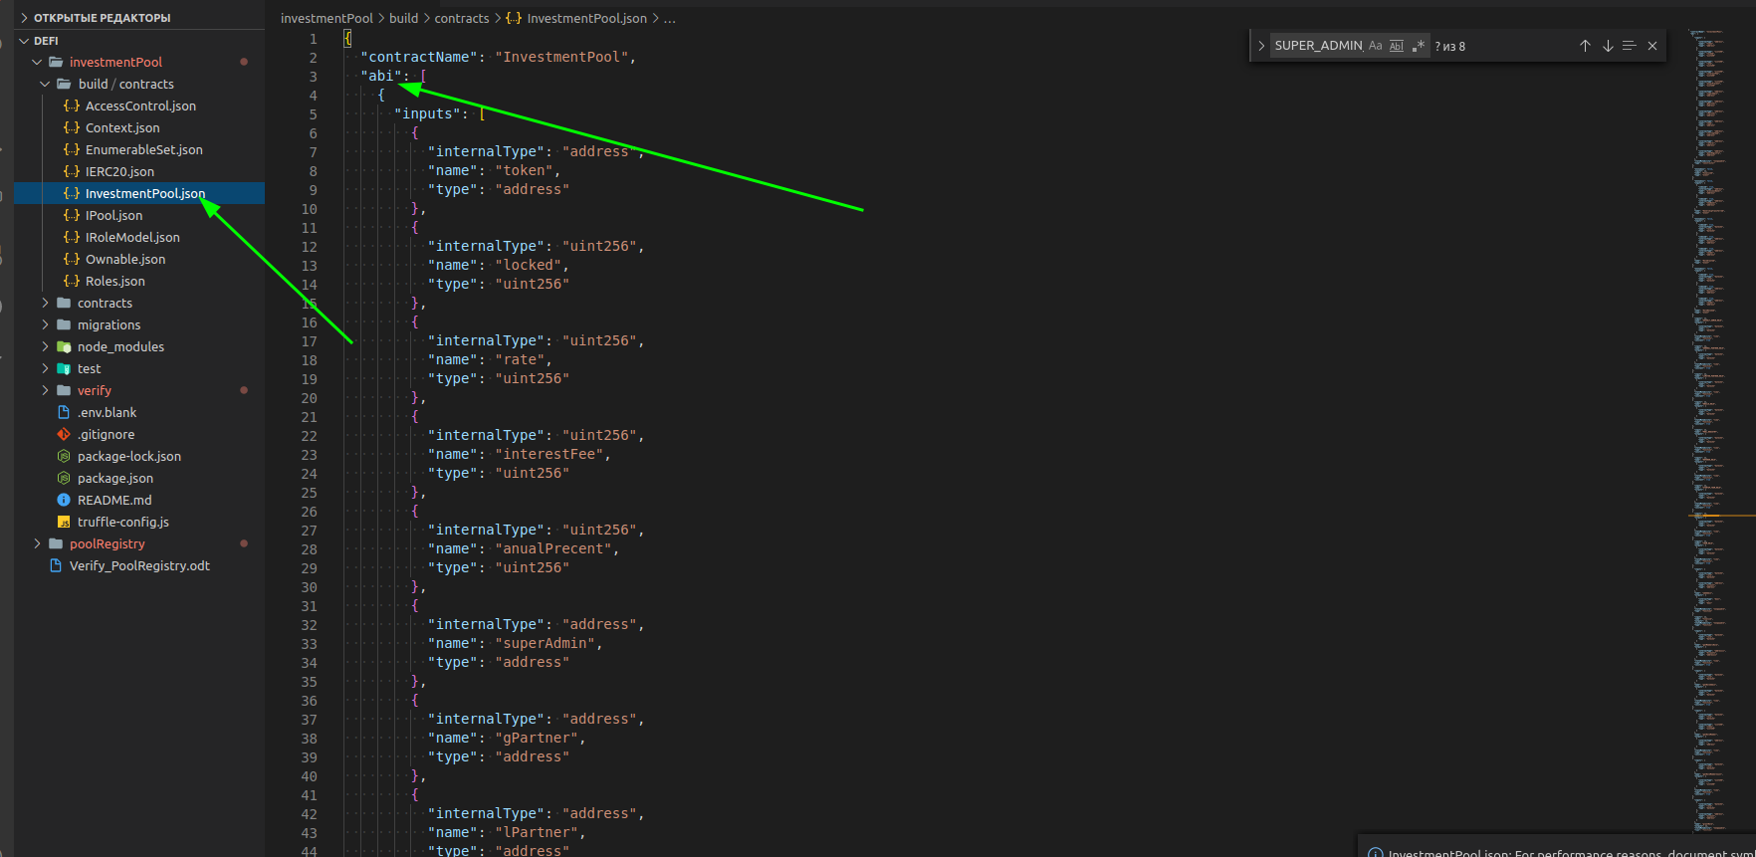
Paste to site HashEx
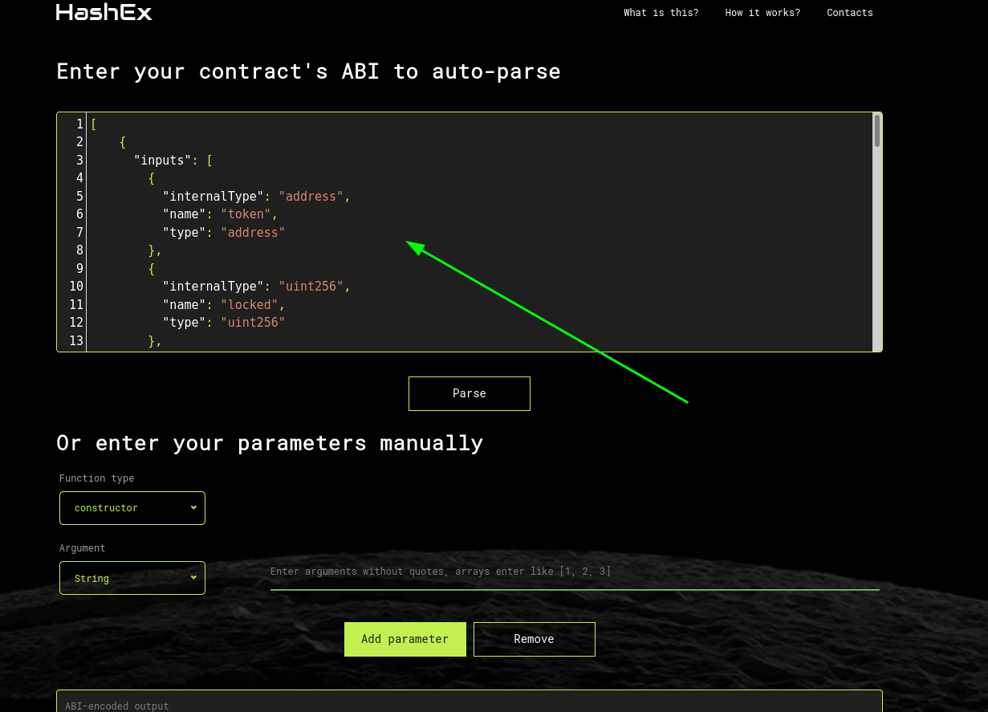
Adding all the parameters that we set when deploying InvestmentPool
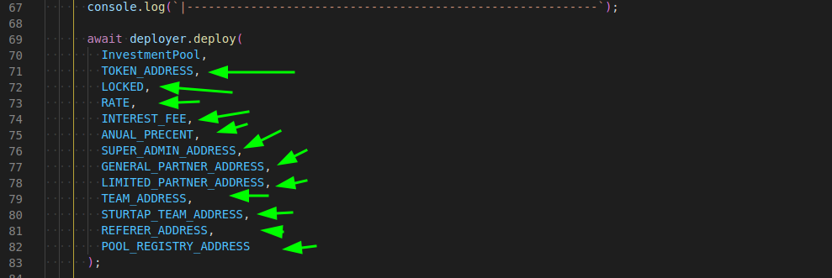
They are located in the .env.blank file(you must STRICTLY OBSERVE the order and values of VARIABLES)

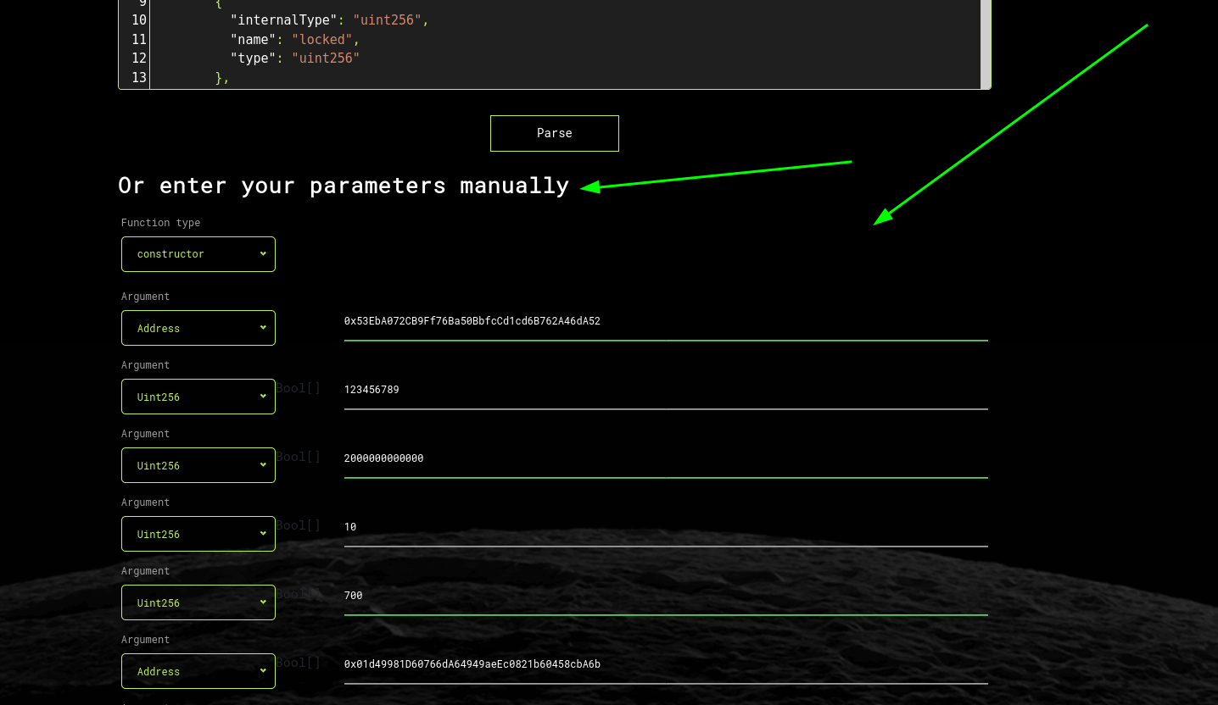
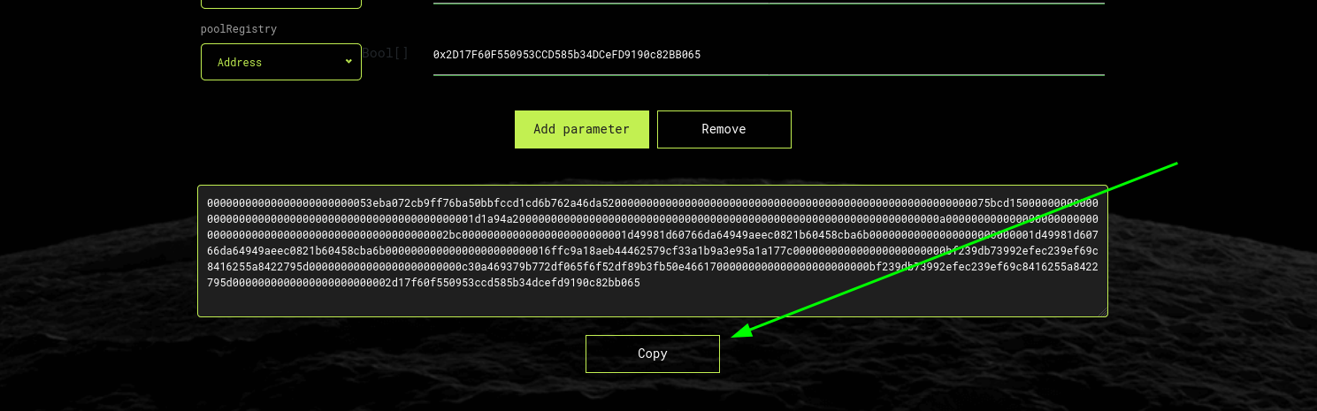
Copy this bytecode, and paste it in the field under #3, before that click #1 select files in the folder investmentPool/verify, then click #2 to download
