UNIVERSITY AMERICAN COLLEGE SKOPJE

SCHOOL OF COMPUTER SCIENCE AND INFORMATION TECHNOLOGY

Graduation Thesis

Scheduling Application



Student: Ivan Markovski

ID: 4286

Mentor: Prof. Goce Gavrilov, PhD

Collaborator: Monika Arsenovska, MCs

Academic year 2023/2024

Contents:

# 1. Introduction

There are many companies that are managing their security personnel, deployment of people on the field, organizing the duty schedules, and flow of information thru the so called “traditional means”, such as using excel spread sheets for post deployment, in which each change was manually updated. Managers, to ensure that all posts are covered with necessary personnel, were going line by line in the spread sheet.

In many situations this manual approach resulted in inefficient post deployment which led to either posts not being covered with enough personnel or being deployed with more people that are needed.

Another very important issue which the company and their employees faced is the poor flow of important information, which was necessary for conducting daily activities, because information was passed to the employees manually, by means of phone or via SMS.

Due to the problems described above companies are losing customers, expenses regarding managing were very high because company needed large number of mangers to keep track of the post’s deployment, organizing duty schedules, mangers for managing employees annual leave plans, and other types of absence.

Another problem that arises from “dark age” management approach was that senior management and company owners did not receive prompt up-to-date information to make strategic decisions which will lead to growth of the company.

To solve the above problems, to maximize efficiency and use of resources, the solution is to implement scheduling application that will automate many of the processes, who were identified as weak links.

# 2. Overview of the project

The project scheduling application consists of two separate projects:

* Front-end: scheduling-app-front-end.go
* Back-end: scheduling-app-back-end.go.

**Front-end project** is created using the React [(Meta Open Source, 2024)](https://react.dev/). Consisting of total 31 React components, from which four of the components are form items.

Figure 1 Front-end project structure

The purpose of the front-end project is to visually present the data to the end user, as well as to ensure that end-user uses the application as easily as possible. The front-end part of the project receives the data from the back end, organizes the received data from back-end to enhance the user experience.

As well as to ensure that end users enter required data very easily to receive the desired response.

Each component build in the front-end performs only one operation which is relatively easy to debug, in case of an error, or update if need arises to expand the functionality of the component.

The functionality of the front-end is divided into two areas.

* User
* Admin

Components available for the user do not allow to manage the system, only to view or request annual leave which need to be approved by the administrator.

Figure 2 Welcome screen

To be more precise the basic user has access to following modules:

* Schedules
* Daily assignments
* Annual Leave Request
* Login
* Positions
* All employees
* All shifts

**Schedules module** allows to user to view the working schedule on the monthly base, where all listed all covered positions, employees engaged in covering those positions, as well as the workload distribution during the duration of the schedule.

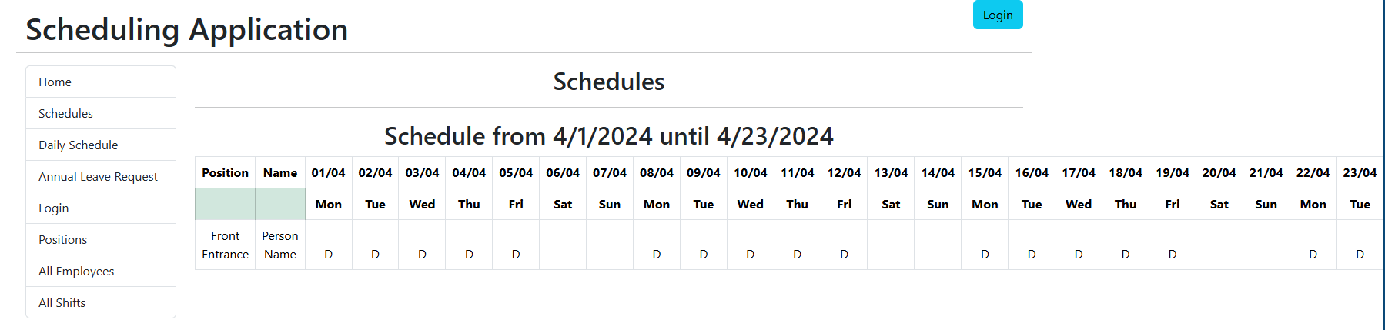

Figure 3 Schedules module

The daily assignments module is responsible for providing important information about the posts, specific tasks, and all kinds of information relevant for the current day, this information is provided by the administrators.

Figure 4 Daily assignments

**Annual Leave Request** module serves to employees to submit i.e. request annual leave, upon sending the request an email message is sent to the appropriate authority for review and approval, as well as confirmation mail to the requestor.

In the future versions of the application this module will be even further automated, it means that before the request will be send it will be providing information about the availability of annual leave slots, for the position where the employee is deployed, therefore the approval process will require even few steps for approval and less involvement of the appropriate authorities.

Figure 5 Annual leave request

Figure 6 Annual leave email confirmation

Login module as the name suggests is used for users i.e. administrators to login to unlock the full potential of the application.

Figure 7 Login screen

If the user does not enter valid credentials, user receives information that the credentials are invalid

Figure 8 Invalid credentials

# 6.Reference:

1. [1.Meta Open Source (2024). React. [online] react.dev. Available at: https://react.dev/.](1.Meta%20Open%20Source%20(2024).%20React.%20%5bonline%5d%20react.dev.%20Available%20at:%20https://react.dev/.)