**4-2 Journal**

Matthew A Keaton

Southern New Hampshire University

CS 320: Software Test, Automation QA

Professor Federico Bermudez

March 30, 2025

* To what extent was your testing approach aligned to the software requirements? Support your claims with specific evidence.
  + The testing approach was aligned to the software requirements by having ContactTest.java validate the contactId length is no more than 10 characters, first and last names are no more than 10 characters, phone number is exactly 10 digits, and the address length is no more than 30 characters. The ContactTestService.java validates requirements such as adding in new contacts, updating all fields, deleting contacts, and ensuring contact IDs are unique.

Example from ContactTest.java that test for long phone number by adding 11 digits.

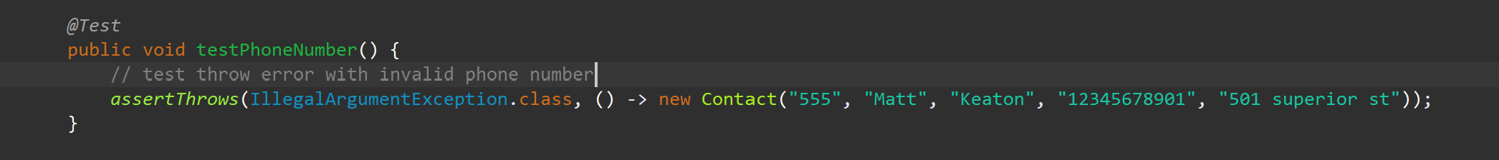

Example from ContactTestService.java that test for having duplicate contact ID

* Defend the overall quality of your JUnit tests for the contact service and task service. In other words, how do you know that your JUnit tests were effective on the basis of coverage percentage?
  + The quality of the tests was effective because the test coverage shows an all-green bar with 4/4 runs and no errors. Also, code was added to validate all inputs to ensure that it meets requirements and throws an exception when requirements are purposely not met.

Example of effective test coverage

* How did you ensure that your code was technically sound? Cite specific lines of code from your tests to illustrate.
  + I ensure the code was technically sound by separating the unit test. In ContactTest.java there are five requirements that must be met with contact Id, first name, last name, phone number, and home address. Creating five separate tests for each field kept the code clear, concise, and technically sound.

Example of separate unit test for each field

* How did you ensure that your code was efficient? Cite specific lines of code from your tests to illustrate.
  + Using industry’s best practices ensures my code is easy to read and efficient. Using data structures like a vector allows for dynamic resizing where I don’t have to allocate too much space and allows for fast indexing when looking up contacts.

Example of using efficient data structure and memory storage

