Milestone Four Narrative

Matthew A. Keaton
Southern New Hamshire University
CS 499: Computer Science Capstone
Professor Joseph Conlan
November 30, 2025

Artifact Description
The artifact I selected is the MongoDB database layer used in the Travlr Getaways application built in CS-465. This part of the project was originally created during the course to store and retrieve trip information using MongoDB collections and queries. The database layer supported basic CRUD operations but did not include any way to export data, filter data beyond simple queries, or manage how data fields were selected and returned. For this enhancement, I expanded the database functionality to allow controlled data exporting and more intentional data retrieval.

Justify the inclusion of the artifact in your ePortfolio
I chose this artifact because it demonstrates my ability to work directly with a database, manage data retrieval, apply filters, control which fields are returned, and secure access to stored information. The enhancements clearly show growth in how I handle and deliver data in a real application. I built a new export feature that pulls trip data from MongoDB and allows it to be downloaded in JSON or CSV format. I added filtering options so the database can return trips for a specific destination. I used MongoDB projection to return only safe fields—code, name, destination, startDate, and price—rather than exposing full documents. I also added a role field to the users collection, allowing only admin users to access the export feature. These changes show that I can improve data-handling patterns and implement secure, useful ways to extract and share stored information.

Did you meet the course outcomes
Yes, this enhancement helped me meet the planned course outcomes. I designed and evaluated a database-focused solution that solves a clear problem: giving administrators a safe and controlled way to export trip data. I used well-founded tools and techniques such as MongoDB filtering, projection, and structured queries to return accurate and secure information. I applied a security mindset by enforcing admin-only access and controlling which fields could be exported. Although this enhancement does not directly relate to collaboration or communication outcomes, it strongly supports the technical outcomes through the design of a reliable, secure database feature.

Reflection
While enhancing this artifact, I learned how to create more controlled and purposeful interactions with a database. I deepened my understanding of MongoDB projection, filtering, and how to return data in different formats like JSON and CSV. I also worked through how to secure exported data by limiting access to admin users only. One of the most important parts of this enhancement was testing each database behavior. I used Postman to test every API endpoint, including registration, login, admin access, JSON export, CSV export, and filtering by destination. Postman allowed me to verify that the database returned the correct results, that only the allowed fields were included, and that unauthorized users were blocked. Challenges included making sure the filtered results matched correctly, ensuring the exported fields stayed consistent, and testing all error cases such as invalid tokens and non-admin access. Overall, this enhancement strengthened my understanding of how to design and test database-driven features that are secure, flexible, and useful.

Examples of using postman to test and verify the API requests:
Using Postman to test for JSON export
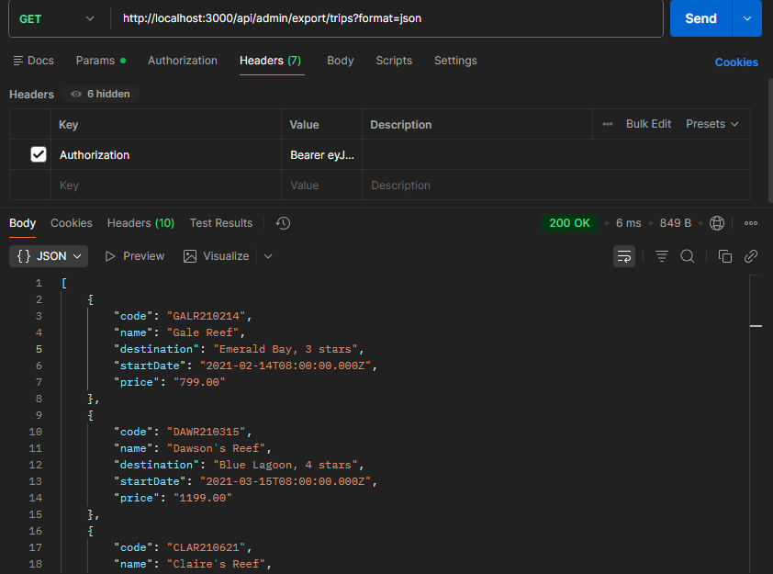
Using Postman to test for csv export
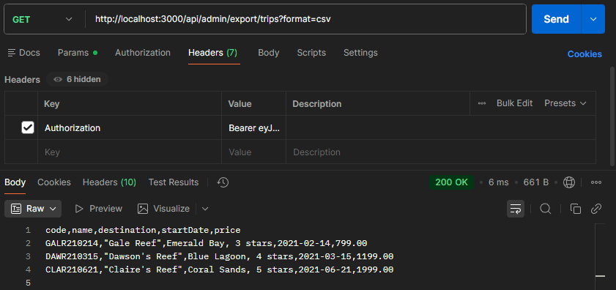
Using Postman to test for filter by destination
