**Cloud Server Rental Plans:**

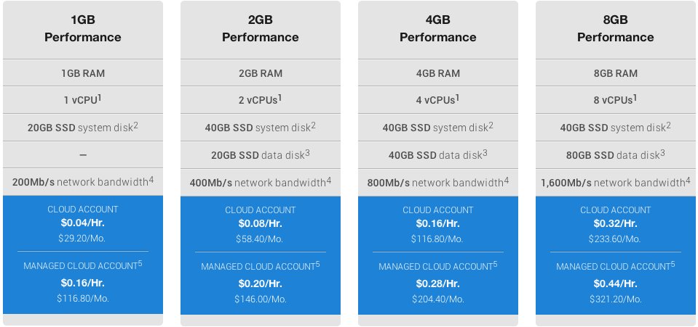

**API server: 8GB Performance**

$233.60 x 12 = $2,803.20 per year.

**Database: 8GB Performance**

$233.60 x 12 = $2,803.20 per year.

**Web server: 4GB Performance**

$116.80 x 12 = $1,401.60 per year.

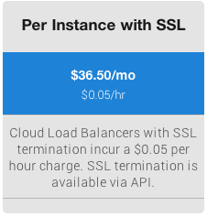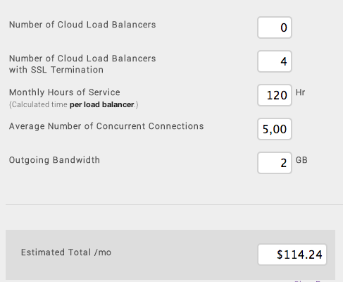

$114.24 x 12 = $1,370.88 per year.

**Average Developer Salaries in Poughkeepsie (indeed.com):**

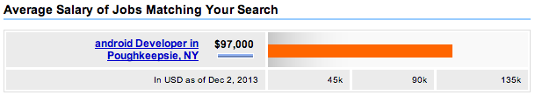

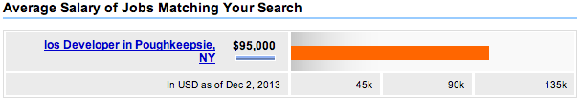

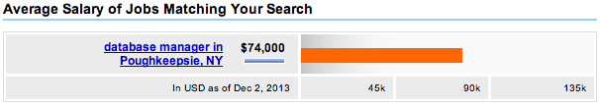

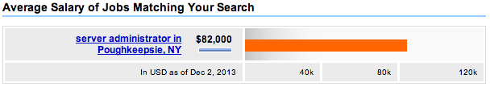

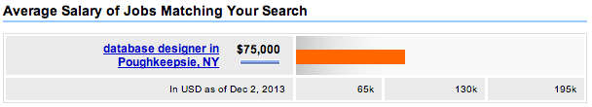

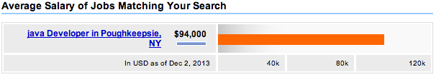

Total Annual Average: $301,000 x 3 developers per part = $903,000

