**Municipality Management Tracking Automation**

**In this application, which is used together with mobile applications, "Send Check", that is, the complaints, suggestions, notifications, etc. that the citizen sends and wants to write from the mobile application, transfers the situations to the municipality, passes the filter if necessary with the help of an operator within the municipality and ensures that they are transferred to the relevant unit, while all this is happening, it is the user. It is a server application that informs and concludes with push notification.**

**All the services used in the application on the mobile device (ios, android) are fed from this application with Webapi.**

Login page

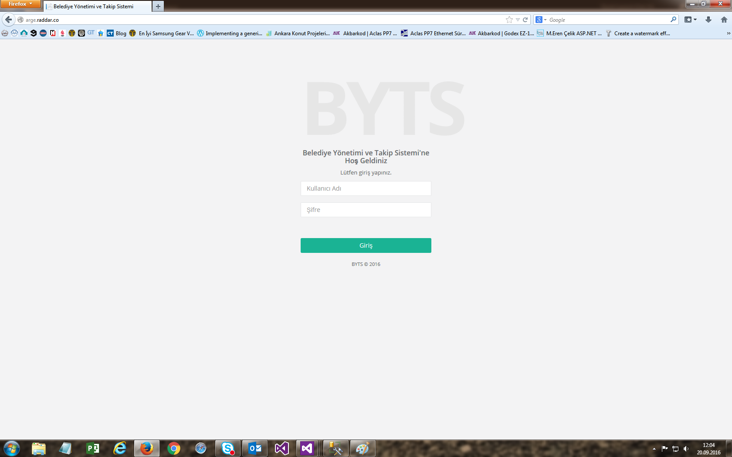

Welcome page and menus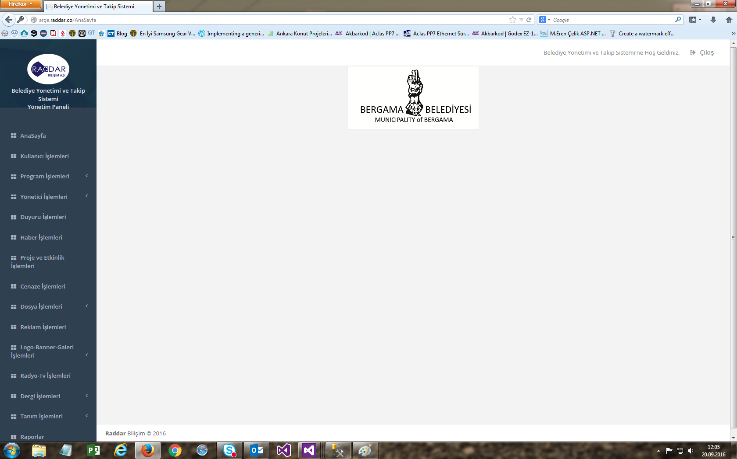

User (server and mobile) page 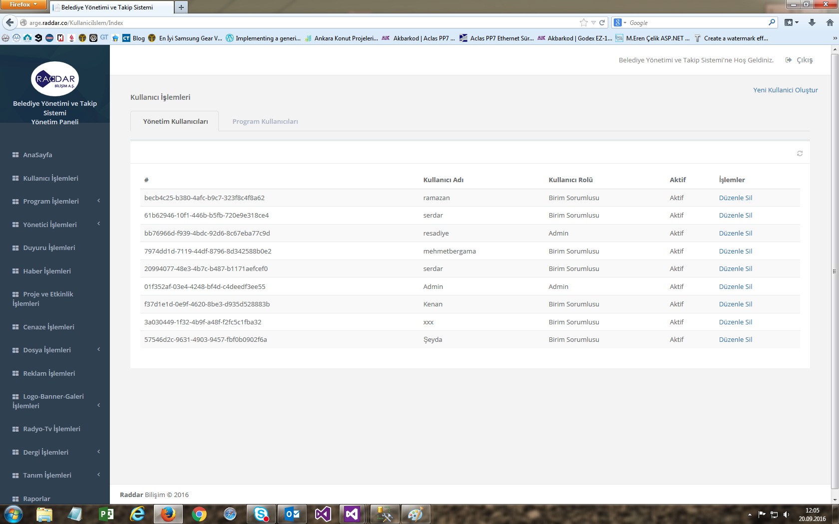

Settings page, here the certificate and notification keys used in ios and android devices are defined and transferred to mobile applications via webapi services.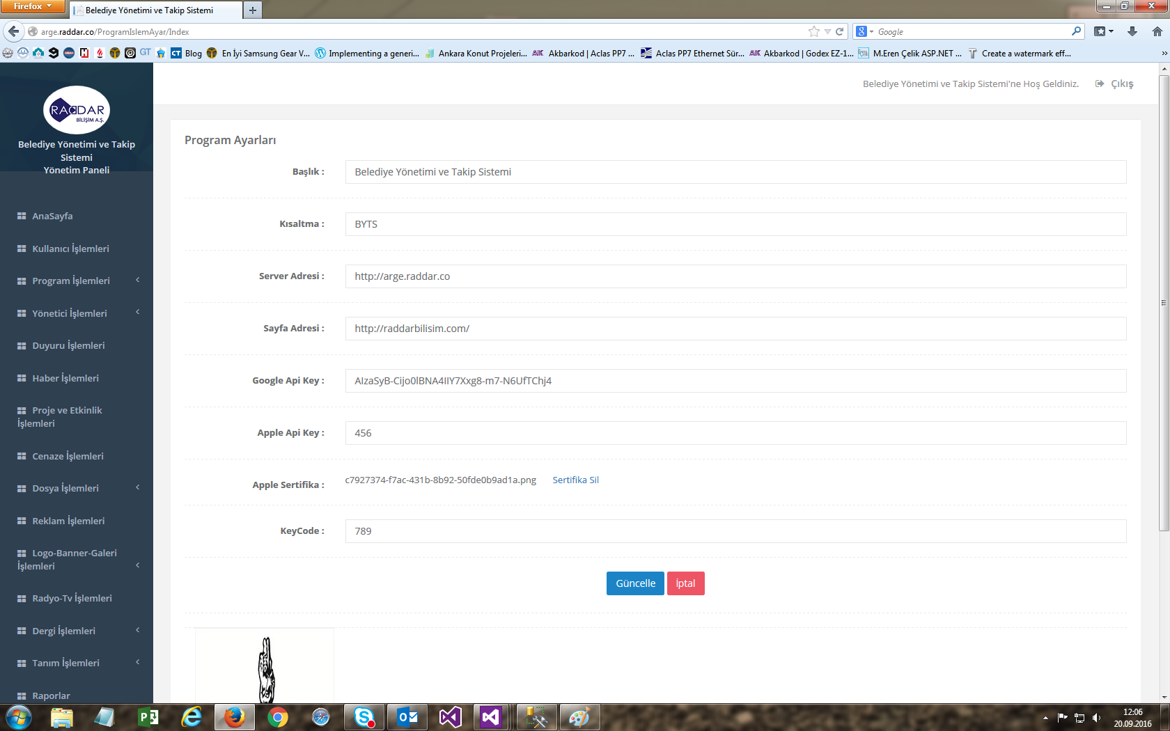

Log page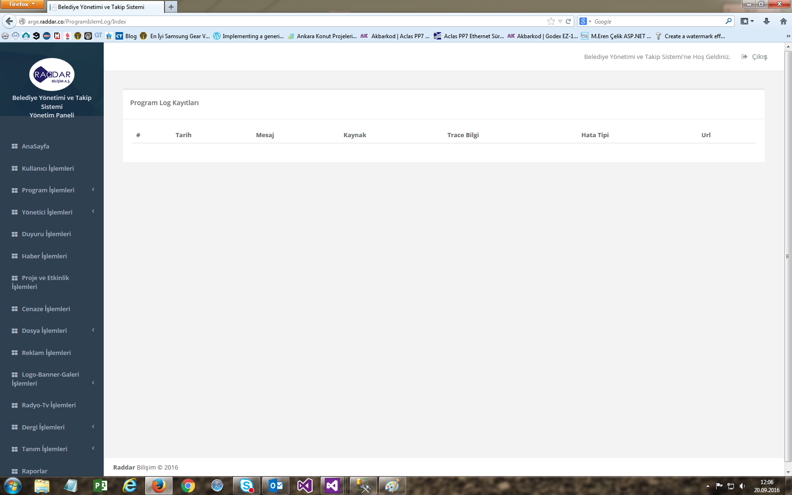

Other pages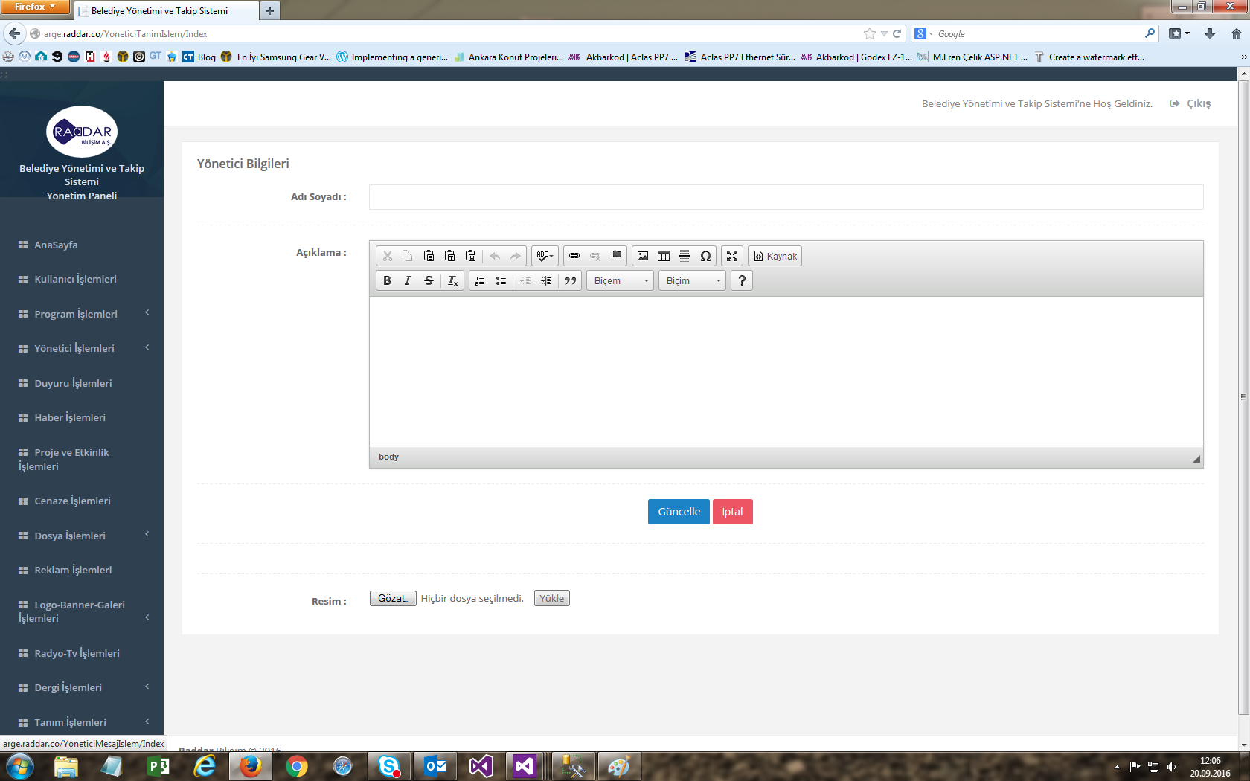

The information entered from this page is sent to the devices with the mobile application installed as a push notification.

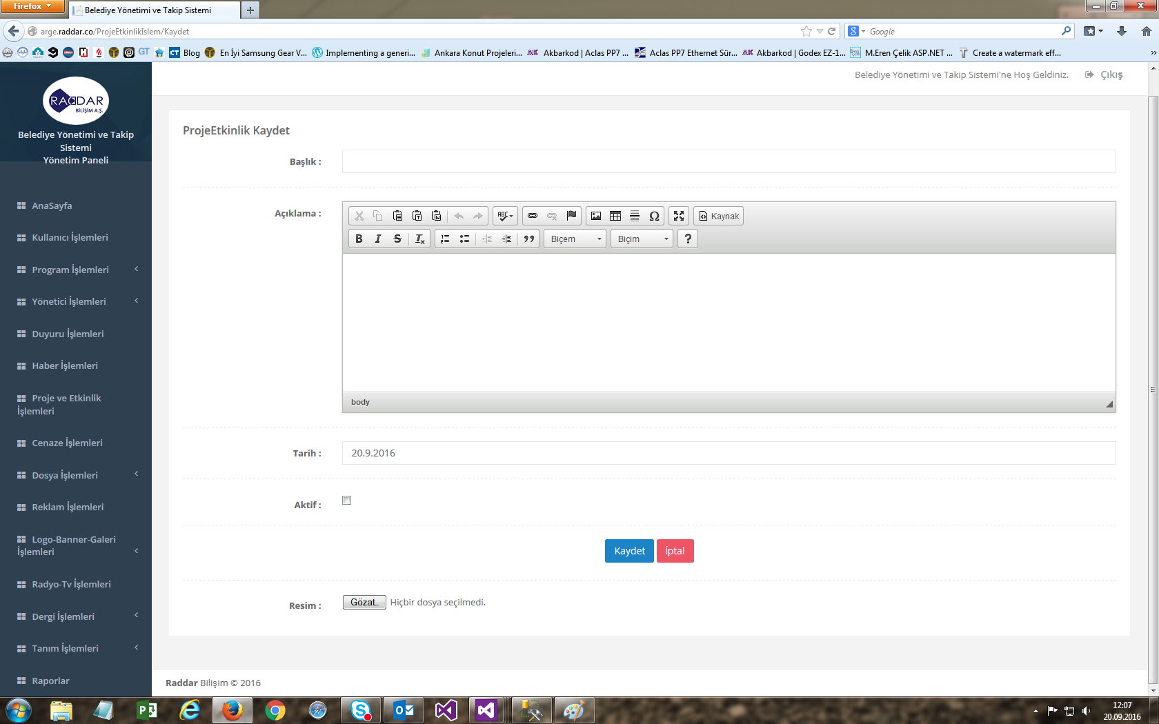

The information sent by the user from the mobile application with send check is displayed on the operator screen.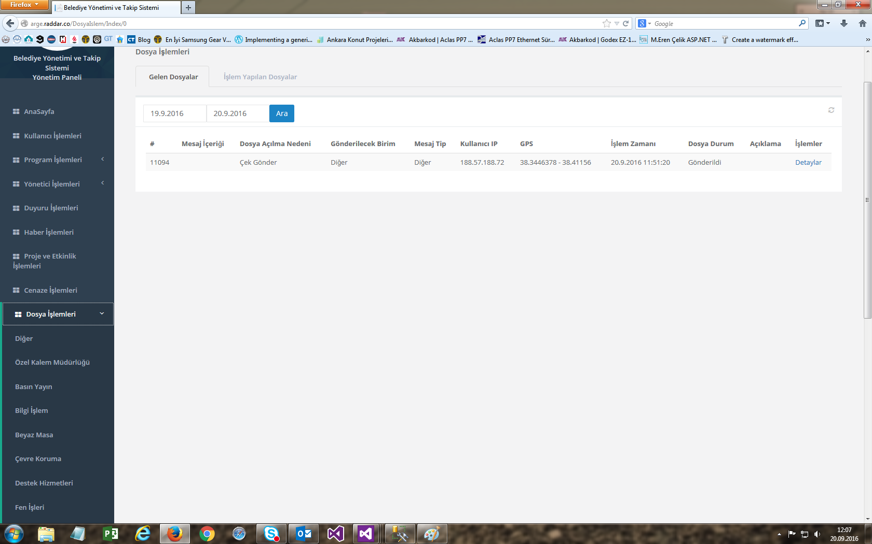

Operator examines the sent message.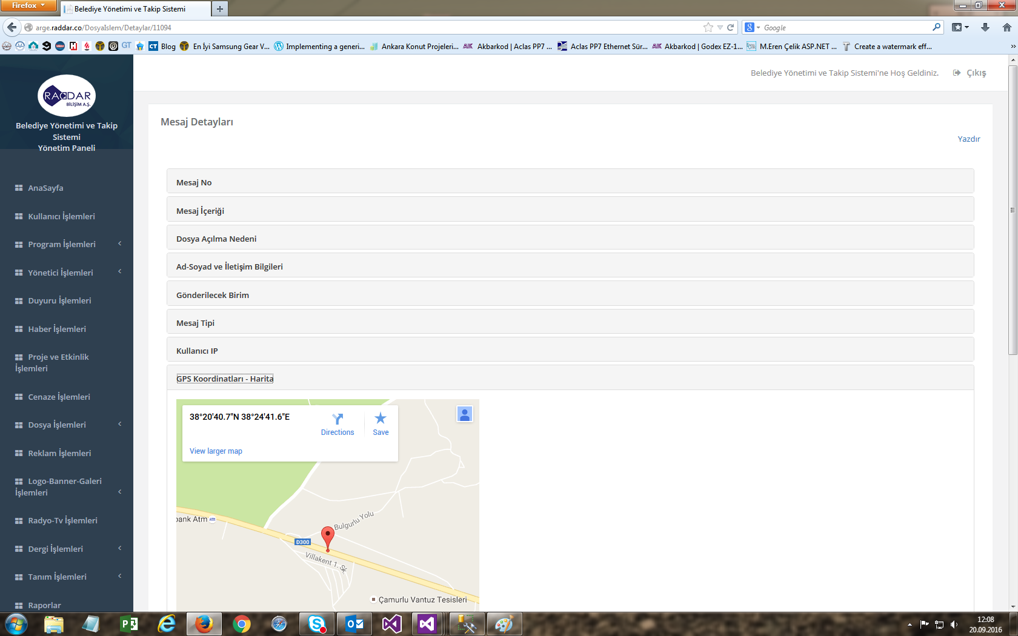

The operator sends it to the relevant unit or blacklists it. 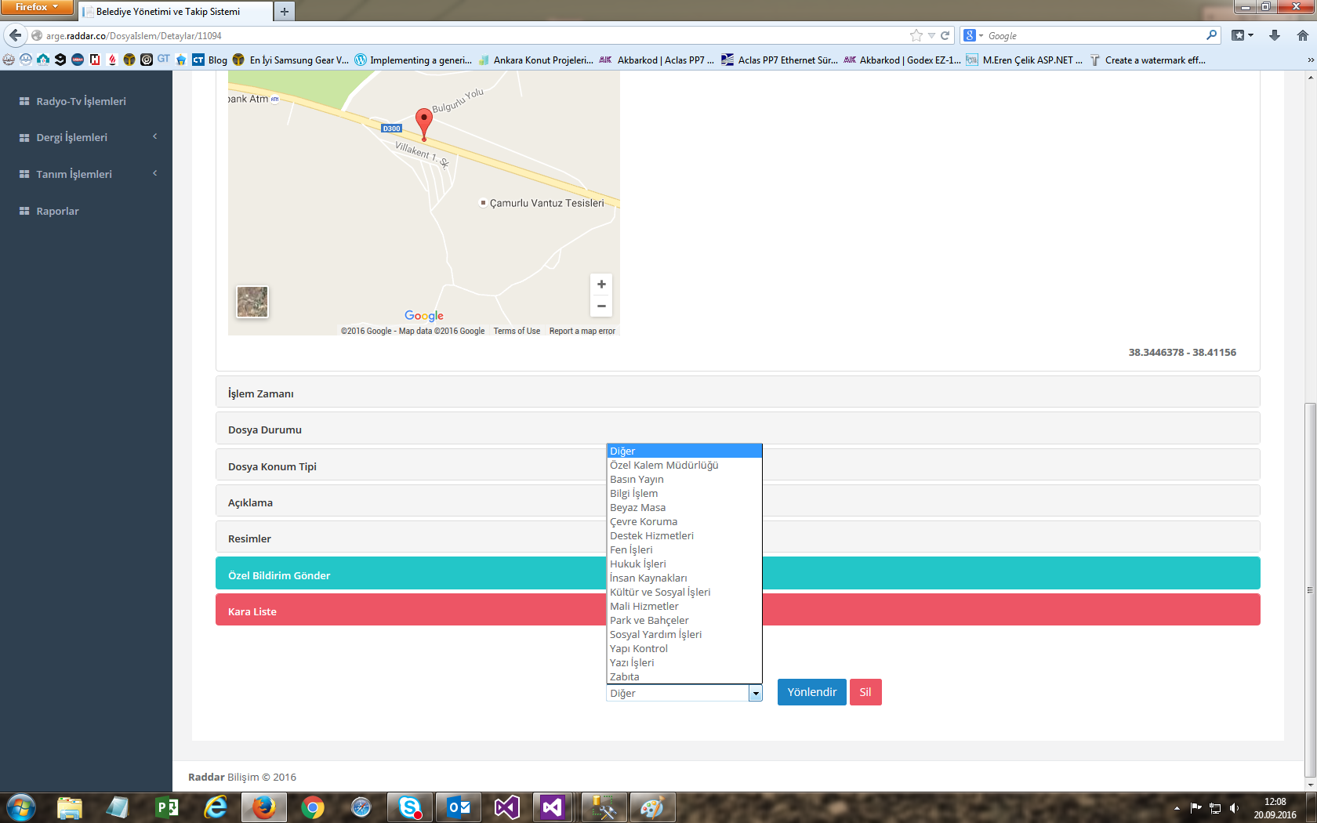

If desired, the sent message can be printed with details.

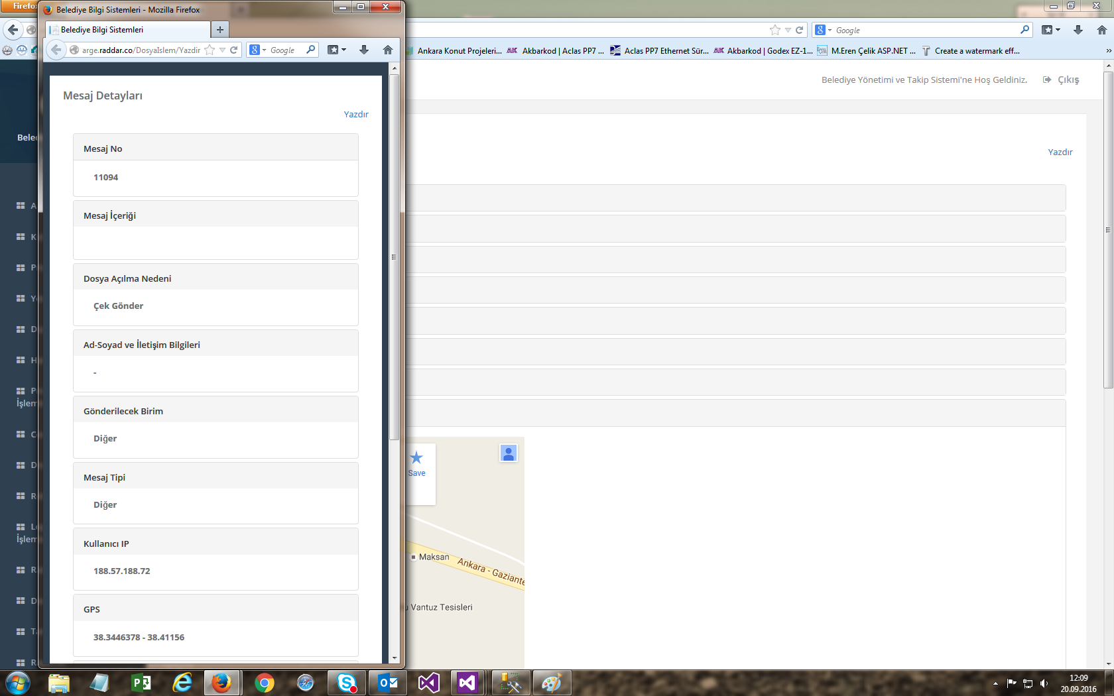

Some pages that the mobile application will use (Some features of the mobile application are set from the server) 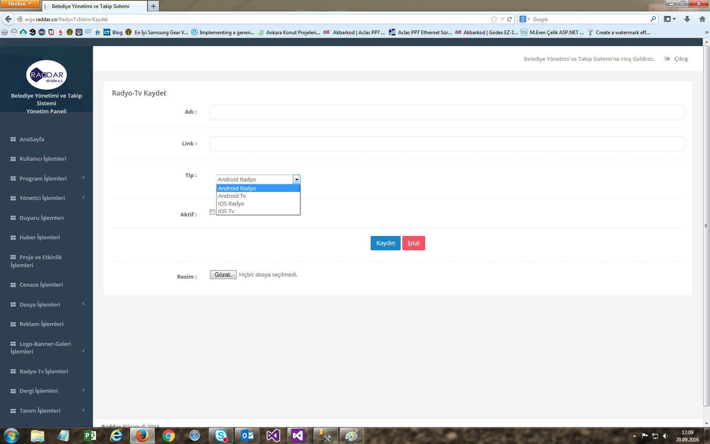

Report page