<https://www.nesever.com.tr>

The project is a platform that allows you to buy gifts for your friends via social network.

.Net Core MVC, C#, MS Sql Server, Web Api, Entity Framework, Swagger, Serilog, Redis cache technologies were used in the project.

**Frontend pages**

**Admin pages**

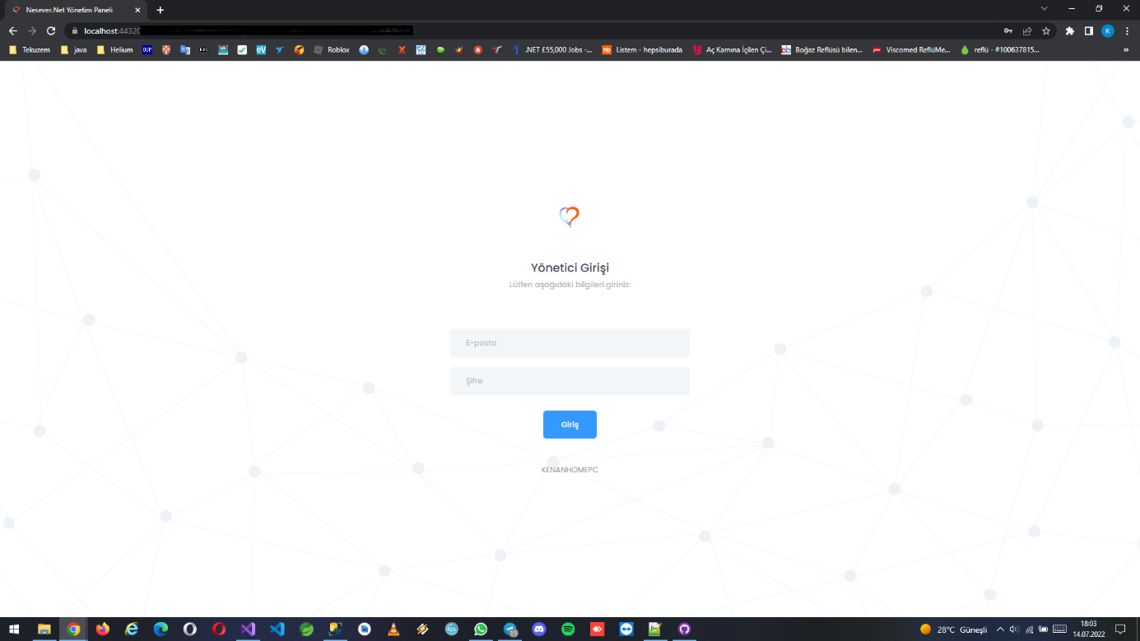

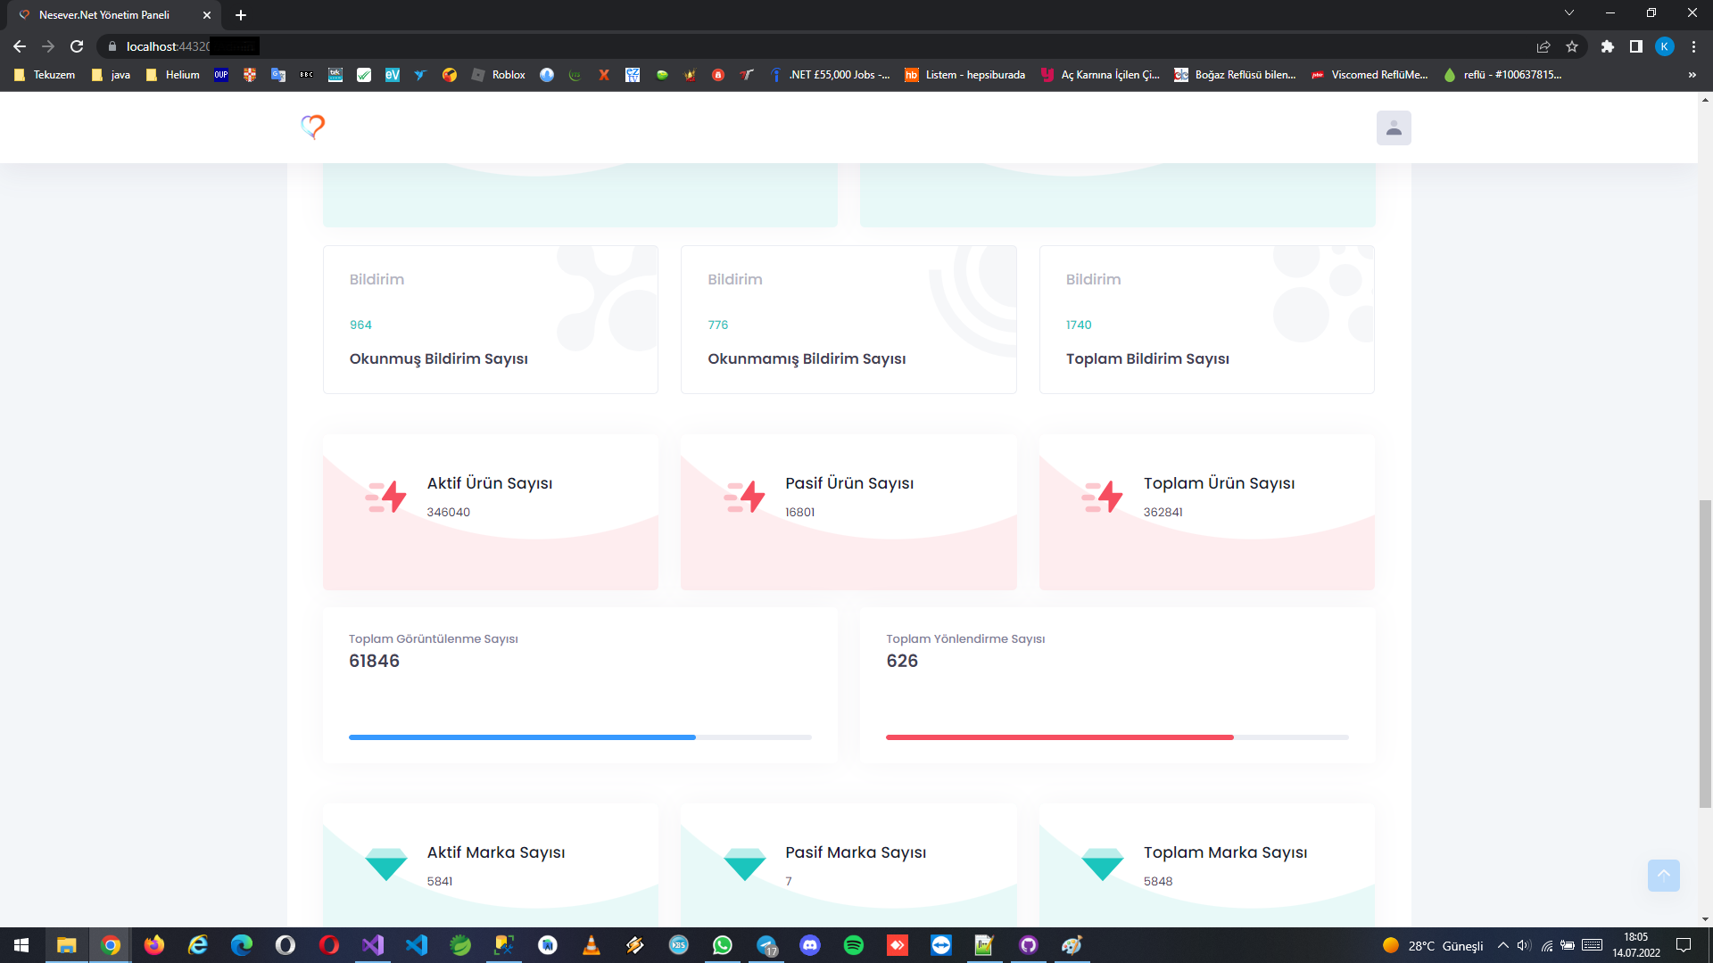

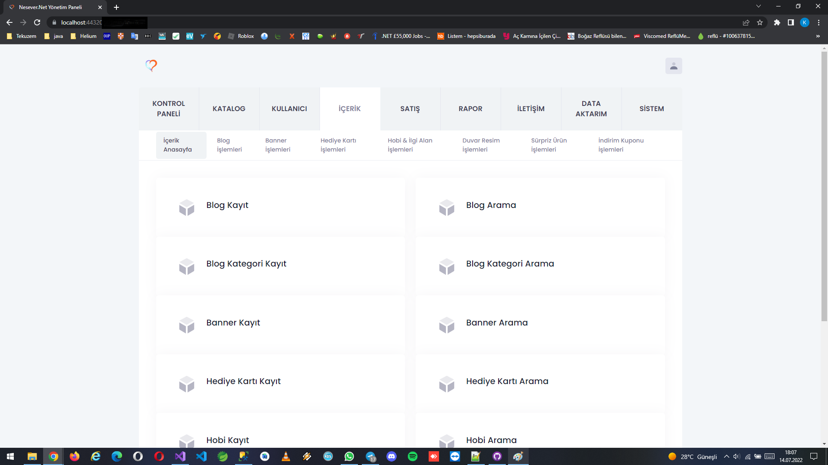

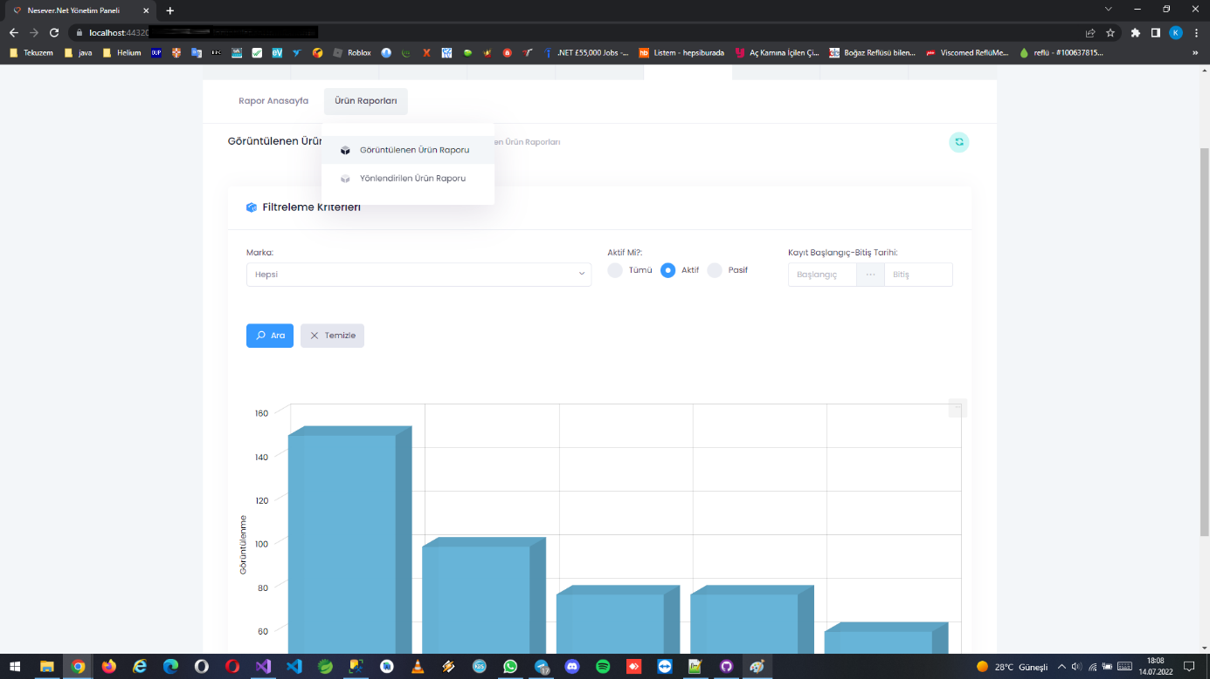

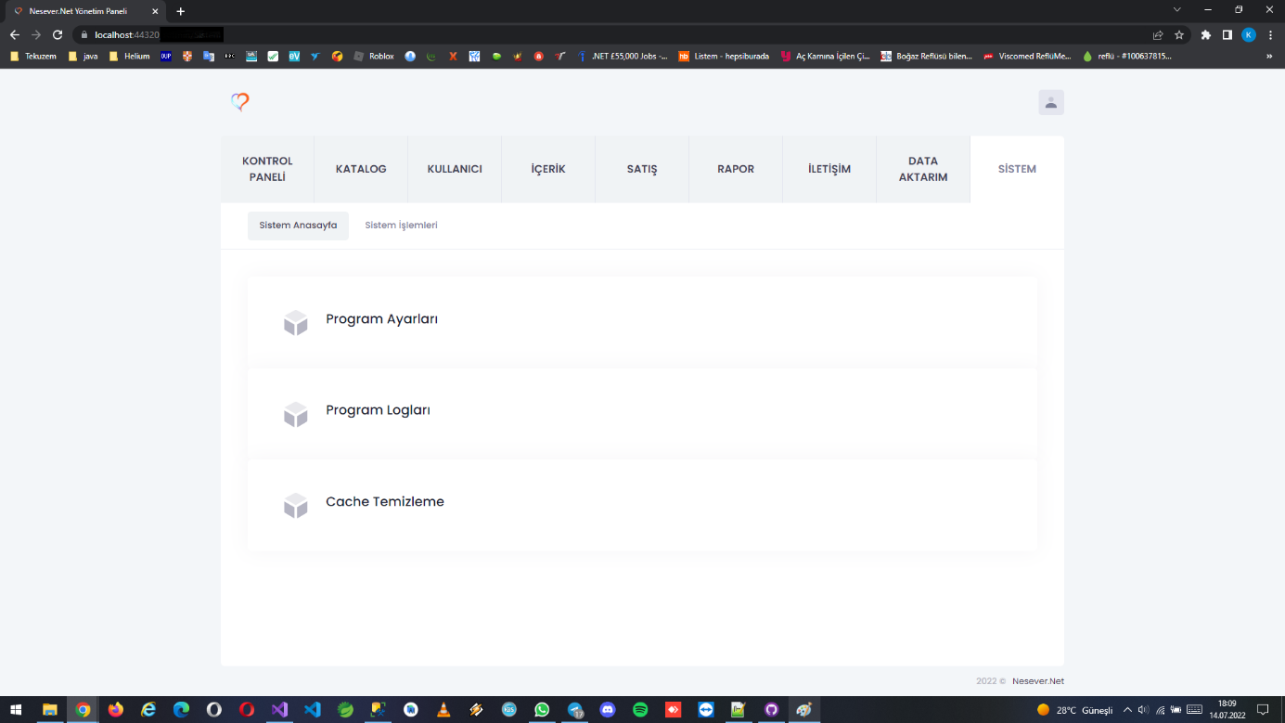

Database Tables

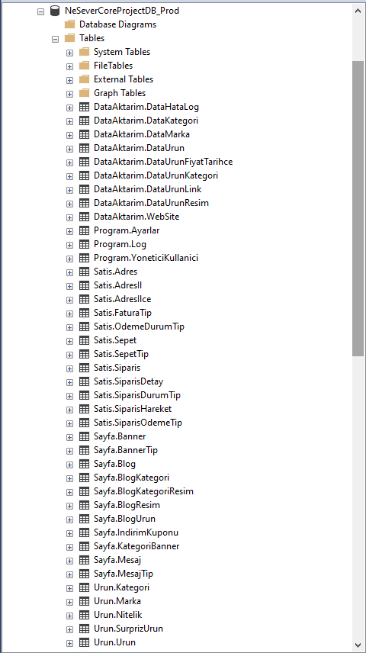

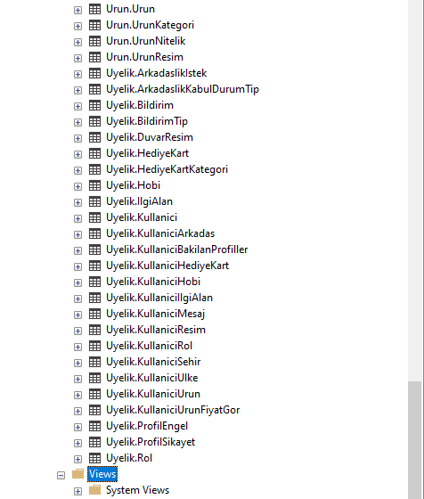

Database Diagram

