History of Computing

Morgan Kennedy

The history of computing dates back as far as approximately 3000 BC with the Abacus. It was made of wooden beads and metal rods and was used for calculations and counting. In the 1600s, Blaise Pascal invented the first mechanical calculator which was called the Pascaline or the Arithmetique. “Blaise’s calculated was a polished brass box, about 350mm by 125 mm by 75mm. It was compact enough to carry. On the top was a row of eight movable dials, with numerals from 0 to 9, which is use to add a column of up to eight figures.” (Blaise Pascal).

The ENIAC (Electronic Numerical Integrator And Computer) was the first large scale computer to be fully electronic. The U.S. Army needed a way to calculate complex wartime ballistics tables and, in 1942, physicist John Muchly proposed the ENIAC. It was built between

1943 and 1945 and contained 18,000 vacuum tubes. “For a decade, until a 1955 lightning strike,

ENIAC may have run more calculations than all mankind had done up to that point.” (Birth of the Computer).

While transistor-based computers were still replacing vacuum-tube machines, big companies realized the potential help computers could be to their business. This meant they required large consolidated machines and the mainframe was invented. American Airlines started using mainframes in 1946 to allow customers to make machine assisted reservations and early models of the ATM machine were created in the 1960s. Mainframes are still alive and well today despite many, such as technology writer Stewart Alsop, who in 1991 said, the mainframe will soon be extinct.

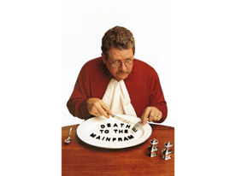<http://s7.computerhistory.org/is/image/CHM/500004507-03-01?$re-zoomed$>

Over the years, computers started to become more user friendly. People started to get together and built their own personal computers. The title of the first personal computer was given to John Blankenbaker’s Kenbak-1. This was decided after a contest was held at the Computer Museum in Boston in 1986. “Designed in 1971, before microprocessors were invented, the Kenbak-1 had 256 bytes of memory and featured small and medium scale

integrated circuits on a single circuit board.” (Personal Computers).

Companies noticed the interest growth in personal computers and started to create products that required little knowledge to operate. “These included three influential computers introduced in 1977: the Apple II, TRS-80, and Commodore PET. The expanding market also meant more demand for software—a niche many companies eagerly filled.” (Personal Computers). The two companies, Apple and IBM took different routes when marketing their new products. Apple focused on schools, donating computers to classrooms and starting a generation of students raised on Apple products. IBM however focused on individual users but their profit was mainly from their dominance in businesses.

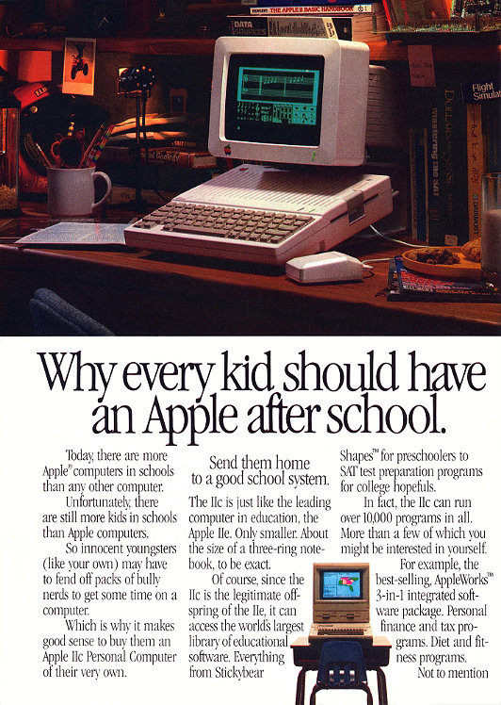

<http://s7.computerhistory.org/is/image/CHM/500004403-03-01?$re-story-hero$>

Personal computers have since advanced further to what we know today. Computing devices have come a long way since the Abacus and are still evolving. What we see today could be considered ancient technology in thirty years.

Reference List:

Computers | Timeline of Computer History | Computer History Museum. (n.d.). Retrieved August 25, 2016, from http://www.computerhistory.org/timeline/computers/

Museum, C. H. (1996). What was the First PC? - CHM revolution. Retrieved August 26, 2016, from http://www.computerhistory.org/revolution/personal-computers/17/297

Blaise Pascal (1623~1662). (n.d.). Retrieved August 25, 2016, from https://www.educalc.net/196488.page

CHM Revolution. (n.d.). Retrieved August 24, 2016, from http://www.computerhistory.org/revolution/birth-of-the-computer/4/78

CHM Revolution. (n.d.). Retrieved August 25, 2016, from http://www.computerhistory.org/revolution/mainframe-computers/7/176