**On Becoming An Ethical Tech-bro**

This. Ask any USP student or NUS admin staff about USP, and their answer is bound to contain a *vanilla platitude*: **being exposed to an interdisciplinary background**. The platitude has been mercilessly beaten to death in countless interviews, dining hall conversations and reflections. And now I find it incumbent on me to walk the same path, and tell you the story of how I learnt to discovered an ethical-cum-research aspect to my major (computer science) thanks to USP.

Every discipline, even a nascent one like computer science, has its own mores or idioms, and we tend to get especially attracted to certain idioms more than others. Personally, I’ve always been attracted to the “hacker” aspect of computer science, which led me to join a group called NUS Hackers at the School of Computing.

Above are some snippets of the rather colourless NUS Hackers website. The focus of the group’s mission is “fun”, “innovation” and “build[ing] a healthy community”. I was won over to the hacker cause by the loose ideal of “learning for **your** learning’s sake,” since it offered a fresh break from my major’s obsession with money-making and job-hunting. While I wasn’t entirely sure about whether simply learning for my own sake was a worthy enough goal, I didn’t find many alternatives in the computer science realm either. To make matters worse, there were some rather problematic signs: the website (and Hackers’ events and my classes) often regressed into a capitalism-fuelled individualistic pandering – “to become more attractive to employers” or “get opportunities from … tech companies.” The logo --- an abstract male silheoutte in front of a barcode (which we call “Barcode Bob”) subtly pointed to the capitalist problem too. Were we conjuring up visions of Enlightenment-style “learning and fun” only to surrender to the altar of tech companies? Was there no higher ethical goal than mere learning?

The aforementioned[1] crisis of ethics and learning extended to USP as well, and left me wondering whether simply learning about different disciplines was “enough.” With a crisis in the background, in my second year, I took a biochemistry module at USP, titled “**UPC2208:** **Molecular Courtship.”** The central thrust of the module was to find explanations to everyday chemistry phenomena using simple chemistry. However, I gained much more – an understanding that *the* *raison d’etre* of finding explanations is ethical – in other words, we seek explanations not for their sake, but to bring about positive change.

The ethical slant to the module was evident from a slide in the very first lecture, shown above. The slide talks about a milk scandal in China, where malicious factories took advantage of an “innovative” chemical melamine, to spoof protein measures and adulterate their produced milk. The incident resulted in the loss of thousands of lives. Interestingly, instead of showing flashy chemical structures and animations about the chemical concepts at play, the professor chose to depict an “empty milk shelf” to depict the human impact.

The module continued teaching me the salience of the “ethical” idiom which drives research in biochemistry. The above image shows my groupmate, Rachel’s idea for our group project, which involved understanding how asthma inhalers relieve patients by delivering the salbutamol drug effectively. We didn’t need to discuss much before settling on asthma – we knew friends who had asthma, and the simple image of the inhaler’s action on pulmonary muscles (amusingly akin to a before/after image used in bogus therapies) provided a clear-enough intuition and motive. Through the project, we learnt how salbutamol was one of the earliest drugs developed by “rational design,” i.e. it was not accidentally discovered but actively sought after by Sir David Jack, who was obsessed with finding a cure for asthma, and found one after several attempts. I realized the power of having a strong ethical backbone when pursuing research – it guides the researcher to answer truly important questions, pushes them to take risks, and serves as a calming North Star when risks don’t pay off – as is often the case in research.





So far, I had envisioned CS as a field bereft of ethical promise in the scientific sense. Learning about the ethical idiom in biochemistry made me wonder whether a similar idiom might exist in the computer sciences as well. Further, I wondered whether I should pursue research via a postgraduate degree as well. To answer the above two questions, I sought out research topics for an undergraduate research project (UROP), and discovered a project about DNA storage, i.e. writing data on DNA molecules (of all things) instead of your regular old flash drives. The DNA project seemed something right out of a sci-fi movie, and I felt it was “the coolest of … projects” because it was (i) capable of vastly improving density and thus reducing energy usage and (ii) extremely risky. The professor, Prof. Djordje Jevdjic, seemed to buy-in to my ethics driven realization – he listed “making DNA storage more practical and cost-effective” as a benefit for students if they embarked on the project – most other projects focused on more individualistic, employer-friendly benefits a la Hackers [1]. I chose to work on the project, and after a lot of failures and pushbacks, I was able to deliver interesting new results about DNA storage in a published paper, and more importantly, I settled on pursuing a career in research.

In sum, I’ve come to realize that learning for learning’s sake will never cut – we should always search for a deeper meaning to why we learn. USP’s vanilla platitude has coloured in my myopic outlook toward computer science with substance, ethics and research.

**Appendix**

The intended audience comprises those who have a good understanding of the USP, its curriculum and importantly, its students.

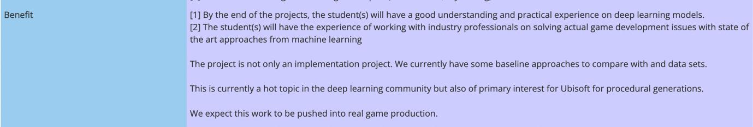

[1] Examples of other project dealing with machine learning and video streaming, whose listed benefits are incredibly student-focused.

1. A cheap substitute for the free-floating “this” keyword. I racked my brains and couldn’t figure out an alternative.