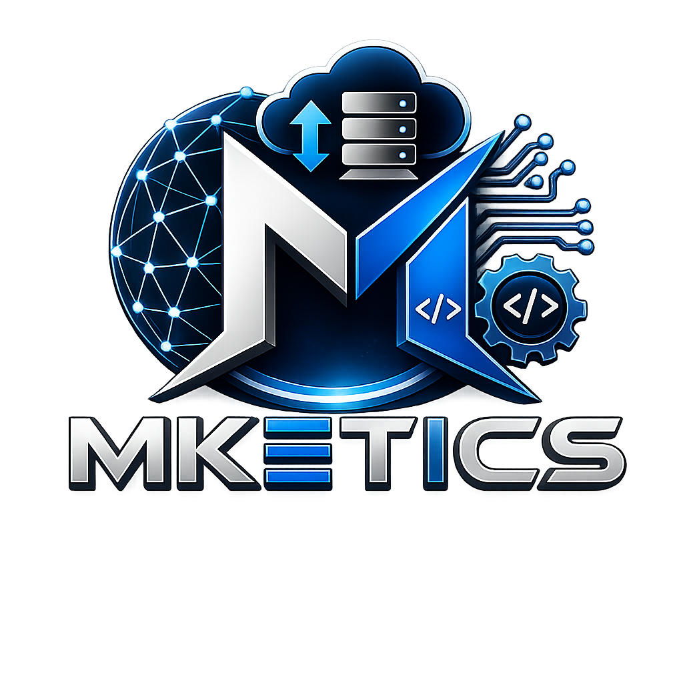
SERVICE CATALOGUE
Software Systems | IT Infrastructure | Cloud | CCTV | Websites | Digital Hub
Speak Innovation. Deliver Value.
Modern Knowledge Engineering, Technology & Innovative Commercial Solutions
Prepared for clients, schools, tertiary institutions, private companies, and individuals
MKETICS (PTY) LTD | B-BBEE Level 1 Contributor | Enterprise No. K2026290708

1. Company Overview
MKETICS (PTY) LTD) provides practical technology solutions that help businesses, schools, tertiary institutions, private companies, and individuals work better, communicate better, and protect their digital and physical assets.
Our work is focused on real client problems: building websites, creating business systems, supporting IT environments, improving networks, planning CCTV, and preparing professional digital documents.
Core Promise  Build | Connect | Protect | Support Model  Remote & Onsite | Compliance  B-BBEE Level 1 | Website  www.mketics.co.za
2. How MKETICS Works
Understand  We listen to the problem, current process, users, budget, and expected outcome. | Design  We recommend the right digital, IT, network, CCTV, or document solution. | Deliver  We build, configure, install, document, or hand over the agreed solution professionally. | Support  We provide updates, maintenance, troubleshooting, and improvement where needed.

3. Websites & Digital Presence
Professional websites and digital platforms that help clients present services clearly and receive enquiries online.
Service | What it includes | Best for | Quote basis
Business Website | Home, About, Services, Contact, WhatsApp button, mobile responsiveness, basic SEO. | Small businesses, organisations, professionals. | Once-off
Portfolio Website | Profile, skills, projects, CV link, contact details, mobile-ready layout. | Job seekers, IT professionals, creatives. | Once-off
Online Store | Product pages, categories, cart/payment planning, delivery options, WhatsApp ordering support. | Product sellers, clothing brands, local shops. | Project quote
Website Maintenance | Minor updates, checks, contact form testing, mobile layout checks, technical support. | Existing website owners. | Monthly

4. Software & Business Systems
Custom digital tools for clients who need more than paper, WhatsApp, Excel, or manual admin.
Service | What it includes | Best for | Quote basis
Custom Business System | Client, booking, stock, report, workflow, or admin system based on client requirements. | Service businesses, schools, admin-heavy teams. | Project quote
Client Portal | Client login, project updates, invoice access, document access, support communication. | Contractors, service businesses, agencies. | Project quote
Invoice & Quote System | Quote creation, invoice creation, Paid/Unpaid tracking, PDF downloads, client records. | Small businesses, freelancers, contractors. | Project quote
CRM / Leads System | Lead capture, client details, follow-up dates, status tracking, notes and history. | Sales teams, consultants, service providers. | Project quote
School / College IT Support System | Support requests, technician updates, ticket status, reports, asset/support tracking. | Schools, TVET colleges, campus IT teams. | Project quote
Loan / Mashonisa System | Client profiles, loan records, repayments, balances, due dates, payment history. | Local lenders and finance businesses. | Project quote

5. IT, Network & Infrastructure
Technical support and infrastructure services for reliable daily operations.
Service | What it includes | Best for | Quote basis
IT Support | Troubleshooting, software setup, printer support, email support, user assistance. | Offices, schools, individuals. | Call-out / monthly
Network Installation | Network planning, switches, routers, cabling guidance, IP planning, Wi-Fi support. | Schools, colleges, offices, premises. | Site quote
Wi-Fi Setup & Optimisation | Router/AP setup, coverage planning, signal checks, secure configuration, guest Wi-Fi. | Homes, offices, schools, accommodation. | Site quote
Cloud Setup | Cloud storage, backup planning, file organisation, user access, basic cloud security. | Businesses, schools, remote teams. | Project quote

6. CCTV & Security Technology
Security technology planning and support for sites that need better visibility, recording, and remote access.
Service | What it includes | Best for | Quote basis
CCTV Installation Planning | Camera placement advice, NVR/DVR guidance, storage planning, remote viewing guidance. | Homes, schools, businesses, security sites. | Site quote
IP Camera & Cloud Surveillance | IP camera planning, network camera management, cloud storage planning, remote monitoring design. | Multi-site clients, schools, colleges, businesses. | Project quote
CCTV Support & Review | Camera checks, remote view checks, storage checks, fault reporting, improvement recommendations. | Existing CCTV clients. | Call-out / monthly

7. Digital Hub Services
Professional digital documents and business support materials for clients who need to look credible and ready.
Service | What it includes | Best for | Quote basis
Company Profile Design | Company overview, services, mission, vision, compliance details, contact details, layout. | Registered businesses and startups. | Once-off
Business Proposal Document | Cover page, executive summary, scope, deliverables, timeline, budget, terms, sign-off. | Client proposals, tenders, project submissions. | Once-off
Invoice & Quotation Documents | Client details, service description, pricing, Paid/Unpaid status, official banking details. | Freelancers, small businesses. | Once-off
CV & LinkedIn Support | CV rewrite, LinkedIn About section, skills, professional summary, career positioning. | Job seekers, graduates, professionals. | Once-off

8. Monthly Support Services
Ongoing support options for clients who need continuous technical care after delivery.
Service | What it includes | Best for | Quote basis
Website Maintenance | Content updates, checks, basic fixes, form checks, mobile layout review. | Business website clients. | Monthly
IT Support Retainer | Remote support, troubleshooting, user support, email/printer support, monthly advice. | Small businesses and offices. | Monthly
System Support | Bug fixes, user support, small improvements, access support, monthly system checks. | Custom system clients. | Monthly
Cloud Backup Support | Backup monitoring, user guidance, access support, storage organisation. | Businesses using cloud files. | Monthly
9. Quote Request Guide
To prepare an accurate quote, MKETICS may request the client to provide the project type, location, timeline, preferred budget range, number of users, existing tools, and any documents or photos that explain the problem.
Client should provide | MKETICS will respond with
Service needed and problem description | Recommended solution and scope
Location and site details where relevant | Estimated cost or price range
Photos, existing documents, or system screenshots | Timeline and deliverables
Urgency and preferred communication method | Next steps and payment terms
10. Contact Details
Email  info@mketics.co.za | Phone / WhatsApp  +27 72 286 4367 | Website  www.mketics.co.za | Location  South Africa
For quotes, clients should use the MKETICS quote page or contact MKETICS directly with a short description of the service needed.

