Name: Minh Khai Tran

zID: z5168080

Exercise 1:

Question 1: Why the throughput achieved by flow tcp2 is higher than tcp1 between time span 6 sec to 8 sec?

* As we know TCP1 and TCP2 flows are intersect at node . But the link has much higher bandwidth than the bandwidth of the link . So, after adjustment, TCP2 at about 6 sec, the throughput of TCP2 higher than the throughput of TCP1 due to TCP2 flows has higher bandwidth compare to TCP1 flow’s bandwidth.

Question 2: Why the throughput for flow tcp1 is fluctuating between time span 0.5 sec to 2 sec?

* As the behaviour of TCP flows, after TCP make the connection between two nodes, TCP1 flow enters “slow start phase” therefore it sends less packet at the start time. Hence the TCP1 is fluctuating between time span 0.5 sec to 2 sec.

Question 3: Why is the maximum throughput achieved by any one flow capped at around 1.5Mbps?

* Because at node is the intersect between TCP1 and TCP2, so is dropping packets when the queue is full, hence these flows will decrease the congestion window size to half (triple acks) or 1(time out). So the maximum throughput achieved by any one flow capped at around 1.5Mps.

Exercise 2:

Question 1: Which data size has caused fragmentation and why? Which host/router has fragmented the original datagram? How many fragments have been created when data size is specified as 2000?

* The data size of 2000 and 3500 has caused fragmentation because it is larger than the default maximum segment size of 1500 bytes.
* The host 192.168.1.103 fragmented the original datagram.
* 2 fragments have been created when the data size is specified as 2000.

Question 2: Did the reply from the destination 8.8.8.8. for 3500-byte data size also get fragmented? Why and why not?

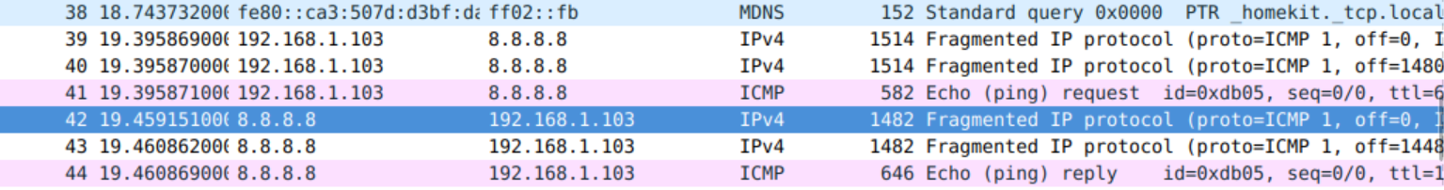

* As we can see, when the server (8.8.8.8) replies with 3500 bytes data and this data is fragmented to smaller segments.

Question 3: Give the ID, length, flag and offset values for all the fragments of the first packet sent by 192.168.1.103 with data size of 3500 bytes?

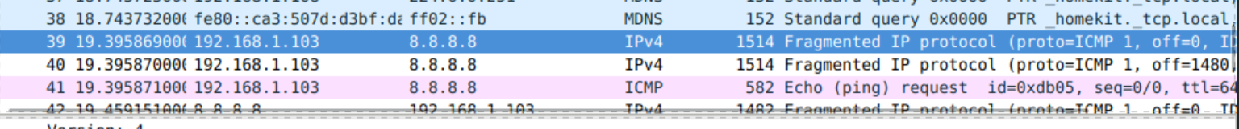

* This packet is fragmented into 3 smaller segments:

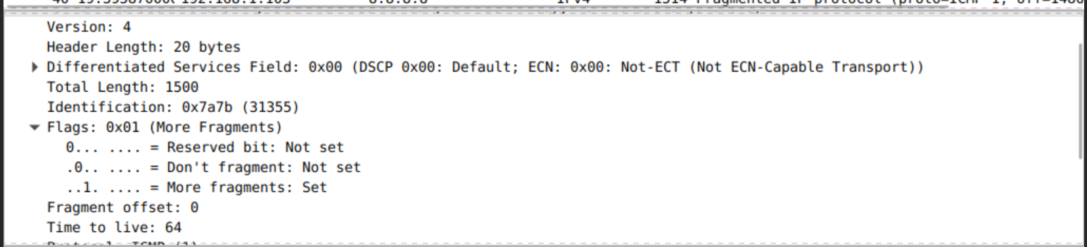

Figure: example of the first segment

* + First segment:
    - ID: 7a7b
    - Length: 1514
    - Flag: 0x01 (More Fragments)
    - Offset: 0
  + Second segment:
    - ID: 7a7b
    - Length: 1514
    - Flag: 0x01 (More Fragments)
    - Offset: 1480185
  + Third segment:
    - ID: 7a7b
    - Length: 582
    - Flag: 0x00
    - Offset: 2960370

Question 4: Has fragmentation of fragments occurred when data of size 3500 bytes has been used? Why and why not?

Question 5: What will happen if for our example one fragment of the original datagram from 192.168.1.103 is lost?

* The entire IP datagram is discarded after a timeout period, so the sender will send the IP datagram again.

Exercise 3:

Question 1: Which nodes communicate with which other nodes? Which route do the packets follow? Does it change over time?

* Node communicates with node and node comunicates with node .
* There are two routes:
* The routes do not change over time.

Question 2: What happens at time 1.0 and at time 1.2? Does the route between the communicating nodes change as a result of that?

* From time 1.0 to time 1.2, link between is set to down.
* The route does not change as is still sending packets but experiencing packet loss. And route from is still running normally.

Question 3: Did you observe any additional traffic as compared to Step 3 above? How does the network react to the changes that take place at time 1.0 and time 1.2 now?

* When link between and is down, the route from to is changed to
* The router informs its neighbours of topology changes periodically recalculate its Distance Vector table.

Question 4: How does this change affect the routing? Explain why.

* Since we increase the cost of the link between node and . Then the Distance Vector algorithm, the router found another path that is cheaper compare to the old route.
* The route from node remains the same.

Question 5: Describe what happens and deduce the effect of the line you just uncommented.

* There is one route from node to node :
  + which has lowest cost of 4 compare to another route
* There are two routes from node to node that has the same cost of 4:
  + Because multi-path is allowed, so in the simulation we can see uses 2 routes to send packet to