Software Engineering 91.411

Product Prototype Report

03/14/2017

**Roles:**

|  |  |
| --- | --- |
| Muhammed Khalid | ScrumMaster and SW Developer |
| Vibhuti Patel | Product Owner and Principal SW Engineer |
| Michael Bertucci | Senior SW Engineer |

**Ceremonies and artifacts:**

Created a product backlog which includes features that we want to add in our product. Using scrum, we created a product backlog in our first Scrum meeting. Additionally, we took features that we had put into the product backlog and added to a sprint one backlog. The features that were added to our sprint one backlog, were tackled in that sprint.

|  |
| --- |
| **Create New Order Submission UI** – User interface that allows a user to create a new order |
| **Create User Login Page** – A User Interface that allows a user to login |
| **Create UI Showing list of orders** – A User Interface that will show list of orders that have been placed |
| **Create UI Allowing user to modify profile information** – Create a separate user interface that will allow users to modify their profile information (i.e email, position, department, etc.) |
| **Create Python SQL API** – Create an interface that will allow the developers to user python abstraction when dealing with database queries and insertions. More of a tool for developers so they do not have to write hard SQL but user functions that represent SQL statements. |
| **Filter displayed orders depending on type of user** – If the user is a manager, he may see all orders that have been placed within the department. A regular employee user will only have access to orders that he or she has placed |
| **Have application send notifications to users** – Created a notification system to let the user know the status of his or her order. Notify when it has been placed, approved, and delivered. |
| **Implement password encryption when storing inside MySQL** **database** – Do not want raw passwords in the database because that is very unsafe. Encrypt the password and then store it I the database. More for user protection |
| **Give Edit permissions for Orders depending on User Type** – A manager will have the ability to modify and change orders. A regular employee with no higher privileges, cannot orders that have been already placed |
| **Find Hosting Platform for MySQL database** – For convenience, host a MySQL database on a cloud service rather than having a locally hosted sql database. |
| **Create a MySQL database schema** – Once a suitable host has been found, create the schema for the database. The tables and the table values. |
| **Add backend to User Submission UI** – The front end will comprise of HTML/CSS and/or JavaScript. The backend which communicates between the submission UI and MySQL database |
| **Login backend** – The login backend will communicate between the User Login UI and the MySQL database. The login backend will also manage user sessions (which users are logged in and/ or logged out). |

**Sprint Planning Meeting**

For our sprint planning meeting, we had a product backlog of features that will be implemented in our product. We took a few items for the product backlog and decided who would do what. We took 8 items from our product backlog and planned to tackle them in our first sprint. Below is our finalized sprint one backlog with stories, respective assignees, and an estimate for each calculated in hours. Our Sprint Planning meeting was conducted on March 7th, 2017 in Lyndon Library. All three members met together and discussed and finalized the sprint backlog.

| **Stories** | **Assignee** | **Estimate (Hours)** |
| --- | --- | --- |
| Create New Order Submission UI | Vibhuti Patel | 4 |
| Add backend to User Submission UI | Michael Bertucci | 5 |
| Create User Login Page | Vibhuti Patel | 2 |
| Login Backend | Muhammed Khalid | 4 |
| Create UI showing list of orders | Vibhuti Patel | 4 |
| Create Python SQL API | Muhammed Khalid | 3 |
| Find Hosting Platform for mySQL Database | Muhammed Khalid | 1 |
| Create a mySQL Database | Vibhuti Patel | 2 |

An important aspect of scrum is prioritization. For our prototype release, we needed to have a working user login. As a team, we prioritized around the user login. Therefore, we wanted to have working user login and working login backend. We took the features and created them into user stories.

**Stories Closed in Sprint 1**

| **Stories** | **Assignee** | **Estimate (Hours)** |
| --- | --- | --- |
| Create New Order Submission UI | Vibhuti Patel | 4 |
| Create User Login Page | Vibhuti Patel | 2 |
| Login Backend | Muhammed Khalid | 4 |
| Create UI showing list of orders | Vibhuti Patel | 4 |
| Create Python SQL API | Muhammed Khalid | 3 |
| Find Hosting Platform for mySQL Database | Muhammed Khalid | 1 |
| Create a mySQL Database | Vibhuti Patel | 2 |

These were the stories that we were able to finish in the first sprint. We had an issue with one story in the sprint and found that I was not feasible for the current sprint and we will tackle the story in a future sprint.

**Summary of Sprint Meetings:**

**Meeting #1 | Location: Olsen 401 | 03/02/2017**

* Discussed some issues regarding the project
* Met after class to discuss the direction the of project
* Set up ideal times for Sprint meetings
* Also discussed if we are not available to meet in person, that we meet via Skype or phone call.

**Meeting #2 | Location: Lyndon Library | 03/07**

* This was our Sprint Planning meeting
* We created a product backlog which contained features to put into the product
* Reviewed the backlog with the entire team.
* Finalized backlog and created a sprint backlog

**Meeting #3 | Location: Online | 03/09**

* Assigned story points to tasks in Sprint 1 Backlog
* Assigned tasks from sprint backlog to team members
* Provided an estimate for each task in hours

| **Stories** | **Assignee** | **Estimate (Hours)** |
| --- | --- | --- |
| Create New Order Submission UI | Vibhuti Patel | 4 |
| Add backend to User Submission UI | Michael Bertucci | 5 |
| Create User Login Page | Vibhuti Patel | 2 |
| Login Backend | Muhammed Khalid | 4 |
| Create UI showing list of orders | Vibhuti Patel | 4 |
| Create Python SQL API | Muhammed Khalid | 3 |
| Find Hosting Platform for mySQL Database | Muhammed Khalid | 1 |
| Create a mySQL Database | Vibhuti Patel | 2 |

**Meeting #4 | Location: Online | 03/10**

* Asked each team member regarding their stories
  + What have you don since the last sprint meeting?
  + What are you going to do today?
  + Do you need help with anything? Are you stuck?
* Overall, each team member has a good grasp of their stories
* No issues thus far

**Meeting #5 | Location: Online | 03/11**

* Began the meeting by asking each team member their progress on tasks
* Vibhuti is still working on her stories with no issues
* Michael is still working on his stories with no issues
* Muhammed is working on the backend for the python sql api in addition to the login backend
* No issues thus far
* Posibility of meeting on campus tomorrow to discuss possible issues

**Meeting #6 | Location: Online | 03/12**

* Talked about our progress regarding the sprints
* An issue came up regarding our feasibility report
* From our discussion, we figured we need to restructure our product backlog
* Some items from this sprint are not feasibile and must be moved to the next sprint
* 3 stories have been closed
  + Hosting for mySQL Database - closed
  + Create mySQL Database - closed
  + Create Python SQL API - closed

**Meeting #7 | Location: Online | 03/13**

* ScrumMaster asked each member on the progress of their stories
* Vibhuti was able to complete the User Login Page along with Company Login page.
* 2 stories have been closed
  + Create User Login Page - closed
  + Login Backend - closed
* Also we discussed the issue of feasibility in one of our features
* We agreed that the backend to the User Submission UI was not feasible for this sprint
* We will tackle this story in a future sprint

| **Stories** | **Assignee** | **Estimate (Hours)** | **Status** |
| --- | --- | --- | --- |
| Create New Order Submission UI | Vibhuti Patel | 4 | Open |
| Add backend to User Submission UI | Michael Bertucci | 5 | Closed |
| Create User Login Page | Vibhuti Patel | 2 | Closed |
| Login Backend | Muhammed Khalid | 4 | Closed |
| Create UI showing list of orders | Vibhuti Patel | 4 | Open |
| Create Python SQL API | Muhammed Khalid | 3 | Closed |
| Find Hosting Platform for mySQL Database | Muhammed Khalid | 1 | Closed |
| Create a mySQL Database | Vibhuti Patel | 2 | Closed |

**Sprint Review and Retrospective**

We created a login page with a supported back end for the login page. Additionally, a cloud service was agreed upon for hosting the MySQL database. A particular schema was created for our MySQL database. With a complete database schema, a python MySQL API was created to aide developers in using a python interface for database operations rather than hard SQL code. Also a non functional UI for list of orders and new order submissions were created.

Unfortunately, there was one story which could not be completed. The backend to the User Submission could not be completed because of the complexity of the problem. It required too much work and it could not be completed by a single team member in this sprint. We moved the issue back into the product backlog and will reopen the task in a future sprint.

We should try to make tasks that are more manageable for all team members. We thought the tasks that we assigned to ourselves were manageable but half way through the sprint, we realized that the tasks were too large to be completed by one individual. What we should have done is made the tasks much smaller so that each member is fully confident in completing the task(s) assigned to him or her.

However, we should be continuing the daily sprint meetings which he had. This was helpful in keeping the team on schedule and an idea of what is happening. Also, helping other team mates when they have issues with their assigned stories. I find this to be the most helpful for team members to complete their tasks when they have another pair of eyes look at them. In general, this is something we should continue doing in the sprints to follow.

**Sprint Burndown Chart:**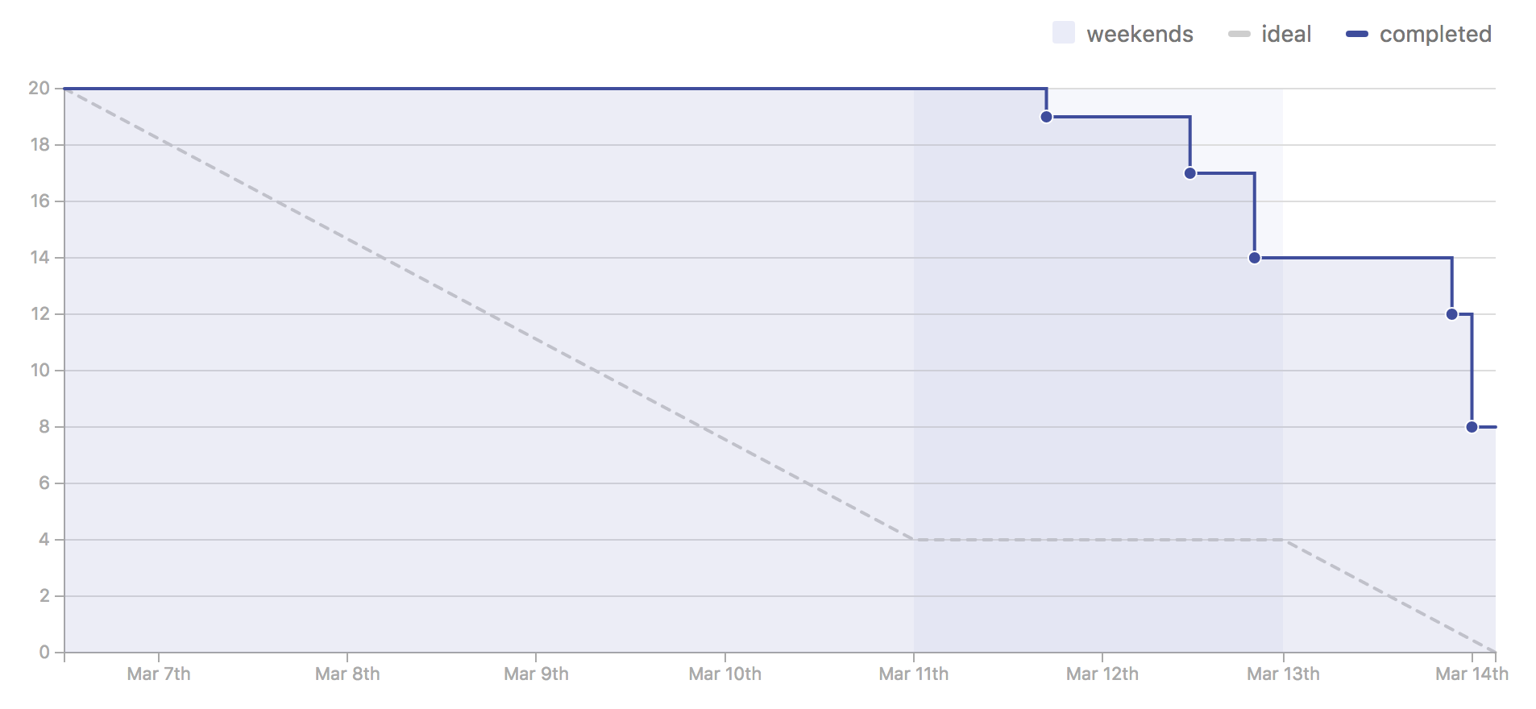

This is our sprint burn down chart. The y-axis represents the estimates which were calculated in hours and not in story points. The burn down chart represents the change in stories completed in the sprint cycle. As it can also be seen that most of stories were closed towards the end of the sprint. From our experience during our co-ops, this was a normal trend because our artifacts or stories would always be closed towards the end rather than in the beginning or in the middle of the sprint cycle.