**Scrum Report**

**Software Engineering I**

**Muhammed Khalid – Vibhuti Patel**

**Roles:**

|  |  |
| --- | --- |
| Muhammed Khalid | ScrumMaster and SW Developer |
| Vibhuti Patel | Product Owner and Principal SW Engineer |

**Ceremonies and artifacts:**

Created a product backlog which includes features that we want to add in our product. Using scrum, we created a product backlog in our first Scrum meeting. Additionally, we took features that we had put into the product backlog and added to a sprint one backlog. The features that were added to our sprint one backlog, were tackled in that sprint.

|  |
| --- |
| **Add MySQL ORM** – a tool that will allow database insertion and extraction with ease (we used SQLAlchemy for our project) |
| **Give Edit Permissions for Orders depending on User Type** – Provide different users with different privileges. Employees will able to see orders they placed while managers will be able to approve and reject orders. |
| **Create UI Showing list of orders** – A User Interface that will show list of orders that have been placed by each user. A user will be able to see an order that he has placed. |
| **Create UI Allowing user to modify profile information** – Create a separate user interface that will allow users to modify their profile information (i.e email, position, department, etc.) |
| **Create User Login Sessions** – Implement a system that will allow users to login with unique profiles for them. That way different users will be able to login and place orders and modify their own profiles. |
| **Filter displayed orders depending on type of user** – If the user is a manager, he may see all orders that have been placed within the department. A regular employee user will only have access to orders that he or she has placed |
| **Modify Login UI** – In the first sprint, we created a login that was bland and straight to the point. We want to build upon from the first sprint by improving the GUI with CSS and JavaScript. |
| **Implement password encryption when storing inside MySQL** **database** – Do not want raw passwords in the database because that is very unsafe. Encrypt the password and then store it I the database. More for user protection |
| **Add backend to User Submission UI –** This is an artifact that was rolled over from the first sprint. We were not able to complete it, but completed it this sprint. Added the functionality for users to place orders which would be appended to the database. |
| **Create New Order Submission UI** – Create a UI or GUI for the client-side. This is what the user will see when placing orders. |

**Sprint Planning Meeting**

For our sprint planning meeting, we had a product backlog of features that will be implemented in our product. We took a few items for the product backlog and decided who would do what. We took 7 items from our product backlog and planned to tackle them in our first sprint. Below is our finalized sprint2 backlog with stories, respective assignees, and an estimate for each calculated in hours. Our Sprint Planning meeting was conducted on March 28th, 2017 in Lyndon Library. All two members met

together and discussed and finalized the sprint backlog.

| **Stories** | **Assignee** | **Estimate (Hours)** | **Status** |
| --- | --- | --- | --- |
| Create UI allowing user to modify profile information | Vibhuti Patel | 2 | Open |
| Give Edit Permissions for Orders depending on User Type | Vibhuti Patel | 1 | Open |
| Add backend to User Submission UI | Muhammed Khalid | 5 | Open |
| Create UI showing list of orders | Vibhuti Patel | 5 | Open |
| Modify Login UI | Muhammed Khalid | 4 | Open |
| Create User Login Sessions | Muhammed Khalid | 5 | Open |
| Add mySQL ORM | Muhammed Khalid | 3 | Open |

An important part of this sprint cycle was to accomplish a complete product. In short, we wanted to have a complete product ready by the 25th, although we would still like to add much more. So, as a team, we worked hard to make sure that everything was working. We tackled the stories above and helped each other on the artifacts even though they were not directly assigned to us. Fortunately for this sprint, we completed all assigned stories.

These were the stories that we were able to finish in the second sprint. We did not have an issue in completing the artifacts as we learned from the first sprint of what we were capable of accomplishing within the deadline:

## Meeting 1 | Sprint Planning

#### Location: Lyndon Library 03/28

* Went back to our product backlog and moved to this sprint
* Also added stories from previous sprint
* Those stories have been rolled over. Hopefully, they can be accomplished in this sprint
* Broke up tasks and assigned to each respective team member best capable of performing them
* Also added estimates to each story (in hours).
* Final Sprint2 Backlog:

| **Stories** | **Assignee** | **Estimate (Hours)** | **Status** |
| --- | --- | --- | --- |
| Create UI allowing user to modify profile information | Vibhuti Patel | 2 | Open |
| Give Edit Permissions for Orders depending on User Type | Vibhuti Patel | 1 | Open |
| Add backend to User Submission UI | Muhammed Khalid | 5 | Open |
| Create UI showing list of orders | Vibhuti Patel | 5 | Open |
| Modify Login UI | Muhammed Khalid | 4 | Open |
| Create User Login Sessions | Muhammed Khalid | 5 | Open |

## Meeting 2 | Sprint Planning

#### Location: Online 03/31

* Still working on the same artifacts
* The Login UI was modified with CSS
* Learning about SQL ORM (SQLAlchemy
* Working on User Login Sessions

| **Stories** | **Assignee** | **Estimate (Hours)** | **Status** |
| --- | --- | --- | --- |
| Create UI allowing user to modify profile information | Vibhuti Patel | 2 | Open |
| Give Edit Permissions for Orders depending on User Type | Vibhuti Patel | 1 | Open |
| Add backend to User Submission UI | Muhammed Khalid | 5 | Open |
| Create UI showing list of orders | Vibhuti Patel | 5 | Open |
| Modify Login UI | Muhammed Khalid | 4 | Open |
| Create User Login Sessions | Muhammed Khalid | 5 | Open |

## Meeting 3 | Daily Sprint

#### **Location: Online 04/04**

* Still working on the same artifacts
* Everyone is making good progress on their stories
* Still working on the same stories from previous sprint meeting
* No new progress and no closed stories

| **Stories** | **Assignee** | **Estimate (Hours)** | **Status** |
| --- | --- | --- | --- |
| Create UI allowing user to modify profile information | Vibhuti Patel | 2 | Open |
| Give Edit Permissions for Orders depending on User Type | Vibhuti Patel | 1 | Open |
| Add backend to User Submission UI | Muhammed Khalid | 5 | Open |
| Create UI showing list of orders | Vibhuti Patel | 5 | Open |
| Modify Login UI | Muhammed Khalid | 4 | Open |
| Create User Login Sessions | Muhammed Khalid | 5 | Open |

## Meeting 4 | Daily Sprint

### **Location: Online 04/05**

* Progress the same and still working on artifacts
* No closed stories yet
* Vibhuti is still working profile data functionality and plans to work on today
* I am still working on Login UI modification and user login sessions and will continue till the next sprint

## Meeting 5 | Daily Sprint

### **Location: Cellphone 04/11**

* Good progress on artifacts
* Vibhuti worked on ajax calls to bridge JS and python code
* Vibhuti completed the profile information user modification functionality
* I implemented a SQL ORM using SQLAlchemy
* Created UI allowing user to modify profile information story is closed
* Create UI showing list of orders is closed

| **Stories** | **Assignee** | **Estimate (Hours)** | **Status** |
| --- | --- | --- | --- |
| Create UI allowing user to modify profile information | Vibhuti Patel | 2 | Closed |
| Give Edit Permissions for Orders depending on User Type | Vibhuti Patel | 1 | Open |
| Add backend to User Submission UI | Muhammed Khalid | 5 | Open |
| Create UI showing list of orders | Vibhuti Patel | 5 | Closed |
| Modify Login UI | Muhammed Khalid | 4 | Open |
| Create User Login Sessions | Muhammed Khalid | 5 | Open |

## Meeting 6 | Daily Sprint

### **Location: Olsen 404 04/20**

* A quick sprint meeting after class
* Muhammed is still working on the submission backend and user login sessions
* Vibhuti is working on creating edit permissions for orders
* No closed stories in this sprint meeting

## Meeting 7 | Sprint Meeting

### **Location: Online 04/24**

* Approaching the end of the sprint.
* Vibhuti has completed and closed are stories that were assigned to her
* Muhammed has also completed the stories that were assigned to him
* Opened a new story: Add mySQL ORM and closed in this sprint
* Currently working on a few bugs as we are doing a full integration with master
* Closed stories:

| **Stories** | **Assignee** | **Estimate (Hours)** | **Status** |
| --- | --- | --- | --- |
| Create UI allowing user to modify profile information | Vibhuti Patel | 2 | Closed |
| Give Edit Permissions for Orders depending on User Type | Vibhuti Patel | 1 | Closed |
| Add backend to User Submission UI | Muhammed Khalid | 5 | Closed |
| Create UI showing list of orders | Vibhuti Patel | 5 | Closed |
| Modify Login UI | Muhammed Khalid | 4 | Closed |
| Create User Login Sessions | Muhammed Khalid | 5 | Closed |
| Add mySQL ORM | Muhammed Khalid | 3 | Closed |

## **Meeting 8 | Sprint End and Retrospective**

### **Location: In class**

* Final demo will be done in class
* An overview and retrospective of the sprint will be discussed in class
* We have completed the project.

**Sprint Review and Retrospective**

We built upon what we had accomplished in the first sprint. In the first sprint we had a database schema created along with a very basic user login and registration. We also presented a demo of our prototype which demonstrated our progress. In the second sprint we accomplished much more. The original bland login UI was modified to look more pleasant and appealing to the eye using CSS and JavaScript. A list of orders was displayed to the application via ajax calls made in JavaScript. A backend support for user order submission and retrieval. And an implementation of a SQL ORM via SQLAlchemy for our MySQL database.

Regarding work that was not completed, we did not have an issue with this because all proposed work was accomplished within this sprint which is something that we were happy about. Also, no team member left the company. Unlike the last sprint, everything story was tackled in sprint2.

Because of this sprint, we have gained a confidence boost in what we are capable of doing. Our skillset in python, flask, and MySQL has vastly improved. We should try to tackle more stories because we were able to work efficiently in this sprint and we accomplished a lot with only 2 members in this team. Also, something that we mentioned in the first retrospective, is that we should make more time to meet in person rather than online. For this sprint, we met more online than in person. It did not impact our output, but it would have helped more with efficiency since we can talk out more issues in person rather than online. Due to limited time and projects from other courses, meeting in person was not very feasible.

For this sprint we could not think of anything that we should stop doing because we have had quite an efficient sprint this time around. However, one thing we should have done is split our sprint into two sprints because this sprint was about 30 days. We began the sprint back on the 28th of March, and currently it is the 24th of April. We should stop having longer sprints and keep it two weeks’ maximum which will allow for more efficient progress.

Things that we should continue doing is using Github and learning about other software practices. We should continue developing our product and continue coming with ideas for what we want to include in our product. How can we improve it and make it even more satisfactory to the user. \

**Sprint Burndown:**

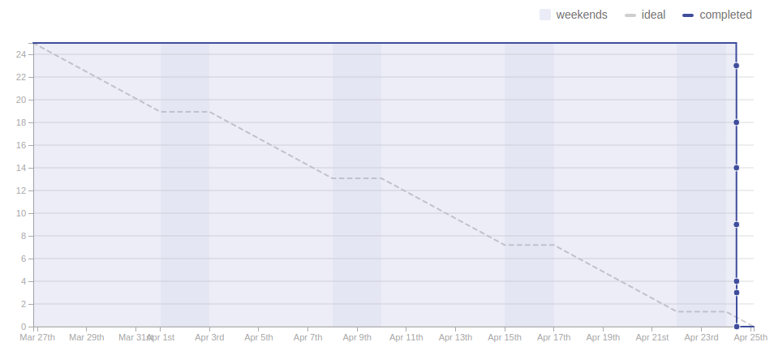

As it can be seen from the burn down chart, we closed all of our stories at the end of the sprint. Also our second sprint started on the 27th of March with 24-25 hours worth of stories. Again, we should have broken our sprint into 2 weeks each therefore we would have had sprint2 and sprint3 which would have produced even better burn down and velocity results. In industry, a sprint size this long is not a good idea.

**Velocity:**

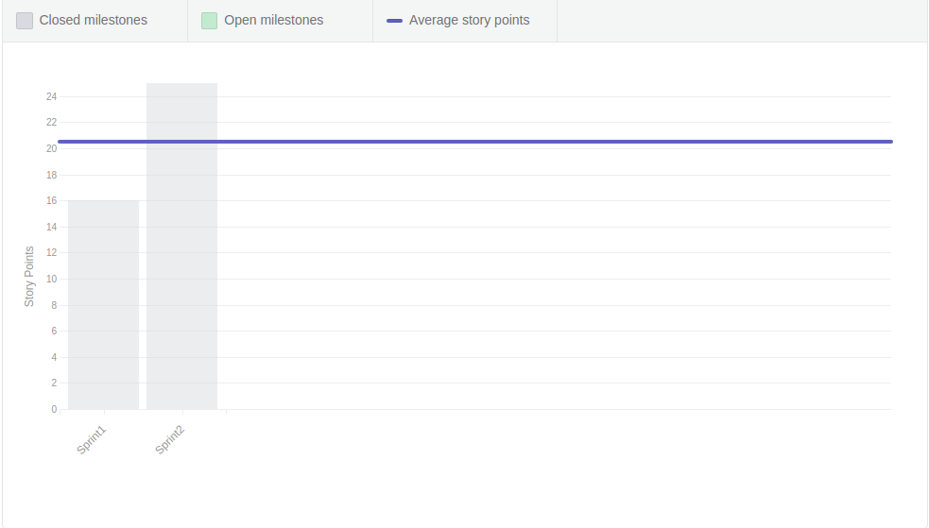

This is our velocity among the two sprints that we had. As it be seen from the graph above, our average sprint velocity was about 20.5 hours. Given that each story was about 3-4 hours, we handled, on average, about 5 stories per sprint. Is that a good value? Given that we had only two members in our company, that is not a bad velocity. However, a company with more employees per team, will of course provide a larger velocity. Also we demonstrated a larger velocity in our second sprint because we learned from the first sprint our capabilities and focused on achieving stories that were more feasible for our team.