**Earphones Wired White, Black - E10**

Top of Form

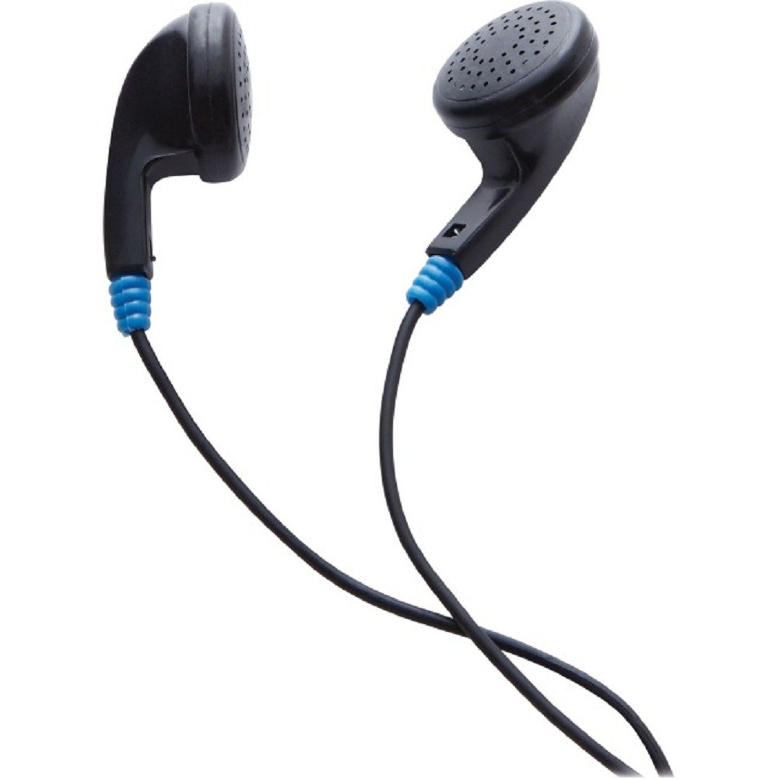Bottom of Form

**DESCRIPTION**

- Wired Earphones compatible with all digital audio players with 3.5 mm jack- With their superior comfort fit, and sound quality, these Earphones are the perfect spare or replacement headphones

Top of Form

# Meseta, Premium Italian Espresso, Bio-Organic, Box Of 10 Capsules, Compatible With Nespresso Machines

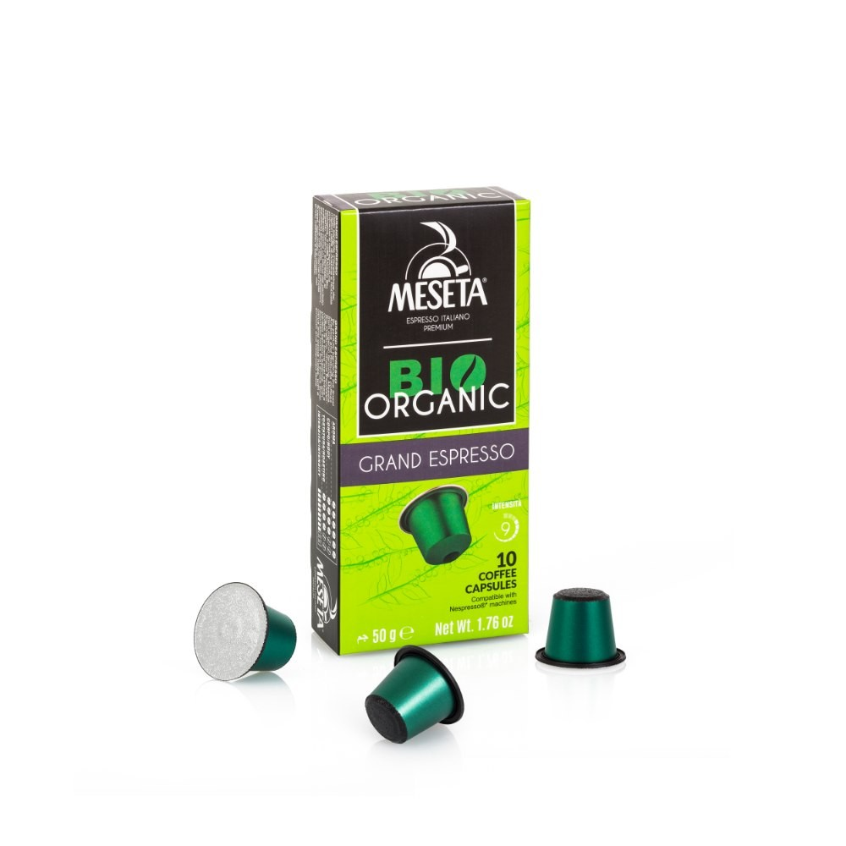

**DESCRIPTION**

By skillfully blending the finest Arabica and Robusta coffees from organic farming, Meseta Bio Organic Grand Espresso coffee is a blend that strikes a perfect sensory balance with aromatic hints that evoke floral, citrus and cocoa notes, with a smooth and balanced taste. Intensity 9/12

Top of Form

# Portable Rechargeable Fan Blue

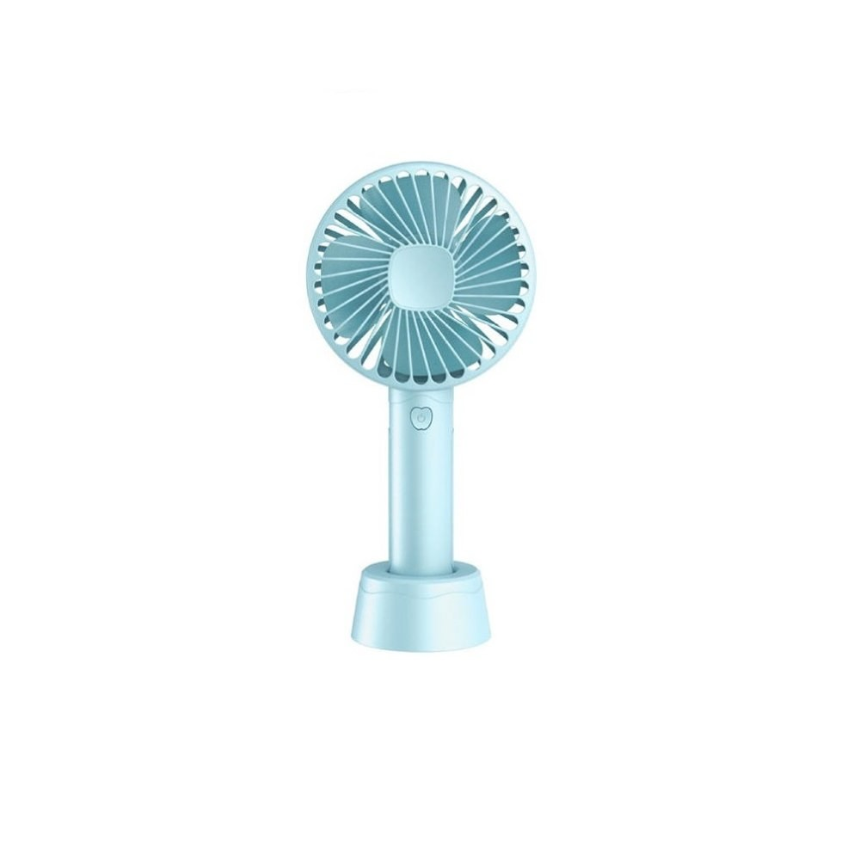

**DESCRIPTION**

Rechargeable Mini Fan, 3 Speeds, Working Time at Highest Speed: 1-2 hrs, Working Time at Lowest Speed: 2-3 hrs, Lithium Battery 1200mAH , With USB Charging Cable, Blue Color

Top of Form

# Transcend, SD 8GB C4

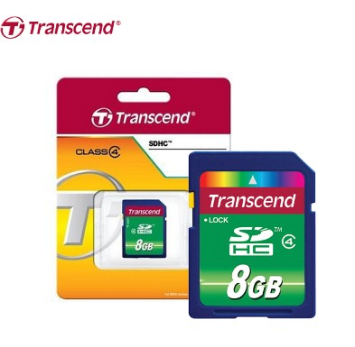

**DESCRIPTION**

SDHC Class 4 and SD 2.0 compliant, a speed of 4MB/s is guaranteed  
Compatible with today's most popular cell phones and portable devices  
Includes a full size SD adapter for multi-use or data transfer  
Exceptional durability of 10,000 insertion and long-life data retention  
Limited lifetime Warranty.

Top of Form

# Westinghouse, A675 Hearing Aid Battery 1.45 Volt Pack of 6

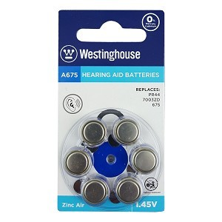

**DESCRIPTION**

Westinghouse A675 Hearing Aid Battery 1.45 Volt Pack of 6

Top of Form

# TNC303 TPU soft cases for use with IQOS 3.0 and DUO

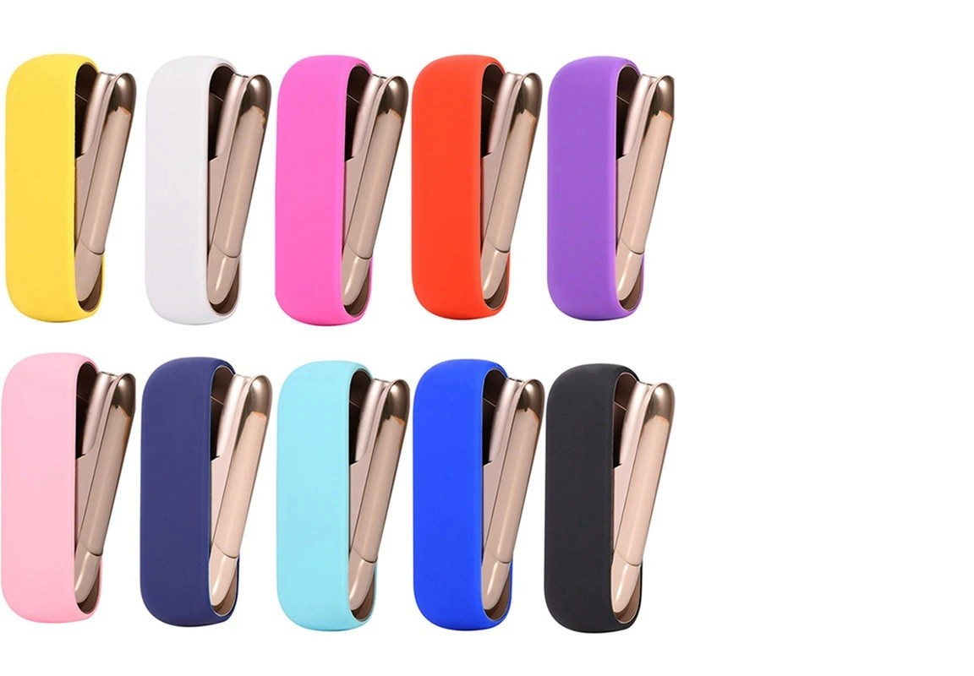

**DESCRIPTION**

TNC303 TPU soft cases for use with IQOS 3.0 and DUO

Top of Form

# Genesis, Gaming Keyboard Nkg-0940 Rhod 220

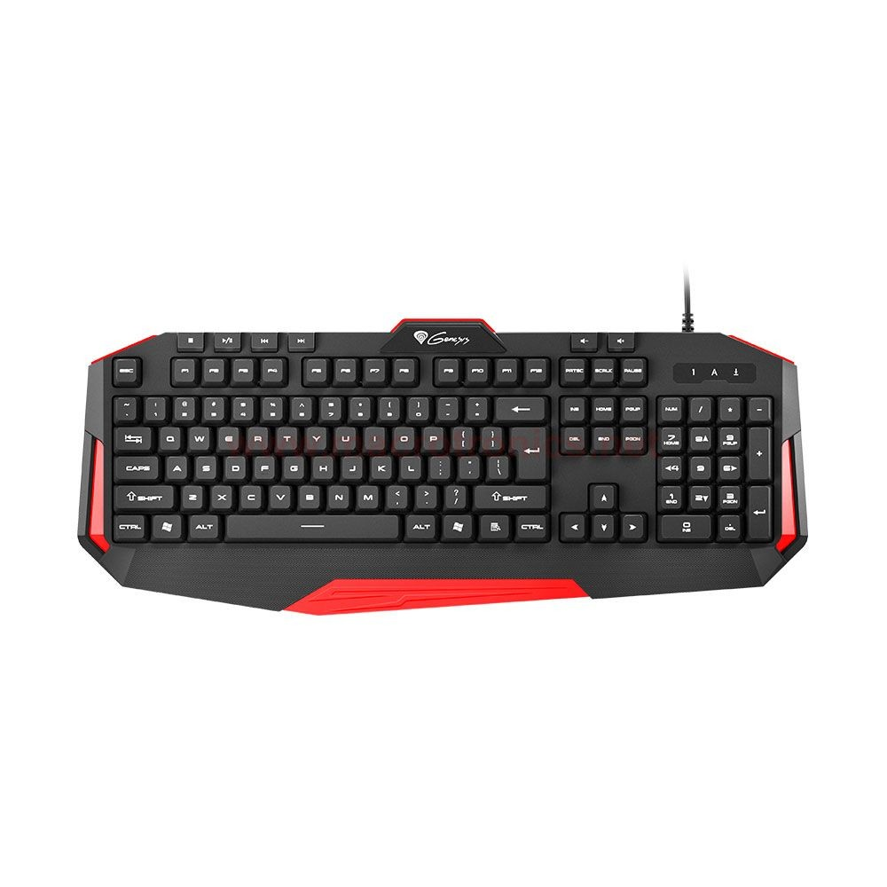

**DESCRIPTION**

Number of keys: 110.Multimedia keys: 6.Key mechanism: Membrane.Profile: High.Connector: USB.Cable length: 165 cm.Backlight: No.Anti-Ghosting: 6-key.Window key lock: Yes.Extra functions: Wrist support.

Top of Form

# Aoas, Gaming Headset For Better Gaming Experience Bass Sound With Microphone

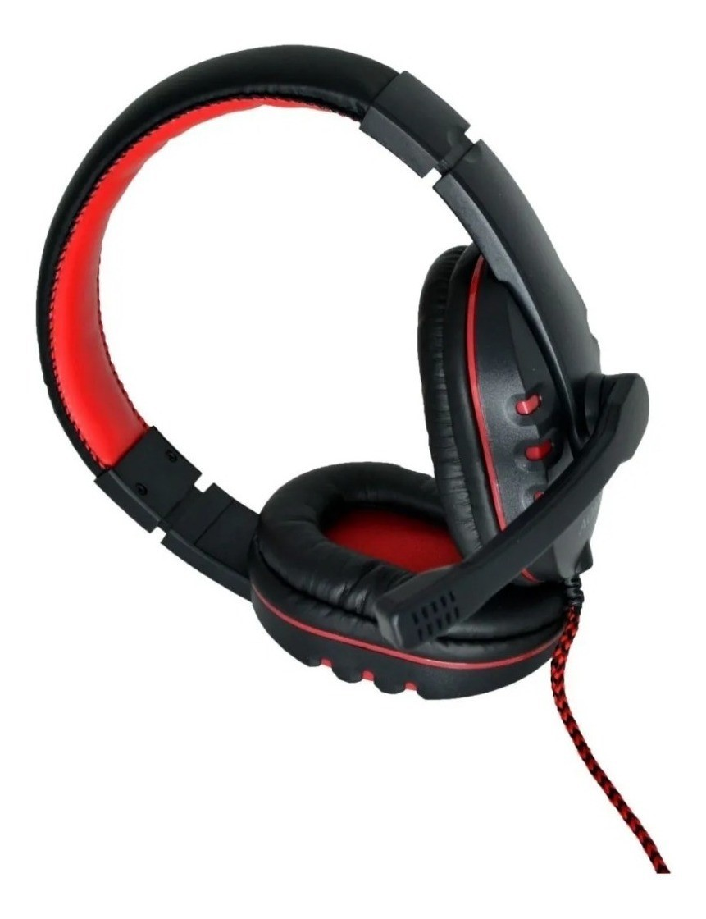

**DESCRIPTION**

Package includes:  
Headset  
Aux cable  
Microphone attachment

Top of Form

# Plug Audio 3.5 mm Male Plug to 2 x RCA Female Adaptor Connector - P203

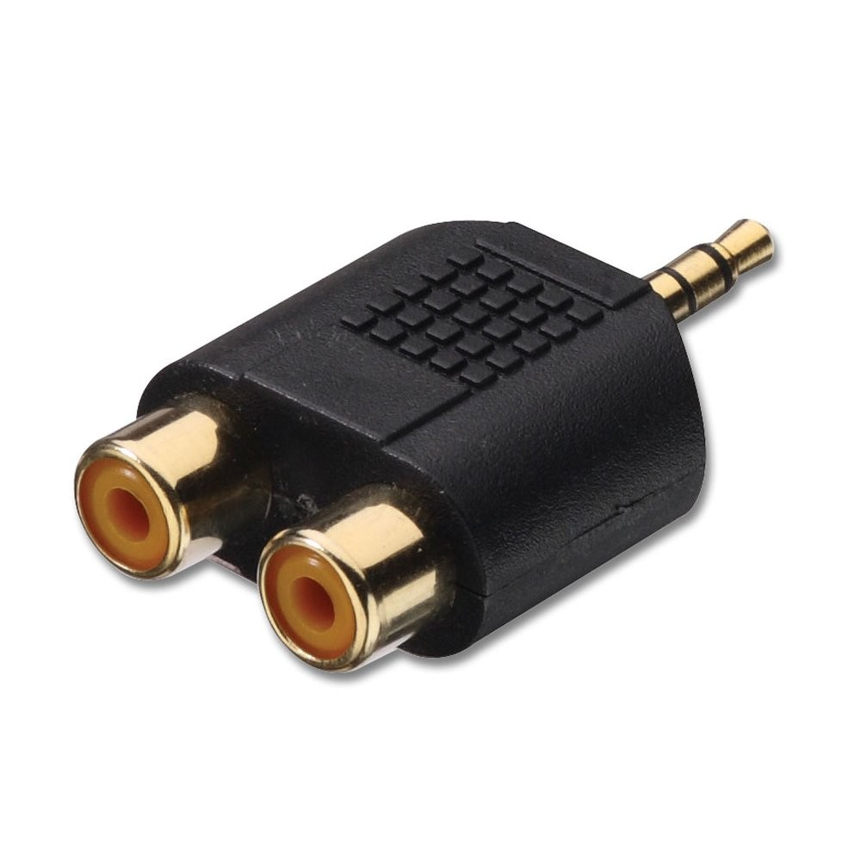

**DESCRIPTION**

Plug Audio 3.5 mm Male Plug to 2 x RCA Female Adaptor Connector - P203

Top of Form

# Conqueror, Fake Security CCTV Surveillance Camera Dummy Indoor / Outdoor with Red LED Light - CA98

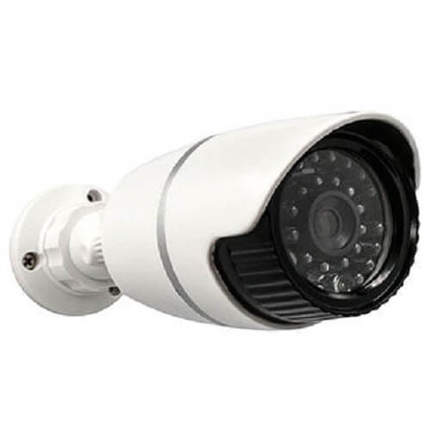

**DESCRIPTION**

- The Dummy camera with Red LED Light has high resemblance to real cameras - Easy to install to the ceiling or wall using the included screws, no wiring is required - Fully adjustable bracket arm movement 0-90 degrees tilting - Operated by 2 x AA batteries • DIMENSIONS 22 x 7 x 7 cm