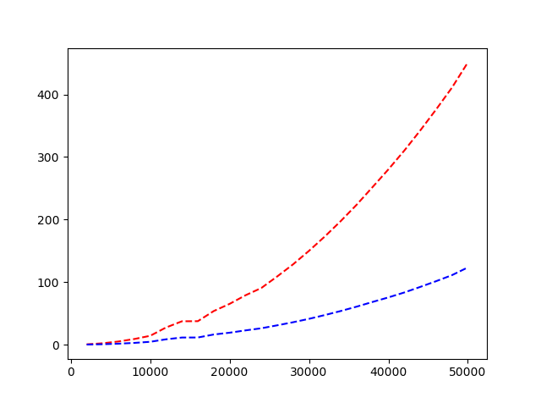

1. **Random inputs**

Bubble sort – Red Insertion sort – Blue X axis – Input size Y axis – Time in seconds

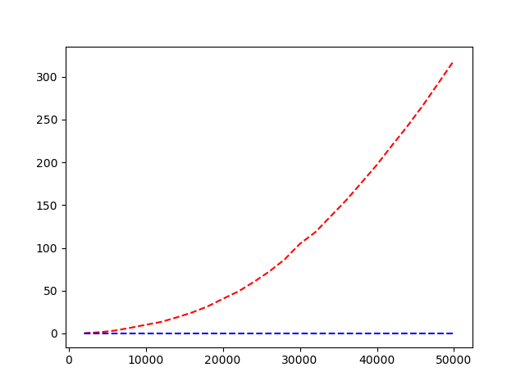

1. **Non-decreasing Inputs**

Bubble sort – Red Insertion sort – Blue X axis – Input size Y axis – Time in seconds

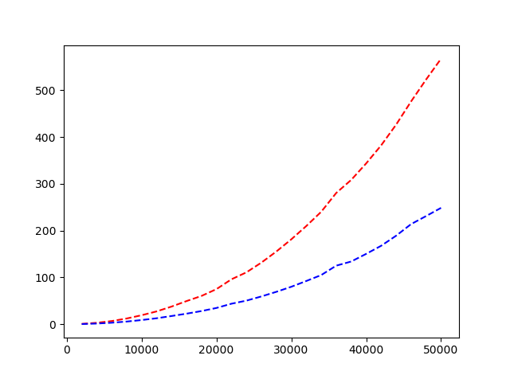

1. **Non-increasing input**

Bubble sort – Red Insertion sort – Blue X axis – Input size Y axis – Time in seconds