Movement Quest Project Proposal
  - Project One | October 18 2026 | Proposed undergraduate scope
Movement Quest is a friendly, quest-themed personal workout companion for planning short routines and recording what the user actually completes. We propose an offline Flutter app with five screen roles, two related SQLite entities, reversible set logging, and an explainable local plan suggestion.

Team and submission details
Course: CSC 4360 Mobile App Development (MAD) Section: Mon-Wed
Team name: CODING MASTER Proposal date: October 18, 2026
GitHub repository: https://github.com/mkhan10004/Movement-Quest-Project-.git
ClickUp board: https://sharing.clickup.com/90141780810/b/h/6-901422403415-2/13f8349006cb5fe
Member and student ID | Pathway | Expected ownership
Mohammed Afeefuddin | 002828362 | Undergraduate | Lead and UI owner: wireframes, navigation, forms, settings and demo coordination. Quality contribution: accessibility and integration review.
Muhammad Samad Khan | 002839953 | Undergraduate | Data owner: SQLite schema, CRUD, activity persistence and integrity. Quality owner: helper evaluation, tests, documentation and release coordination; Afeef reviews the quality gates.
The team has two undergraduate members. Named ownership and responsibilities are listed below; both members will review shared quality gates.

Problem and intended outcome
Students who want to record a short routine can lose track of completed sets or forget to correct a mistaken entry. Our app will keep the planned target and actual repetitions distinct. Users can create a plan, start a session, record sets, correct entries, and review a truthful local history.
The quest theme supplies friendly labels and restrained progress feedback. The app will not rank users, diagnose conditions, prescribe exercise intensity, predict physical ability, or claim health outcomes. One plan contains one exercise and its set target, keeping the build within two entities.
Submission gate: the team roster, course details, repository and ClickUp links are filled in. The actual October 18 board snapshot is embedded on the final page. Instructor access is reported by the team. Attach the completed official signed acknowledgment separately; no approval or completed implementation tests are claimed.

Core scope and implementation plan
Role | Planned behavior and Flutter connection
S1 Workout catalog | ListView with reusable StatelessWidget plan cards, tap gesture and Open button alternative, Add, equipment filter, completed count, suggestion card and empty state.
S2 Workout editor | StatefulWidget Form with labeled fields, exercise dropdown, sets/repetitions numeric inputs, intensity slider, Save and Cancel.
S3 Workout detail | Start, log/edit/undo sets, finish/reset draft, edit/delete plan, history shortcut, confirmation dialogs and save feedback.
S4 Training history | Read/add/edit/delete linked session logs with an editor dialog; recompute count after corrections and deletions.
S5 Settings | Theme, equipment preference and reduced motion using Switch/dropdown controls and SharedPreferences.

Two related entities
WorkoutPlan: id INTEGER PRIMARY KEY; name TEXT; exercise_key TEXT from a small bundled list; equipment TEXT; target_sets INTEGER (1–10); target_reps INTEGER (1–100); intensity INTEGER (1–5, user-selected); created_at INTEGER and updated_at INTEGER in UTC milliseconds. Validate trimmed nonempty names and all numeric bounds before writes; add database CHECK constraints where applicable.
TrainingLog: id INTEGER PRIMARY KEY; plan_id INTEGER NOT NULL REFERENCES WorkoutPlan(id) ON DELETE CASCADE; session_token TEXT UNIQUE NOT NULL; status TEXT (draft or completed); started_at INTEGER; completed_at INTEGER nullable; target_sets_snapshot INTEGER; target_reps_snapshot INTEGER; exercise_name_snapshot TEXT; actual_sets_json TEXT containing ordered integer repetitions. Sets are embedded values, not a third entity. Validate JSON length, integer values and completion rules in Dart.
Enable PRAGMA foreign_keys = ON on each database connection; index TrainingLog(plan_id). Use parameterized reads/writes and transactions for changes that must be atomic. Historical snapshots preserve the targets at session creation when the plan is later edited.

CRUD and integrity policy
Entity | Create and read | Update and delete
WorkoutPlan | S1 Add → S2 Save; S1 list and S3 detail read saved rows. | S2 edits by ID. S3 Delete confirms that this plan and all linked logs will be removed; Cancel changes nothing.
TrainingLog | S3 Start creates one draft; S4 Add log records a completed past session. S3/S4 read linked logs. | S3 corrects draft sets; S4 corrects completed logs and deletes by ID after confirmation. Refresh aggregates after every write.
Session count = COUNT of completed TrainingLog rows for the selected plan/filter. Drafts never count. Finish updates the existing session row instead of inserting another row; a stable token, guarded status transition and disabled pending-write buttons prevent duplicate finishes.

Activity state and required local smart helper
Activity flow: idle → Start creates a persisted draft → Log set updates the same draft → Finish marks that row completed after all planned sets have valid repetitions. Corrections replace or undo a set rather than append duplicates. Reset requires confirmation and deletes only the current draft. Previously completed sessions remain unchanged. Back offers keep draft, discard draft, or stay; a kept draft resumes after restart. Only one active draft per plan is allowed, checked transactionally.
The intensity slider records the user’s chosen label from 1 to 5; it does not recommend exertion. Stateful owners manage drafts and saving/error flags. Reusable cards only render supplied values. No timer is needed; controllers/listeners will be disposed, and asynchronous results will check mounted state before UI updates.

Local recommendation design
Question: can an equipment preference and recent local history help a user choose a plan? The helper will rank stored plans on S1. Owner: Muhammad Samad Khan, with Mohammed Afeefuddin reviewing the rationale and test cases. Inputs are equipment categories, completed-session timestamps in UTC milliseconds, and integer counts per plan over the preceding seven days. No health, biometric or ability inputs are used.
Method: deterministic rule-based ranking, not a trained model. Score = 3 × equipmentMatch − min(recentCompletedCount, 2). equipmentMatch is 1 for an exact selected category match and 0 otherwise; with no preference it is 0 for every plan. Highest score wins; ties use the lowest plan ID. Baseline: lowest plan ID regardless of preference/history. With bodyweight selected, plan 1 dumbbell/0 recent scores 0; plan 2 bodyweight/2 recent scores 1; plan 3 bodyweight/0 recent scores 3, so plan 3 is suggested.
The card states “Suggested, not guaranteed,” shows the equipment and recent-use reason, and offers Apply and Not now. Apply only selects/opens the plan; an explicit Start action creates a session. Users can dismiss it and choose any other plan. Empty catalog produces “Create a plan first.” No history means recent counts are zero and the explanation says so. Invalid inputs suppress a suggestion and show an actionable message.
Alternative: nearest-neighbor matching with fictional labeled examples. We prefer explicit rules for this small dataset because each score is reproducible and easy to explain. Equipment and novelty do not capture exercise preference; therefore this is a convenience ranking with a visible override, not a claim of the best workout.
Planned case | Expected evidence
Normal | Fixture above selects plan 3; baseline selects plan 1. Explain scores.
No data | Empty catalog: no suggestion; plans but empty history: preference-only score and honest explanation.
Invalid input | Unknown equipment value or malformed history: message and no write; preserve the user’s selection.
Boundary and tie | Counts 2 and 3 both incur penalty 2; equal scores choose lowest stable ID; seven-day boundary uses a fixed test clock.
Counterexample | User prefers a recently used plan with the same equipment. Ranking may disagree; show manual override and document this limitation.
Evaluation plan: record expected and actual results for these five case types; compare helper and baseline top-1 choice against explicit synthetic preference labels on valid fixtures, reporting matches/N for both. Report invalid/empty-state checks separately. These are planned cases, not results. Keep pure decision logic separate from widgets and record rationale, baseline, sample size, counterexample and revision in AI_FEATURE.md.

Wireframes for planning a workout
Legend: S1–S5 identify core screen roles; [text] is a control or input; arrows below name navigation actions. Sample numbers are illustrative, not completed testing evidence. Dialogs belong to their parent role.
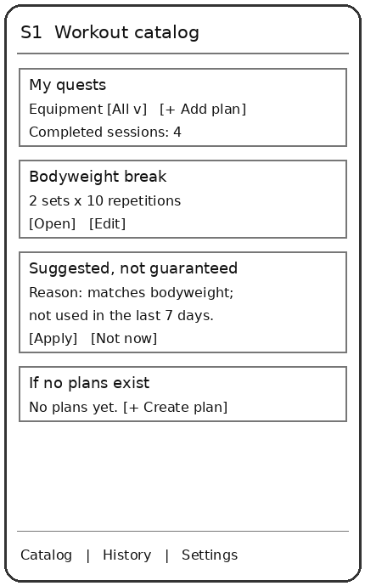 | 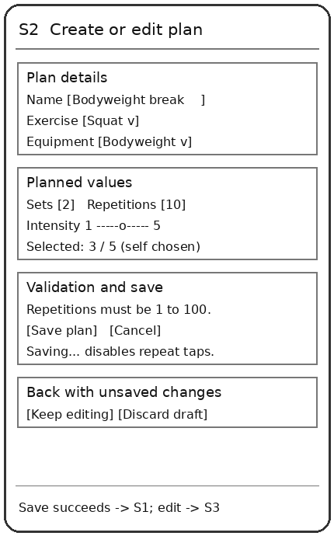
S1 Add → S2 blank editor. S1 Edit → S2 populated editor. S1 Open → S3 detail. S2 Save success → S1 for a new plan or S3 for an edit, with refreshed data and confirmation. Save failure → remain on S2 with values intact and Retry. Cancel/back discards only after an unsaved-change confirmation.
S1 equipment filter changes the list and completed-session count for visible plans. Suggestion Apply opens S3 without starting; Not now dismisses the card. S1 History/Settings tabs → S4/S5. Returning preserves the selected filter.

Wireframes for progress and corrections
Legend: S1–S5 identify core screen roles; [text] is a control or input; arrows below name navigation actions. Sample numbers are illustrative, not completed testing evidence. Dialogs belong to their parent role.
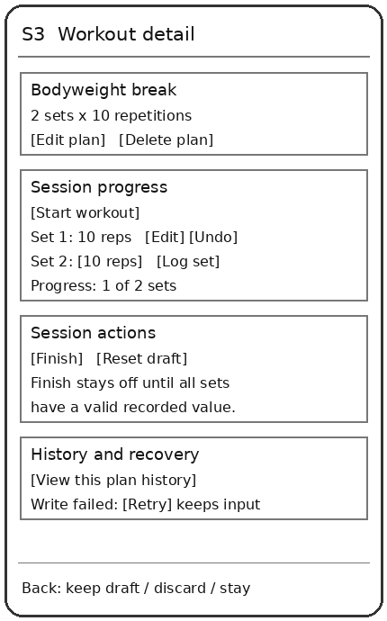 | 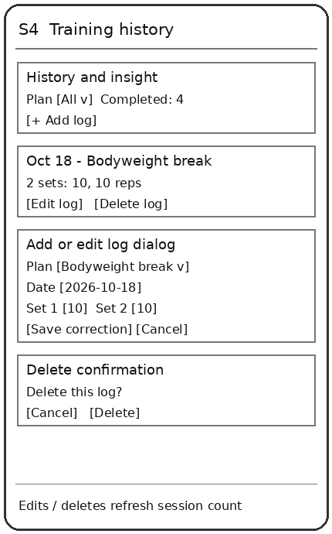
S3 Start/log/correct/finish stays on the same screen; successful Finish refreshes the completed count and offers S4. S3 History → S4 filtered by plan. S4 Add/Edit → log editor dialog; Save returns to refreshed S4. S4 Delete → confirmation → refreshed history. S3 plan deletion → consequence confirmation → S1 on success.
S3 Reset → confirmation → idle for this plan; Cancel keeps the draft. Failed log writes preserve input and do not advance progress. When S3 Back encounters a draft, offer Keep draft and leave, Discard draft and leave, or Stay. Resume reuses the saved row.

Wireframe for persistent settings
Legend: S1–S5 identify core screen roles; [text] is a control or input; arrows below name navigation actions. Sample numbers are illustrative, not completed testing evidence. Dialogs belong to their parent role.
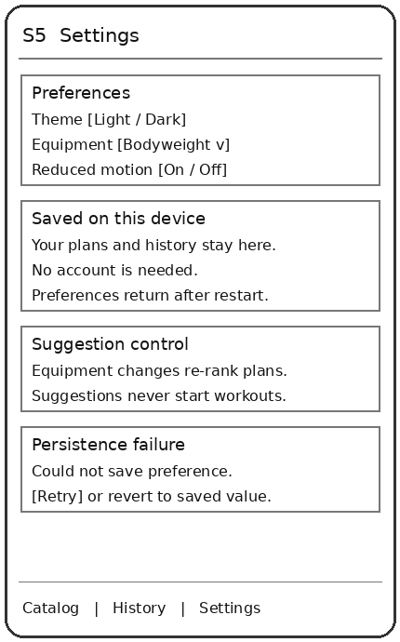 | 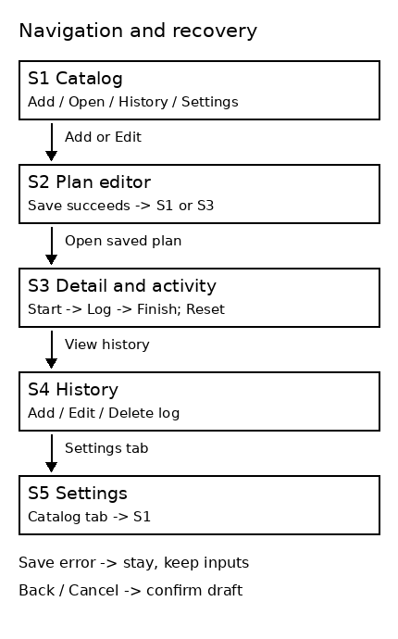
S5 changes display immediately and persists them with SharedPreferences. Returning to S1 re-ranks plans when equipment preference changes. Theme and reduced motion affect the existing five screens; settings never become workout records.
All screens use a scrollable layout, readable contrast, semantic control labels, numeric units and at least 48 logical-pixel tap targets. Large text wraps without clipping; landscape rearranges fields or scrolls. Progress uses text as well as visual fill. Reduced motion disables optional transitions. Keyboard insets keep Save reachable. Validation focuses the first invalid field.
Edge case A: no plans or logs → an informative empty state with Add and no invented aggregate. Edge case B: repetitions blank, nonnumeric, 0 or 101 → inline 1–100 message; no write. Edge case C: database failure → retain draft and offer Retry; never show success before the write completes.

Verification and design iteration
All checks below are proposed acceptance tests. Actual outcomes, device versions and screenshots will be recorded after approval and implementation. We will use two distinct Android devices or emulator configurations and test portrait, landscape and increased text size.
Check | Expected outcome
Both entities CRUD | Create/read/edit/delete one plan and one linked log; results persist after restart.
Validation | Reject invalid bounds and blank names without writes; valid boundary values save once.
Duplicate action | Rapid Start/Log/Finish taps cannot duplicate the current session or set position.
Parent deletion | Cancel preserves all rows; confirm deletes plan and its logs, refreshing all views.
Draft reset and resume | Restart restores a kept draft; confirmed Reset removes that draft only.
History corrections | Edit or delete a completed log; the selected count and helper history immediately reflect the database.
Offline persistence | Disable networking, save plan/log/preferences, close and relaunch; all saved values return.
Failure recovery | Simulate rejected write; editor stays usable, values remain, repeated controls are guarded and Retry is available.
Helper and baseline | Run five case types with fixed clock and record expected/actual outputs, valid-case metric and limitation.
Usability and access | Peer can create a plan, log/correct a set, cancel deletion and find settings without coaching; check text scale and reduced motion.

Peer feedback and revision plan
Before implementation, ask a peer to trace the five wireframes without coaching. Record the date, task, point of hesitation and suggested correction. Preserve an initial and revised drawing, then recheck the same task. Planned improvement example: if a peer cannot find corrections, move Edit/Undo beside the set. This is a proposed response, not a claim that feedback has already occurred.

Architecture and scope control
Proposed folders: models for WorkoutPlan/TrainingLog; data for the SQLite helper and settings adapter; services for the pure ranking function; screens for the five roles; widgets for reusable cards; test for logic/widget checks. The UI will call local data operations and refresh from saved records. ARCHITECTURE.md will explain state ownership and lifecycle cleanup.
Flutter/Dart, sqflite and shared_preferences are planned. Exact compatible package and SDK versions will be documented after approval. No Firebase, remote database, cloud login, online inference, live feed or online multiplayer will be used. GitHub and ClickUp hold project coordination artifacts, not app-user data. No extra leaderboard, chatbot, nutrition tracker or wearable integration is planned.

Kanban workflow and delivery schedule
Board URL: https://sharing.clickup.com/90141780810/b/h/6-901422403415-2/13f8349006cb5fe. Use one shared List with Backlog, Ready, In progress, Review / test and Done. Ready requires a named owner, acceptance criteria, due date and resolved dependencies. In progress has WIP one task per member; Review / test has WIP two tasks across the team. Blocked work stays in its current column and counts toward WIP.
Done requires acceptance criteria met, an actual test/review result, relevant documentation, and an authentic commit/PR link when code is involved. For planning-only work, link the reviewed document or board evidence. Do not mark implementation complete before approval or invent earlier activity. Hold a five-minute working-day check-in and record WIP, completed tasks, age and cycle time as evidence becomes available.
Due date 2026 | Owned work and acceptance gate
Oct 18 | Lead: finalize proposal/roster/wireframes and obtain signatures. Data owner: active repository and instructor/member access. Quality owner: actual ClickUp setup, tasks and dated readable snapshot. Submit before 11:59 PM Eastern.
After approval–Oct 21 | Lead: five-screen navigation and accessible forms. Data owner: schema and initial CRUD slice. Quality owner: peer review/revision. Capture actual Oct 21 UI snapshot.
Oct 22–24 | Data owner: full CRUD, cascade/duplicate/draft integrity. Lead: activity/settings/filter/count. Quality owner: helper, baseline and evaluation. Capture actual Oct 24 functional snapshot.
Oct 25–27 | All owners: two-device/offline/error checks, fix defects, prepare documentation, selected questions and 20–25 minute presentation. Each member explains own code and contribution.
Oct 28 | Quality owner coordinates APK and artifacts; all members verify links and upload individual final packages before 11:59 PM Eastern. Capture actual final snapshot.
The companion task-card file provides proposed card titles, owners, dates, dependencies and acceptance criteria for import/copy into ClickUp. The proposed task cards are assigned to Mohammed Afeefuddin and Muhammad Samad Khan; verify each card has its named owner in ClickUp. Every person will work toward at least 20 meaningful commits over the project using feature branches and pull requests; this is a future plan, not existing history.
Final evidence will include Kanban_Contribution_Evidence.pdf in the repository and every member’s final ZIP, the README board URL/evidence path, four actual dated snapshots, task-to-code/test traces and a flow improvement with its observed result or limitation. The team presentation will show one actual ClickUp task → code → test/review trace.
Approval delays: do not initialize Flutter or implement until instructor-team approval. If approval arrives late, record the delay, keep the required core first and request schedule guidance; never backdate milestones. Graduate participation requires revised ownership and scope for advanced state management, repository/DI architecture, automated tests/coverage, animations, background processing, local notifications, file operations and held-out helper comparison.

October 18 planning evidence
ClickUp board URL: https://sharing.clickup.com/90141780810/b/h/6-901422403415-2/13f8349006cb5fe
Repository URL: https://github.com/mkhan10004/Movement-Quest-Project-.git
Capture date and time: October 18, 2026; 6:10 PM shown on the screenshot taskbar (Eastern time)
Instructor/member access check: Team confirmed that the instructor and both members can access the repository and ClickUp board.
October 18, 2026 ClickUp board snapshot. The screenshot taskbar displays 6:10 PM on October 18, 2026.
The team-provided October 18 ClickUp board snapshot appears on the final page and shows all five status columns.

Approval request
We request approval to build Movement Quest within the scope described above. The expected result is an offline, understandable app that records planned and completed exercise accurately and supports corrections. We will revise the proposal if the instructor requests changes and begin development only after approval.

Required separate acknowledgment
Use the official printable acknowledgment linked from the supplied Proposal page. Complete all names, IDs where requested, signatures and actual signing dates, including continuation pages. Attach the signed PDF or readable PNG/JPG separately with this Word proposal. An unsigned draft is not a completed submission.

Source basis
Prepared from the supplied PROJECT DETAILS.docx proposal requirements, wireframe workshop, required smart-helper lab, ClickUp checklist and project guide, plus Topic Studio _ Project One.html. The supplied wireframe lecture informs structure only; the current project guide controls deadlines and the local-only scope. All drawings are original planning wireframes.

October 18, 2026 ClickUp board snapshot
