To restore Nuget paches , right click on solution and select “Manage Nuget Pacckages” menu item.

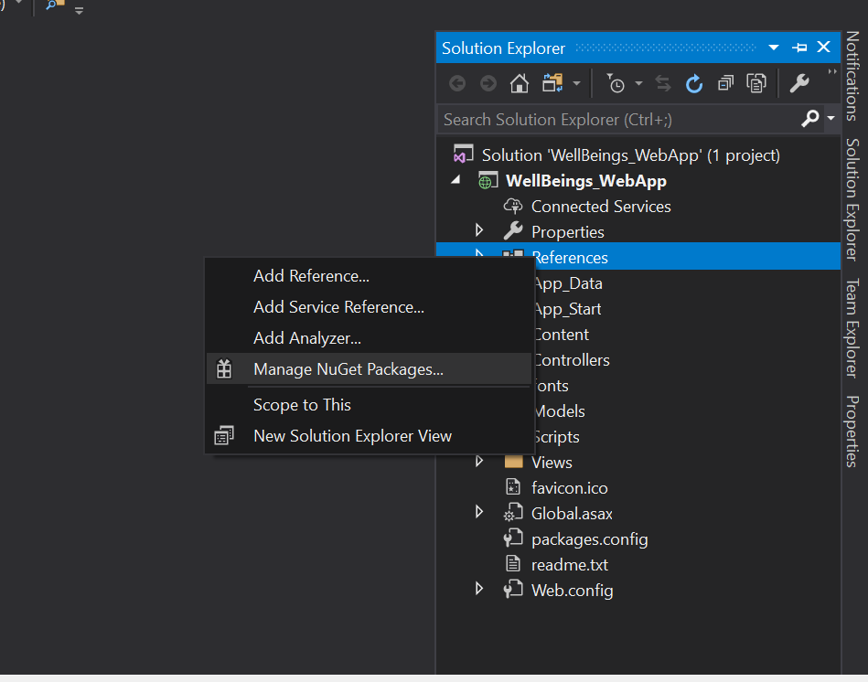

Click on Restore to restore missing packages.

