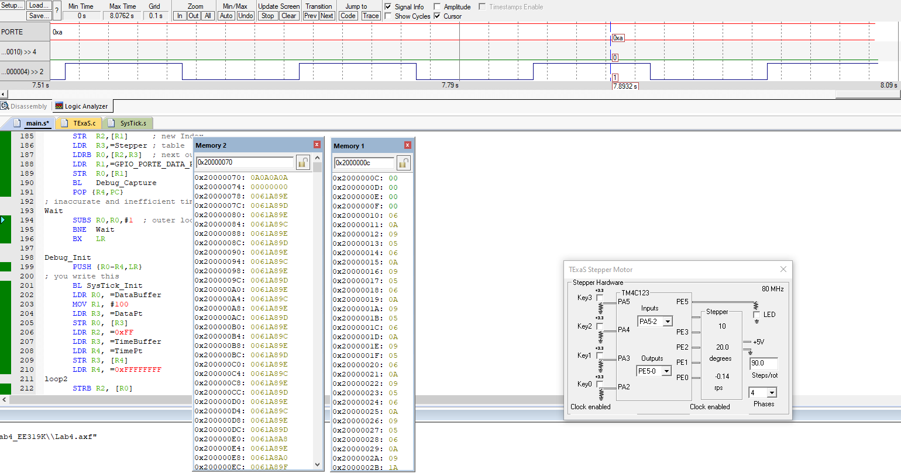

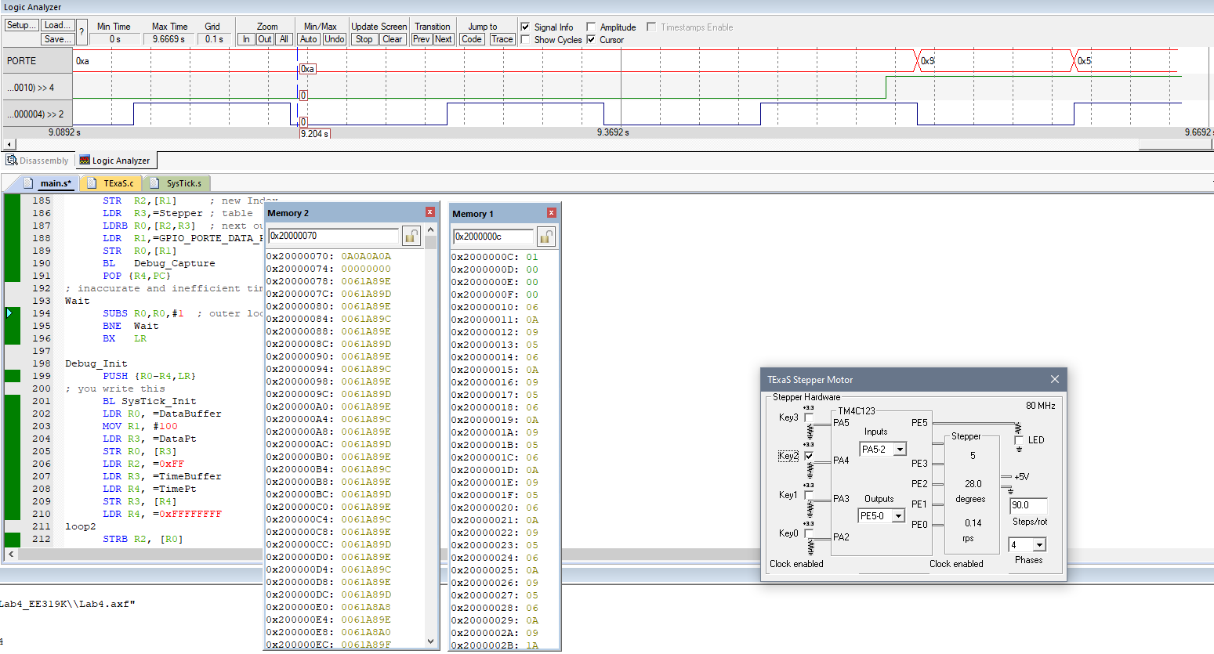

3. Execution time of Debug_Capture:

41 instructions *2 = 82 Duty Cycles in order to run the instructions.

82*12.5ns = 1.025 micro seconds

4. Minimum elapsed time: 0x61A89C

Maximum elapsed time: 0x61A89E