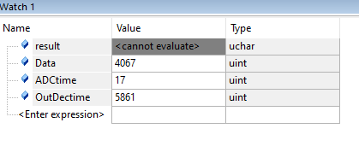

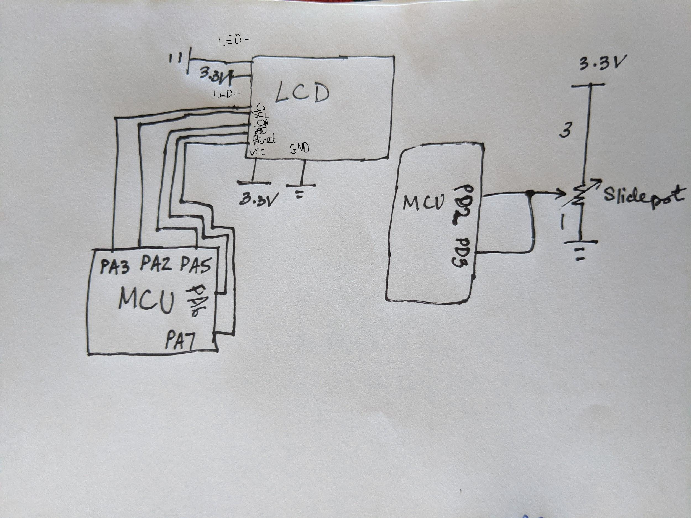

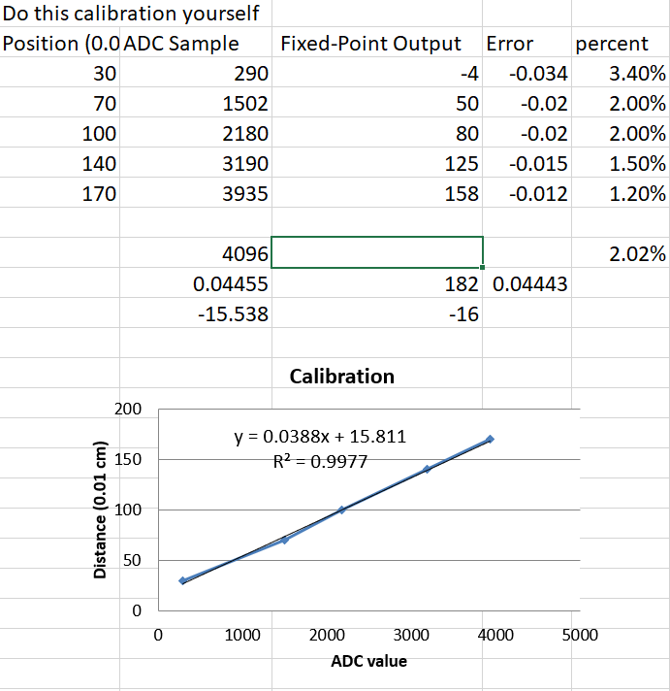

void ADC_Init(void){

//*** students write this ******

SYSCTL_RCGCADC_R |= 1;

SYSCTL_RCGCGPIO_R |= 0x8;

__nop();

__nop();

__nop();

__nop();

GPIO_PORTD_DIR_R &= ~(4);

GPIO_PORTD_DEN_R |= 4;

GPIO_PORTD_AFSEL_R |= 4;

GPIO_PORTD_AMSEL_R |= 4;

ADC0_PC_R |= 1;

ADC0_SSPRI_R = 0x123;

ADC0_ACTSS_R &= ~8;

ADC0_EMUX_R &= ~(0xF000);

ADC0_SSMUX3_R = (ADC0_SSMUX3_R & 0xFFFFFFF0) + 5;

ADC0_SSCTL3_R = 6;

ADC0_IM_R &= ~(8);

ADC0_ACTSS_R |= 8;

ADC0_SAC_R = 6;

}

uint32_t ADC_In(void){

//*** students write this ******

int result;

ADC0_PSSI_R = 0x0008;

while((ADC0_RIS_R&8) == 0) {}

//read data and do what you want with it

result = ADC0_SSFIFO3_R&0xFFF;

ADC0_ISC_R &= 8;

return result; // remove this, replace with real code

}

void SysTick_Init(unsigned long period){

//*** students write this ******

NVIC_ST_CTRL_R = 0;

NVIC_ST_RELOAD_R = period;

NVIC_ST_CURRENT_R = 0;

NVIC_ST_CTRL_R = 7;

}

uint32_t SlidePot::Convert(uint32_t n){

//*** students write this ******

// use calibration data to convert ADC sample to distance

return 159*data/4096+16; // replace this with solution

}

int main(void){

*** students write this ******

DisableInterrupts();

TExaS_Init(); // bus clock at 80 MHz

ST7735_InitR(INITR_REDTAB);

ADC_Init(); // turn on ADC, PD2, set channel to 5

PortF_Init();

EnableInterrupts();

SysTick_Init(8000000);

while(1){

Sensor.Sync(); // wait for semaphore

// can call Sensor.ADCsample, Sensor.Distance, Sensor.Convert as needed

ST7735_SetCursor(0,0);

LCD_OutFix(Sensor.Distance());

ST7735_OutString(" cm");

}

}

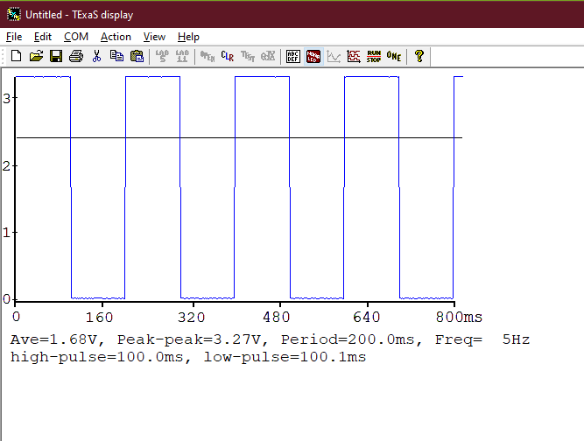

|  |  |  |
| --- | --- | --- |
| True position  xti | Measured Position  xmi | Error  xti - xmi |
| 0.3 | 0.33 | -0.030 |
| 0.6 | 0.6 | 0 |
| 1 | 0.97 | 0.030 |
| 1.4 | 1.4 | 0.000 |
| 1.6 | 1.57 | 0.030 |