
MSc in Data Analytics
MSC_DA_CA1
Predicting Final Destination Waste Treatment Type
from Irish EPA Waste Data, 2021-2024
Detailed report based on the executed Jupyter notebook attached with the submission files.

Author: Abdul Wahab
Email: 2026243@student.cct.ie
Student Id: 2026243

1. Short summary
This report elaborates the assessment that was executed in a Jupyter notebook, which utilised four years of Irish EPA waste data. The work studies one clear question. It asks if the final destination waste treatment type can be predicted from simple operational fields. The chosen target was grouped into five broader classes. These were recycling related recovery, other recovery, thermal treatment, landfill disposal, and other disposal.
The merged raw dataset had 31,028 rows and 15 columns. But the raw file had many empty values. That looked bad at first. After checking the structure, it became clear that many missing fields were expected. A lot of rows were not transfer rows, so final destination fields were empty by design. The notebook solved this by building a cleaner modelling subset. It kept only transferred waste rows with a known final destination. That gave 12,537 rows.
The results were solid. Random Forest performed best. It reached an F1 score of 0.8365 on the test set. Logistic Regression also did well, with an F1 score of 0.7978. The statistical part also worked well. Binomial suited the abroad or not abroad field. Poisson worked as a first count model, but the counts were over-dispersed. Normal distribution became more useful only after log transformation of waste quantity. Overall, the notebook met the brief well, and the final model was useful, but some limits still remain.

2. Introduction and chosen problem
This project is situated within the broader context of waste management in Ireland. Each year, the EPA publishes license waste data. According to the EPA, the extract presents yearly reported tonnages of waste accepted at EPA-licensed facilities, along with information on treatment and transfer (Environmental Protection Agency, 2025). National waste indicators are also published by the CSO (Central Statistics Office, 2024).
The problem selected is basic and realistic. The problem is to forecast the ultimate destination type of waste treatment of transferred waste records. This is more powerful than a general descriptive subject matter. It is more of a real routing or compliance question. A planner, regulator, or facility might be interested in the destination of a transferred waste stream.
The work is guided by three small research questions. To begin with, is it possible to predict the final destination treatment class based on the given fields? Second, what cleaning and preparation should be done prior to modelling? Third, what the Binomial, Poisson and Normal distributions tell us about the data. These are the concise questions.
All the numbers, plots and output in this report are based on the executed notebook. All analysis was done in Python in a Jupyter notebook, as required. The notebook was plain-coded with plain markdown. This was a good decision here.

3. Project framework and machine learning choice
The optimal framework for this project was CRISP-DM. According to IBM, CRISP-DM is a process built on business understanding, data understanding, preparation, modelling, evaluation, and deployment (IBM, n.d.). That is an apt fit for this task. Model choice did not begin the work. It began with an actual question concerning the routing of waste treatment. Then it proceeded through cleaning, checking, modelling and interpretation.
KDD would not have been so helpful in this case. It is more discovery-led. This case would also be weak to SEMMA as it is more model-centred. Early problem framing is important in a real waste project. A local government might be interested in finding out why a stream is terminating in a landfill more frequently than it should. Or an EPA analyst might want to investigate whether transfer patterns change over time. First are CRISP-DM type questions.
The machine learning option was supervised classification. It was the right decision. The dataset included a known label, Final Destination Waste Treatment Type. Once the detailed EPA labels were grouped into five larger classes, the problem became a multiclass classification task. Unsupervised learning was not the most appropriate, since they did not need to discover hidden groups but rather obtain labels. Semi-supervised learning was also unnecessary since the final subset was already known to have labels.

4. Data understanding and data quality
The raw combined data had 31,028 rows and 15 columns. The four annual reports of 2021-2024 were prepared and fitted into a single frame. This was an easy step, yet it was important. A poor merge would render all the subsequent weak. The notebook checked the file's existence before printing the merged shape and a preview sample. A good clean start that was.
A glance at the raw data revealed a mix of field types. It had text fields of licence, waste code and treatment text. There were also numeric fields for accepted quantity and yearly waste tonnage. This appeared to be a normal operation reporting file. The first actual problem, however, was the lack of data. A number of columns were largely vacant. Next Destination Waste Treatment Type had the highest percentage of missing values at 82.32. Final Destination Waste Treatment Type had a 59.59% missing. The accepted quantity fields had a 58.30% missing rate. Final Destination Abroad was 57.25% missing. On-site Waste Treatment Type was missing 55.40% of the time. Waste Quantity Tonnes per Year still had 41.70% missing in the raw file.
This may appear to be a data quality issue. But the notebook did the right thing and did not jump to that conclusion. A lot of missingness was structural. Final destination fields can only be used when there was a transfer of waste. Only on-site treatment fields are reasonable when the waste remains on-site. In itself, one raw missingness plot was insufficient. The situation of each column was to be verified as well. This was among the best aspects of the notebook.
The modelling subset addressed this issue in a reasonable manner. It retained only those rows in which Waste Action was Transferred, and Final Destination Waste Treatment Type was known. This gave 12,537 rows. That is about 40.4% of the raw data. In this subgroup, a few fields were intentionally left empty. Accepted Waste Quantity, Accepted Waste Quantity foreign, Accepted Waste Quantity Ireland, and Type of On-Site Waste Treatment were all 100% missing. Thus, they were excluded from modelling. Next Destination Waste Treatment Type was missing 93.34% of the time, which is high, but it still had some useful signal. The subset had only 0.92% missing in the Respondent Waste Description, which was later omitted as it was extremely noisy free text.
This part of the work was important. It showed that not all missing data are the same. Some missing values show poor quality. Some show process logic. That difference shaped the whole project.
Key raw column | Missing %
Next Destination Waste Treatment Type | 82.32%
Final Destination Waste Treatment Type | 59.59%
Accepted Waste Quantity | 58.30%
Accepted waste quantity from abroad | 58.30%
Accepted Waste Quantity from Ireland | 58.30%
Final Destination Abroad | 57.25%
On Site Waste Treatment Type | 55.40%
Waste Quantity Tonnes per Year | 41.70%

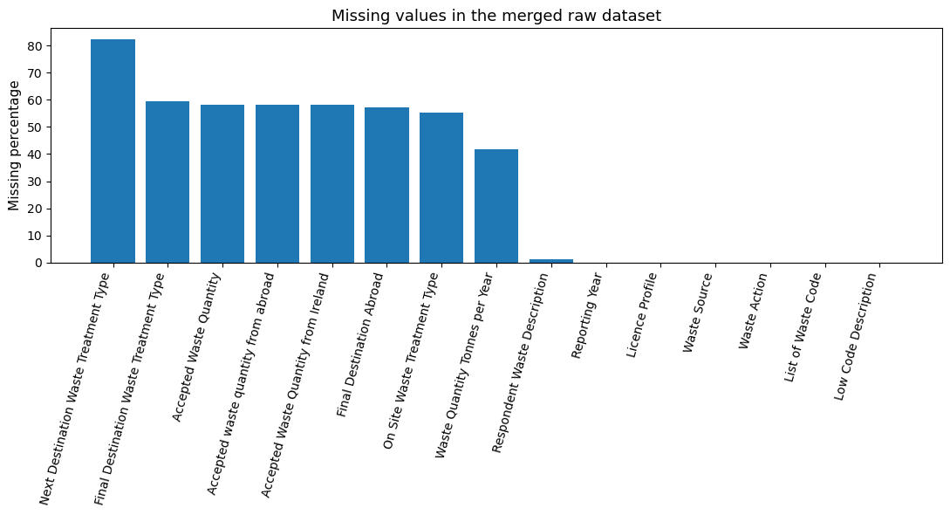
Figure 1. Screenshot from notebook: missing values in the merged raw dataset.

5. Exploratory data analysis and visual design
The target was constructed by clustering detailed EPA treatment codes into five larger categories. This was a strong choice. The uncoded labels were too elaborate and disjointed to be a neat student model. The targeted grouping stabilised the problem and made it easier to explain. There were 5,096 records, or 40.6%, in the recycling-related recovery category. Other recovery had 3,878 records, or 30.9%. Thermal treatment records were 2, 274 or 18.1. Landfill disposal records were 771 or 6.1. Other disposal had 518 records, or 4.1%.
This was not an extreme balance of classes, but it was not equal. The smaller disposal classes were much less common. That matters later. A model can learn larger recovery classes better than smaller disposal classes. The plot of the class distribution was handy at the beginning, therefore.
Waste Quantity Tonnes per Year was the main continuous variable in the modelling subset. This variable was very skewed. It was 1,121.10 tonnes (mean) and 46.90 tonnes (median). It was a maximum of 402,520 tonnes. This was easy to see on the box plot by target class. The mean of landfill disposal was 2,947.87 tonnes, although even there the median was significantly less at 508.28 tonnes. The mean of the thermal treatment was also very high at 1,954.75 tonnes, with a median of just 17.34 tonnes. A few huge cases were, so, drawing averages upwards.
The year pattern chart also provided a valuable anecdote. It did not use raw counts but proportional stacked bars. The decision was a good one, since the annual counts of rows were similar but not identical. The graph indicated a definite increase in recycling-associated recovery. It moved from 34.2% in 2021 to 50.2% in 2024. Other recovery moved in the opposite direction, from 37.4% in 2021 to 20.2% in 2024. The percentage of thermal treatment increased slightly, to 19.2. The disposal in landfills decreased to 5.8%.
The graphic layout was basic, which helped. The plots were plain coloured with direct titles and axis labels. No 3D effects and excessive ornamentation. That is in the spirit of Tufte's concepts of clear data graphics (Tufte, n.d.).
Target class | Count | Share
recycling_related_recovery | 5096 | 40.6%
other_recovery | 3878 | 30.9%
thermal_treatment | 2274 | 18.1%
landfill_disposal | 771 | 6.1%
other_disposal | 518 | 4.1%

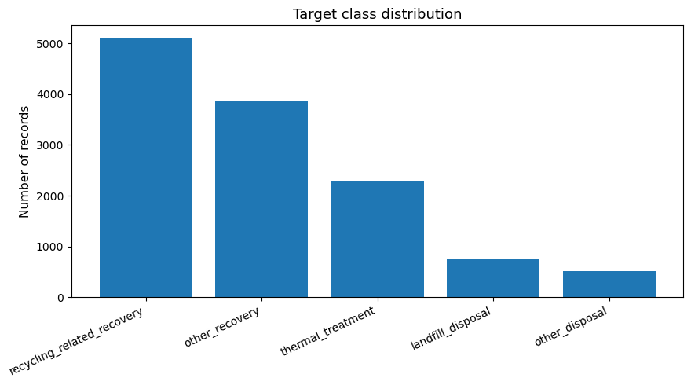
Figure 2. Screenshot from notebook: grouped target class distribution.
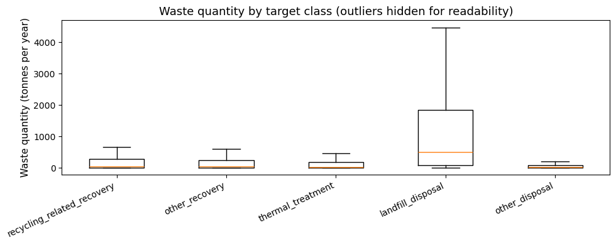
Figure 3. Screenshot from notebook: waste quantity by target class, with outliers hidden for readability.
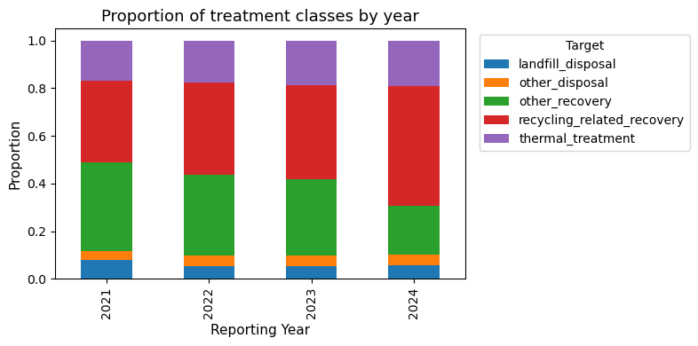
Figure 4. Screenshot from notebook: proportional treatment class pattern by year.

6. Statistical analysis
Binomial, Poisson and Normal distributions were required in the brief. The notebook applied all three in a reasonable manner. It did not subject them to random variables. They corresponded to the type of feature.
‘Final Destination Abroad’ was used in the Binomial part. There are two possible outcomes of this field: Yes or No. That renders it a natural Binomial variable. Within the modelling subdivision 6,775 out of 12,537 records were indicated Yes. Thus, the probability of sending abroad was estimated to be 0.5404. The fitted Binomial mean of a sample of 100 records would be approximately 54.0, and the standard deviation would be approximately 4.98. The centred Binomial distribution was plotted, and this was intuitive. The Binomial plot number 2 exhibited big sample behaviour. The shape was more bell-like as n increased. This is what theory dictates. In large n, a Binomial distribution tends to resemble a Normal distribution. That is handy because it helps relate discrete and continuous arguments.
This Binomial finding has a practical meaning, too. Of this sub-group, slightly more than half of the transferred records were sent to foreign countries. That is a mere fact of operation in the selected rows. It can be important for policy or for route planning. Yet the report must be prudent. This likelihood is based on the filtered modelling subset, rather than on all waste records. It should therefore not be considered a national export rate.
The Poisson component employed the number of transferred records per licence-year. It is a fixed-time-interval count data set, which is why the Poisson was a reasonable initial model. The estimated lambda was 25.327. But the variance was 1,735.646. That is much larger than the average. A Poisson process is a true process in which the mean and the variance are expected to be close. The plot was therefore useful in the sense that it was not a perfect fit but rather a baseline. The bars were more spread out and showed more long-tail behaviour than the Poisson fit. That suggests over-dispersion. Simply put, there were a few license-years in which records were transferred much more than a simple Poisson process would predict. This does not come as a surprise. Waste operations vary widely depending on the type of licence, scale, and waste stream. It is too simple to have a single rate for all licence years.
The second Poisson plot was not in vain. It demonstrated that the Poisson distribution is more symmetric and bell-shaped as lambda increases. That again correlates discrete counts with the normal way of thinking about large samples. The report must not overclaim. The big lambda is a theory plot. The observed counts still showed clear dispersion problems.
The Normal part used Waste Quantity Tonnes per Year. A normal model could not be used on the raw variable. The average was 1,121.1, and the median was 46.9, indicating heavy skew. So the notebook used log1p as a transformation. It is a logical and typical remedy for positive-skewed data. The average of the log quantity after transformation was 3.965, and the standard deviation was 2.527. The raw variable was a lot less reasonable in shape than the histogram with a fitted Normal curve. The Q-Q plot was also not very far apart from the middle line, but the tails still deviated.
This was supported by the standard deviation check. Approximately 63 percent of the cases fell within a one standard deviation of the mean, and 96.6 percent fell within two standard deviations. The values are not exactly equal to the ideal 68% and 95% rule, but are close, indicating that the transformed variable has much more of a behaviour of a Normal variable than the raw one. This simplifies subsequent modelling and interpretation.
The importance of these distributions was not just box ticking. Binomial provided a clear manner of thinking of the abroad flag. Poisson provided a baseline model for the number of records, revealing over-dispersion. Normal reasoning was not useful, until it was transformed, and this demonstrated why distribution checking is important. The discrete variables Binomial and Poisson could not be replaced by the Normal distribution initially. Only large samples can resemble Binomial counts as more Normal. When the lambda is large, Poisson counts may also appear more bell-shaped. But that is only an approximation, not a permission to disregard the actual data shape. So the notebook was right to use each of these distributions for a definite reason, and also to criticise the fit.
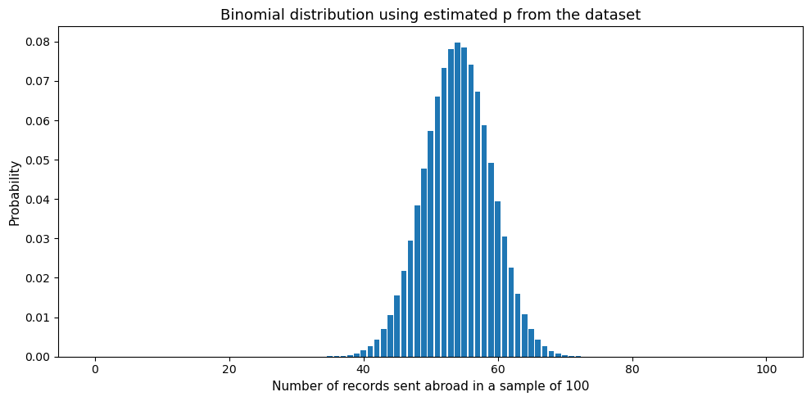
Figure 5. Screenshot from notebook: fitted Binomial distribution using the estimated abroad probability.
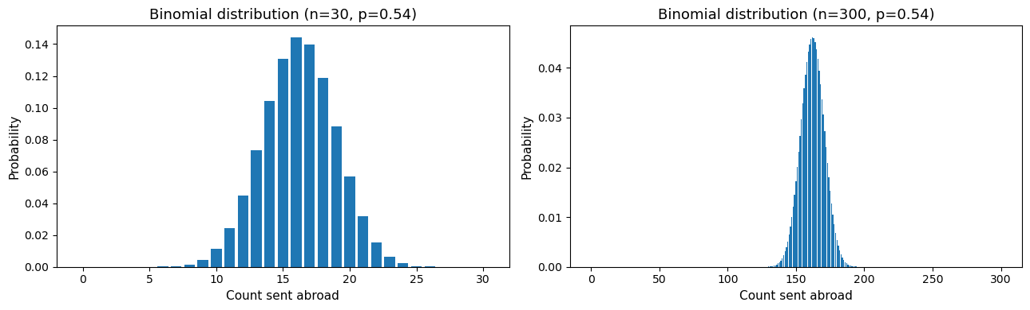
Figure 6. Screenshot from notebook: Binomial large sample behaviour.
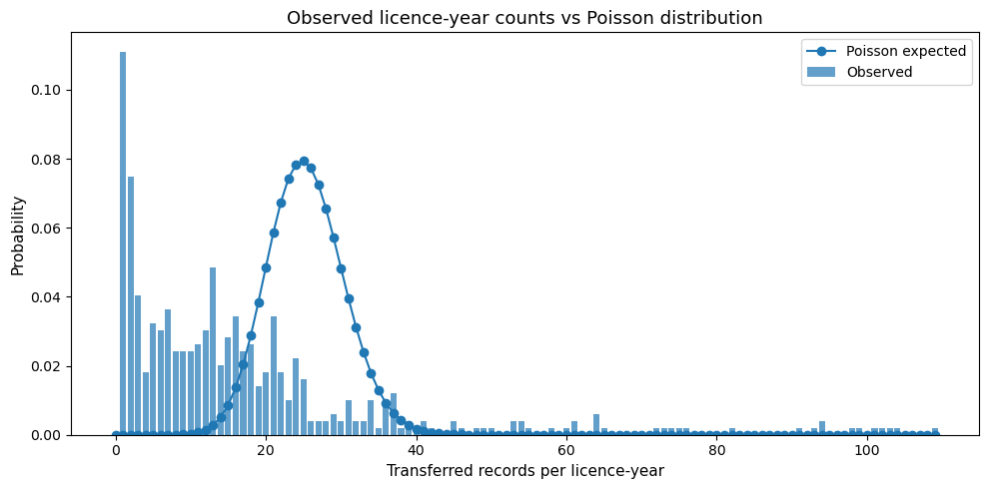
Figure 7. Screenshot from notebook: observed licence-year counts compared with a fitted Poisson distribution.
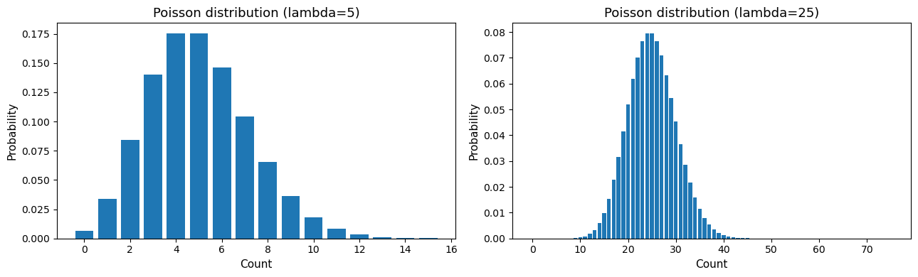
Figure 8. Screenshot from notebook: Poisson large lambda behaviour.
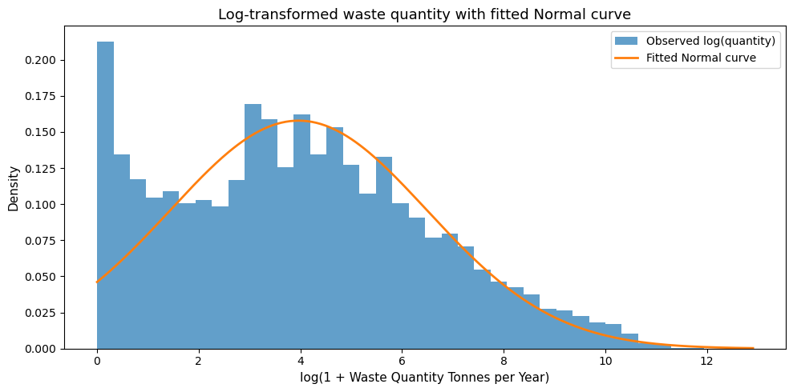
Figure 9. Screenshot from notebook: log-transformed quantity with fitted Normal curve.
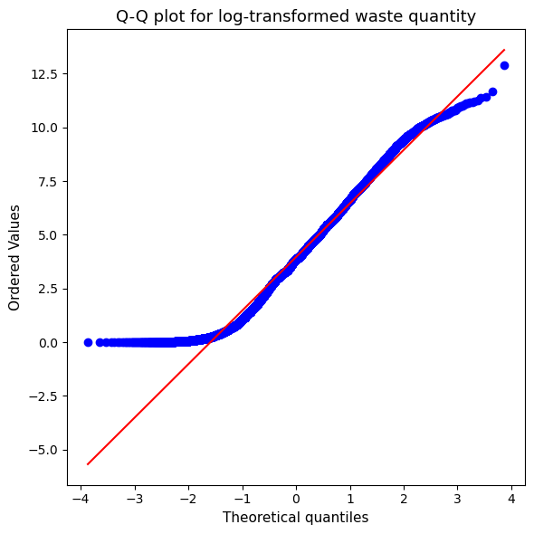
Figure 10. Screenshot from notebook: Q-Q plot for log-transformed waste quantity.

7. Data preparation for machine learning
The machine learning data preparation was also straightforward and understandable. It was one of the notebook's strengths. The feature set had 9 columns, namely Reporting Year, Licence Profile, List of Waste Code, Low Code Description, Final Destination Abroad, Waste Quantity Tonnes per Year, Next Destination Waste Treatment Type, waste_code_chapter and next_dest_code.
Two simple engineered features were included. waste_code_chapter was the first part of the waste code. next_dest_code was the first code in the next destination text. These were nice additions. They kept the code minimal and used messy strings to add structure. Good feature engineering, that. It is tiny, yet handy.
The data types were aligned with the preparation pipeline. Median imputation and StandardScaler were applied to numeric fields. Most frequently, imputation and OneHotEncoder were used to handle missing values in categorical fields. These are typical and reasonable options for handling mixed tabular data. The mean is less safe than median imputation in the presence of a skewed variable. That obviously counted on the amount of waste. Most frequent imputation is fine for sparse categorical fields. One-hot encoding was required because most of the predictive fields were text categories. Scaling was also reasonable for Logistic Regression, which is more sensitive to feature scaling.
The test and train split was stratified. Training was done on 10,029 rows and testing on 2,508 rows. Stratification was important because the target classes were unevenly distributed. It helped maintain the similarity of the class distribution between the training and test sets. That was fairer in the evaluation.
Dataset split | Rows
Training set | 10029
Test set | 2508

8. Models, tuning and evaluation
Two supervised models were experimented with. The initial one was the Logistic Regression. This was a good baseline option. It is easy to follow, quick and relatively simple to describe. Second was Random Forest. This was a nice contrasting model. It can learn non-linear trends and intricate relationships among one-hot-encoded categories and numeric values. The two were team players. One of them was plain and simple. One of them was more flexible.
GridSearchCV was used to do hyperparameter tuning. It is a well-known and obvious approach to small search spaces. According to the scikit-learn documentation, gridsearchCV is an exhaustive search through the values of a set of parameters (scikit-learn developers, 2025). This was appropriate for this notebook since the code remained small and legible. Two C values (0.1 and 1) were tested using Logistic Regression. Random Forest was tested on 120 trees, two max depths, and two min samples split. The grid was not enormous, but that was okay. A notebook should be able to restart and finish without causing any pain to a student.
Only a single F1 score was used as the evaluation metric for tuning and comparison. The micro-averaged F1 was used in the notebook. Micro F1 in this form of single-label multiclass task will be equal to the overall accuracy. That is why both reported values were the same for each model. This is no mistake. It is a property of the metric setup. Even the F1 score is an effective option, as it maintains focus on classification accuracy rather than just the raw percentage correct (scikit-learn developers, 2025).
This area of the notebook was clean. The pipelines continued to preprocess in the model workflow. That avoided data leakage. It also allowed for a fair comparison, as both models were split using the same split and prepared using the same features.
Model | Best parameters | Accuracy | F1 score
Random Forest | max_depth=None, min_samples_split=5, n_estimators=120 | 0.8365 | 0.8365
Logistic Regression | C=1 | 0.7978 | 0.7978

9. Model results and interpretation
The last comparison was evident. Random Forest was the best. It reached an F1 score of 0.8365. Logistic Regression reached 0.7978. The difference was approximately four percentage points or 0.039. It is a true improvement. It implies that the target relies not only on linear boundaries.
The optimal settings of the Random Forest were 120 trees, no maximum depth, and a minimum split size of 5. The best value of C to use was 1. These are not surprising results. The data consists of numerous one-hot categories, sparse fields, and probably waste code and destination hints, as well as quantity and licence profile interactions. Random Forest can capture such a structure with less difficulty.
The results of the level in the class corroborate this. In the case of Random Forest, the best recall was for recycling-related recovery, with 0.91 and 0.88 for recall and F1, respectively. Other recovery was also good with an F1 score of 0.87. Thermal treatment reached 0.78. The other disposal and landfill disposal were the weaker classes, with F1 scores of 0.63 each. Even these smaller classes proved to be more difficult to predict. Random Forest, however, performed significantly better on them than Logistic Regression. Logistic Regression only reached 0.50 F1 on other disposal, and 0.61 on landfill disposal.
The confusion matrices indicated the error points. The greatest confusion was with other recovery and recycling-related recovery. That makes sense. The conceptual distance between the two classes is small, and certain waste streams can have common route signals. These two classes were mixed more frequently by Logistic Regression than by Random Forest. It predicted 105 recycling-related recovery cases as other recovery, and 83 other recovery cases as recycling-related recovery. Random Forest minimised these errors to 49 and 69. A handy acquisition.
Disposal through landfills was also a challenge. In the Random Forest matrix, 89 of 154 landfill cases were correctly forecast. A large number of them were forced to undergo recycling-associated recovery or thermal treatment. Other disposal had the same issues. This indicates that the smaller disposal routes are not very clean among the available features. It might require more detailed process variables to distinguish them.
Nonetheless, the findings are satisfactory for utilisation. A F1 score of 0.8365 on the five-class messy operational data problem is a good result. This does not imply that the model is flawless. But it does imply that the ultimate destination type can be estimated to a practical extent using only the structured fields.
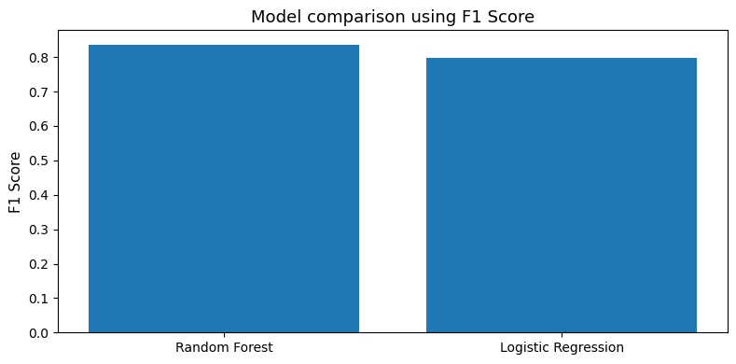
Figure 11. Screenshot from notebook: model comparison using one F1 score.
Random Forest class | Precision | Recall | F1
landfill_disposal | 0.70 | 0.58 | 0.63
other_disposal | 0.72 | 0.56 | 0.63
other_recovery | 0.89 | 0.84 | 0.87
recycling_related_recovery | 0.86 | 0.91 | 0.88
thermal_treatment | 0.75 | 0.82 | 0.78

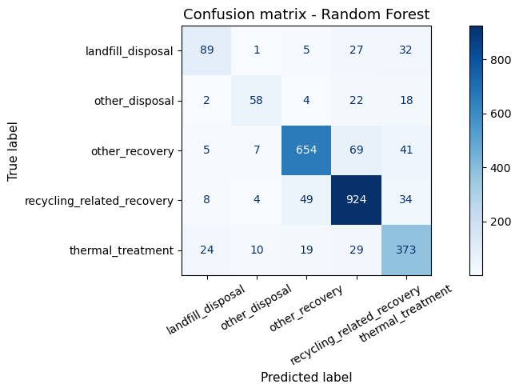
Figure 12. Screenshot from notebook: Random Forest confusion matrix.
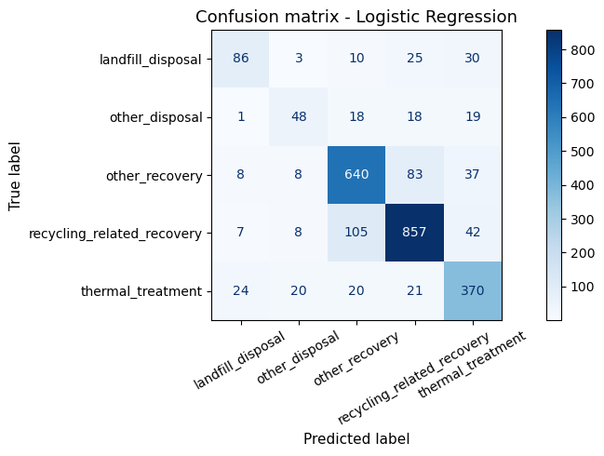
Figure 13. Screenshot from notebook: Logistic Regression confusion matrix.

10. Discussion of the full workflow
There are several findings of interest. To begin with, the raw data were not clean. Much of the missingness was due to the nature of the reporting process. After selecting the appropriate subset, the issue became a lot clearer. The correct subset is often the first step to good analytics, not the model of the moment.
Second, a very crucial design option was treatment grouping. In the absence of grouping, the target would be overly fragmented. Using grouping, the model might acquire helpful patterns. This simplified the final report as well.
Third, the more adaptable model was the best. That tells us something of the problem. Combined signals, rather than a single rule, probably determine the final treatment type. The waste code chapter, destination hints, abroad flag, quantity and licence profile are likely to be collaborative.
The machine learning part was also assisted by the statistical section. The biased quantity variable was the reason why median imputation was reasonable. The imbalance plot of the classes explained the importance of the F1 score. Therefore, the statistics and ML components complemented each other.
The notebook format was also desirable. The code was simple. The variable names were easy to understand. There were key blocks followed by markdown in the notebook. And the code may run to the end. That addresses the programming and documentation aspects of the brief satisfactorily.

11. Limits and future work
There are limits to this project. The former constraint is target grouping. The five general classes prove helpful, but they are simplistic in the detail of actual treatment. A little bit of subtlety is lost. The second limit is field coverage. The model utilised only the available ones in the structured columns. It did not use more elaborate text cleaning, site metadata, or route network data. The third limit is that the data are row based licence records. They do not constitute the entire Irish waste system.
The other constraint is in the statistical assumptions. The Poisson fit was poor since the counts were over-dispersed. Only the log transformation made the Normal distribution fit reasonably well. That, in itself, is not an issue, but it suggests the raw variables are not well-behaved. The report ought to acknowledge that.
The disposal classes were still difficult. Additional work would be beneficial. A subsequent iteration might standardise the Respondent Waste Description, attempt gradient boosting, weight by class, or even fit individual models to disposal and recovery, respectively. That can enhance the small classes. It can also help add more contextual EPA or facility data where available.
Nevertheless, these constraints do not undermine the project to any great extent. To a large extent, they indicate the direction the next step would take.

12. Conclusion
In this report, a complete Python notebook covering Irish EPA waste data from 2021 to 2024 was reviewed. The problem selected was good. The waste treatment type at the final destination was predicted, providing an easy and realistic classification task. There were many blank fields in the raw data, though most of it was structural. Once the transferred rows were filtered to exclude those with a known final destination, the issue was far cleaner.
The notebook met the brief well. It employed descriptive statistics, at least three plots, Binomial, Poisson and Normal distributions, explicit EDA, justifiable preprocessing, two tuned machine learning models, and a direct comparison of results. It also employed plain, readable code and markdown everywhere.
The optimal was the Random Forest, which had an F1 score of 0.8365. The useful baseline at 0.7978 was also provided by the Logistic Regression. Recycling was the strongest predictor of recycling-related recovery and other recovery. The less powerful were the smaller disposal classes. It is there that improvement is needed.
In general, the project was effective. It was easy, and yet not over-easy. The analysis was realistic, the reasoning was generally clear, and the outputs were useful. It is a good fit for the module brief because of that.

References
Central Statistics Office (2024) Waste Environmental Indicators Ireland 2024. Available at: https://www.cso.ie/en/releasesandpublications/ep/p-eii/environmentalindicatorsireland2024/waste/ (Accessed: 20 April 2026).
Environmental Protection Agency (2025) EPA Licensee Waste Data. Available at: https://www.epa.ie/our-services/monitoring--assessment/waste/national-waste-statistics/waste-statistics-data-archive/epa-licensee-waste-data/ (Accessed: 20 April 2026).
IBM (n.d.) Introduction to CRISP-DM. Available at: https://www.ibm.com/docs/en/spss-modeler/18.1.1?topic=guide-introduction-crisp-dm (Accessed: 20 April 2026).
scikit-learn developers (2025) f1_score. Available at: https://scikit-learn.org/stable/modules/generated/sklearn.metrics.f1_score.html (Accessed: 20 April 2026).
scikit-learn developers (2025) GridSearchCV. Available at: https://scikit-learn.org/stable/modules/generated/sklearn.model_selection.GridSearchCV.html (Accessed: 20 April 2026).
Tufte, E. (n.d.) The Visual Display of Quantitative Information. Available at: https://www.edwardtufte.com/book/the-visual-display-of-quantitative-information/ (Accessed: 20 April 2026).

Appendix A. Notebook output screenshots
The items below are screenshots taken from the executed notebook outputs. They are included as evidence for the tables, summaries and model outputs used in the report.
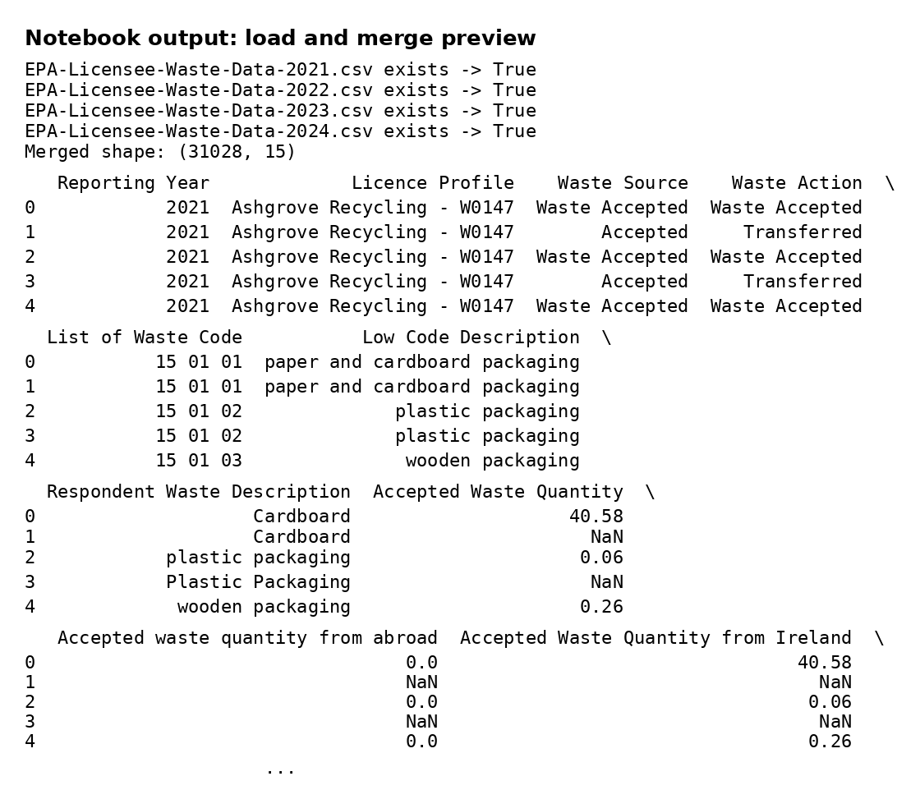
Appendix A1. Notebook output screenshot: load and merge preview
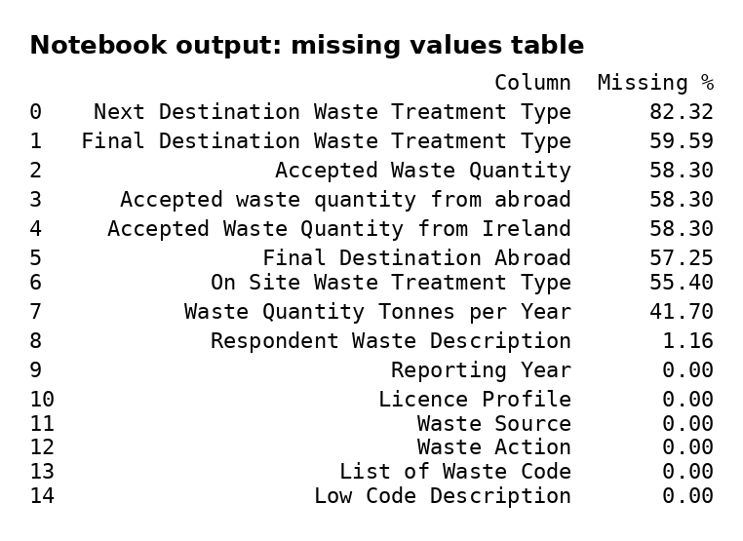
Appendix A2. Notebook output screenshot: missing values table
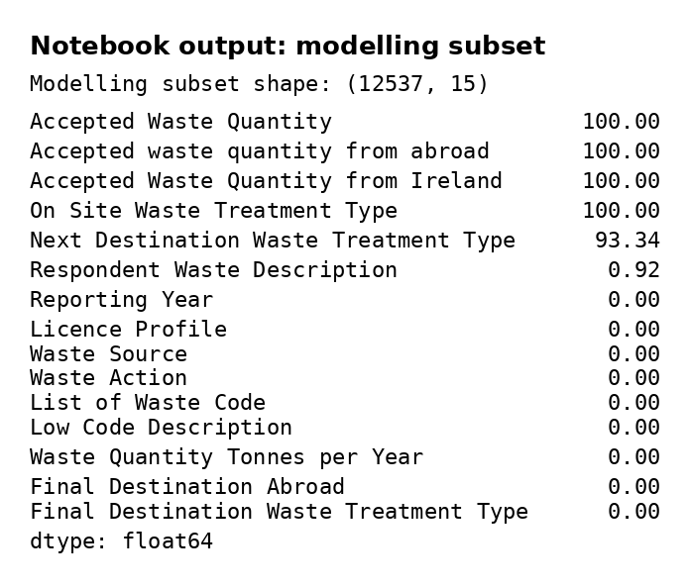
Appendix A3. Notebook output screenshot: modelling subset and subset missingness
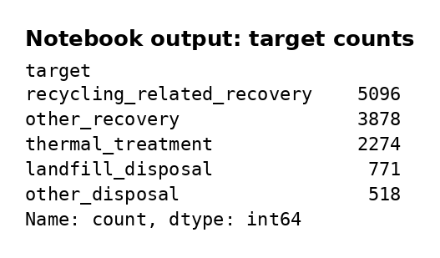
Appendix A4. Notebook output screenshot: target counts
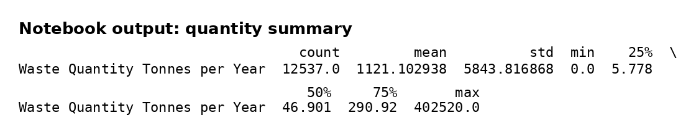
Appendix A5. Notebook output screenshot: quantity summary
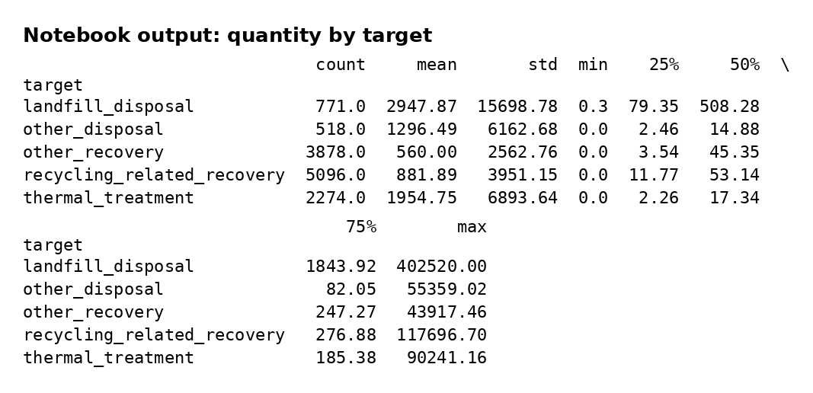
Appendix A6. Notebook output screenshot: quantity by target summary
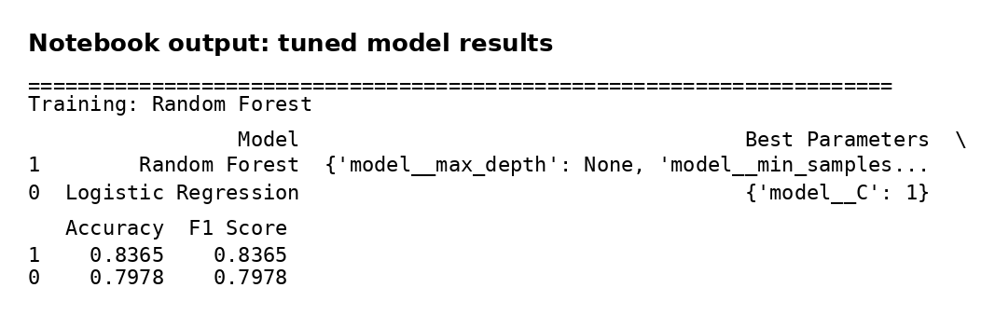
Appendix A7. Notebook output screenshot: tuned model comparison table
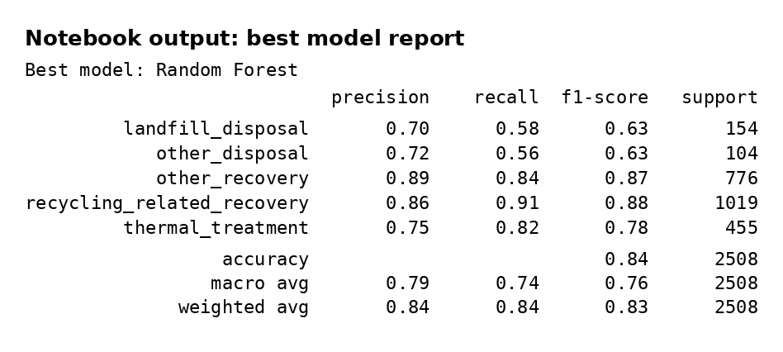
Appendix A8. Notebook output screenshot: best model classification report

