Name: Mohmadhusen Ahmadbhai Khimani
Enrollment No: 22FOTCA11071
Roll No: 14
Div: 6-BCA-B
Subject: Python Programming
Subject Code: BCA619
Date: 27/01/2025
—---------------------------------------------------------------------------
TCIE-1 (Part-1)
—---------------------------------------------------------------------------

Q.1 | Write a program to print Empid, Employeename, EmpSalary (Dynamic value taking using datatypes) ---[2 Marks]
Code: | #Name: Mohmadhusen Ahmadbhai Khimani  #Enrollment No: 22FOTCA11071  #Roll No: 14  #Div: 6BCAB  print("Name: Mohmadhusen Ahmadbhai Khimani")  print("Enrollment No: 22FOTCA11071")  print("Roll No: 14")  print("Div: 6BCAB")  print("-----------------------------------------")  """  Q.1: Write a program to print Empid, Employeename,  EmpSalary (Dynamic value taking using datatypes)  ---[2 Marks]  """  EmpId = int(input("Enter the Employee Id: "))  EmployeeName = input("Enter the Employee Name: ")  EmpSalary = float(input("Enter the Employee Salary: "))  print("-----------------------------------------")  print("-------------Employee Details------------")  print("-----------------------------------------")  print(EmpId)  print(EmployeeName)  print(EmpSalary)
Output: | Name: Mohmadhusen Ahmadbhai Khimani  Enrollment No: 22FOTCA11071  Roll No: 14  Div: 6BCAB  -----------------------------------------  Enter the Employee Id: 123456  Enter the Employee Name: Mohmadhusen  Enter the Employee Salary: 9600000  -----------------------------------------  -------------Employee Details------------  -----------------------------------------  123456  Mohmadhusen  9600000.0
Full Screen: | 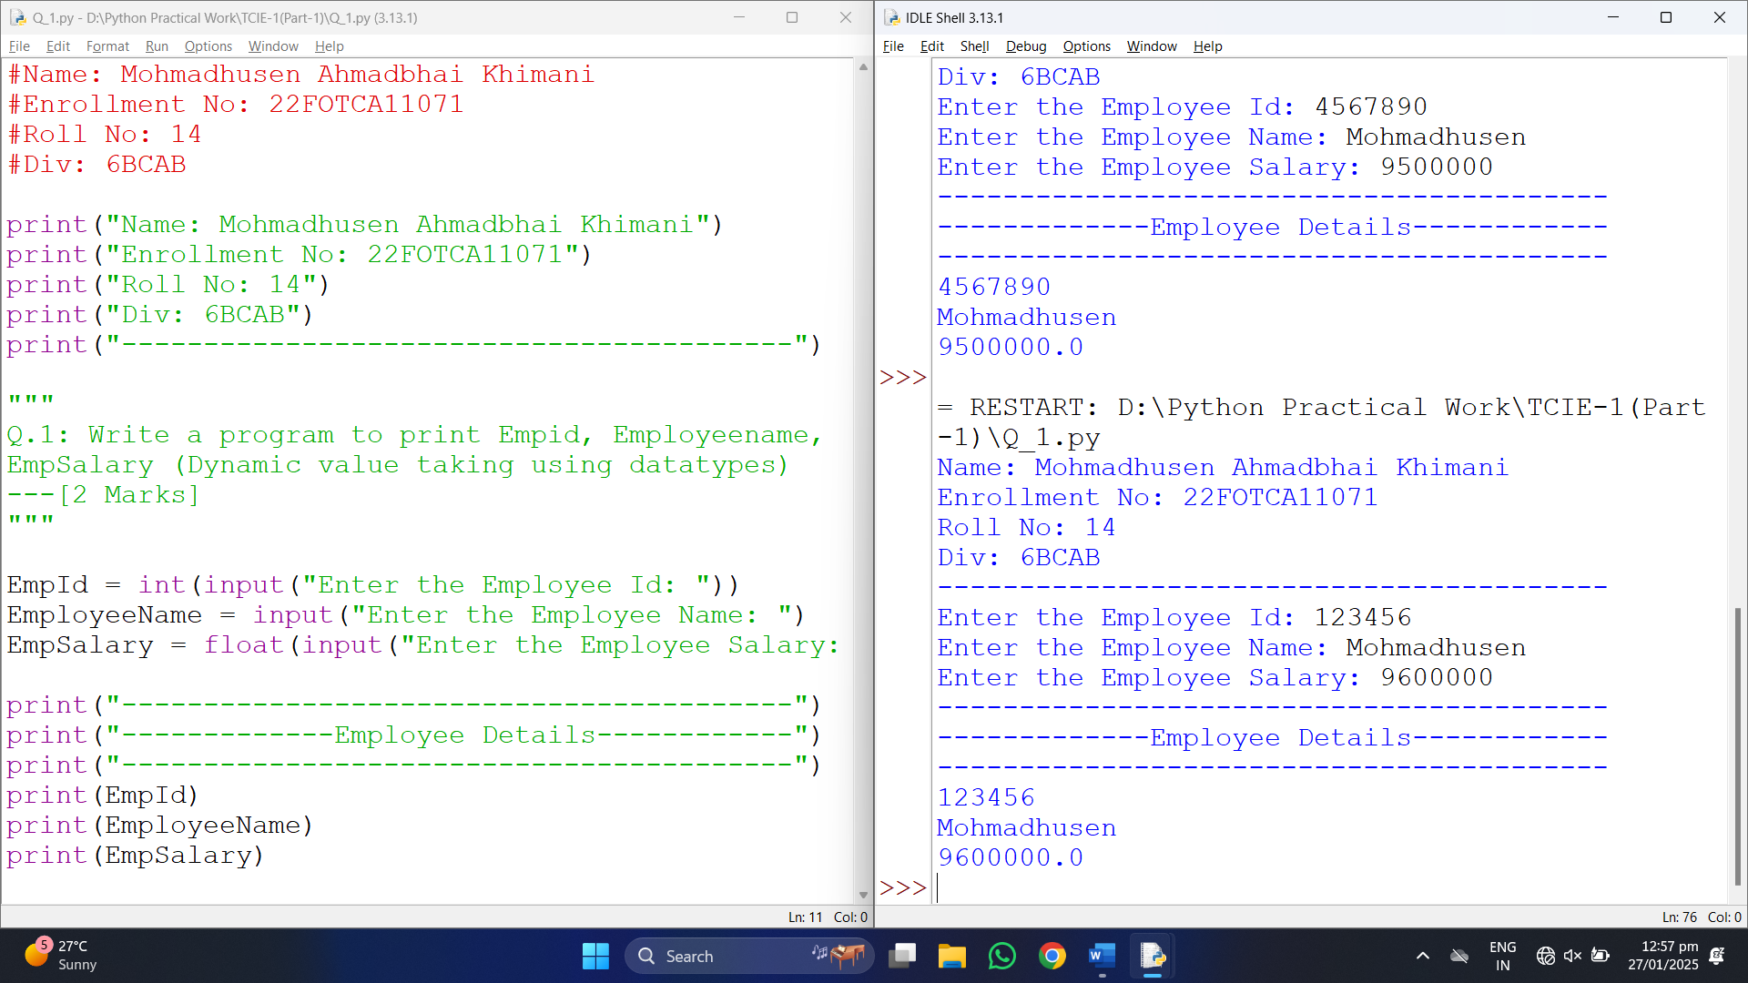
Q.2 | Generate a code for printing factorial program [dynamic] ------[4 marks]
Code: | #Name: Mohmadhusen Ahmadbhai Khimani  #Enrollment No: 22FOTCA11071  #Roll No: 14  #Div: 6BCAB  print("Name: Mohmadhusen Ahmadbhai Khimani")  print("Enrollment No: 22FOTCA11071")  print("Roll No: 14")  print("Div: 6BCAB")  print("-----------------------------------------")  """  Q.2: Generate a code for printing factorial  program [dynamic] ------[4 marks]  """  n=int(input("Enter the value of n: "))  fact=1  for i in range(1,n+1):  fact*=i  print("Factorial Number = ",fact)
Output: | Name: Mohmadhusen Ahmadbhai Khimani  Enrollment No: 22FOTCA11071  Roll No: 14  Div: 6BCAB  -----------------------------------------  Enter the value of n: 5  Factorial Number = 120
Full Screen: | 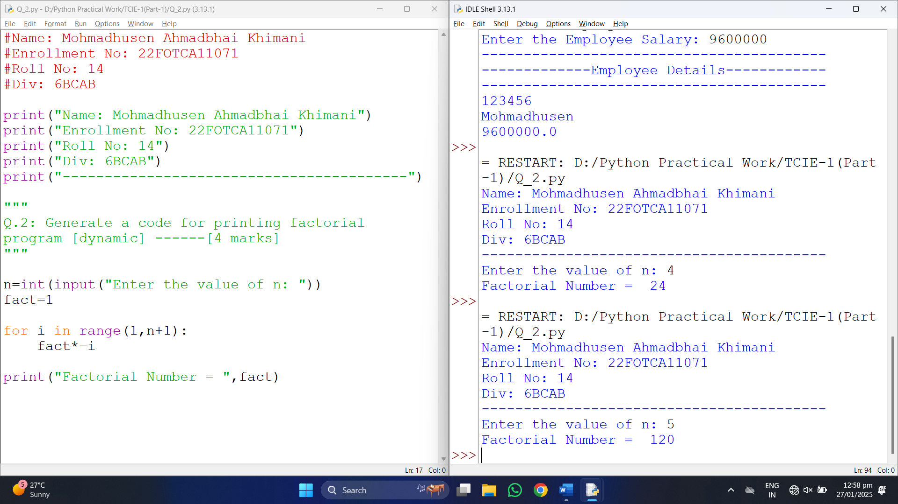
Q.3 | Generate the code for Slicing: --------------------------------------[1 marks each]  Take an data from user and perform below operation  ---- Write a program to extract a sublist from the given list using slicing.  -----Write a program to reverse a list using slicing.  -----Write a program to create a new list by skipping every second element of the original list.  -----Write a program to replace a portion of the list with new elements using slicing.  -----Write a program to extract every third element from a list.
Code: | #Name: Mohmadhusen Ahmadbhai Khimani  #Enrollment No: 22FOTCA11071  #Roll No: 14  #Div: 6BCAB  print("Name: Mohmadhusen Ahmadbhai Khimani")  print("Enrollment No: 22FOTCA11071")  print("Roll No: 14")  print("Div: 6BCAB")  print("-----------------------------------------")  """  Q.3: Generate the code for Slicing: --------------------------------------[1 marks each]  Take an data from user and perform below operation  ---- Write a program to extract a sublist from the given list using slicing.  -----Write a program to reverse a list using slicing.  -----Write a program to create a new list by skipping every second element of the original list.  -----Write a program to replace a portion of the list with new elements using slicing.  -----Write a program to extract every third element from a list.  """  lst = [10, 20, 30, 40, 50]  # Nested slicing  nested_list = [[1, 2], [3, 4], [5, 6], [7, 8]]  print("nested_list[1:4][1] =", nested_list[1:4][1]) # [5, 6]  # Slicing a string  s = 'abcdef'  print("'abcdef'[1:4] =", s[1:4]) # 'bcd'  # Duplicate list  print("lst[::] =", lst[::]) # [10, 20, 30, 40, 50]  new_list = lst[:]  print("28. Duplicated list =", new_list) # [10, 20, 30, 40, 50]  # Reverse with step  print("lst[::-2] =", lst[::-2]) # [50, 30, 10]
Output: | Name: Mohmadhusen Ahmadbhai Khimani  Enrollment No: 22FOTCA11071  Roll No: 14  Div: 6BCAB  -----------------------------------------  nested_list[1:4][1] = [5, 6]  'abcdef'[1:4] = bcd  lst[::] = [10, 20, 30, 40, 50]  28. Duplicated list = [10, 20, 30, 40, 50]  lst[::-2] = [50, 30, 10]
Full Screen: | 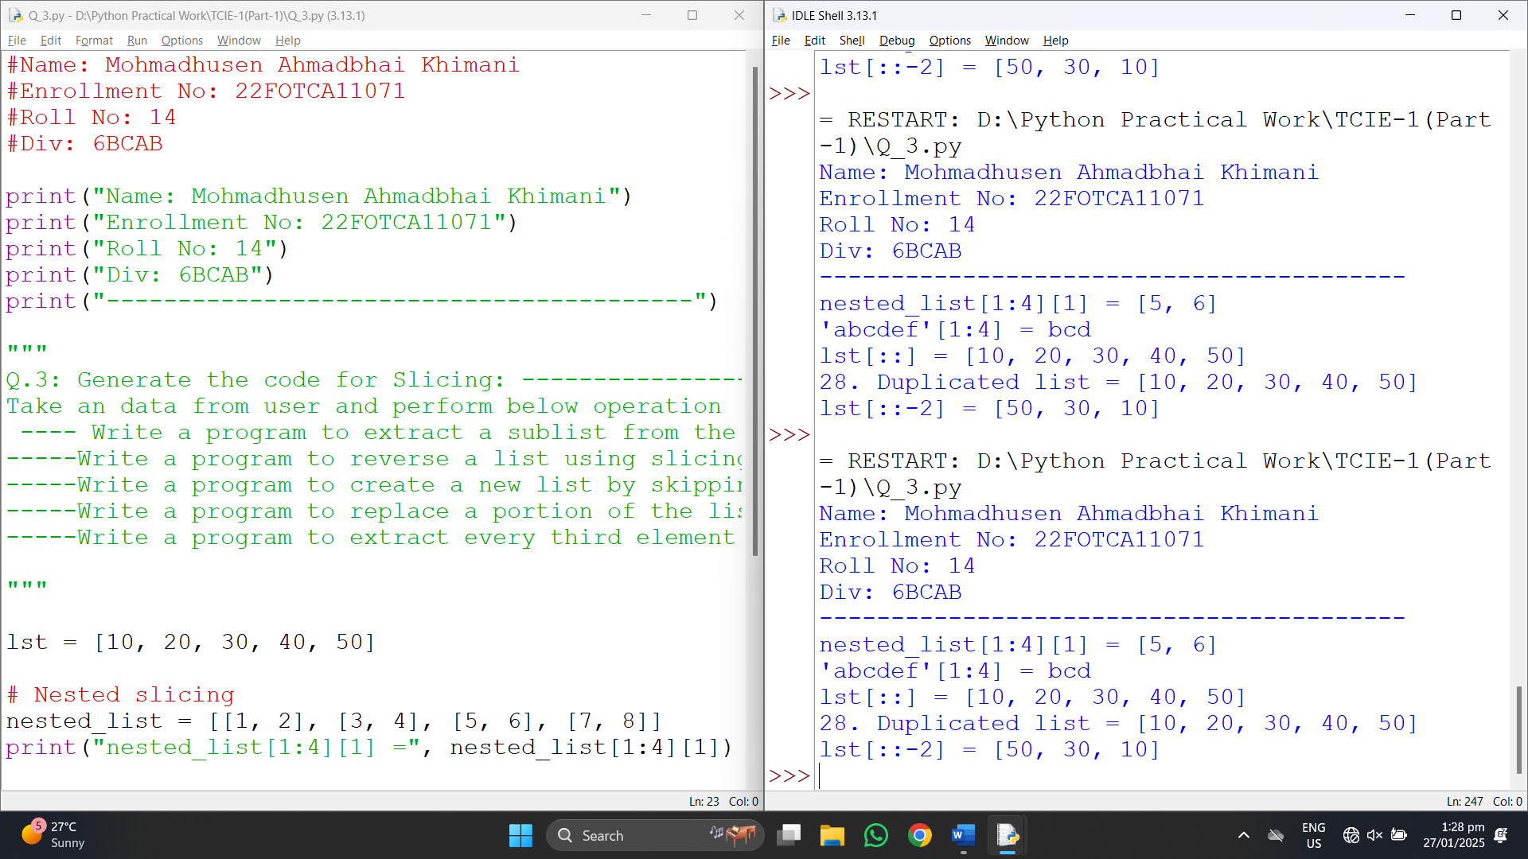
Q.4 | Write a program to use nested if and print day wise fruits name ------[3 marks]
Code: | #Name: Mohmadhusen Ahmadbhai Khimani  #Enrollment No: 22FOTCA11071  #Roll No: 14  #Div: 6BCAB  print("Name: Mohmadhusen Ahmadbhai Khimani")  print("Enrollment No: 22FOTCA11071")  print("Roll No: 14")  print("Div: 6BCAB")  print("-----------------------------------------")  """  Q.4: Write a program to use nested if and  print day wise fruits name ------[3 marks]  """  fruits = ["apple","Mango","Orange","Banana","Grapes","Kiwi","Pineapple"]  n = int(input("Enter the value of n: "))  if n==0:  print(fruits[0])  elif n==1:  print(fruits[1])  elif n==2:  print(fruits[2])  elif n==3:  print(fruits[3])  elif n==4:  print(fruits[4])  elif n==5:  print(fruits[5])  elif n==6:  print(fruits[6])  else:  print("No Fruits")
Output: | Name: Mohmadhusen Ahmadbhai Khimani  Enrollment No: 22FOTCA11071  Roll No: 14  Div: 6BCAB  -----------------------------------------  Enter the value of n: 5  Kiwi
Full Screen: | 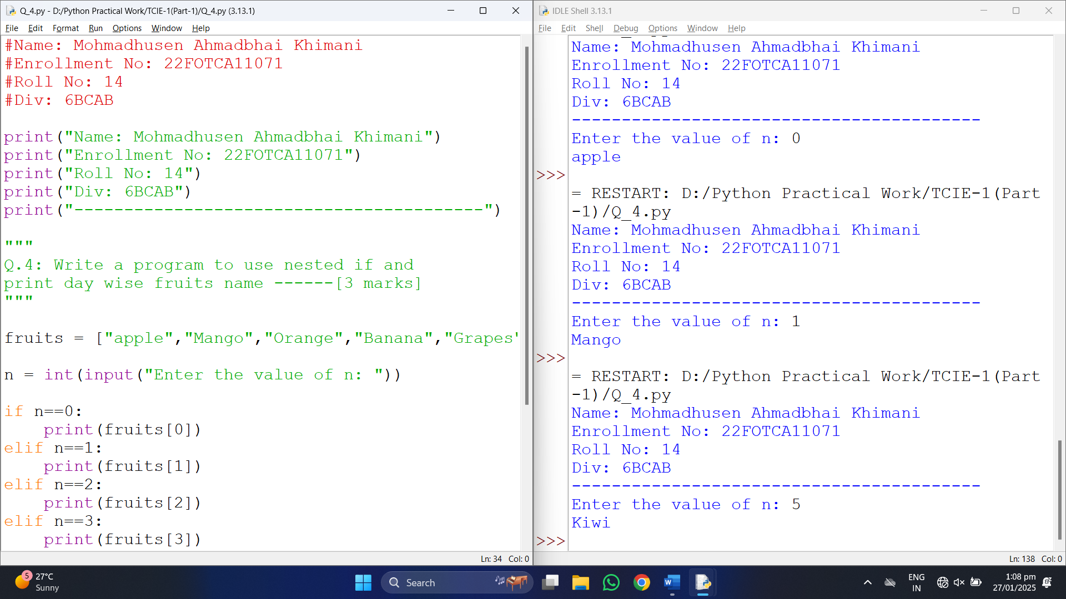
Q.5 | Generate a program using function to print 5 different built in function [5 marks]
Code: | #Name: Mohmadhusen Ahmadbhai Khimani  #Enrollment No: 22FOTCA11071  #Roll No: 14  #Div: 6BCAB  print("Name: Mohmadhusen Ahmadbhai Khimani")  print("Enrollment No: 22FOTCA11071")  print("Roll No: 14")  print("Div: 6BCAB")  print("-----------------------------------------")  """  Q.5: Generate a program using function to print  5 different built in function [5 marks]  """  # 1. Default Function  print("\n------- 1. Default Function -------")  def greet(name="Guest"):  print(f"Hello, {name}!")  greet() # Default parameter  greet("Mohmadhusen") # Passing parameter  # 2. Parameter Passing Function  print("\n------- 2. Parameter Passing Function -------")  def add_numbers(a, b):  return a + b  print(f"Sum of 5 and 10: {add_numbers(5, 10)}")  # 3. Passing * to Function (Variable-Length Arguments)  print("\n------- 3. Passing * to Function -------")  def show_items(*items):  print("Items:", items)  show_items("Apple", "Banana", "Mango")  show_items(1, 2, 3, 4, 5)
Output: | Name: Mohmadhusen Ahmadbhai Khimani  Enrollment No: 22FOTCA11071  Roll No: 14  Div: 6BCAB  -----------------------------------------  ------- 1. Default Function -------  Hello, Guest!  Hello, Mohmadhusen!  ------- 2. Parameter Passing Function -------  Sum of 5 and 10: 15  ------- 3. Passing * to Function -------  Items: ('Apple', 'Banana', 'Mango')  Items: (1, 2, 3, 4, 5)
Full Screen: | 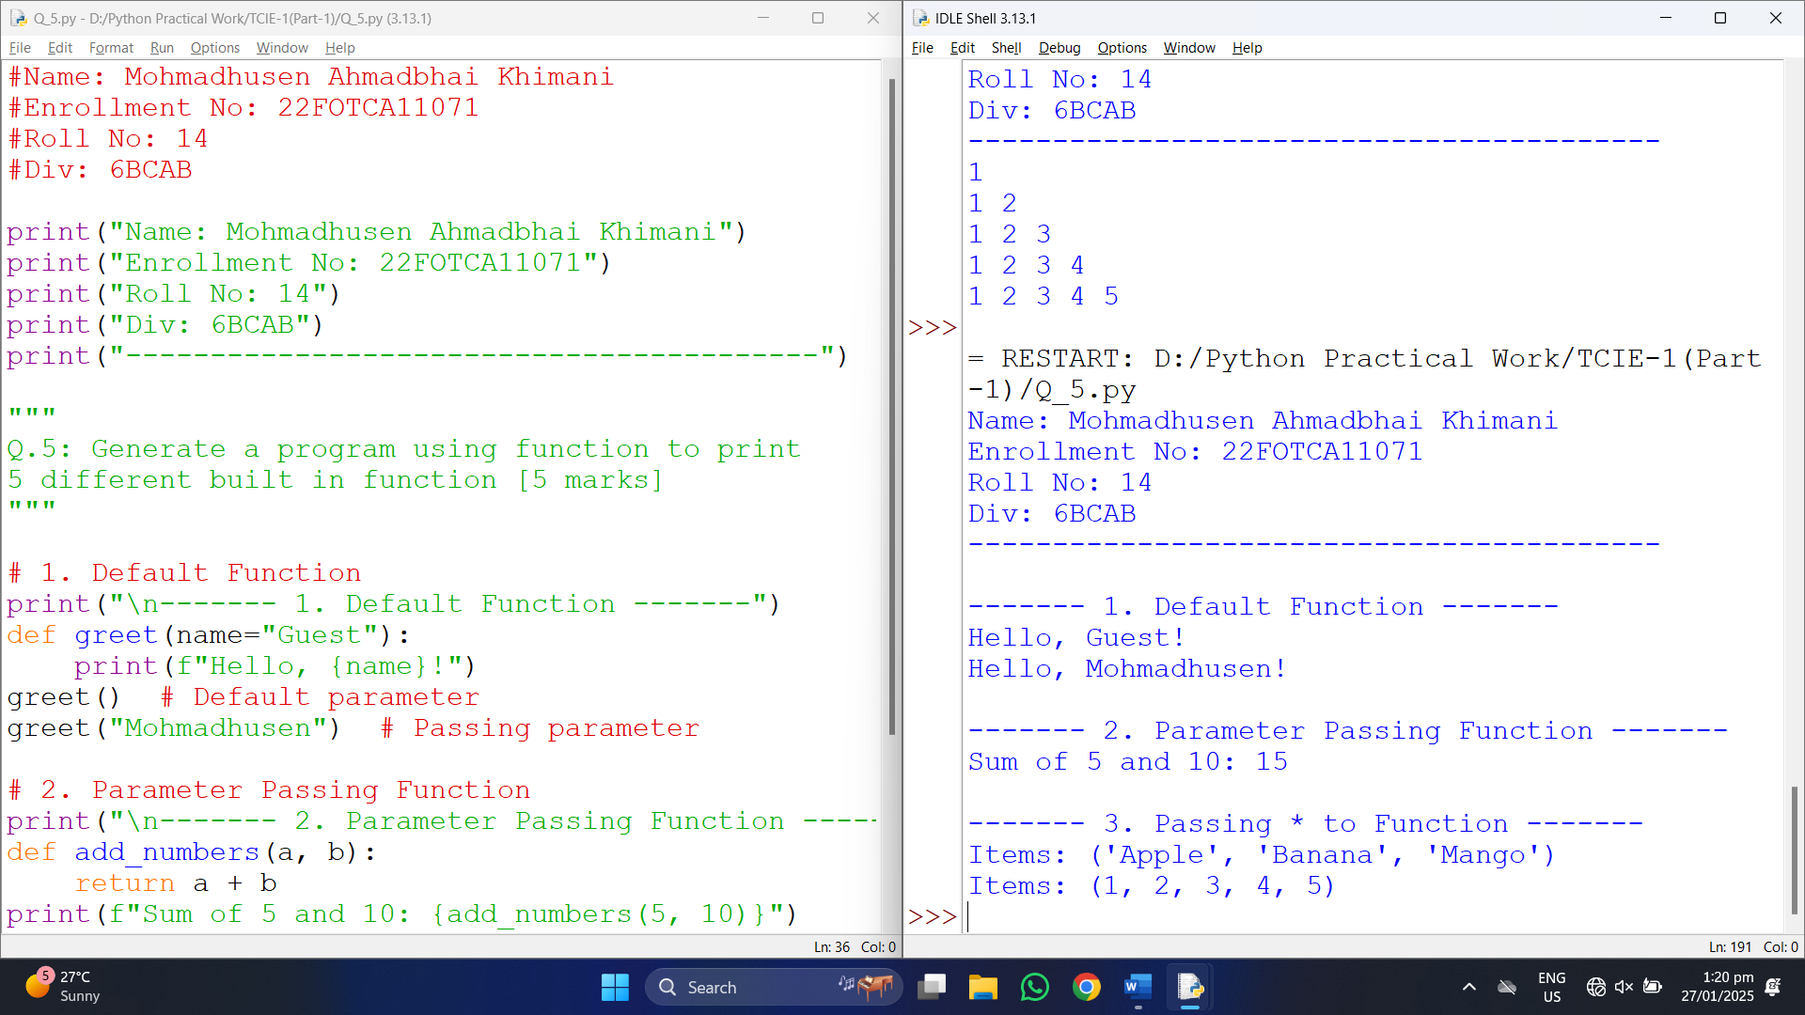
Q.6 | Print an pattern using for loop -------- [ 5 marks]
Code: | #Name: Mohmadhusen Ahmadbhai Khimani  #Enrollment No: 22FOTCA11071  #Roll No: 14  #Div: 6BCAB  print("Name: Mohmadhusen Ahmadbhai Khimani")  print("Enrollment No: 22FOTCA11071")  print("Roll No: 14")  print("Div: 6BCAB")  print("-----------------------------------------")  """  Q.6: Print an pattern using for loop  -------- [ 5 marks]  """  for i in range(1, 6):  for j in range(1, i + 1):  print(j, end=" ")  print()
Output: | Name: Mohmadhusen Ahmadbhai Khimani  Enrollment No: 22FOTCA11071  Roll No: 14  Div: 6BCAB  -----------------------------------------  1  1 2  1 2 3  1 2 3 4  1 2 3 4 5
Full Screen: | 



