

Project Title

A PROJECTREPORT

SUBMITTED IN PARTIAL FULFILLMENT OF THE REQUIREMENT FOR THE AWARD OF THE
DEGREE OF

Master in Computer Application TO
RK UNIVERSITY,RAJKOT

SUBMITTED BY
NameofStudent Enrollment No.

Zala Nirbhay ________________
Ghumaiya Rajesh
Maulik Ujjeniya _______________

UNDER THE GUIDANCE OF

Guide Name Dr.Nirav Bhatt
Assistant Professor, Professor(HOD),
RKUniversity, RK University,
RAJKOT RAJKOT
1 | P a g e


SCHOOL OF ENGINEERING, RK UNIVERSITY, RAJKOT



DECLARATION

Wehere by certify that weare the sole authors of this project workand that neither any part of this project work nor the whole of the project work has been submitted for a degreetoanyotherUniversityorInstitution.Wecertifythat,tothebestofourknowledge, our project work does not infringe upon anyone’s copyright nor violate any proprietary rights and that any ideas, techniques, quotations, or any other material from the work of other people included in our project document, published or otherwise, are fully acknowledged in accordance with the standard referencing practices. We declare that this is a truecopy of our projectwork ,including any final revisions ,asapproved by ourproject review committee.

ProjectTeam

Student Name (Enrollment No)
Date: - Place: -
2 | P a g e

TABLE OF CONTENTS

TITLE | PAGE NO.
ACKNOWLEDGEMENT
ABSTRACT
1. INTRODUCTION
1.1 PROJECT SUMMARY
1.2 PURPOSE
1.3 HTML, CSS, PHP
2. PROJECT MANAGEMENT
2.1 PROJECT PLANNING AND SCHEDULING
2.1.1 PROJECT DEVELOPMENT APPROACH
2.1.2 PROJECT PLAN
2.1.3 SCHEDULE REPRESENTATION
3. SYSTEM REQUIREMENTS STUDY
3.1 USER CHARACTERISTICS
3.2 HARDWARE
4. SYSTEM ANALYSIS
4.1 STUDY OF CURRENT SYSTEM
4.2 PROBLEM & WEAKNESS OF CURRENT SYSTEM
4.3 FEASIBILITY STUDY
4.4 REQUIREMENT VALIDATION
4.5 FUNCTION SYSTEM
4.5.1 E-R DIAGRAM
4.5.2 USE CASE DIAGRAM
4.5.3DATA FLOW DIAGRAM
4.6 DATA MODELING

4.7 MAIN MODULES OF NEW SYSTEM | 22
5. SYSTEM DESIGN | 23
5.1 FLOW CHART | 24
6. TESTING | 25
6.1 TEST PLAN | 26
6.2 TESTING STRATEGY | 27
6.3 TESTING METHODS | 28
6.4 TESTING CASES | 29
7. SCREEN SHOTS | 30
8. LIMITATION & FUTURE ENHANCEMENT | 31
9. CONCLUSION AND DISCUSSION | 32
10 REFERENCES | 33

ACKNOWLEDGEMENT

The success and final outcome of this project required a lot of guidance and assistance from many people and We are extremely fortunate to have got this all along the completion of my project work. Whatever we have done is only due to such guidance and assistance and we would not forget to thank them.
We respect and thank RK University for giving us an opportunity to do the project work in 6BCA and providing us all support and guidance which make us complete the project on time. We are extremely grateful to him for providing such a nice support and guidance though he had busy schedule managing the company affairs.
We also thank our internal project guide, Guide Name, RK University Rajkot, for his guidance and suggestions during this project work.
We are thankful to and fortunate enough to get constant encouragement, support and guidance from all Teaching staffs of Department of Bachelor of Computer Application whichhelpedusinsuccessfullycompletingourprojectwork.Also,wewouldliketoextend our sincere regards to all the non-teaching staff of department for their timelysupport.

ABSTRACT

KidsKorner is an e-commerce platform designed to provide an easy and interactive way for parents and users to browse and purchase kids’ essentials online. The system offers a variety of kids’ products such as clothes, toys, and baby care items. The key objective of this project is to implement a secure, user-friendly, and responsive online shopping experience for users.

The system ensures that guests can browse products freely, but to add items to cart or wishlist, users are required to log in. Once logged in, they can make purchases using both Cash-on-Delivery and online payment methods. The system integrates the Cashfree payment gateway to facilitate secure online transactions.

The platform includes several modern features such as a user dashboard, online order tracking, product reviews, wishlist, and order history. The admin can manage products, categories, and users, as well as monitor total products, sales, stock, reviews, and customer information. The system ensures proper data storage using MySQL and implements server-side scripting using PHP.

The entire project is developed using HTML, CSS, JavaScript, Bootstrap, Tailwind CSS, PHP, MySQL, and Cashfree payment gateway, ensuring good performance and reliability. It is currently deployed on a localhost setup for academic and demonstration purposes

1. INTRODUCTION

E-commerce has become one of the fastest-growing trends in modern technology. It has revolutionized the buying and selling process, allowing customers to shop conveniently from their homes. KidsKorner is a web-based e-commerce application built to simplify the process of purchasing children’s items online. Unlike traditional shopping methods where users physically visit stores, KidsKorner enables customers to explore multiple products, compare their prices, and place orders instantly.
The system simplifies the experience for users, allowing them to browse products based on predefined categories such as clothes, toys, and baby care. The platform restricts guest users from placing orders, which promotes secure transaction processing and customer data management. Registered users can add products to the cart, wishlist, check order status, and track delivery, making the system highly interactive and user-friendly.
KidsKorner provides an admin dashboard that supports back-end management such as product updates, category management, user monitoring, and order tracking. The use of Cashfree Payment Gateway enhances trust and ensures secure transactions while supporting both Cash-on-Delivery and online payment methods.
The system is developed using a combination of front-end and back-end technologies including HTML, CSS, Bootstrap, Tailwind CSS, JavaScript, PHP, and MySQL. The application employs a structured database to maintain user accounts, product inventories, and sales records. KidsKorner demonstrates essential components of an online retail platform and highlights how modern technologies can be integrated to provide a complete e-commerce solution

  - Project Summary

KidsKorner is an online e-commerce platform specifically designed to sell kids’ essential products. The system allows users to register, log in, browse products, add items to their cart or wishlist, and purchase them using Cash-on-Delivery or online payment. Products available include children’s clothing, toys, and baby care items. The main objective of KidsKorner is to create an efficient, secure, and user-friendly shopping experience for customers.
The platform contains two main interfaces:
- User Panel – Allows registered users to shop products, make payments, view order status, track orders, and write reviews for delivered products.
- Admin Panel – Allows the admin to add, edit, update, and remove product categories, manage users, manage products and orders, track available stock, view sales and reviews.
KidsKorner aims to demonstrate all basic and advanced e-commerce functions commonly used in real-world e-commerce systems.

  - Purpose

The purpose of the KidsKorner project is to develop a reliable, secure, and convenient platform for buying kids’ essentials online. It reduces the limitations of physical shopping such as time constraints, availability, and product comparison. The system allows customers to view products, compare prices, and place orders conveniently from home.
The system supports the following objectives:
- Provide an online shopping facility for kids’ products.
- Offer secure online + offline payment options.
- Provide user authentication and profile management.
- Ensure smooth cart, wishlist, and order management.
- Track orders and view purchase history.
- Allow admin to maintain products and business information easily.
Overall, the purpose of the project is to build a feature-rich e-commerce website with modern functionalities and a smooth user experience.

  - HTML, CSS, PHP

• HTML (Hyper Text Markup Language) is used to design the structure of web pages like product display, navigation menus, login form, and dashboard.
• CSS (Cascading Style Sheets) and Tailwind CSS + Bootstrap are used to style the webpages and provide responsiveness, animations, and layout arrangements.
• JavaScript is used to perform validations, DOM manipulation, and enhance the user experience on the client-side.
• PHP is used as a server-side programming language to manage database operations such as login, product management, and order processing.
• MySQL is used as the database to store user information, product data, categories, transactions, and order details.
• Cashfree Payment Gateway is integrated to handle online payment securely

PROJECT MANAGEMENT

Project management plays an essential role in the successful execution of any software development project. It involves the planning, organizing, allocating, scheduling, and controlling of resources and activities to achieve the desired objectives. The objective of project management in KidsKorner is to ensure that the project is developed within the given time, cost, and quality constraints while delivering a fully functional and user-friendly e-commerce platform.

KidsKorner follows a structured approach to manage resources, define the scope, and implement each module in a phased manner. The development process includes requirement gathering, designing the layout, back-end implementation, database integration, and finally deployment and testing. Each phase is executed with proper coordination to ensure that no requirements are missed, and the final software product works smoothly.

Proper project management helped in clear understanding of user requirements such as product categories, login system, payment methods, order tracking, and admin-side functionalities. Efficient scheduling helped in organizing tasks according to priority and interdependency. The project was broken into small manageable modules such as user interface, payment system, admin dashboard, cart management, wishlist, and product listing. This modular approach reduced complexity and improved efficiency.

The KidsKorner project was developed keeping future enhancements in mind. The management of this project ensures that the system maintains user convenience, performance, security, and ease of maintenance. The management approach focuses on dividing responsibilities, reducing errors, and achieving the main goal of creating a reliable and feature-rich e-commerce application

2.1 PROJECT PLANNING AND SCHEDULING

Project planning is the most important phase in the development of KidsKorner. Planning involves the identification of project scope, defining objectives, estimating time requirements, and preparing a development strategy. The main aim of planning is to ensure that the system is developed efficiently and timely. In this project, planning helped decide the sequence of activities such as designing the UI, choosing technologies, preparing database, and integrating the payment gateway.

Scheduling is preparing a timeline for each module with predefined start and end dates. KidsKorner development was divided into logical phases like registration, login, product display, cart, checkout system, payment system, order tracking, and admin dashboard. This not only helps in smooth execution but also avoids delays and rework.

Planning and scheduling also helped in resource allocation. The work was distributed among different modules, ensuring better team coordination. This phase is essential because poor planning may lead to failure or incomplete implementation of the system.

2.1.1 PROJECT DEVELOPMENT APPROACH

For the development of KidsKorner, we follow Waterfall Model, because it is most suitable for academic and small scale projects. It is a linear sequential model where each phase must be completed before the next begins. The stages of Waterfall Model used in our project are:

- Requirement Analysis – Gathering functional and non-functional requirements of the website.
- System Design – Creating database design, UI design, and architecture of the project.
- Implementation – Coding front-end and back-end using HTML, CSS, JS, Bootstrap, PHP, and MySQL.
- Integration – Connecting modules like login, cart, payment gateway, admin panel, etc.
- Testing – Ensuring that all functionalities work as expected and detecting bugs.
- Deployment – Uploading the project on localhost for demonstration.
- Maintenance – Bug fixing and future enhancement like animations using GSAP.

This approach is chosen because it provides structured development, clear documentation, proper requirement validation and ensures better understanding.

2.1.2 PROJECT PLAN

The system development activities of KidsKorner are divided into phases:
Phase | Activity
Phase 1 | Requirement analysis and planning
Phase 2 | Design of user interface and database
Phase 3 | Front-end development
Phase 4 | Back-end development
Phase 5 | Database connection
Phase 6 | Cart, wishlist and payment integration
Phase 7 | Admin dashboard development
Phase 8 | Testing and debugging
Phase 9 | Documentation and deployment
This plan follows a systematic approach ensuring each functionality is developed in the correct order.

2.1.3 SCHEDULE REPRESENTATION

Task | Time Required
UI Designing | 1 Week
Database Design | 1 Week
Login & Authentication | 1 Week
Product Categories & Listing | 1 Week
Cart & Wishlist | 1 Week
Payment Gateway Integration | 1 Week
Admin Panel | 2 Weeks
Testing | 1 Week

This schedule ensures the whole development process is conducted in a planned manner. By following this timeline, it becomes easy to track progress and maintain control over the development.

3. SYSTEM REQUIREMENTS STUDY

System requirement study is a critical phase in the development of KidsKorner as it provides a clear understanding of what is needed to build, run, and maintain the system. This phase includes analyzing the requirements of users, administrators, and the hardware system on which this application will be executed. Proper requirement analysis ensures that the system is developed efficiently without missing important functionalities.

The system must meet certain criteria related to usability, performance, scalability, storage, and security. KidsKorner is an e-commerce platform, so it must be accessible, easy to navigate, and fast enough to handle multiple user interactions such as browsing products, adding items to cart, managing orders, and processing payments.

Requirement study also ensures that the developed system works smoothly on available resources such as standard laptops or desktop computers, as the project is deployed locally on XAMPP. The primary objective of requirement study is to ensure that all stakeholders, including developers, testers, and end-users, get a clear picture of what the final system should deliver.

KidsKorner requires minimal hardware resources because it is a lightweight web-based system. The database, backend logic, and user interface run on localhost, ensuring smooth performance on systems with basic specifications. Understanding these requirements ensures that the system remains affordable, easy to deploy, and practical for academic use

3.1 USER CHARACTERISTICS

KidsKorner is designed for different types of users, each having unique needs, technical skills, and access levels. Understanding user characteristics helps in designing user-friendly interfaces and ensuring that the system fits the expectations of all users.

1. Guest Users
Guest users are visitors who browse products without logging in.
Characteristics:
- They have limited access.
- They can only view products and product details.
- They cannot add items to cart or wishlist.
Purpose:
- Encourages visitors to sign up.
- Gives basic exposure to site design and product availability.

2. Registered Users / Customers
These are users who have created an account.
Characteristics:
- Basic computer and mobile browsing knowledge.
- Able to log in, update profile, place orders, track deliveries, and write reviews.
- Expect fast loading pages and easy navigation.
Features available:
- Add to cart
- Add to wishlist
- Online payment (Cashfree)
- Cash-on-delivery
- Track order
- View order history
- Write review
- Access user dashboard

3. Administrator (Admin Panel User)
Admins manage the entire e-commerce system.
Characteristics:
- Higher technical understanding
- Ability to manage product categories and stock
- Able to update, delete, modify, and track products
- Can view sales reports, user data, and reviews
- Responsible for updating order status and maintaining records

Summary of User Characteristics:
User Type | Knowledge Level | Access Level
Guest | Basic browsing | Very Limited
Registered User | Basic to moderate | High
Admin | Technical | Full Access

KidsKorner is built keeping all these user types in mind, ensuring the interface is simple, responsive, and easy to use.

3.2 HARDWARE REQUIREMENTS

KidsKorner is a lightweight web-based application that runs on average hardware configuration. Since the application is deployed locally using XAMPP, the hardware requirements are minimal, making it ideal for college projects.

1. Server-Side Hardware Requirements
(Server means the system running XAMPP/PHP/MySQL)
- Processor: Minimum Intel Core i3 or equivalent
- RAM: Minimum 4GB (8GB recommended for smooth database operations)
- Hard Disk: 10GB free space for XAMPP, project files, database storage
- Operating System: Windows 7/8/10/11 or Linux
- Web Server: Apache (via XAMPP)
- Database Server: MySQL/MariaDB

2. Client-Side Hardware Requirements
(Client means users browsing the website)
- Any mobile, laptop, or desktop capable of running modern browsers
- RAM: 2GB or more
- Internet Connection: Minimum 2 Mbps for smooth product loading
- Browser: Chrome, Firefox, Edge, Safari

3. Additional Hardware (Optional)
- External storage for backup
- Printer (if generating order reports)
- UPS for power backup in case of offline work

Why KidsKorner requires minimal hardware?
- Built using lightweight web technologies
- Runs on localhost, so no external hosting pressure
- MySQL database is optimized and fast
- PHP scripts execute on low system resources
- CSS frameworks like Bootstrap/Tailwind load quickly

This ensures that even students with basic laptops can run, test, and demonstrate the complete KidsKorner e-commerce system smoothly.

4. SYSTEM ANALYSIS

System analysis is one of the most important parts of software development as it helps in identifying problems in the existing system and finding suitable solutions in the form of a new proposed system. The objective of system analysis in KidsKorner is to study the current shopping methods followed by users and understand the challenges, limitations, and demand for a modern e-commerce application. This section clarifies why the new system is required and how it improves upon the current traditional shopping model.

KidsKorner is designed to solve real-world challenges in buying kids’ products. The analysis phase examines user requirements, system components, functional behavior, and technical feasibility. During system analysis, various modules like user authentication, product browsing, payment system, order tracking and admin dashboard were carefully planned and evaluated. This ensures that the new system will fulfill customer needs and work efficiently under different operating conditions.

4.1 STUDY OF CURRENT SYSTEM

In the existing or traditional shopping method, customers usually visit multiple physical stores to purchase kids’ essentials like clothes, toys, and baby care items. The shopping process becomes exhausting and time-consuming as customers need to travel from one shop to another, compare prices manually, and physically check availability. The current system relies on manual operations which are inefficient and often lead to confusion and delays.

Some of the major issues observed in the current system are as follows:
✔ 1. Limited Product Variety
Customers often do not find a wide range of products in a single store. They need to visit multiple shops which increases time and effort.

✔ 2. Time Consuming Process
Parents need to spend considerable time exploring shops, waiting in queues, and checking product details manually. This becomes inconvenient especially when buying multiple products.

✔ 3. No Online Payment or Convenient Delivery
Traditional shops do not support online payment or home delivery services. Customers need to carry cash and visit the shop personally, which is not always feasible.

✔ 4. No Customer Reviews or Ratings
In offline shops, customers cannot see feedback from other buyers. This makes it difficult to judge the quality of products, seller service, durability and pricing.
Due to all these limitations, customers face inconvenience and more physical effort. The absence of reviews and comparison also affects decision-making. Therefore, the traditional system is inefficient and lacks modern features required in today’s digital buying platforms

4.2 PROBLEM & WEAKNESS OF CURRENT SYSTEM

After studying the current shopping model, some major problems and weaknesses were identified:

● Lack of variety and comparison
In a physical market, customers cannot compare multiple products, reviews, ratings, and prices easily.

● Time consuming
Customers need to spend more time and energy for shopping. Traveling, exploring and selecting products take too much time.

● Limited Payment Options
Only cash payment is supported. Customers cannot pay online or use digital wallets.

● No Order Tracking
Once a purchase is made, there is no tracking or delivery updates which reduces convenience.

● Limited customer satisfaction
No product reviews or recommendations decrease purchasing confidence and customer experience.

● Manual record keeping
Billing, stock checking, receipts and payments are manually handled which is slow and prone to human error.
These limitations clearly show the need for a modern solution like KidsKorner that can provide a secure, fast, and convenient online shopping experience.

4.3 FEASIBILITY STUDY

Feasibility study determines whether the project is practically possible and beneficial. For KidsKorner, feasibility was analyzed under different aspects:

✔ Technical Feasibility
The project uses simple and widely available technologies like:
- HTML, CSS, JavaScript
- Tailwind CSS & Bootstrap
- PHP and MySQL
- Cashfree payment gateway
These tools are efficient, affordable and easy to maintain. Any basic laptop or PC can run the system using XAMPP, so it is technically feasible.

✔ Operational Feasibility
The system is user-friendly and easy to operate. Both admin and users can perform operations like:
- Adding products to cart
- Placing orders
- Updating stock and details
Customer dashboard, wishlist, order section, and review system make the operation efficient and understandable. Hence, operational feasibility is high.

✔ Economic Feasibility
KidsKorner is developed in a cost-effective manner using open-source tools. No extra hardware is required and deployment is done on localhost. There is no maintenance or hosting cost. So the project is economically feasible.

✔ Legal Feasibility
No illegal data, pirated tools, or copyrighted materials are used. The project is safe from legal issues.

✔ Time Feasibility
KidsKorner was completed within the project timeline and can be demonstrated successfully in the college duration.
Hence, the feasibility study confirms that the system is practical, implementable, affordable and reliable.

4.4 REQUIREMENT VALIDATION

Requirement validation ensures that all features requested in the requirement specification phase are implemented correctly. It checks whether the system is developed according to the user needs and developer expectations.

In KidsKorner, the following requirements were validated:
- Users can register, login, and logout.
- Users can add products to cart and wishlist.
- Guests can browse products but cannot place orders.
- Payment system includes both COD & Cashfree online gateway.
- Admin can add, delete, update categories and product details.
- Order tracking, reviews, and dashboard features are available.

All functional and non-functional requirements of the system were verified with test cases, user testing, and simulation. The requirements match the objective of the project.

4.5 FUNCTION SYSTEM

Functional system analysis describes how various system components communicate, how data flows, and how users interact with the application. It defines the actual working of the KidsKorner system, identifies actors involved, and explains how information is processed at each stage.

The KidsKorner system consists of two major actors: Customer/User and Administrator, supported by the database and server. Users interact with different modules for browsing products, adding to cart, checkout, payments, and order tracking. Admin performs operations like managing products, categories, stock, orders, and reviews

The functional system defines the flow between frontend (UI), backend (PHP), and database (MySQL). When users browse the website or perform any operation, data is fetched or updated in the database through PHP scripts and queries. Similarly, admin-side modules update the business logic and system data.
The functional description provides the foundation for analysis diagrams like E-R, use case, and DFD to understand the structure and behavior of the system.

4.6 DATA MODELING

Data modeling is the process of analyzing and designing the data required for the system. The main objective of data modeling is to create a structured database that stores the necessary information in a secure, organized, and efficient manner. The KidsKorner e-commerce website uses a relational database model implemented in MySQL 8.0, where the entire system data is stored across multiple inter-related tables.

The database has been designed based on the requirements of an e-commerce system including product management, user management, cart, orders, payments, and reviews. The data model ensures minimum redundancy, proper indexing, foreign key relationships, and referential integrity.

Registration:

Stores all registered user information.
- Primary Key: id
- Contains authentication fields such as name, email, password, phone, profile, role, verification tokens, etc

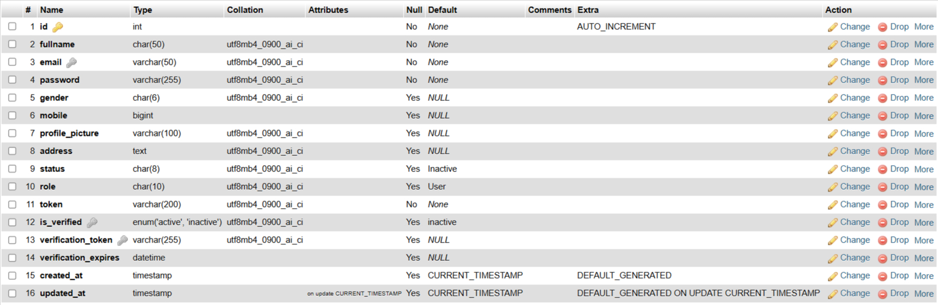

Categorie :

Stores the product categories like Toys, Baby Care, and Clothes.
- Primary Key: id
- Used to classif
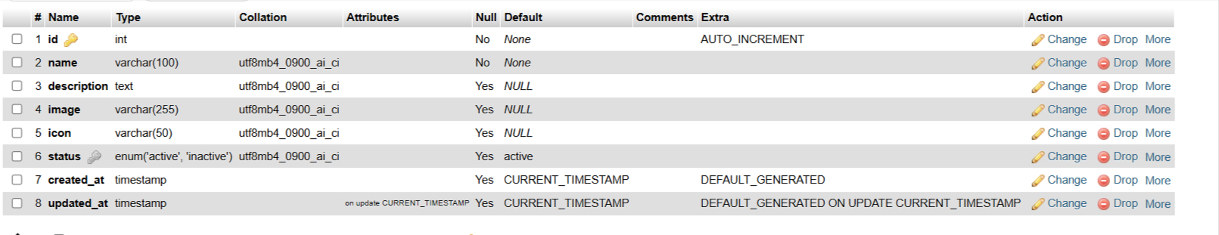

products :

Stores complete product details added by admin.
- Primary Key: id
- Foreign Key: category_id
- Includes image, description, pricing, stock, status, timestamps.

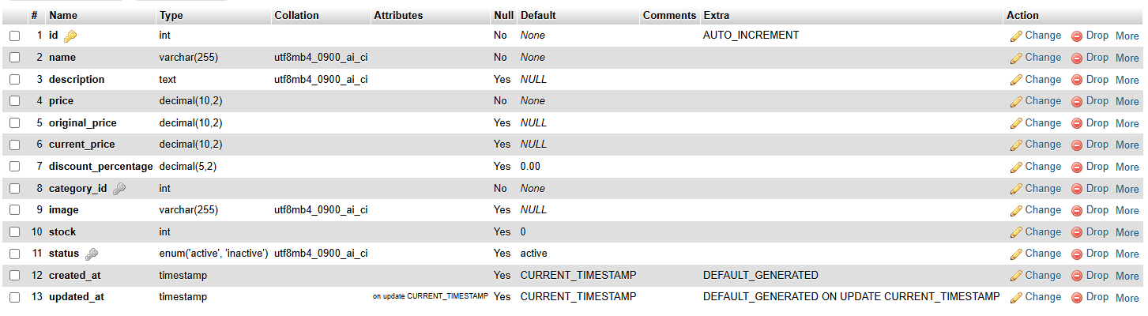

Cart:

Stores products temporarily added to cart by a logged-in user.
- Primary Key: id
- Foreign Keys: user_id, product_id
- Unique constraint prevents duplicate products per user.
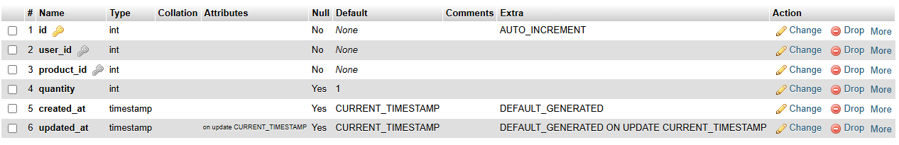

Wishlist:

Stores items added by user for future purchase.
- Primary Key: id
- Foreign Keys: user_id, product_id

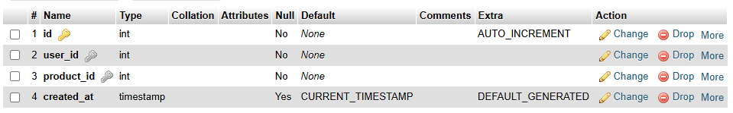
Orders:

Stores complete order details after checkout.
- Primary Key: id
- Includes shipping address, payment method, total amount, status, timestamps.

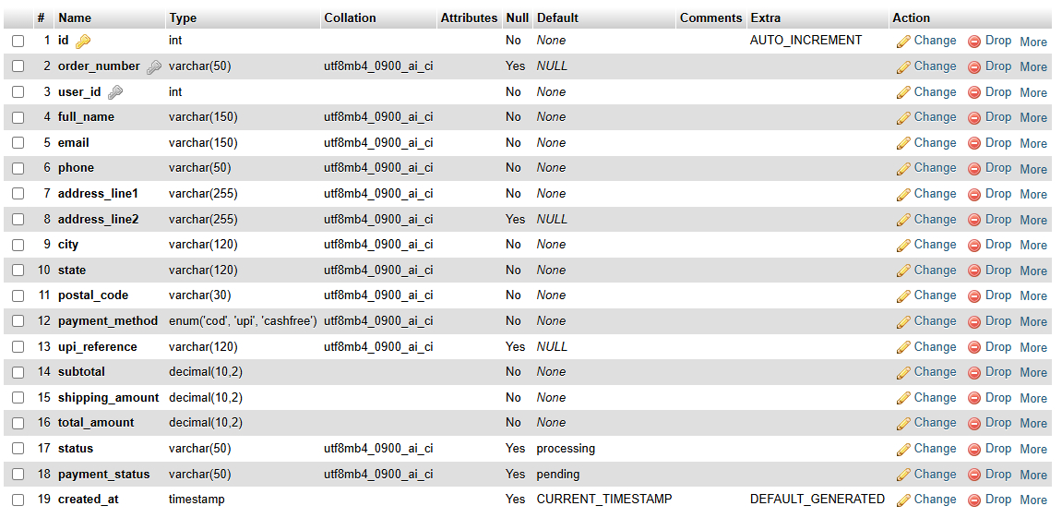

Order_items:

Stores individual product items included in an order.
- Primary Key: id
- Foreign Keys: order_id, product_id
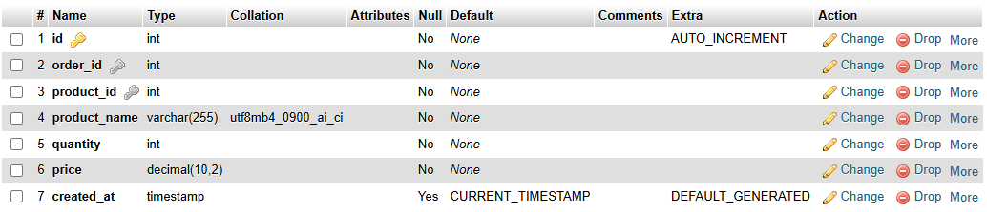

Reviews:

Stores customer reviews for products after delivery.
- Foreign Keys: user_id, product_id, order_id
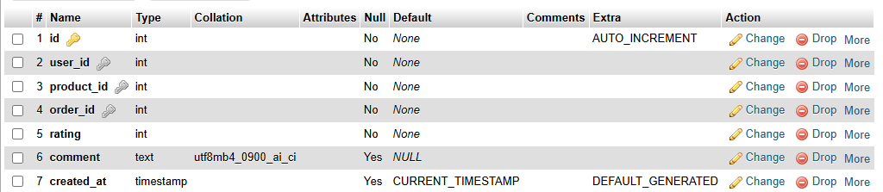

Password_reset_codes:

Stores OTP and verification data for resetting passwords.

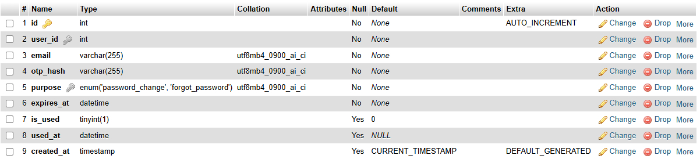

4.5.1 E-R DIAGRAM

An Entity-Relationship (ER) Diagram is used to represent the logical relationship between different entities in a database. It shows how data is stored and linked inside the database.
In KidsKorner, major entities are:
- Users
- Products
- Categories
- Cart
- Orders
- Wishlist
- Reviews
Each entity has attributes such as:
- User entity has: User ID, Name, Email, Password, Address
- Product entity has: Product ID, Name, Price, Category, Description
- Order entity has: Order ID, Product Details, Payment Type, Status, Date
The relationships between entities are modeled using one-to-one, one-to-many or many-to-many connections. Example:
- One user can place multiple orders.
- One category contains multiple products.
- One product can have multiple reviews.
This ER diagram helps database designers and developers understand how data is structured and stored, ensuring normalization, referential integrity and minimizing redundancy.

Diagram:

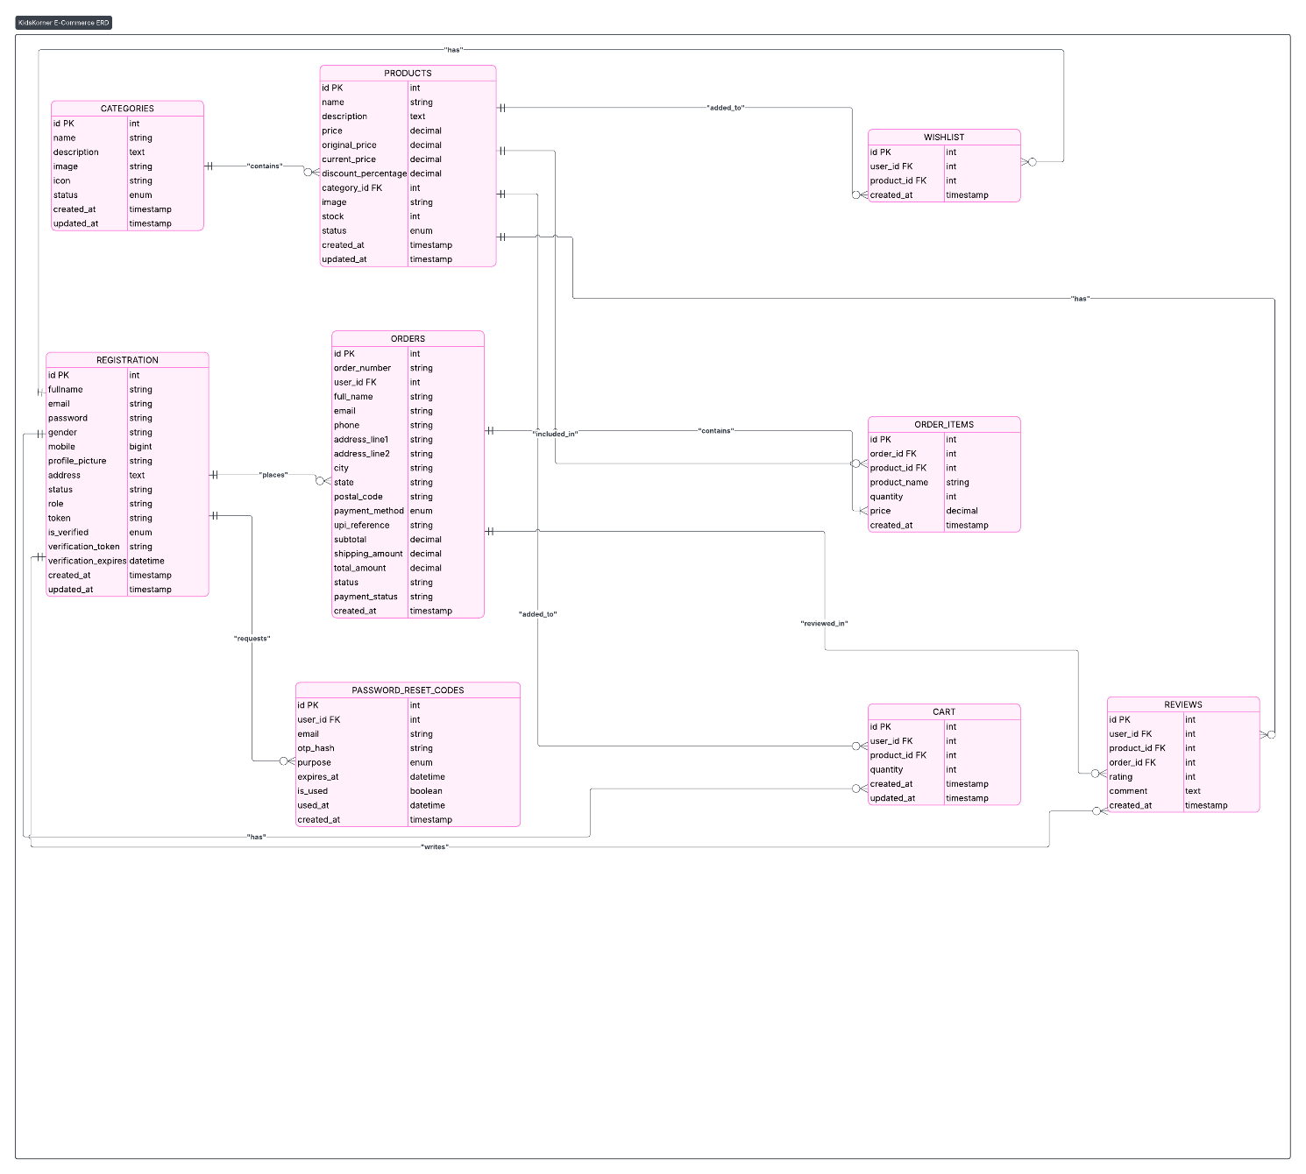

4.5.2 USE CASE DIAGRAM

A Use Case Diagram is used to represent the interaction between the user and the system. It shows what tasks the user can perform in the system and how the system responds.

There are two main actors:
- User (Customer)
- Administrator

User Use Cases:
- Register/Login
- View Products
- Add to Cart / Wishlist
- Checkout & Payment
- Order Tracking
- Write Review
- Manage Profile

Admin Use Cases:
- Add/Update/Delete Product
- Manage Categories
- Manage Users
- View Orders & Sales
- Update Order Status
- Manage Stock
- View Reviews

This diagram clearly represents system behavior from a user perspective. It gives a visual understanding of how the system is expected to function and what features are available to each actor. It also helps in validating system requirements and functionality coverage.

List of figures

Diagram

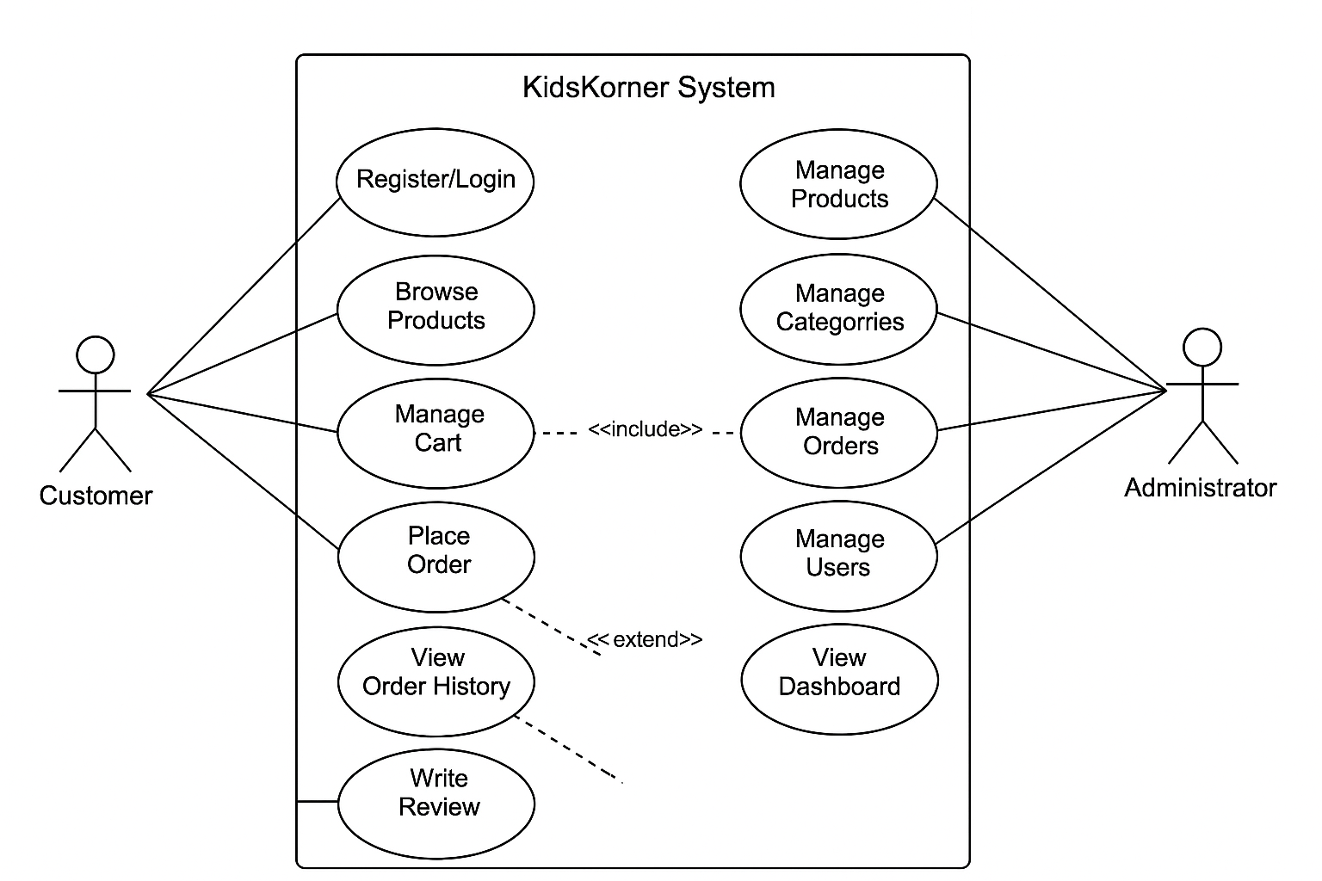

4.5.3 DATA FLOW DIAGRAM

Data modeling defines the structure, relationships, constraints, and rules of the database. It ensures that the information is stored in a logical and systematic manner.
KidsKorner uses relational database design using MySQL. The data is divided into multiple tables to ensure normalization and avoid data redundancy. Proper primary keys, foreign keys, indexes, and constraints are used to maintain data integrity.

For example:
- Users table uses User ID as primary key.
- Products table uses Product ID.
- Orders table references both User ID and Product ID.
- Categories table references Product relationships.

Data modeling helps:
- Improve performance
- Simplify queries
- Organize data efficiently
- Manage relationships
In KidsKorner, the data model is designed to support fast searching, filtering, adding to cart, order processing, stock updates, and managing product details.

0th level Data Flow Diagram

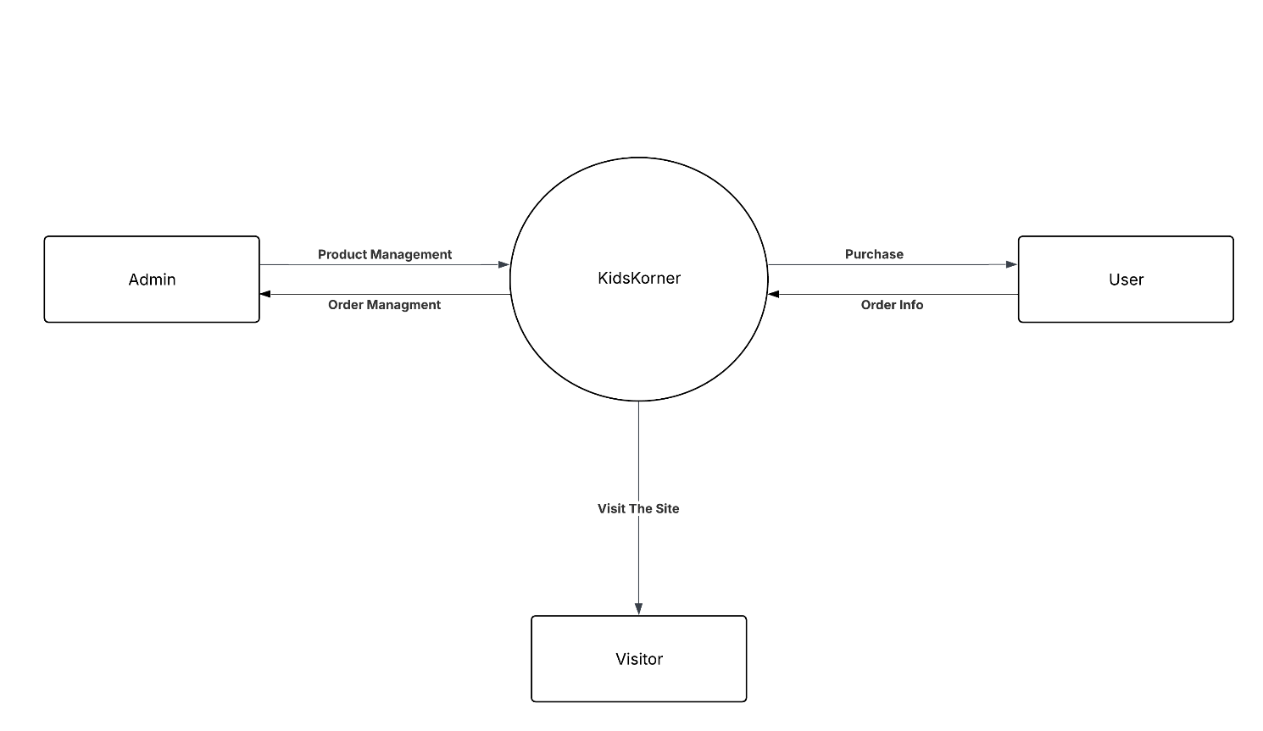

1st level User Side

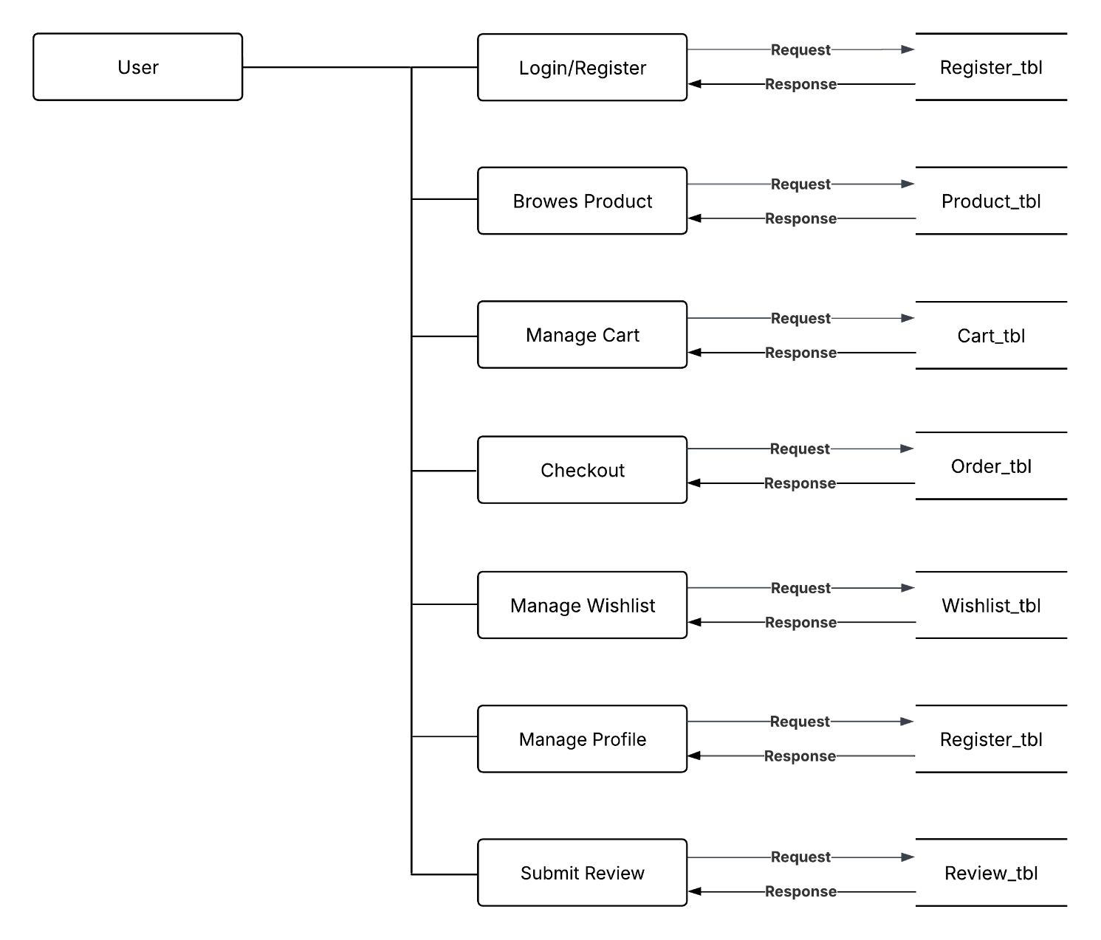

1st level Admin Side

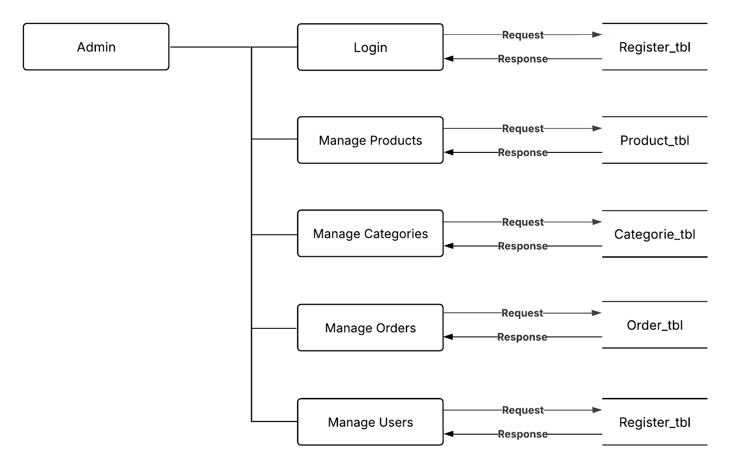

5. SYSTEM DESIGN

System design represents the blueprint and high-level structure of the KidsKorner application. It provides a detailed description of how the major components of the software are organized and how they interact with each other. The purpose of system design is to convert requirements and analysis into a technical architecture that guides development.

KidsKorner uses a modular and layered design approach. The system is divided into different modules like authentication, product display, payment gateway, cart management, and admin management. Each module performs a specific task while remaining connected with the main workflow of the system.

System design ensures:
- Clear separation of front-end and back-end logic
- Database connectivity and secure data processing
- Maintainability and scalability for future enhancements
- Efficient resource utilization and performance

The system architecture focuses on three major aspects:
- User Interface Design: Developed using HTML, CSS, JavaScript, Tailwind, and Bootstrap.
- Server-Side Processing: Managed through PHP scripts.
- Database Design: Implemented using MySQL to store users, products, orders, and categories.

The design maintains a smooth information flow from user request to backend processing and then to the database and output display. This approach ensures that each module works independently, but the overall application functions as a single integrated system.

5.1 FLOW CHART

Since your flowchart is one single diagram, we will add a detailed explanation of the flow:
The flowchart of KidsKorner represents the main operational sequence of the system from the user’s first interaction to the final order placement. The flow begins when a user visits the website and reaches the homepage. The system checks if the user is logged in or browsing as a guest.
Main Process Flow:
- Start
- Display homepage
- User browses products
- System checks:
  - If user is guest → Only view products
  - If logged in → Allow cart & wishlist access
- User selects product
- Options provided:
  - Add to cart
  - Add to wishlist
- Checkout process:
  - Fill address details
  - Select payment mode (COD or Online Payment)
- Payment processing is handled by Cashfree for online transactions.
- Order is confirmed and stored in the database.
- System generates order history and tracking details.
- User can track, review, and manage orders from dashboard.
- End

Flow chart demonstrates:
- Sequential steps involved in purchasing
- Decision blocks (Login required? Payment mode?)
- Data flow between cart → checkout → payment → order
It provides a simplified top-level overview of the entire application flow and ensures that the system runs smoothly from beginning to end.

List Of Figurer

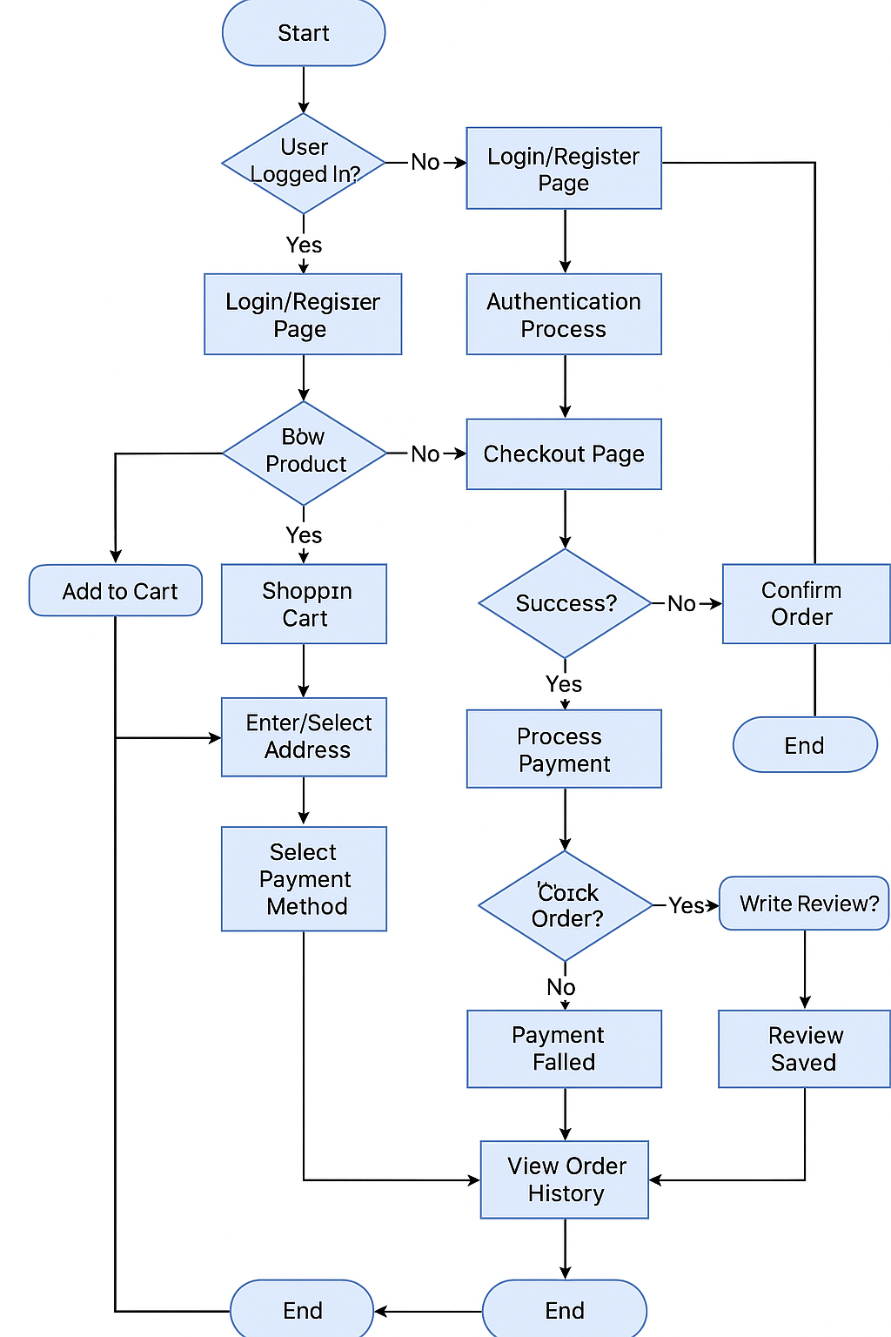

6. TESTING

Software testing is one of the most important phases in the development cycle of KidsKorner. The purpose of testing is to verify that the system operates correctly, meets the requirements, and is free from defects. Testing ensures the quality and reliability of the application before deployment.

The goal of testing is to identify any errors or bugs that may occur in the system and fix them before the system is used by real users. Testing was performed on each module of the application including registration, login, product management, payment, and admin dashboard. Manual testing was carried out to validate all functionalities and to ensure the proper working of both user-side and admin-side operations.

Through proper testing, we ensure:
- The system works according to the functional requirements
- The performance of the system remains smooth
- The output displayed is accurate and expected
- The system remains user-friendly and error-free
Testing plays a crucial role in system development as it improves reliability, accuracy, speed, and `` efficiency.

6.1 TEST PLAN

A test plan defines the scope, objectives, procedure, and resources used to test the system. The main purpose of defining a test plan for KidsKorner is to ensure that every module is tested thoroughly and that the final product meets the required quality standards.

Test Plan for KidsKorner includes:
- Identifying test scenarios
- Testing each module individually
- Testing complete workflow
- Checking system response with valid and invalid inputs
- Verifying payment gateway behavior
- Checking integration between modules and database

Test Objectives:
- Verify that the software meets user requirements
- Find and correct defects
- Ensure that all input validations and database operations work correctly
- Ensure smooth functioning of login, cart, wishlist, payment and admin modules

Scope of Testing:
- Front-end and UI testing
- Back-end logic testing
- Database communication testing
- Payment gateway testing
- Security and input validation
This ensures the platform is stable and ready for use.

6.2 TESTING STRATEGY

The testing strategy describes the approach and methods used for testing. KidsKorner follows a systematic testing approach:

✔ Manual Testing
Manual testing involves interacting with the application directly and checking the outputs manually. The website was tested using different test scenarios, user inputs, and operations.

✔ Module-wise Testing
Each module was tested separately:
- Registration/Login
- Product listing
- Add to cart
- Wishlist
- Checkout
- Payment
- Admin operations

✔ Integration Testing
After individual modules were tested, they were integrated to ensure smooth data flow between them. Example:
- Product selected in cart must appear in checkout.
- Orders should be stored and readable in admin panel.

✔ System Testing
The entire system was tested as a whole from starting the website to making orders and tracking them.

✔ Error and Exception Testing
Invalid inputs were entered during:
- Login
- Registration
- Payment
- Cart updates
This ensures the application handles wrong inputs gracefully.

6.3 TESTING METHODS

KidsKorner uses two primary testing methods:

✔ Black Box Testing:

Testing is done without knowing internal code. Only input and output are checked.
Examples:
- User enters incorrect password → Error message displayed
- Product is added to cart → Cart updates
This ensures the system behaves correctly from a user’s perspective.

✔ Functional Testing:

Functional checking was done on:
- Signup and login forms
- Cart and wishlist working
- Payment gateway redirect
- Order and profile modules
- Admin dashboard features
Functional testing ensures every module performs correctly as per requirements.

6.4 TESTING CASES

Here are sample standard test cases for the application:

Login Module
Test Case | Input | Expected Result | Actual Result
Valid login | Correct email, password | Redirect to dashboard | Successful
Invalid login | Wrong password | Error message | Correct

Registration
Test Case | Input | Expected Result | Actual
Valid details | Unique email, password | Account created | Successful
Duplicate email | Same email | Error shown | Correct

Cart Module
Test Case | Input | Expected Result | Actual
Add product | Click Add to Cart | Item shown in cart | Pass
Remove item | Click Remove | Item removed | Pass

Payment
Test Case | Input | Expected Result | Actual
COD | Select COD | Order placed | Pass
Online | Select online | Redirect to Cashfree | Pass

Admin Panel
Test Case | Input | Expected Result | Actual
Add new product | Form filled | Product saved | Pass
Update stock | Edit | Updated | Pass

6.4 ScreenShots

8. LIMITATIONS & FUTURE ENHANCEMENT

Although KidsKorner provides a complete online shopping experience and covers all major functionalities of an e-commerce system, there are still some limitations that can be improved in future versions. The current version is developed for academic and demonstration purposes on a local server environment, and hence, certain advanced features are not fully implemented.

Limitations of the System

- The system is currently deployed only on a local server (localhost) using XAMPP and not hosted on a live server.

- There is limited product filtering and searching functionality compared to large commercial platforms.

- The admin panel currently provides basic analytics and reporting but does not include advanced modules like automatic inventory forecasting.

- The system currently uses basic email notifications and does not include SMS or WhatsApp updates for users.

- Customer support features like chatbot or live assistance are not implemented.

- The site needs further optimization for performance, especially for high traffic and large product databases.

These limitations do not reduce the usability of the system but provide scope for further improvements and modernization in the future.

Future Enhancements

KidsKorner can be expanded and improved with new modern features, better design, and enhanced user experience:

- Deploying the website on a live domain and cloud hosting for real-world usage.

- Implementing advanced search and filtering options based on price, brand, ratings, and user preference.

- Adding more secure and popular payment options such as UPI, Google Pay, PhonePe, and net banking.

- Introducing mobile app version of KidsKorner using Flutter or Android Studio.

- Adding chatbot or AI-based assistant for customer support.

- Integrating courier tracking API for accurate real-time delivery updates.

- Improving admin dashboard with business statistics, reports, and graphs.

- Implementing loyalty points, discount coupons, offers, and membership features.

These enhancements will make the platform more scalable, efficient, and suitable for real commercial use. With these improvements, KidsKorner can easily grow into a competitive and modern e-commerce platform.

REFERENCES

• PHP Manual and Documentation – php.net

• MySQL Database Documentation – mysql.com

• Cashfree Payment Gateway Developer Docs

• Bootstrap Official Website – getbootstrap.com

• Tailwind CSS Documentation – tailwindcss.com

• JavaScript Tutorials – w3schools.com

• HTML & CSS Tutorials – mdn Web Docs

• StackOverflow Developer Community

• Various open-source articles and programming blogs

