Lab 9

Tên: Trần Nguyễn Minh Khôi
MSSV: 1150080059
Lớp: CNPM1
Form1.cs:
using System;
using System.Windows.Forms;
using Npgsql;

namespace _1150080059_TranNguyenMinhKhoi_Lab9
{
public partial class Form1 : Form
{
public Form1() { InitializeComponent(); }

private void Form1_Load(object sender, EventArgs e)
{
LoadDanhSachNxb();
txtMa.Focus();
}

private void LoadDanhSachNxb()
{
using (var conn = Db.GetOpenConnection())
using (var cmd = new NpgsqlCommand("SELECT * FROM sp_hienthi_nxb()", conn))
using (var rd = cmd.ExecuteReader())
{
lsvDanhSach.Items.Clear();
while (rd.Read())
{
string ma = rd.GetString(0);
string ten = rd.IsDBNull(1) ? "" : rd.GetString(1);
string dc = rd.IsDBNull(2) ? "" : rd.GetString(2);

var it = new ListViewItem(ma.Trim());
it.SubItems.Add(ten);
it.SubItems.Add(dc);
lsvDanhSach.Items.Add(it);
}
}
}

private void lsvDanhSach_SelectedIndexChanged(object sender, EventArgs e)
{
if (lsvDanhSach.SelectedItems.Count == 0) return;
var ma = lsvDanhSach.SelectedItems[0].SubItems[0].Text;
HienThiChiTietNxb(ma);
}

private void HienThiChiTietNxb(string ma)
{
using (var conn = Db.GetOpenConnection())
using (var cmd = new NpgsqlCommand("SELECT * FROM sp_chitiet_nxb(@p_ma)", conn))
{
cmd.Parameters.AddWithValue("p_ma", PadChar10(ma));

using (var rd = cmd.ExecuteReader())
{
txtMa.Text = txtTen.Text = txtDiaChi.Text = "";
if (rd.Read())
{
txtMa.Text = rd.GetString(0).Trim();
txtTen.Text = rd.IsDBNull(1) ? "" : rd.GetString(1);
txtDiaChi.Text = rd.IsDBNull(2) ? "" : rd.GetString(2);
}
}
}
}

private void btnThem_Click(object sender, EventArgs e)
{
var ma = PadChar10(txtMa.Text);
var ten = (txtTen.Text ?? "").Trim();
var dc = (txtDiaChi.Text ?? "").Trim();

if (string.IsNullOrWhiteSpace(ma.Trim()))
{ MessageBox.Show("Nhập mã NXB!"); txtMa.Focus(); return; }

using (var conn = Db.GetOpenConnection())
using (var cmd = new NpgsqlCommand("SELECT sp_them_nxb(@ma,@ten,@dc)", conn))
{
cmd.Parameters.AddWithValue("ma", ma);
cmd.Parameters.AddWithValue("ten", ten);
cmd.Parameters.AddWithValue("dc", dc);

int kq = Convert.ToInt32(cmd.ExecuteScalar());
if (kq > 0)
{
MessageBox.Show("Thêm thành công!");
LoadDanhSachNxb();
ClearInputs();
}
else MessageBox.Show("Mã NXB đã tồn tại!");
}
}

private void btnSua_Click(object sender, EventArgs e)
{
var ma = PadChar10(txtMa.Text);
var ten = (txtTen.Text ?? "").Trim();
var dc = (txtDiaChi.Text ?? "").Trim();

if (string.IsNullOrWhiteSpace(ma.Trim()))
{ MessageBox.Show("Chọn/nhập mã NXB để sửa!"); return; }

using (var conn = Db.GetOpenConnection())
using (var cmd = new NpgsqlCommand("SELECT sp_sua_nxb(@ma,@ten,@dc)", conn))
{
cmd.Parameters.AddWithValue("ma", ma);
cmd.Parameters.AddWithValue("ten", ten);
cmd.Parameters.AddWithValue("dc", dc);

int kq = Convert.ToInt32(cmd.ExecuteScalar());
if (kq > 0)
{
MessageBox.Show("Sửa thành công!");
LoadDanhSachNxb();
ClearInputs();
}
else MessageBox.Show("Không tìm thấy NXB để sửa!");
}
}
private void btnXoa_Click(object sender, EventArgs e)
{
var ma = PadChar10(txtMa.Text);
if (string.IsNullOrWhiteSpace(ma.Trim()))
{ MessageBox.Show("Chọn mã NXB để xóa!"); return; }

if (MessageBox.Show($"Xóa NXB {ma.Trim()}?", "Xác nhận",
MessageBoxButtons.YesNo, MessageBoxIcon.Warning) != DialogResult.Yes) return;

using (var conn = Db.GetOpenConnection())
using (var cmd = new NpgsqlCommand("SELECT sp_xoa_nxb(@ma)", conn))
{
cmd.Parameters.AddWithValue("ma", ma);

int kq = Convert.ToInt32(cmd.ExecuteScalar());
if (kq > 0)
{
MessageBox.Show("Xóa thành công!");
LoadDanhSachNxb();
ClearInputs();
}
else if (kq == -1)
{
MessageBox.Show("Không thể xóa do đang bị ràng buộc bởi bảng Sách.",
"Lỗi ràng buộc", MessageBoxButtons.OK, MessageBoxIcon.Error);
}
else MessageBox.Show("Không tìm thấy NXB để xóa!");
}
}

private void btnReload_Click(object sender, EventArgs e) => LoadDanhSachNxb();

private void ClearInputs()
{
txtMa.Text = txtTen.Text = txtDiaChi.Text = "";
txtMa.Focus();
}

private static string PadChar10(string s)
{
s = (s ?? "").Trim();
if (s.Length > 10) s = s.Substring(0, 10);
return s.PadRight(10, ' ');
}
}
}
Form1.Design.cs:
namespace _1150080059_TranNguyenMinhKhoi_Lab9
{
partial class Form1
{
private System.ComponentModel.IContainer components = null;

protected override void Dispose(bool disposing)
{
if (disposing && (components != null)) components.Dispose();
base.Dispose(disposing);
}

#region Windows Form Designer generated code
private void InitializeComponent()
{
this.lsvDanhSach = new System.Windows.Forms.ListView();
this.colMa = ((System.Windows.Forms.ColumnHeader)(new System.Windows.Forms.ColumnHeader()));
this.colTen = ((System.Windows.Forms.ColumnHeader)(new System.Windows.Forms.ColumnHeader()));
this.colDiaChi = ((System.Windows.Forms.ColumnHeader)(new System.Windows.Forms.ColumnHeader()));
this.label1 = new System.Windows.Forms.Label();
this.txtMa = new System.Windows.Forms.TextBox();
this.label2 = new System.Windows.Forms.Label();
this.txtTen = new System.Windows.Forms.TextBox();
this.label3 = new System.Windows.Forms.Label();
this.txtDiaChi = new System.Windows.Forms.TextBox();
this.btnThem = new System.Windows.Forms.Button();
this.btnSua = new System.Windows.Forms.Button();
this.btnXoa = new System.Windows.Forms.Button();
this.btnReload = new System.Windows.Forms.Button();
this.SuspendLayout();

// lsvDanhSach

this.lsvDanhSach.Columns.AddRange(new System.Windows.Forms.ColumnHeader[] {
this.colMa,
this.colTen,
this.colDiaChi});
this.lsvDanhSach.FullRowSelect = true;
this.lsvDanhSach.GridLines = true;
this.lsvDanhSach.HideSelection = false;
this.lsvDanhSach.Location = new System.Drawing.Point(12, 12);
this.lsvDanhSach.MultiSelect = false;
this.lsvDanhSach.Name = "lsvDanhSach";
this.lsvDanhSach.Size = new System.Drawing.Size(560, 260);
this.lsvDanhSach.TabIndex = 0;
this.lsvDanhSach.UseCompatibleStateImageBehavior = false;
this.lsvDanhSach.View = System.Windows.Forms.View.Details;
this.lsvDanhSach.SelectedIndexChanged += new System.EventHandler(this.lsvDanhSach_SelectedIndexChanged);

// colMa

this.colMa.Text = "Mã NXB";
this.colMa.Width = 90;

// colTen

this.colTen.Text = "Tên NXB";
this.colTen.Width = 180;

// colDiaChi

this.colDiaChi.Text = "Địa chỉ";
this.colDiaChi.Width = 270;

// label1

this.label1.AutoSize = true;
this.label1.Location = new System.Drawing.Point(590, 20);
this.label1.Name = "label1";
this.label1.Size = new System.Drawing.Size(49, 13);
this.label1.TabIndex = 1;
this.label1.Text = "Mã NXB";

// txtMa

this.txtMa.Location = new System.Drawing.Point(593, 36);
this.txtMa.MaxLength = 10;
this.txtMa.Name = "txtMa";
this.txtMa.Size = new System.Drawing.Size(220, 20);
this.txtMa.TabIndex = 2;

// label2

this.label2.AutoSize = true;
this.label2.Location = new System.Drawing.Point(590, 70);
this.label2.Name = "label2";
this.label2.Size = new System.Drawing.Size(51, 13);
this.label2.TabIndex = 3;
this.label2.Text = "Tên NXB";

// txtTen

this.txtTen.Location = new System.Drawing.Point(593, 86);
this.txtTen.Name = "txtTen";
this.txtTen.Size = new System.Drawing.Size(220, 20);
this.txtTen.TabIndex = 4;

// label3

this.label3.AutoSize = true;
this.label3.Location = new System.Drawing.Point(590, 120);
this.label3.Name = "label3";
this.label3.Size = new System.Drawing.Size(43, 13);
this.label3.TabIndex = 5;
this.label3.Text = "Địa chỉ";

// txtDiaChi

this.txtDiaChi.Location = new System.Drawing.Point(593, 136);
this.txtDiaChi.Multiline = true;
this.txtDiaChi.Name = "txtDiaChi";
this.txtDiaChi.Size = new System.Drawing.Size(220, 60);
this.txtDiaChi.TabIndex = 6;

// btnThem

this.btnThem.Location = new System.Drawing.Point(593, 215);
this.btnThem.Name = "btnThem";
this.btnThem.Size = new System.Drawing.Size(100, 30);
this.btnThem.TabIndex = 7;
this.btnThem.Text = "TH2 - Thêm";
this.btnThem.UseVisualStyleBackColor = true;
this.btnThem.Click += new System.EventHandler(this.btnThem_Click);

// btnSua

this.btnSua.Location = new System.Drawing.Point(713, 215);
this.btnSua.Name = "btnSua";
this.btnSua.Size = new System.Drawing.Size(100, 30);
this.btnSua.TabIndex = 8;
this.btnSua.Text = "TH3 - Sửa";
this.btnSua.UseVisualStyleBackColor = true;
this.btnSua.Click += new System.EventHandler(this.btnSua_Click);

// btnXoa

this.btnXoa.Location = new System.Drawing.Point(593, 255);
this.btnXoa.Name = "btnXoa";
this.btnXoa.Size = new System.Drawing.Size(100, 30);
this.btnXoa.TabIndex = 9;
this.btnXoa.Text = "TH4 - Xóa";
this.btnXoa.UseVisualStyleBackColor = true;
this.btnXoa.Click += new System.EventHandler(this.btnXoa_Click);

// btnReload

this.btnReload.Location = new System.Drawing.Point(713, 255);
this.btnReload.Name = "btnReload";
this.btnReload.Size = new System.Drawing.Size(100, 30);
this.btnReload.TabIndex = 10;
this.btnReload.Text = "TH1 - Reload";
this.btnReload.UseVisualStyleBackColor = true;
this.btnReload.Click += new System.EventHandler(this.btnReload_Click);

// Form1

this.ClientSize = new System.Drawing.Size(830, 300);
this.Controls.Add(this.btnReload);
this.Controls.Add(this.btnXoa);
this.Controls.Add(this.btnSua);
this.Controls.Add(this.btnThem);
this.Controls.Add(this.txtDiaChi);
this.Controls.Add(this.label3);
this.Controls.Add(this.txtTen);
this.Controls.Add(this.label2);
this.Controls.Add(this.txtMa);
this.Controls.Add(this.label1);
this.Controls.Add(this.lsvDanhSach);
this.Name = "Form1";
this.StartPosition = System.Windows.Forms.FormStartPosition.CenterScreen;
this.Text = "Quản lý Nhà Xuất Bản (PostgreSQL) — TH1–TH4";
this.Load += new System.EventHandler(this.Form1_Load);
this.ResumeLayout(false);
this.PerformLayout();
}
#endregion

private System.Windows.Forms.ListView lsvDanhSach;
private System.Windows.Forms.ColumnHeader colMa;
private System.Windows.Forms.ColumnHeader colTen;
private System.Windows.Forms.ColumnHeader colDiaChi;
private System.Windows.Forms.Label label1;
private System.Windows.Forms.TextBox txtMa;
private System.Windows.Forms.Label label2;
private System.Windows.Forms.TextBox txtTen;
private System.Windows.Forms.Label label3;
private System.Windows.Forms.TextBox txtDiaChi;
private System.Windows.Forms.Button btnThem;
private System.Windows.Forms.Button btnSua;
private System.Windows.Forms.Button btnXoa;
private System.Windows.Forms.Button btnReload;
}
}
Program.cs:
using System;
using System.Windows.Forms;

namespace _1150080059_TranNguyenMinhKhoi_Lab9
{
internal static class Program
{
[STAThread]
static void Main()
{
Application.EnableVisualStyles();
Application.SetCompatibleTextRenderingDefault(false);
Application.Run(new Form1());
}
}
}
DB.cs:
using System;
using System.Collections.Generic;
using System.Linq;
using System.Text;
using System.Threading.Tasks;
using Npgsql;
using System.Data;

namespace _1150080059_TranNguyenMinhKhoi_Lab9
{

public static class Db
{
private const string CONN_STR ="Host=localhost;Port=5432;Database=QuanLyBanSach;Username=postgres;Password=Minhkhoi2204";

public static NpgsqlConnection GetOpenConnection()
{
var conn = new NpgsqlConnection(CONN_STR);
conn.Open();
return conn;
}
}

}

Thực hành 1: Hiển thị danh sách nhà xuất bản sách.
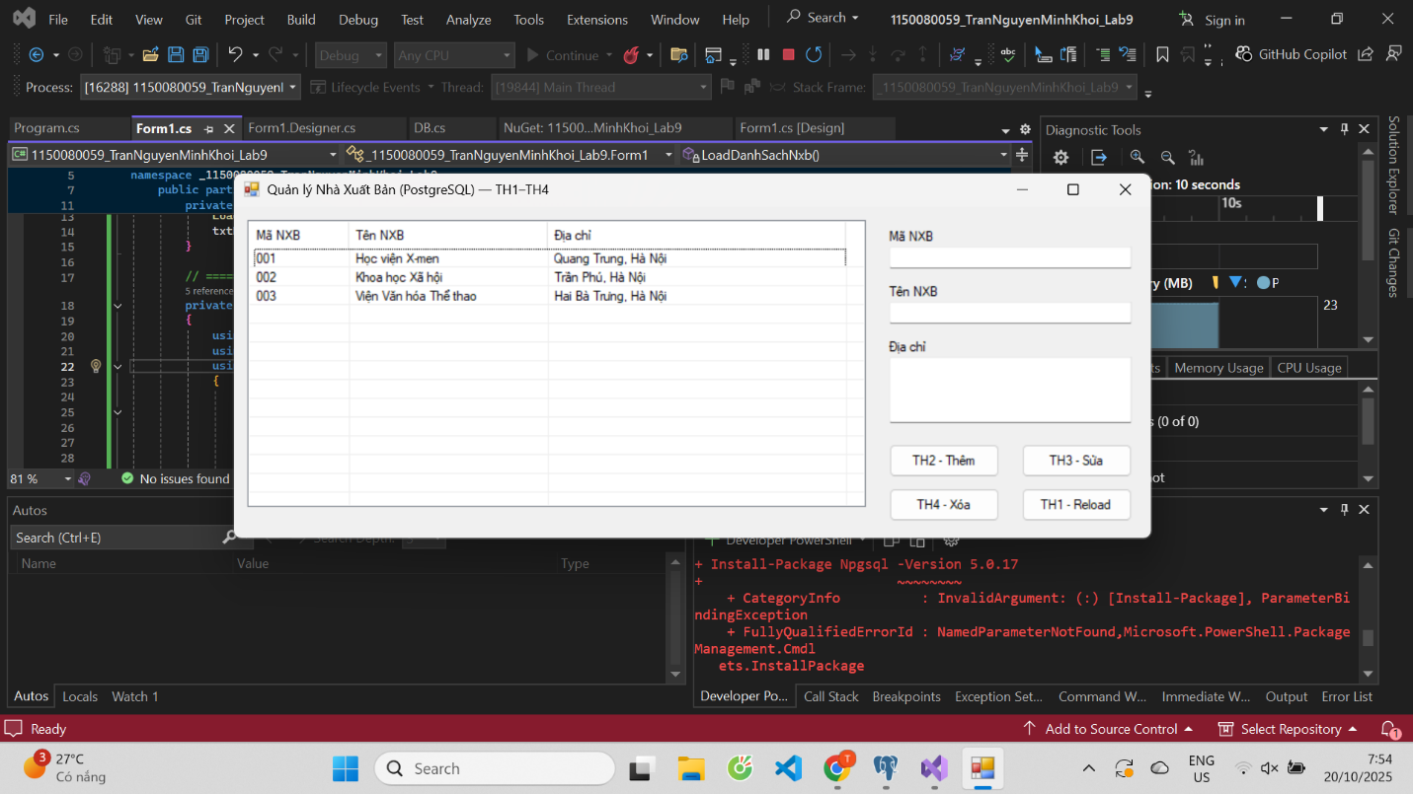
Thực hành 2: Thêm dữ liệu cho bảng Nhà xuất bản
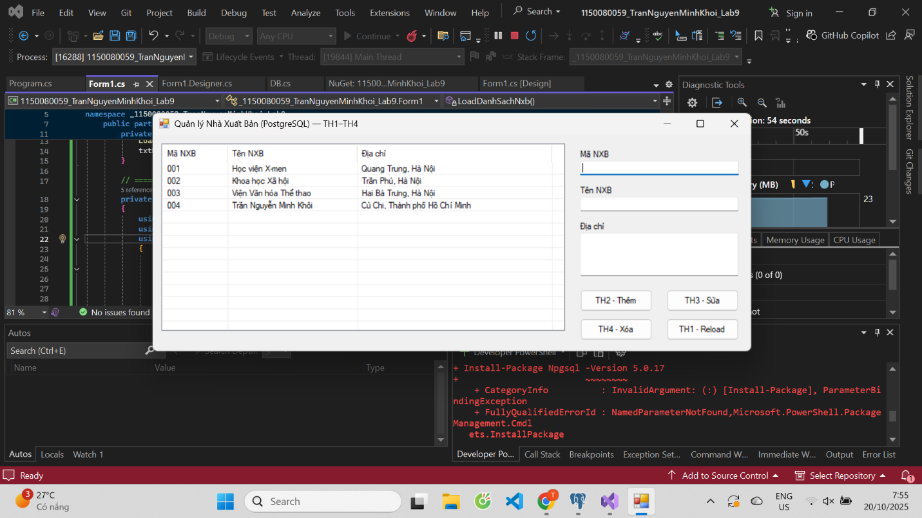
Thực hành 3: Sửa dữ liệu cho bảng Nhà Xuất bản.
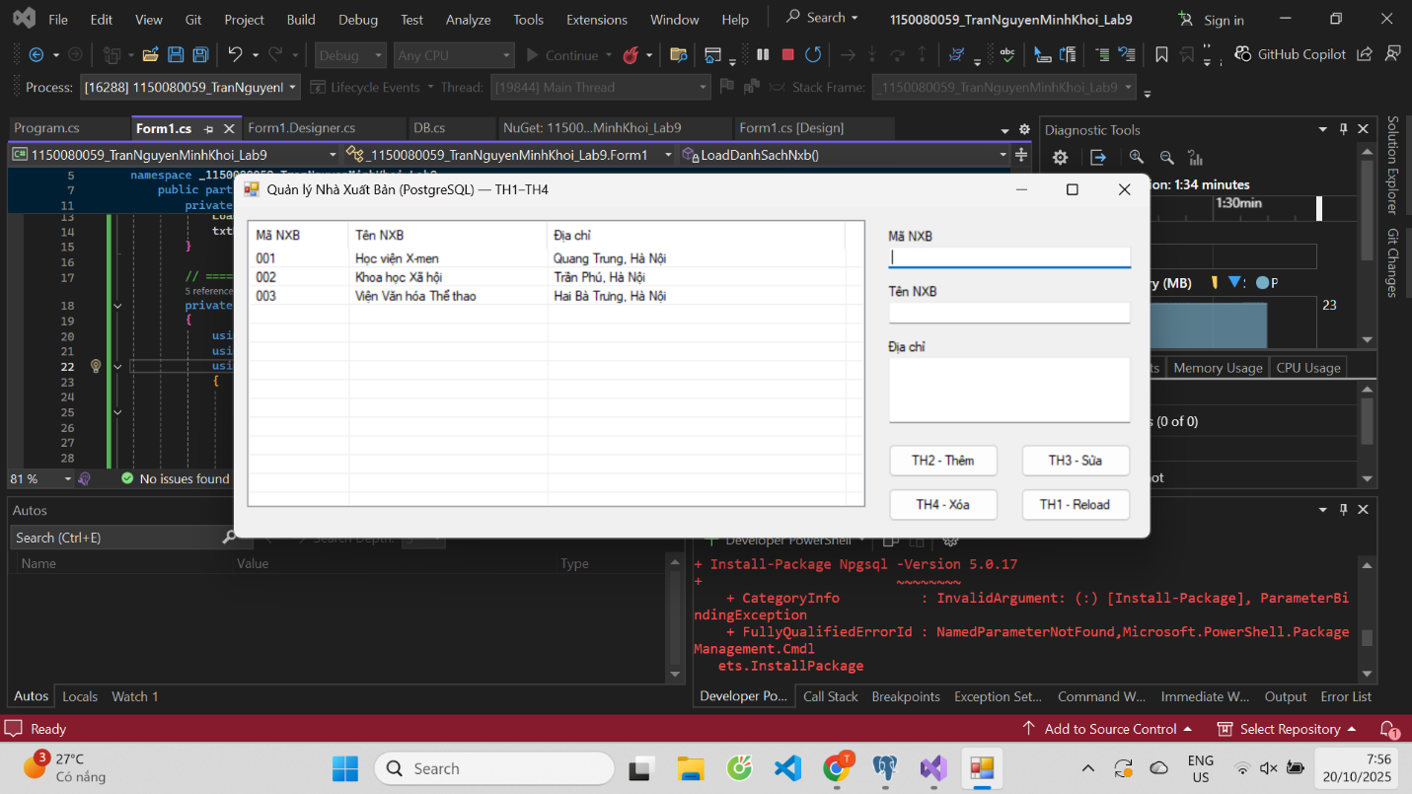
Thực hành 4: Xóa dữ liệu cho bảng Nhà xuất bản.

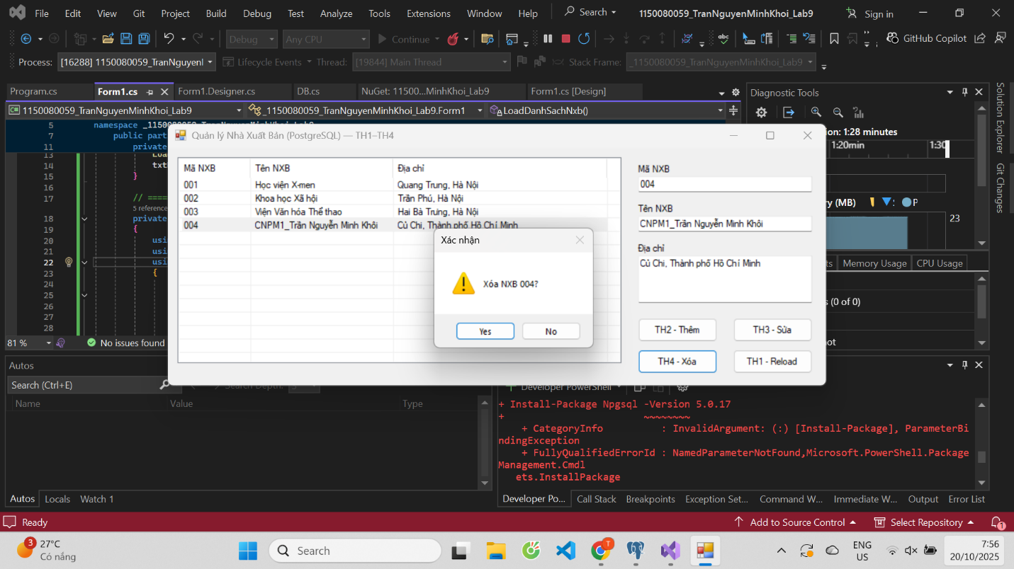
Thêm và xem dữ liệu trên cơ sở dữ liệu Postgresql:
