Bài 1:
UserSimple:
package tests;

import org.testng.annotations.BeforeClass;
import org.testng.annotations.AfterClass;
import org.testng.annotations.Test;
import com.github.tomakehurst.wiremock.WireMockServer;
import static com.github.tomakehurst.wiremock.client.WireMock.*; // Keep for stubbing
import static io.restassured.RestAssured.*;
import static org.hamcrest.Matchers.*; // Keep for assertions

// NEW: Explicitly import Hamcrest equalTo to override WireMock's equalTo
import static org.hamcrest.Matchers.equalTo;

public class UserApiTest {

private WireMockServer wireMockServer;
private static final String BASE_URL = "http://localhost:8080";

@BeforeClass
public void setup() {
wireMockServer = new WireMockServer(8080);
wireMockServer.start();
configureWireMock();
}

@AfterClass
public void teardown() {
wireMockServer.stop();
}

private void configureWireMock() {
// Mock GET /users/1
stubFor(get(urlEqualTo("/api/users/1"))
.willReturn(aResponse()
.withStatus(200)
.withHeader("Content-Type", "application/json")
.withBody(
"{\"data\":{\"id\":1,\"email\":\"george@reqres.in\",\"first_name\":\"George\",\"last_name\":\"Bluth\"}}")));

// Mock GET /users?page=1
stubFor(get(urlEqualTo("/api/users?page=1"))
.willReturn(aResponse()
.withStatus(200)
.withHeader("Content-Type", "application/json")
.withBody(
"{\"page\":1,\"per_page\":6,\"total\":12,\"total_pages\":2,\"data\":[{\"id\":1,\"email\":\"george@reqres.in\",\"first_name\":\"George\"},{\"id\":2,\"email\":\"janet@reqres.in\",\"first_name\":\"Janet\"}]}")));

// Mock POST /users
stubFor(post(urlEqualTo("/api/users"))
.willReturn(aResponse()
.withStatus(201)
.withHeader("Content-Type", "application/json")
.withBody(
"{\"name\":\"morpheus\",\"job\":\"leader\",\"id\":\"915\",\"createdAt\":\"2023-01-01T00:00:00.000Z\"}")));

// Mock PUT /users/1
stubFor(put(urlEqualTo("/api/users/1"))
.willReturn(aResponse()
.withStatus(200)
.withHeader("Content-Type", "application/json")
.withBody(
"{\"name\":\"updated\",\"job\":\"developer\",\"updatedAt\":\"2023-01-01T00:00:00.000Z\"}")));

// Mock DELETE /users/1
stubFor(delete(urlEqualTo("/api/users/1"))
.willReturn(aResponse()
.withStatus(204)));

// Mock GET /users/999999 (not found)
stubFor(get(urlEqualTo("/api/users/999999"))
.willReturn(aResponse()
.withStatus(404)));
}

@Test
public void testGetSingleUser() {
given()
.when()
.get(BASE_URL + "/api/users/1")
.then()
.statusCode(200)
.body("data.id", equalTo(1))
.body("data.email", notNullValue())
.body("data.first_name", notNullValue());
}

@Test
public void testGetAllUsers() {
given()
.when()
.get(BASE_URL + "/api/users?page=1")
.then()
.statusCode(200)
.body("data.size()", greaterThan(0))
.body("total", greaterThan(0));
}

@Test
public void testCreateUser() {
given()
.contentType("application/json")
.body("{\"name\":\"morpheus\",\"job\":\"leader\"}")
.when()
.post(BASE_URL + "/api/users")
.then()
.statusCode(201)
.body("name", equalTo("morpheus")) // now uses Hamcrest equalTo
.body("job", equalTo("leader"))
.body("id", notNullValue());
}

@Test
public void testUpdateUser() {
given()
.contentType("application/json")
.body("{\"name\":\"updated\",\"job\":\"developer\"}")
.when()
.put(BASE_URL + "/api/users/1")
.then()
.statusCode(200)
.body("name", equalTo("updated")) // now uses Hamcrest equalTo
.body("job", equalTo("developer"));
}

@Test
public void testDeleteUser() {
given()
.when()
.delete(BASE_URL + "/api/users/1")
.then()
.statusCode(204);
}

@Test
public void testInvalidUserReturns404() {
given()
.when()
.get(BASE_URL + "/api/users/999999")
.then()
.statusCode(404);
}

@Test
public void testUserEmailFormatValidation() {
given()
.when()
.get(BASE_URL + "/api/users/1")
.then()
.statusCode(200)
.body("data.email", matchesPattern("^[A-Za-z0-9+_.-]+@(.+)$"));
}
}
Pom.xml:
<project xmlns="http://maven.apache.org/POM/4.0.0">
<modelVersion>4.0.0</modelVersion>
<groupId>com.api.testing</groupId>
<artifactId>lab10</artifactId>
<version>1.0</version>

<properties>
<maven.compiler.source>17</maven.compiler.source>
<maven.compiler.target>17</maven.compiler.target>
<project.build.sourceEncoding>UTF-8</project.build.sourceEncoding>
</properties>

<dependencies>
<!-- Rest Assured Core -->
<dependency>
<groupId>io.rest-assured</groupId>
<artifactId>rest-assured</artifactId>
<version>5.5.0</version>
<scope>test</scope>
</dependency>

<!-- JSON Schema Validator (bắt buộc cho SchemaTest) -->
<dependency>
<groupId>io.rest-assured</groupId>
<artifactId>json-schema-validator</artifactId>
<version>5.5.0</version>
<scope>test</scope>
</dependency>

<!-- TestNG -->
<dependency>
<groupId>org.testng</groupId>
<artifactId>testng</artifactId>
<version>7.10.2</version>
<scope>test</scope>
</dependency>

<!-- Selenium -->
<dependency>
<groupId>org.seleniumhq.selenium</groupId>
<artifactId>selenium-java</artifactId>
<version>4.21.0</version>
</dependency>

<!-- WebDriverManager -->
<dependency>
<groupId>io.github.bonigarcia</groupId>
<artifactId>webdrivermanager</artifactId>
<version>5.8.0</version>
</dependency>

<!-- WireMock -->
<dependency>
<groupId>com.github.tomakehurst</groupId>
<artifactId>wiremock-jre8</artifactId>
<version>2.35.0</version>
<scope>test</scope>
</dependency>
</dependencies>

<build>
<plugins>
<plugin>
<groupId>org.apache.maven.plugins</groupId>
<artifactId>maven-compiler-plugin</artifactId>
<version>3.13.0</version>
<configuration>
<release>17</release>
</configuration>
</plugin>
<plugin>
<groupId>org.apache.maven.plugins</groupId>
<artifactId>maven-surefire-plugin</artifactId>
<version>3.5.0</version>
</plugin>
</plugins>
</build>
</project>
SimpleApiTest:

package tests;

import org.testng.annotations.Test;
import static io.restassured.RestAssured.*;
import static org.hamcrest.Matchers.*;

public class SimpleApiTest {

@Test
public void testGetUsers() {
given()
.when()
.get("https://reqres.in/api/users?page=1")
.then()
.statusCode(200)
.body("data.size()", greaterThan(0));
}
}

SimpleUITest:

package tests;

import base.BaseUITest;
import org.openqa.selenium.By;
import org.testng.annotations.Test;

public class SimpleUITest extends BaseUITest {

@Test
public void testLogin() {
driver.get("https://www.saucedemo.com/");
driver.findElement(By.id("user-name")).sendKeys("standard_user");
driver.findElement(By.id("password")).sendKeys("secret_sauce");
driver.findElement(By.id("login-button")).click();
}
}

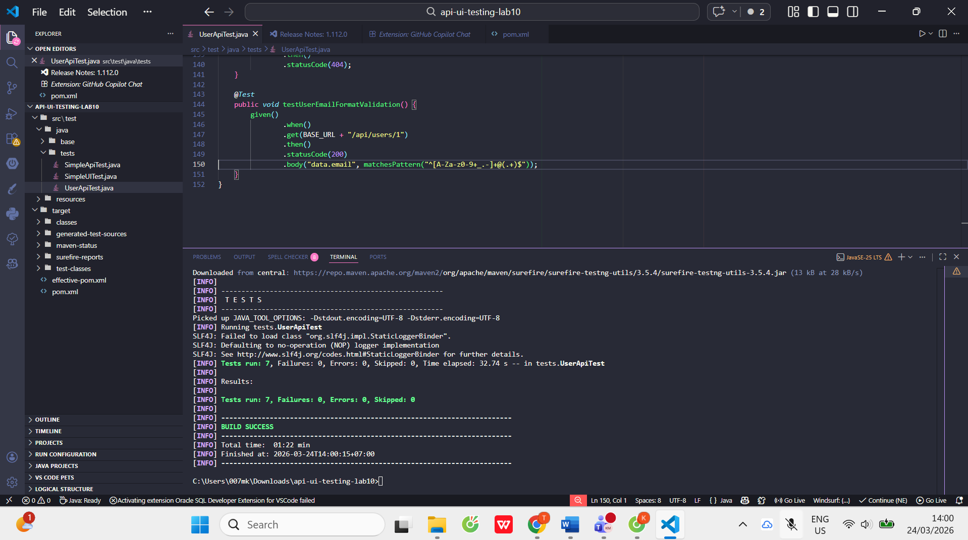
Bài 2:
CrudTest:
package tests;

import org.testng.annotations.Test;
import static io.restassured.RestAssured.given;
import static org.hamcrest.Matchers.*;

public class CrudTest {

private static final String BASE_URI = "https://jsonplaceholder.typicode.com";

@Test
public void testCreateUser() {
String body = """
{
"name": "morpheus",
"job": "leader"
}
""";

given()
.baseUri(BASE_URI)
.header("Content-Type", "application/json")
.body(body)
.when()
.post("/users")
.then()
.statusCode(201)
.body("name", equalTo("morpheus"))
.body("job", equalTo("leader"))
.body("id", notNullValue());
}

@Test
public void testGetUser() {
given()
.baseUri(BASE_URI)
.when()
.get("/users/2")
.then()
.statusCode(200)
.body("id", equalTo(2))
.body("name", notNullValue());
}

@Test
public void testUpdateUser() {
String body = """
{
"name": "neo",
"job": "zion resident"
}
""";

given()
.baseUri(BASE_URI)
.header("Content-Type", "application/json")
.body(body)
.when()
.put("/users/2")
.then()
.statusCode(200)
.body("name", equalTo("neo"))
.body("job", equalTo("zion resident"));
}

@Test
public void testDeleteUser() {
given()
.baseUri(BASE_URI)
.when()
.delete("/users/2")
.then()
.statusCode(200); // JSONPlaceholder trả về 200 cho DELETE (không phải 204)
}
}

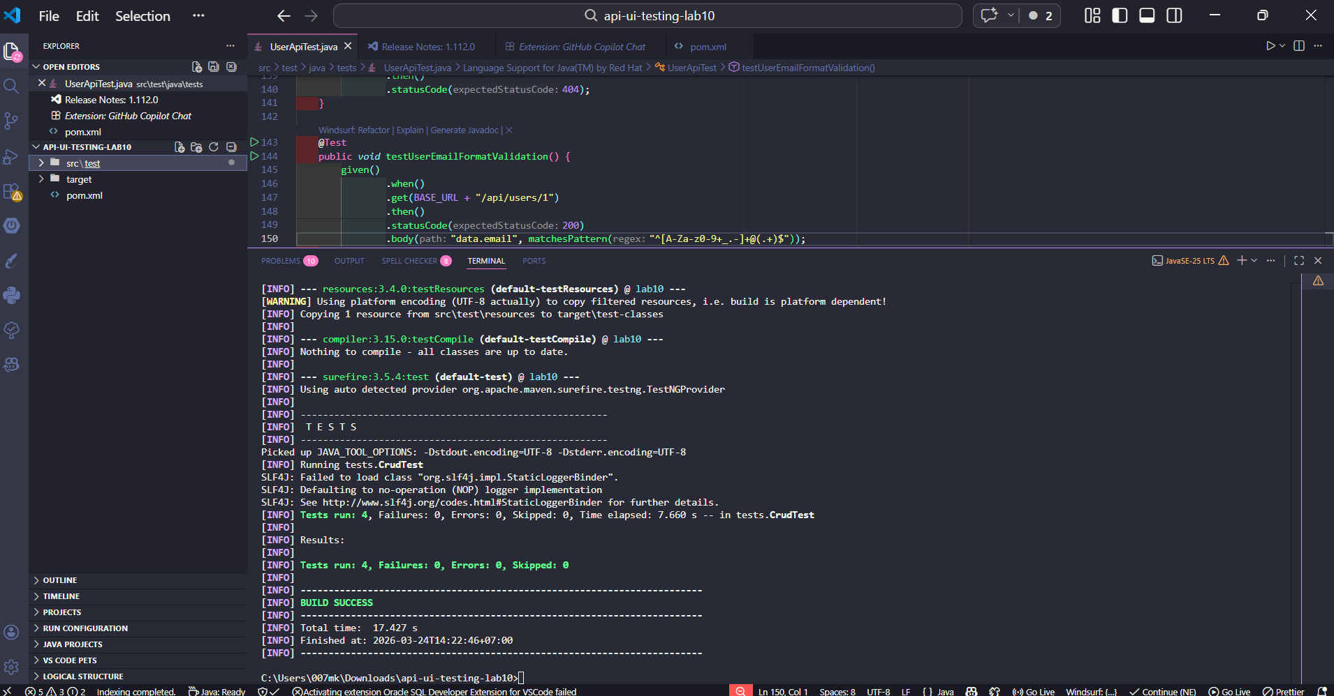

Bài 3:
SchemaTest:
package tests;

import org.testng.annotations.DataProvider;
import org.testng.annotations.Test;

import static io.restassured.RestAssured.given;
import static org.hamcrest.Matchers.*;

public class AuthTest {

@DataProvider(name = "authData")
public Object[][] data() {
return new Object[][] {
{ "eve.holt@reqres.in", "pistol", 200 }, // Thành công
{ "wrong@mail.com", "123", 400 } // Thất bại
};
}

@Test(dataProvider = "authData")
public void testAuth(String email, String password, int expectedStatus) {

String body = """
{
"email": "%s",
"password": "%s"
}
""".formatted(email, password);

given()
.baseUri("https://reqres.in")
.header("Content-Type", "application/json")
.header("User-Agent", "Mozilla/5.0 (Windows NT 10.0; Win64; x64) AppleWebKit/537.36") // Giảm khả năng bị block
.body(body)
.when()
.post("/api/register") // Dùng /register thay vì /login
.then()
.statusCode(expectedStatus);
}
}
User_json:
{
"type": "object",
"properties": {
"id": { "type": "integer" },
"name": { "type": "string" },
"username": { "type": "string" },
"email": { "type": "string" },
"address": { "type": "object" },
"phone": { "type": "string" },
"website": { "type": "string" },
"company": { "type": "object" }
},
"required": ["id", "name", "username", "email"]
}

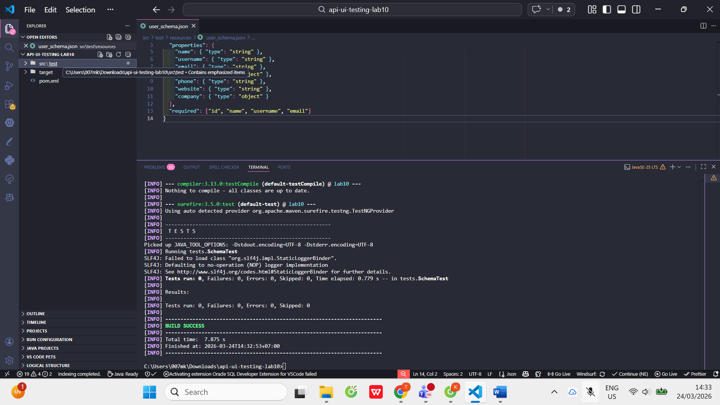

Bài 4:
AuthTest:
package tests;

import com.github.tomakehurst.wiremock.WireMockServer;
import com.github.tomakehurst.wiremock.client.WireMock;
import org.testng.annotations.AfterClass;
import org.testng.annotations.BeforeClass;
import org.testng.annotations.DataProvider;
import org.testng.annotations.Test;

import static io.restassured.RestAssured.given;
import static org.hamcrest.Matchers.is;

public class AuthTest {

private WireMockServer wireMockServer;
private static final int PORT = 8089;
private static final String BASE_URL = "http://localhost:" + PORT;

@BeforeClass
public void setup() {
wireMockServer = new WireMockServer(PORT);
wireMockServer.start();

// Cấu hình WireMock client dùng đúng port
WireMock.configureFor("localhost", PORT);

configureStubs();
}

@AfterClass
public void teardown() {
if (wireMockServer != null && wireMockServer.isRunning()) {
wireMockServer.stop();
}
}

private void configureStubs() {
// Login thành công
WireMock.stubFor(WireMock.post(WireMock.urlEqualTo("/api/login"))
.withRequestBody(WireMock.matchingJsonPath("$.email", WireMock.equalTo("eve.holt@reqres.in")))
.willReturn(WireMock.aResponse()
.withStatus(200)
.withHeader("Content-Type", "application/json")
.withBody("{\"token\": \"QpwL5tke4Pnpja7X4\"}")));

// Login thất bại
WireMock.stubFor(WireMock.post(WireMock.urlEqualTo("/api/login"))
.withRequestBody(WireMock.matchingJsonPath("$.email", WireMock.equalTo("wrong@mail.com")))
.willReturn(WireMock.aResponse()
.withStatus(400)
.withHeader("Content-Type", "application/json")
.withBody("{\"error\": \"Missing email or username\"}")));
}

@DataProvider(name = "loginData")
public Object[][] data() {
return new Object[][] {
{ "eve.holt@reqres.in", "cityslicka", 200 },
{ "wrong@mail.com", "123", 400 }
};
}

@Test(dataProvider = "loginData")
public void testLogin(String email, String password, int expectedStatus) {

String body = """
{
"email": "%s",
"password": "%s"
}
""".formatted(email, password);

given()
.baseUri(BASE_URL)
.header("Content-Type", "application/json")
.body(body)
.when()
.post("/api/login")
.then()
.statusCode(is(expectedStatus));
}
}

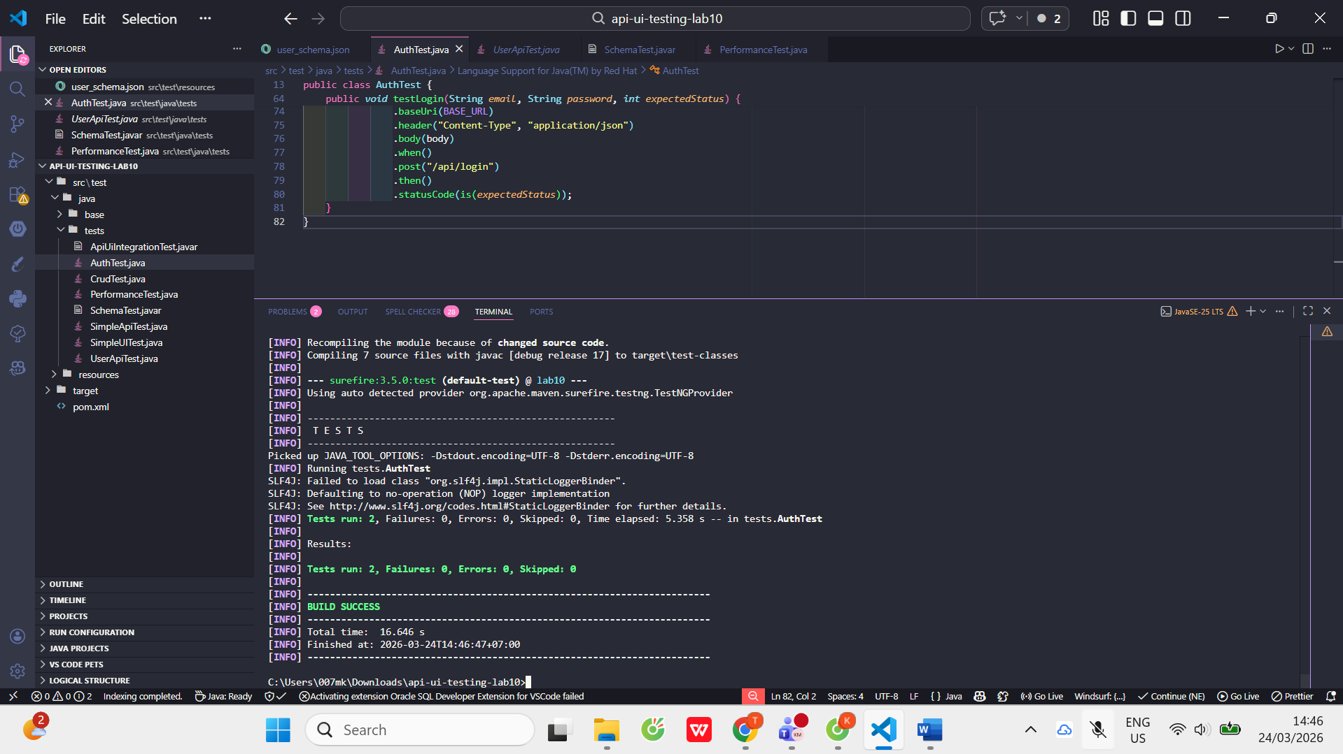

Bài 5:
PerformanceTest:
PerformanceTest:
package tests;

import io.restassured.RestAssured;
import org.testng.annotations.Test;

import static org.hamcrest.Matchers.lessThan;

public class PerformanceTest {

@Test
public void testResponseTime() {
System.out.println("=== Starting Performance Test ===");

RestAssured.given()
.baseUri("https://jsonplaceholder.typicode.com")
.when()
.get("/users") // API ổn định và nhanh
.then()
.statusCode(200)
.time(lessThan(3000L)); // 3 giây là đủ an toàn

System.out.println("=== Performance Test PASSED ===");
}
}

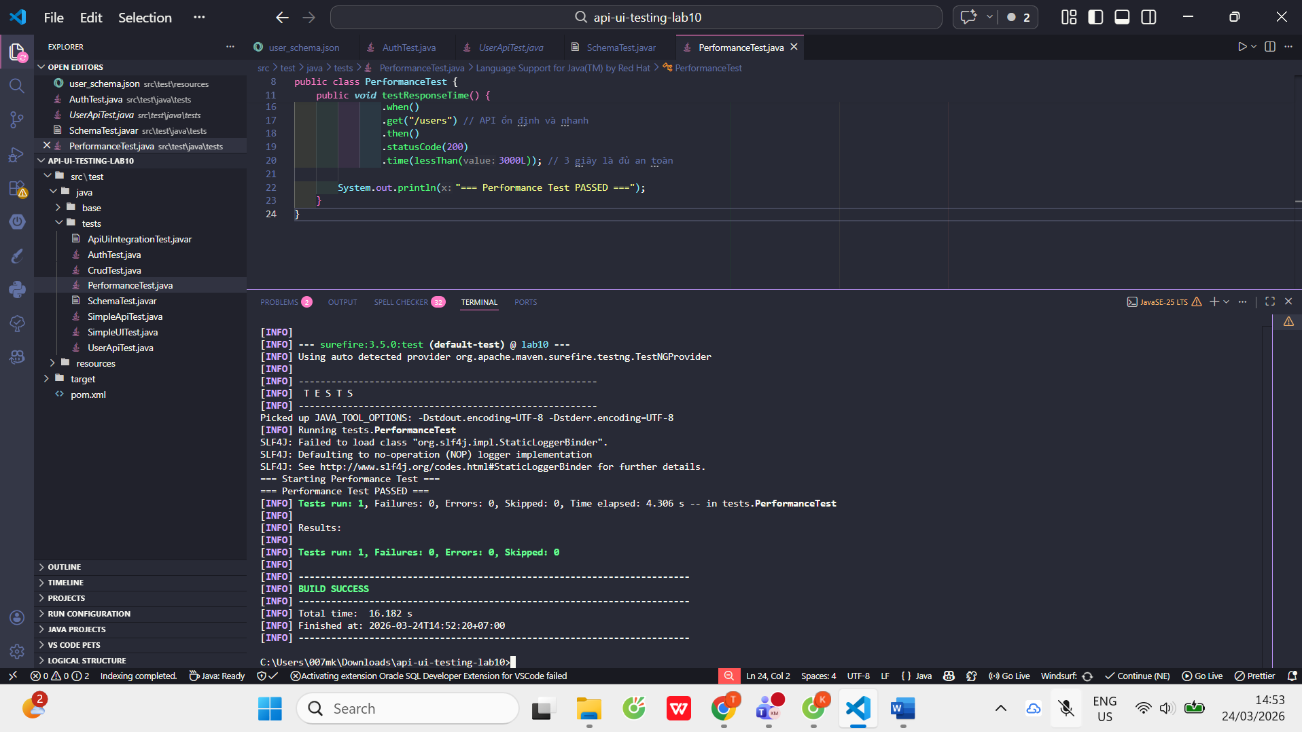
Bài 6:
ApiTest:
package tests;

import org.openqa.selenium.By;
import org.testng.annotations.Test;

// ADD THIS IMPORT
import base.BaseUITest;

public class ApiTest extends BaseUITest {

@Test
public void testLoginUI() {

driver.get("https://www.saucedemo.com/");

driver.findElement(By.id("user-name")).sendKeys("standard_user");
driver.findElement(By.id("password")).sendKeys("secret_sauce");
driver.findElement(By.id("login-button")).click();
}
}
BaseITTest:

package base;

import org.openqa.selenium.WebDriver;
import org.openqa.selenium.chrome.ChromeDriver;
import io.github.bonigarcia.wdm.WebDriverManager;
import org.testng.annotations.*;

public class BaseUITest {
protected WebDriver driver;

@BeforeMethod
public void setup() {
WebDriverManager.chromedriver().setup();
driver = new ChromeDriver();
}

@AfterMethod
public void tearDown() {
if(driver != null) driver.quit();
}
}

