Bài 1.2:
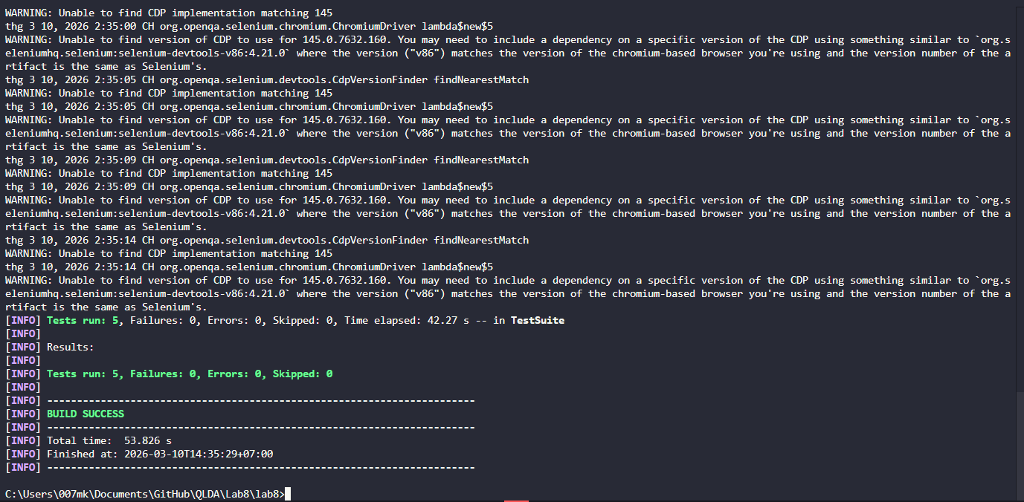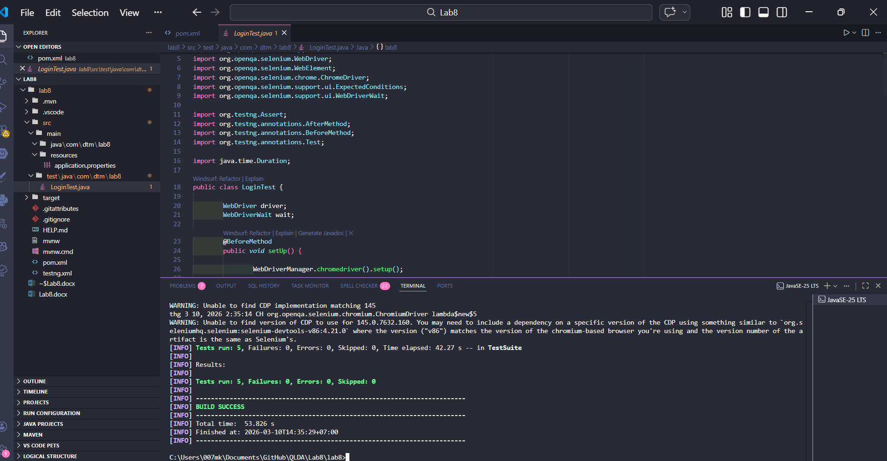
LoginTest.java:
package com.dtm.lab8;

import io.github.bonigarcia.wdm.WebDriverManager;
import org.openqa.selenium.By;
import org.openqa.selenium.WebDriver;
import org.openqa.selenium.WebElement;
import org.openqa.selenium.chrome.ChromeDriver;
import org.openqa.selenium.support.ui.ExpectedConditions;
import org.openqa.selenium.support.ui.WebDriverWait;

import org.testng.Assert;
import org.testng.annotations.AfterMethod;
import org.testng.annotations.BeforeMethod;
import org.testng.annotations.Test;

import java.time.Duration;

public class LoginTest {

WebDriver driver;
WebDriverWait wait;

@BeforeMethod
public void setUp() {

WebDriverManager.chromedriver().setup();

driver = new ChromeDriver();
driver.manage().window().maximize();
driver.get("https://www.saucedemo.com");

wait = new WebDriverWait(driver, Duration.ofSeconds(10));
}

@AfterMethod
public void tearDown() {

if (driver != null) {
driver.quit();
}
}

@Test(description = "Login thanh cong")
public void testLoginSuccess() {

driver.findElement(By.id("user-name")).sendKeys("standard_user");
driver.findElement(By.id("password")).sendKeys("secret_sauce");
driver.findElement(By.id("login-button")).click();

wait.until(ExpectedConditions.urlContains("inventory.html"));

Assert.assertTrue(
driver.getCurrentUrl().contains("inventory"),
"Dang nhap thanh cong nhung khong chuyen trang!");
}

@Test(description = "Sai mat khau")
public void testLoginWrongPassword() {

driver.findElement(By.id("user-name")).sendKeys("standard_user");
driver.findElement(By.id("password")).sendKeys("wrong_pass");
driver.findElement(By.id("login-button")).click();

WebElement error = wait.until(
ExpectedConditions.visibilityOfElementLocated(By.cssSelector("[data-test='error']")));

Assert.assertTrue(
error.isDisplayed(),
"Nhap sai password nhung khong hien thong bao loi");
}

@Test(description = "Bo trong username")
public void testLoginEmptyUsername() {

driver.findElement(By.id("password")).sendKeys("secret_sauce");
driver.findElement(By.id("login-button")).click();

WebElement error = wait.until(
ExpectedConditions.visibilityOfElementLocated(By.cssSelector("[data-test='error']")));

Assert.assertEquals(
error.getText(),
"Epic sadface: Username is required",
"Thong bao Username required khong dung");
}

@Test(description = "Bo trong password")
public void testLoginEmptyPassword() {

driver.findElement(By.id("user-name")).sendKeys("standard_user");
driver.findElement(By.id("login-button")).click();

WebElement error = wait.until(
ExpectedConditions.visibilityOfElementLocated(By.cssSelector("[data-test='error']")));

Assert.assertEquals(
error.getText(),
"Epic sadface: Password is required",
"Thong bao Password required khong dung");
}

@Test(description = "User bi khoa")
public void testLoginLockedUser() {

driver.findElement(By.id("user-name")).sendKeys("locked_out_user");
driver.findElement(By.id("password")).sendKeys("secret_sauce");
driver.findElement(By.id("login-button")).click();

WebElement error = wait.until(
ExpectedConditions.visibilityOfElementLocated(By.cssSelector("[data-test='error']")));

Assert.assertTrue(
error.getText().contains("locked out"),
"User bi khoa nhung khong hien thong bao");
}
}
Pom.xml:
<?xml version="1.0" encoding="UTF-8"?>

<project xmlns="http://maven.apache.org/POM/4.0.0"
xmlns:xsi="http://www.w3.org/2001/XMLSchema-instance"
xsi:schemaLocation="http://maven.apache.org/POM/4.0.0
https://maven.apache.org/xsd/maven-4.0.0.xsd">

<modelVersion>4.0.0</modelVersion>

<groupId>com.dtm</groupId>
<artifactId>lab8</artifactId>
<version>0.0.1-SNAPSHOT</version>

<properties>
<maven.compiler.source>21</maven.compiler.source>
<maven.compiler.target>21</maven.compiler.target>
</properties>

<dependencies>

<!-- Selenium -->
<dependency>
<groupId>org.seleniumhq.selenium</groupId>
<artifactId>selenium-java</artifactId>
<version>4.21.0</version>
</dependency>

<!-- WebDriverManager -->
<dependency>
<groupId>io.github.bonigarcia</groupId>
<artifactId>webdrivermanager</artifactId>
<version>5.8.0</version>
</dependency>

<!-- TestNG -->
<dependency>
<groupId>org.testng</groupId>
<artifactId>testng</artifactId>
<version>7.10.2</version>
</dependency>

</dependencies>

<build>
<plugins>

<!-- Compiler -->
<plugin>
<groupId>org.apache.maven.plugins</groupId>
<artifactId>maven-compiler-plugin</artifactId>
<version>3.13.0</version>
<configuration>
<source>21</source>
<target>21</target>
</configuration>
</plugin>

<!-- Run TestNG -->
<plugin>
<groupId>org.apache.maven.plugins</groupId>
<artifactId>maven-surefire-plugin</artifactId>
<version>3.2.5</version>
<configuration>
<suiteXmlFiles>
<suiteXmlFile>testng.xml</suiteXmlFile>
</suiteXmlFiles>
</configuration>
</plugin>

</plugins>
</build>

</project>

Testing.xml: <!DOCTYPE suite SYSTEM "https://testng.org/testng-1.0.dtd">
<suite name="LoginTestSuite">

<test name="LoginTest">
<classes>
<class name="com.dtm.lab8.LoginTest"/>
</classes>
</test>

</suite>

Bai2.2:
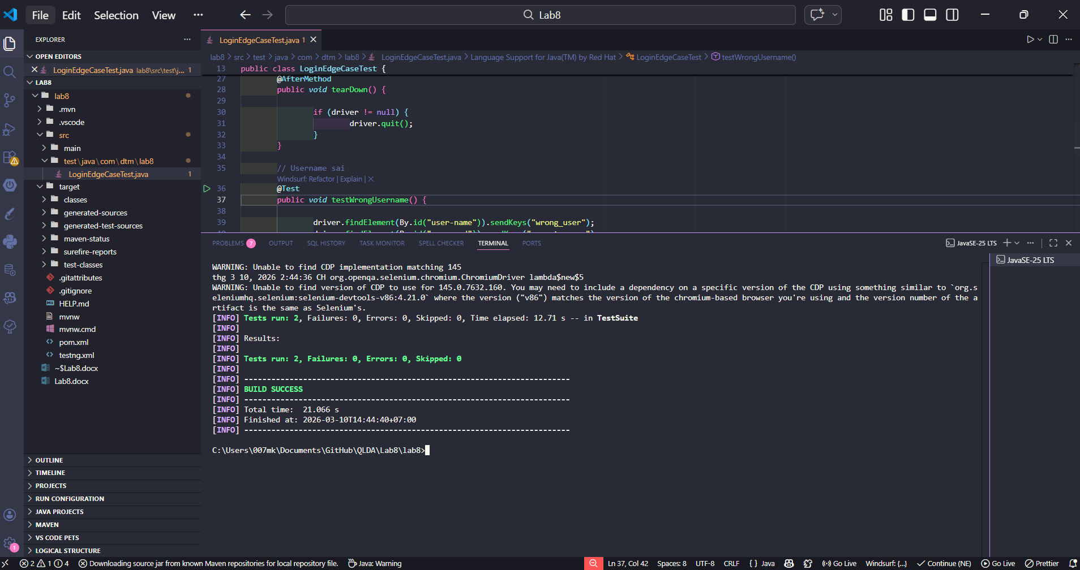
LoginEdgeCaseTest.java:
package com.dtm.lab8;

import io.github.bonigarcia.wdm.WebDriverManager;
import org.openqa.selenium.By;
import org.openqa.selenium.WebDriver;
import org.openqa.selenium.chrome.ChromeDriver;

import org.testng.Assert;
import org.testng.annotations.AfterMethod;
import org.testng.annotations.BeforeMethod;
import org.testng.annotations.Test;

public class LoginEdgeCaseTest {

WebDriver driver;

@BeforeMethod
public void setUp() {

WebDriverManager.chromedriver().setup();
driver = new ChromeDriver();

driver.manage().window().maximize();
driver.get("https://www.saucedemo.com");
}

@AfterMethod
public void tearDown() {

if (driver != null) {
driver.quit();
}
}

// Username sai
@Test
public void testWrongUsername() {

driver.findElement(By.id("user-name")).sendKeys("wrong_user");
driver.findElement(By.id("password")).sendKeys("secret_sauce");
driver.findElement(By.id("login-button")).click();

String error = driver.findElement(By.cssSelector("[data-test='error']")).getText();

Assert.assertTrue(error.contains("Username and password do not match"));
}

// Username và password sai
@Test
public void testWrongUserAndPassword() {

driver.findElement(By.id("user-name")).sendKeys("abc");
driver.findElement(By.id("password")).sendKeys("123");
driver.findElement(By.id("login-button")).click();

String error = driver.findElement(By.cssSelector("[data-test='error']")).getText();

Assert.assertTrue(error.contains("Username and password do not match"));
}
}
Bai2.2:
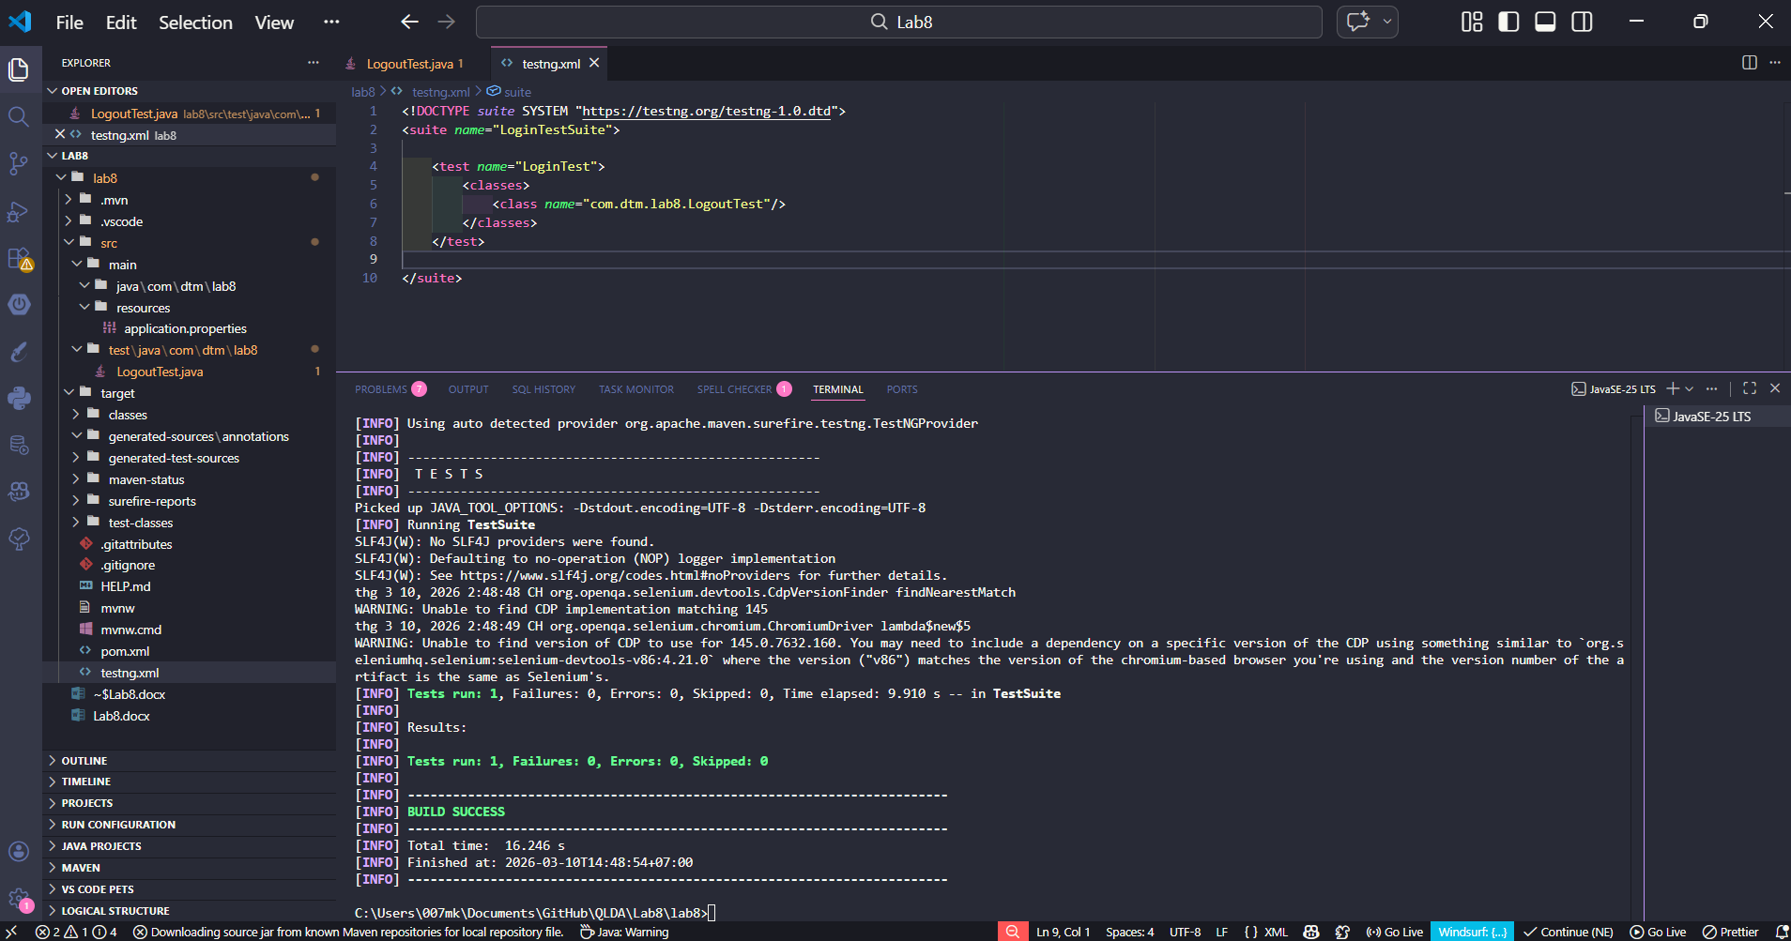
LogoutTest.java: package com.dtm.lab8;

import io.github.bonigarcia.wdm.WebDriverManager;
import org.openqa.selenium.By;
import org.openqa.selenium.WebDriver;
import org.openqa.selenium.chrome.ChromeDriver;

import org.testng.Assert;
import org.testng.annotations.AfterMethod;
import org.testng.annotations.BeforeMethod;
import org.testng.annotations.Test;

public class LogoutTest {

WebDriver driver;

@BeforeMethod
public void setup() {

WebDriverManager.chromedriver().setup();
driver = new ChromeDriver();

driver.manage().window().maximize();
driver.get("https://www.saucedemo.com");

driver.findElement(By.id("user-name")).sendKeys("standard_user");
driver.findElement(By.id("password")).sendKeys("secret_sauce");
driver.findElement(By.id("login-button")).click();
}

@AfterMethod
public void tearDown() {

if (driver != null) {
driver.quit();
}
}

@Test
public void testLogout() {

driver.findElement(By.id("react-burger-menu-btn")).click();
driver.findElement(By.id("logout_sidebar_link")).click();

Assert.assertTrue(driver.getCurrentUrl().contains("saucedemo.com"));
}
}

Bai2.3:
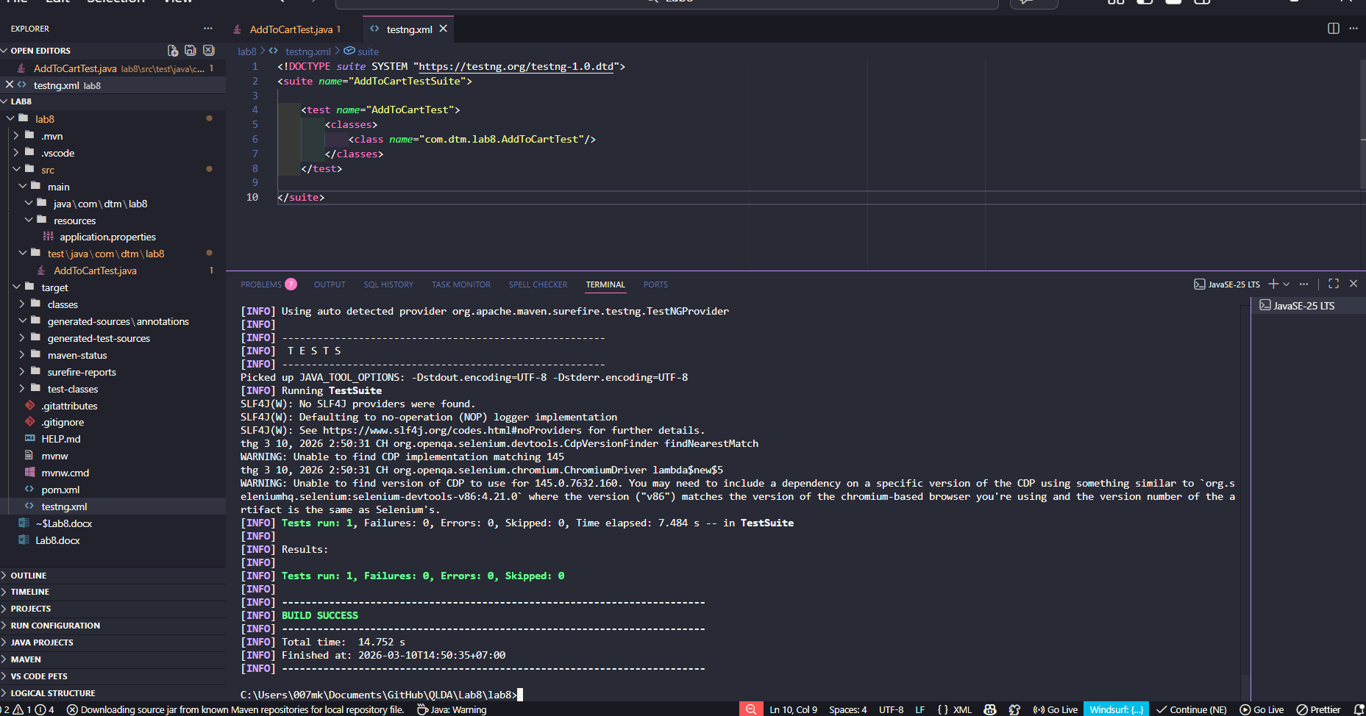
AddToCartTest.java: package com.dtm.lab8;

import io.github.bonigarcia.wdm.WebDriverManager;
import org.openqa.selenium.By;
import org.openqa.selenium.WebDriver;
import org.openqa.selenium.chrome.ChromeDriver;

import org.testng.Assert;
import org.testng.annotations.*;

public class AddToCartTest {

WebDriver driver;

@BeforeMethod
public void setup() {

WebDriverManager.chromedriver().setup();
driver = new ChromeDriver();

driver.manage().window().maximize();
driver.get("https://www.saucedemo.com");

driver.findElement(By.id("user-name")).sendKeys("standard_user");
driver.findElement(By.id("password")).sendKeys("secret_sauce");
driver.findElement(By.id("login-button")).click();
}

@AfterMethod
public void tearDown() {

if (driver != null) {
driver.quit();
}
}

@Test
public void testAddProductToCart() {

driver.findElement(By.id("add-to-cart-sauce-labs-backpack")).click();

String cartBadge = driver.findElement(By.className("shopping_cart_badge")).getText();

Assert.assertEquals(cartBadge, "1");
}
}

Bai2.4:
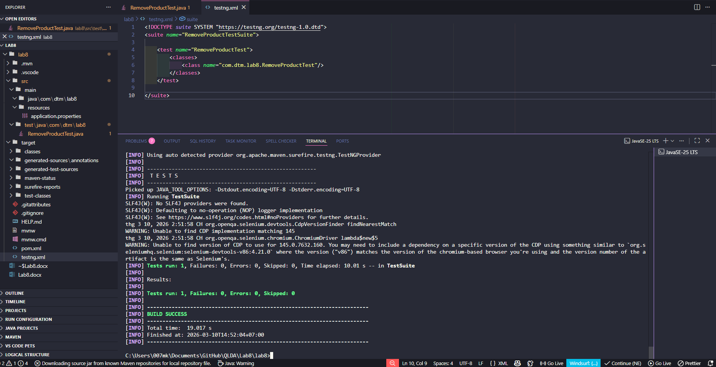
RemoveProductTest.java:
package com.dtm.lab8;

import io.github.bonigarcia.wdm.WebDriverManager;
import org.openqa.selenium.By;
import org.openqa.selenium.WebDriver;
import org.openqa.selenium.chrome.ChromeDriver;

import org.testng.Assert;
import org.testng.annotations.*;

public class RemoveProductTest {

WebDriver driver;

@BeforeMethod
public void setup() {

WebDriverManager.chromedriver().setup();
driver = new ChromeDriver();

driver.manage().window().maximize();
driver.get("https://www.saucedemo.com");

driver.findElement(By.id("user-name")).sendKeys("standard_user");
driver.findElement(By.id("password")).sendKeys("secret_sauce");
driver.findElement(By.id("login-button")).click();
}

@AfterMethod
public void tearDown() {

if (driver != null) {
driver.quit();
}
}

@Test
public void testRemoveProduct() {

driver.findElement(By.id("add-to-cart-sauce-labs-backpack")).click();
driver.findElement(By.id("remove-sauce-labs-backpack")).click();

boolean cartEmpty = driver.findElements(By.className("shopping_cart_badge")).isEmpty();

Assert.assertTrue(cartEmpty);
}
}

Bai3.1:
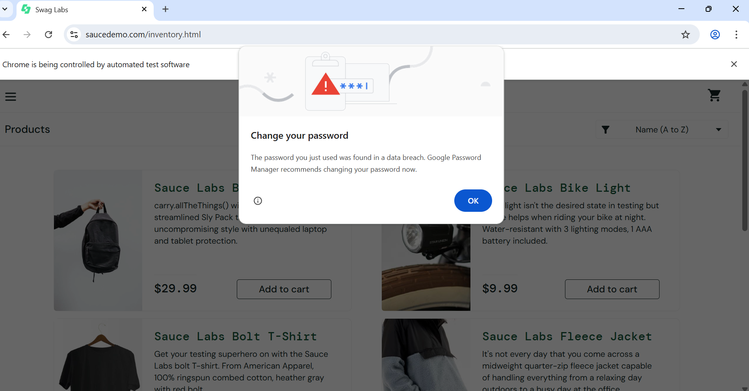
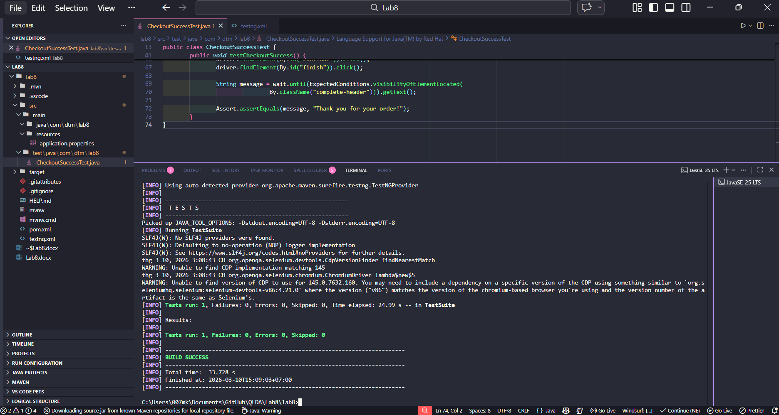
Bai3.2:
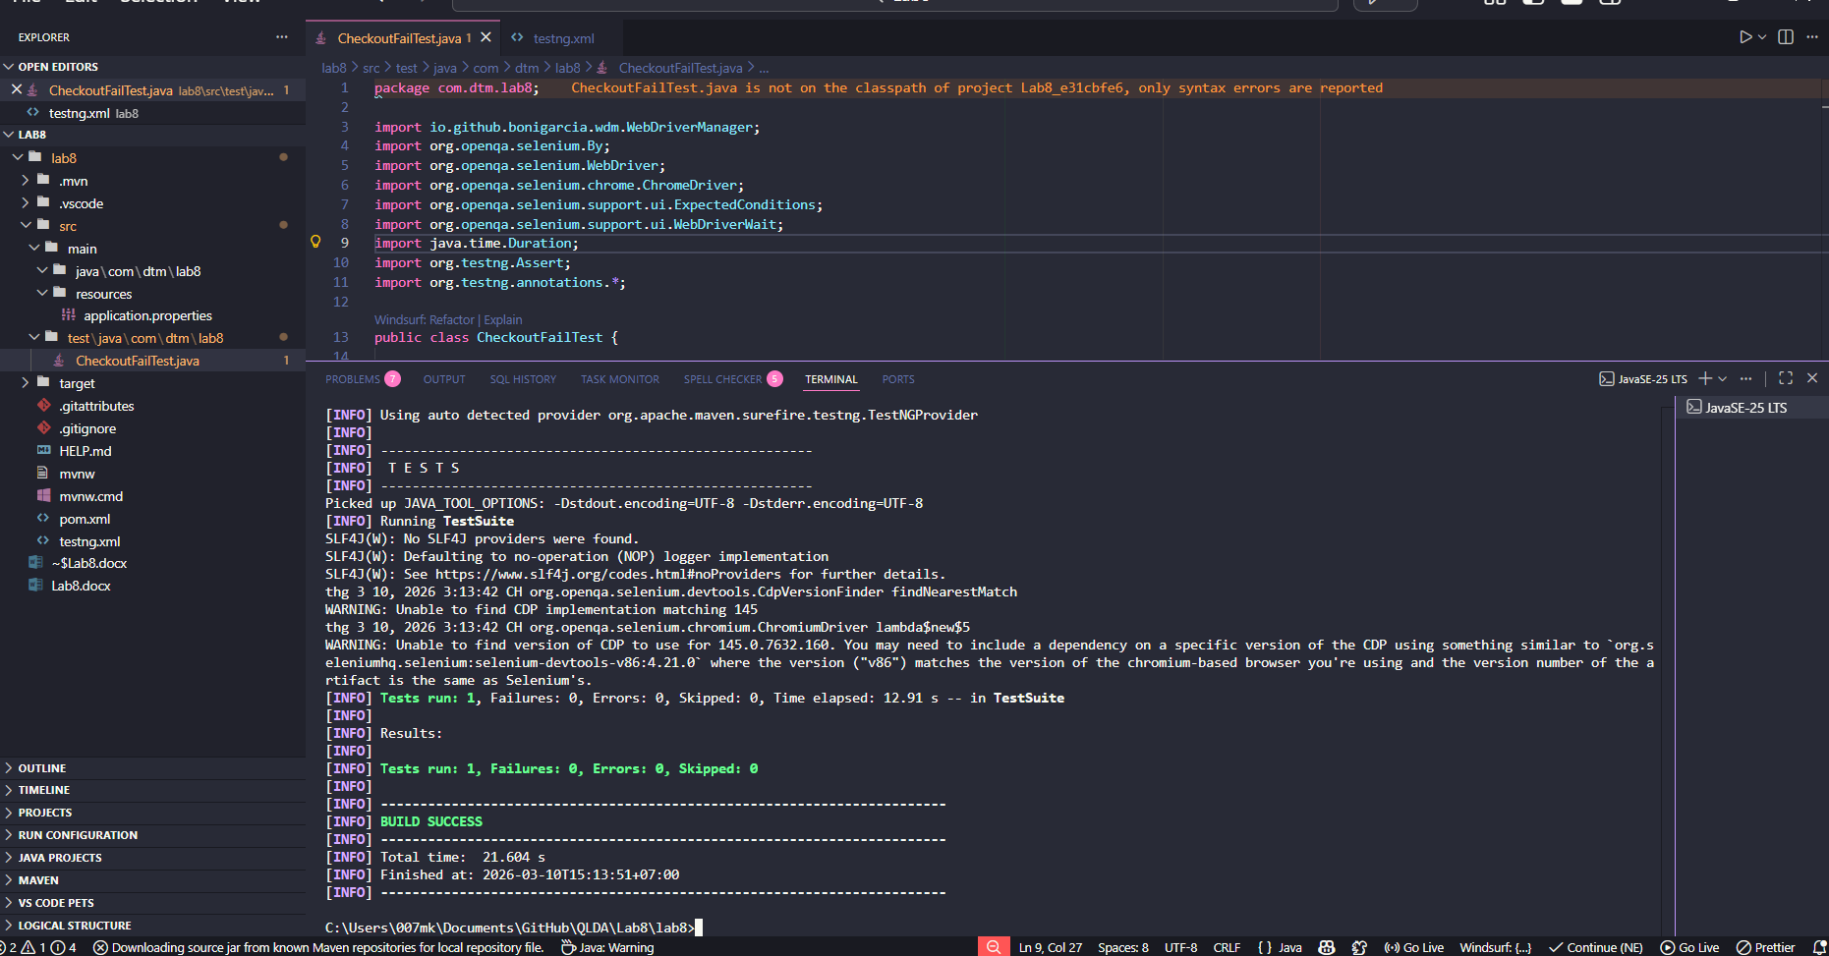
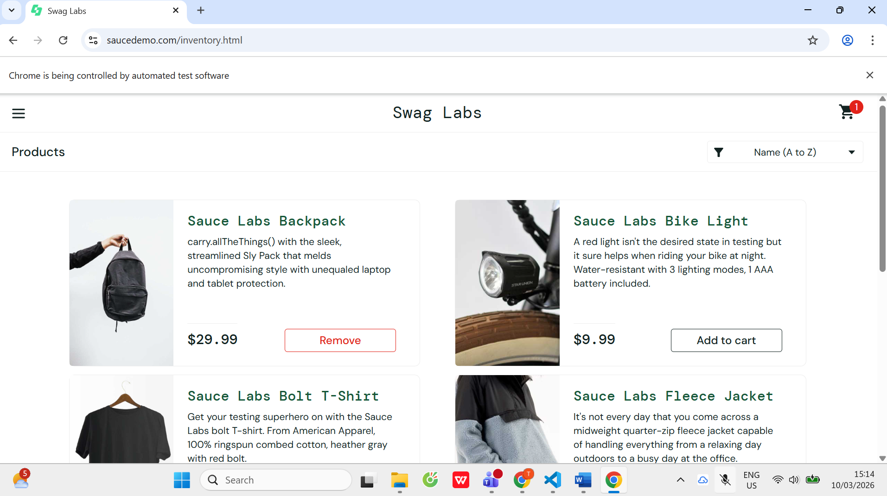
Bai4.1:
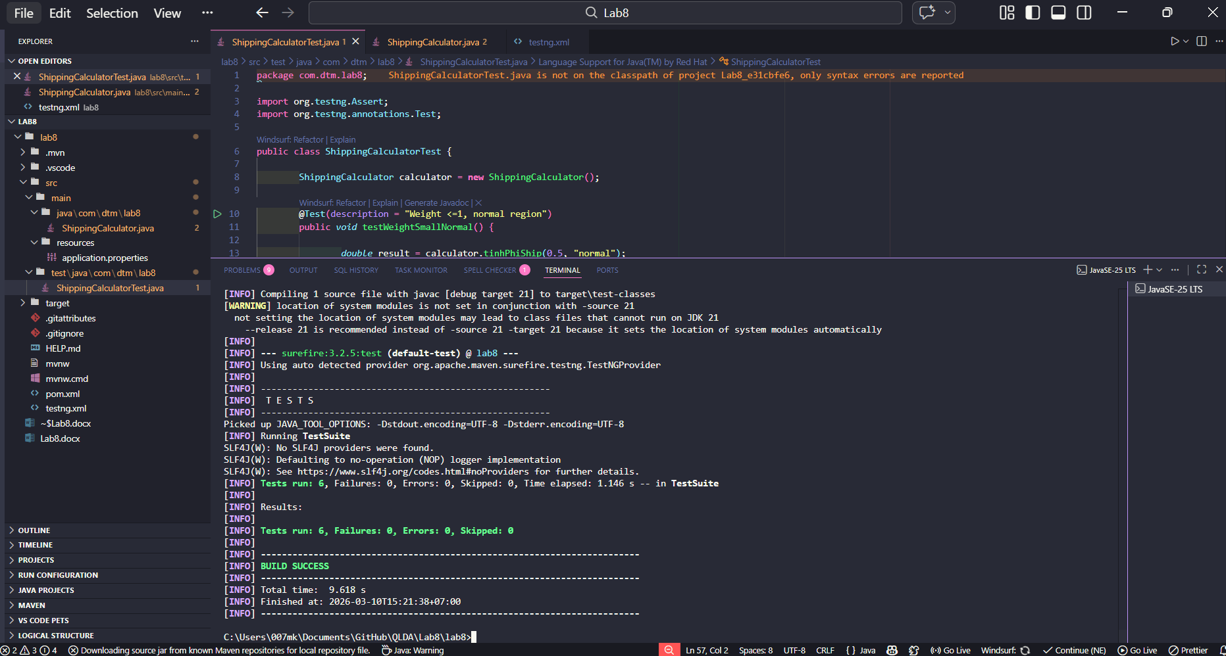
Bai4.2:
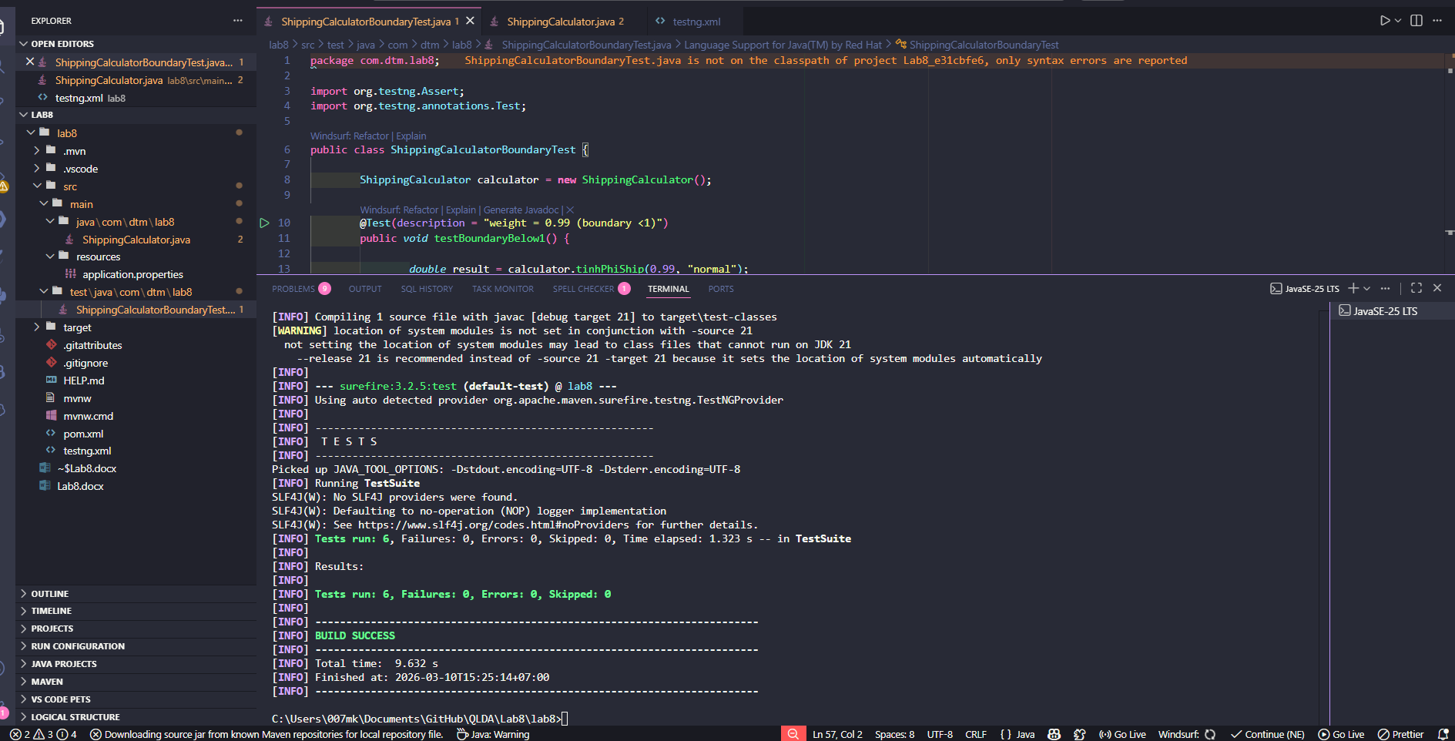
Bai4.3:
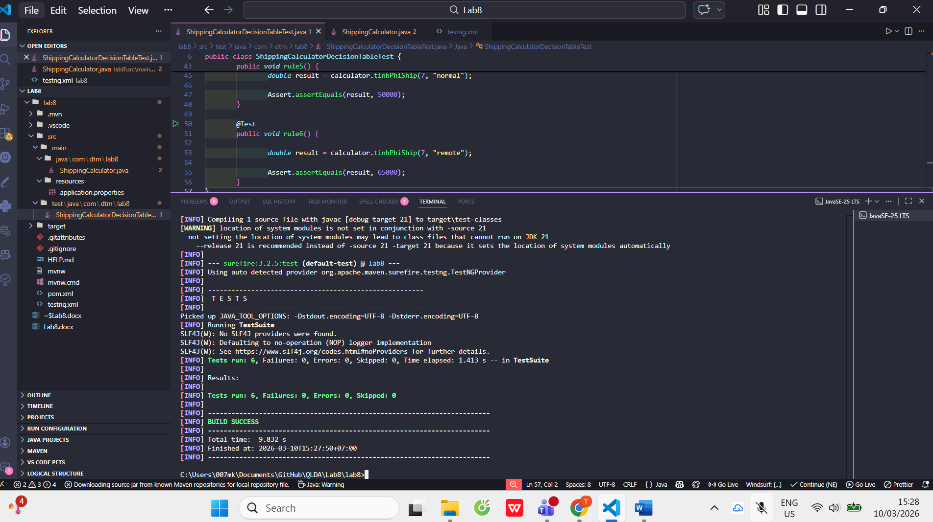
Bai5.1:
