**ANN OR GATE - Michael Kibugu 093371**

The **OR gate** is a digital logic gate that implements logical disjunction and behaves like the Truth table shown below. This is our expected output from the ANN implementation.

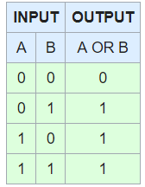

In this implementation, I make use of an artificial neural network to implement an **OR gate**. The neural network takes two inputs which are then passed through two hidden layers.

The network also uses the backpropagation algorithm with the sigmoid activation function to produce an output(either 1 or 0), depending on the combination of input values.

Some of the other variables are stated below:-

Iterations - 15,000

Random Weights - [-0.3,0.5] and [-0.4,0.8]

**My ANN Implementation Output.**

