**DATE SUBMITTED: 11/10/18**

**Task 1**

|  |
| --- |
| /* TI-RTOS Header files */ #include <xdc/std.h> #include <ti/sysbios/BIOS.h> #include <ti/sysbios/knl/Task.h> #include <ti/drivers/GPIO.h> /* Example/Board Header files */ #include "Board.h" void myDelay(int count); /* Could be anything, like computing primes */ #define FakeBlockingSlowWork() myDelay(12000000) #define FakeBlockingFastWork() myDelay(2000000) Task_Struct workTask; /* Make sure we have nice 8-byte alignment on the stack to avoid wasting memory */ #pragma DATA_ALIGN(workTaskStack, 8) #define STACKSIZE 1024 static uint8_t workTaskStack[STACKSIZE]; void doUrgentWork(void) {  GPIO_write(Board_GPIO_LED1, Board_GPIO_LED_OFF);  FakeBlockingFastWork(); /* Pretend to do something useful but time-consuming */  GPIO_write(Board_GPIO_LED1, Board_GPIO_LED_ON); } void doWork(void) {  GPIO_write(Board_GPIO_LED0, Board_GPIO_LED_OFF);  FakeBlockingSlowWork(); /* Pretend to do something useful but time-consuming */  GPIO_write(Board_GPIO_LED0, Board_GPIO_LED_ON); } Void workTaskFunc(UArg arg0, UArg arg1) {  while (1) {  /* Do work */  doWork();  /* Wait a while, because doWork should be a periodic thing, not continuous.*/  myDelay(24000000);  } } /* * ======== main ======== * */ int main(void) {  Board_initGeneral();  GPIO_init();  /* Set up the led task */  Task_Params workTaskParams;  Task_Params_init(&workTaskParams);  workTaskParams.stackSize = STACKSIZE;  workTaskParams.priority = 2;  workTaskParams.stack = &workTaskStack;  Task_construct(&workTask, workTaskFunc, &workTaskParams, NULL);  /* Start kernel. */  BIOS_start();  return (0); } /* * ======== myDelay ======== * Assembly function to delay. Decrements the count until it is zero * The exact duration depends on the processor speed. */ __asm(" .sect \".text:myDelay\"\n"  " .clink\n"  " .thumbfunc myDelay\n"  " .thumb\n"  " .global myDelay\n"  "myDelay:\n"  " subs r0, #1\n"  " bne.n myDelay\n"  " bx lr\n"); |

**Task 2**

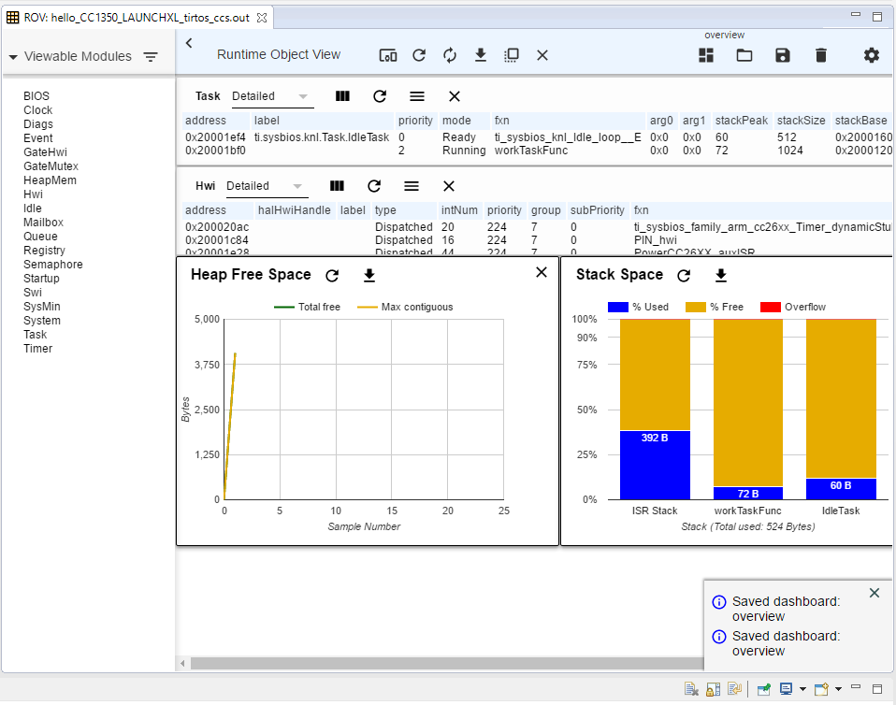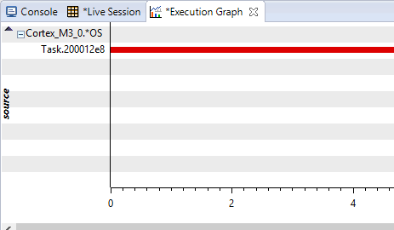



**Task 3**

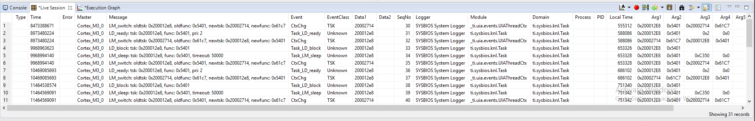

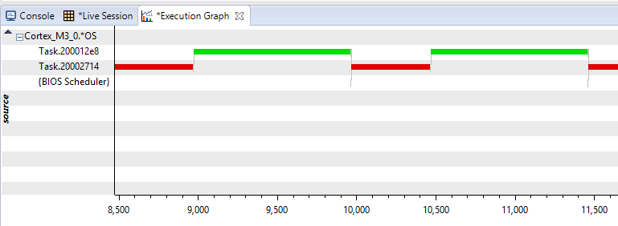

**Task 4**

|  |
| --- |
| /* TI-RTOS Header files */  #include <xdc/std.h>  #include <ti/sysbios/BIOS.h>  #include <ti/sysbios/knl/Task.h>  #include <ti/sysbios/knl/Clock.h>   #include <ti/drivers/GPIO.h>   /* Example/Board Header files */  #include "Board.h"   void myDelay(int count);   /* Could be anything, like computing primes */  #define FakeBlockingSlowWork() myDelay(12000000)  #define FakeBlockingFastWork() myDelay(2000000)   Task_Struct workTask;  Task_Struct urgentWorkTask;  /* Make sure we have nice 8-byte alignment on the stack to avoid wasting memory */  #pragma DATA_ALIGN(workTaskStack, 8)  #define STACKSIZE 1024  static uint8_t workTaskStack[STACKSIZE];  static uint8_t urgentWorkTaskStack[STACKSIZE];   void doUrgentWork(void)  {  GPIO_write(Board_GPIO_LED1, Board_GPIO_LED_OFF);  FakeBlockingFastWork(); /* Pretend to do something useful but time-consuming */  GPIO_write(Board_GPIO_LED1, Board_GPIO_LED_ON);  }   void doWork(void)  {  GPIO_write(Board_GPIO_LED0, Board_GPIO_LED_OFF);  FakeBlockingSlowWork(); /* Pretend to do something useful but time-consuming */  GPIO_write(Board_GPIO_LED0, Board_GPIO_LED_ON);  }   Void workTaskFunc(UArg arg0, UArg arg1)  {  while (1) {   /* Do work */  doWork();   /* Wait a while, because doWork should be a periodic thing, not continuous.*/  //myDelay(24000000);  Task_sleep(500 * (1000 / Clock_tickPeriod));  }  }   Void urgentWorkTaskFunc(UArg arg0, UArg arg1)  {  while (1) {   /* Do work */  doUrgentWork();   /* Wait a while, because doWork should be a periodic thing, not continuous.*/  //myDelay(24000000);  Task_sleep(50 * (1000 / Clock_tickPeriod));  }  }   /*  * ======== main ========  *  */  int main(void)  {  Board_initGeneral();  GPIO_init();   /* Set up the led task */  Task_Params workTaskParams;  Task_Params_init(&workTaskParams);  workTaskParams.stackSize = STACKSIZE;  workTaskParams.priority = 2;  workTaskParams.stack = &workTaskStack;   Task_construct(&workTask, workTaskFunc, &workTaskParams, NULL);   workTaskParams.priority = 1;  workTaskParams.stack = &urgentWorkTaskStack;   Task_construct(&urgentWorkTask, urgentWorkTaskFunc, &workTaskParams, NULL);   /* Start kernel. */  BIOS_start();   return (0);  }   /*  * ======== myDelay ========  * Assembly function to delay. Decrements the count until it is zero  * The exact duration depends on the processor speed.  */  __asm(" .sect \".text:myDelay\"\n"  " .clink\n"  " .thumbfunc myDelay\n"  " .thumb\n"  " .global myDelay\n"  "myDelay:\n"  " subs r0, #1\n"  " bne.n myDelay\n"  " bx lr\n"); |



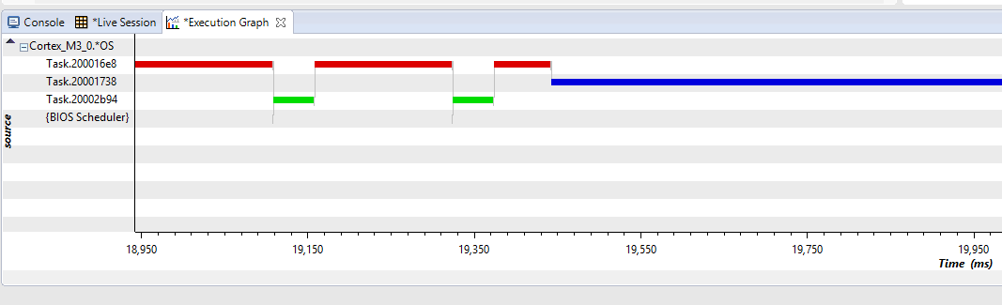

workTaskParams.priority = 3;

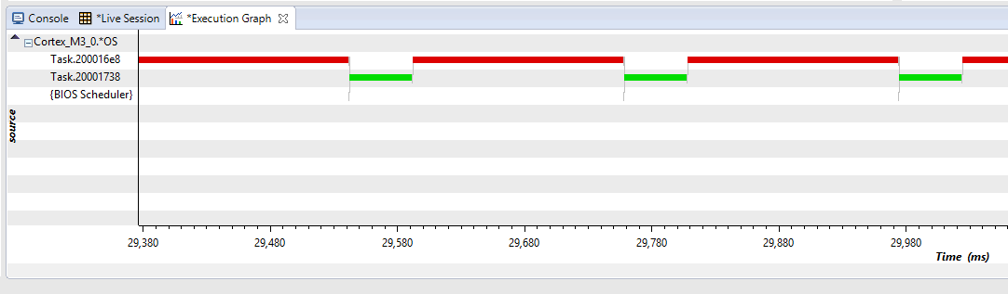

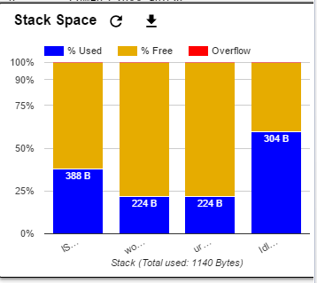

**Youtube Link:** <https://youtu.be/bPYf4W6afQQ>