**DATE SUBMITTED: 11/10/18**

**Task 1**

|  |
| --- |
| /*  * ======== empty.c ========  */   /* For usleep() */  #include <unistd.h>  #include <stdint.h>  #include <stddef.h>   /* Driver Header files */  #include <ti/drivers/GPIO.h>  #include <ti/drivers/ADC.h>  #include <ti/display/Display.h>  // #include <ti/drivers/I2C.h>  // #include <ti/drivers/SDSPI.h>  // #include <ti/drivers/SPI.h>  // #include <ti/drivers/UART.h>  // #include <ti/drivers/Watchdog.h>   /* Board Header file */  #include "Board.h"   /* global variableS FOR GUI COMPOSER */  uint16_t adcValue = 0;  uint16_t threshold = 100;  uint16_t trigger = 0;   /*  * ======== mainThread ========  */   void *mainThread(void *arg0)  {  /* ~10 loops/second */  uint32_t time = 100000; // update ~10/second   /* Call driver init functions */  GPIO_init();  ADC_init();  // I2C_init();  // SDSPI_init();  // SPI_init();  // UART_init();  // Watchdog_init();   /* Open ADC Driver */  ADC_Handle adc;  ADC_Params params;  ADC_Params_init(&params);  adc = ADC_open(Board_ADC0, &params);  if (adc == NULL) {  // Error initializing ADC channel 0  while (1);  }   /* Open Display Driver */  Display_Handle displayHandle;  Display_Params displayParams;  Display_Params_init(&displayParams);  displayHandle = Display_open(Display_Type_UART, NULL);   while (1) {  int_fast16_t res;  res = ADC_convert(adc, &adcValue);  if (res == ADC_STATUS_SUCCESS) {  Display_printf(displayHandle, 1, 0, "ADC Reading %d", adcValue);   if(adcValue >= threshold){  GPIO_write(Board_GPIO_LED0, Board_GPIO_LED_ON);  trigger = 1;  } else{  GPIO_write(Board_GPIO_LED0, Board_GPIO_LED_OFF);  trigger = 0;  }  }   usleep(time);  }  } |

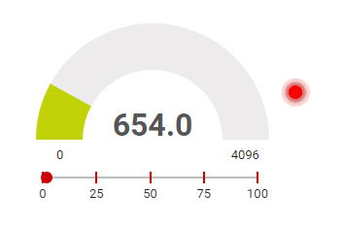

**Task 2**

|  |
| --- |
| /*  * ======== empty.c ========  */  /* For usleep() */  #include <unistd.h>  #include <stdint.h>  #include <stddef.h>  /* Driver Header files */  #include <ti/drivers/GPIO.h>  #include <ti/drivers/ADC.h>  #include <ti/display/Display.h>  // #include <ti/drivers/I2C.h>  // #include <ti/drivers/SDSPI.h>  // #include <ti/drivers/SPI.h>  // #include <ti/drivers/UART.h>  // #include <ti/drivers/Watchdog.h>  /* Board Header file */  #include "Board.h"  /* GLOBAL VARIABLES FOR GUI COMPOSER */  uint16_t adcValue = 0;  uint16_t threshold = 100;  uint16_t trigger = 0;  /*  * ======== gpioButtonFxn0 ========  * Callback function for the GPIO interrupt on Board_GPIO_BUTTON0.  */  void gpioButtonFxn0(uint_least8_t index)  {  /* Clear the GPIO interrupt and decrement threshold */  if(threshold < 250){ // Ensure threshold doesn't go below zero  threshold = 0;  } else {  threshold -= 250; // decrement by 250  }  }  /*  * ======== gpioButtonFxn1 ========  * Callback function for the GPIO interrupt on Board_GPIO_BUTTON1.  * This may not be used for all boards.  */  void gpioButtonFxn1(uint_least8_t index)  {  /* Clear the GPIO interrupt and increment threshold */  if(threshold > 16133){ // Ensure threshold doesn't go above max ADC range  threshold = 16383;  } else {  threshold += 250; // increment by 250  }  }   /*  * ======== mainThread ========  */  void *mainThread(void *arg0)  {  /* ~10 loops/second */  uint32_t time = 100000;  /* Call driver init functions */  GPIO_init();  ADC_init();  // I2C_init();  // SDSPI_init();  // SPI_init();  // UART_init();  // Watchdog_init();  /* Open Display Driver */  Display_Handle displayHandle;  Display_Params displayParams;  Display_Params_init(&displayParams);  displayHandle = Display_open(Display_Type_UART, NULL);   /* Open ADC Driver */  ADC_Handle adc;  ADC_Params params;  ADC_Params_init(&params);  adc = ADC_open(Board_ADC0, &params);  if (adc == NULL) {  // Error initializing ADC channel 0  while (1);  }  /* install Button callback */  GPIO_setCallback(Board_GPIO_BUTTON0, gpioButtonFxn0);  GPIO_setCallback(Board_GPIO_BUTTON1, gpioButtonFxn1);  /* Enable interrupts */  GPIO_enableInt(Board_GPIO_BUTTON0);  GPIO_enableInt(Board_GPIO_BUTTON1);   while (1) {  int_fast16_t res;  res = ADC_convert(adc, &adcValue);  if (res == ADC_STATUS_SUCCESS) {  Display_printf(displayHandle, 1, 0, "ADC Reading %d", adcValue);   if(adcValue >= threshold){  GPIO_write(Board_GPIO_LED0, Board_GPIO_LED_ON);  trigger = 1;  } else{  GPIO_write(Board_GPIO_LED0, Board_GPIO_LED_OFF);  trigger = 0;  }  }  usleep(time);  }  } |

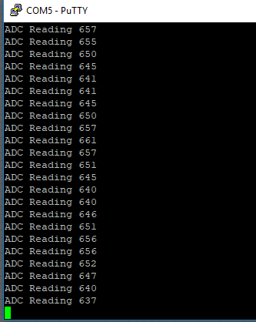

**Youtube Link:** <https://youtu.be/tSAt7geVt6o>