**DATE SUBMITTED: 12/2/18**

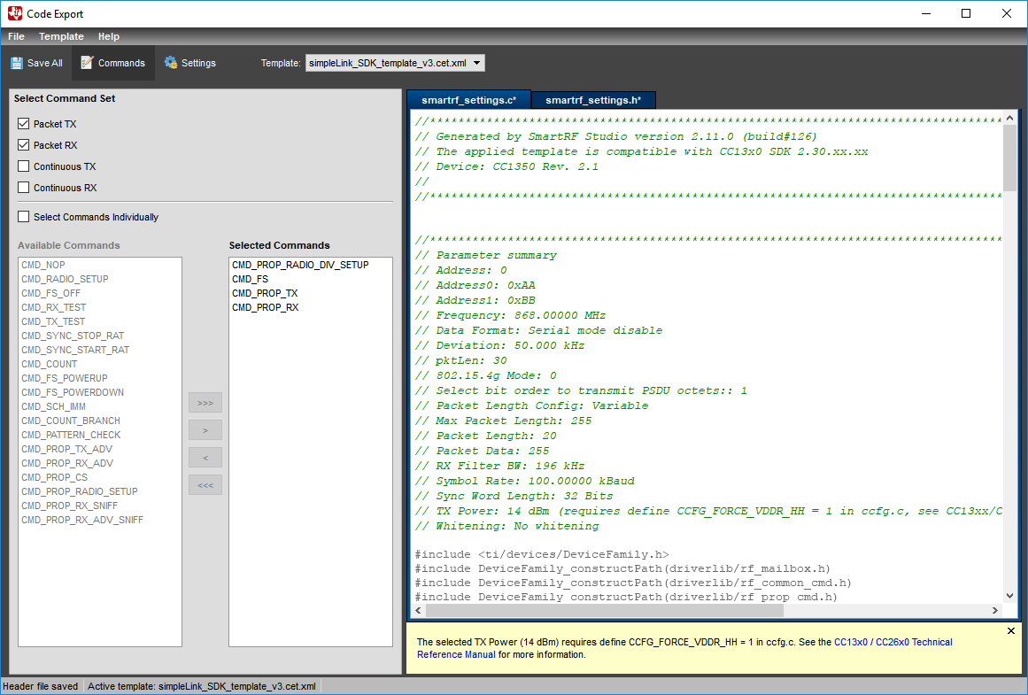

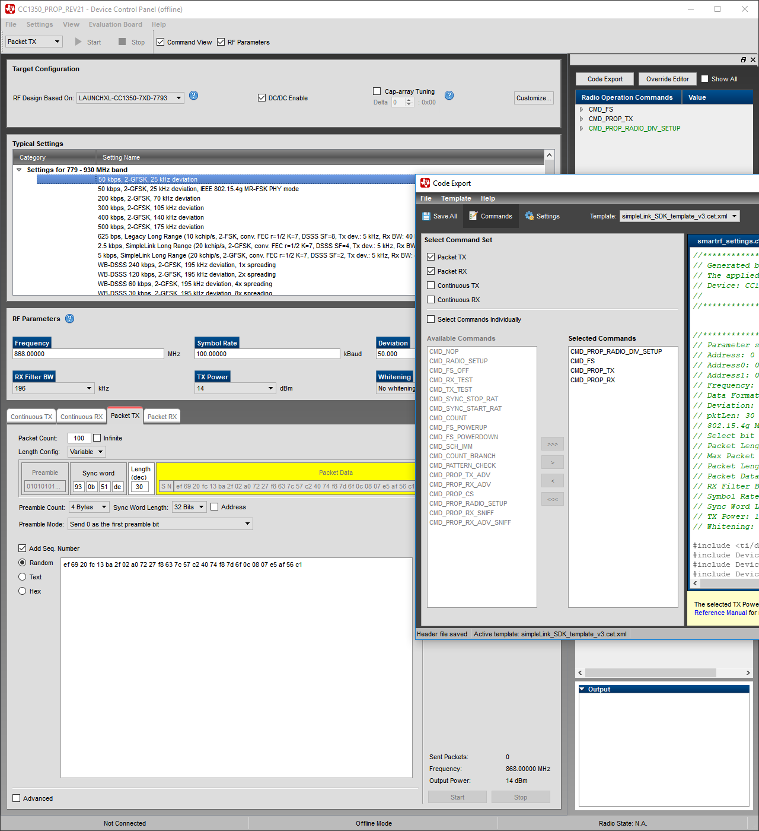

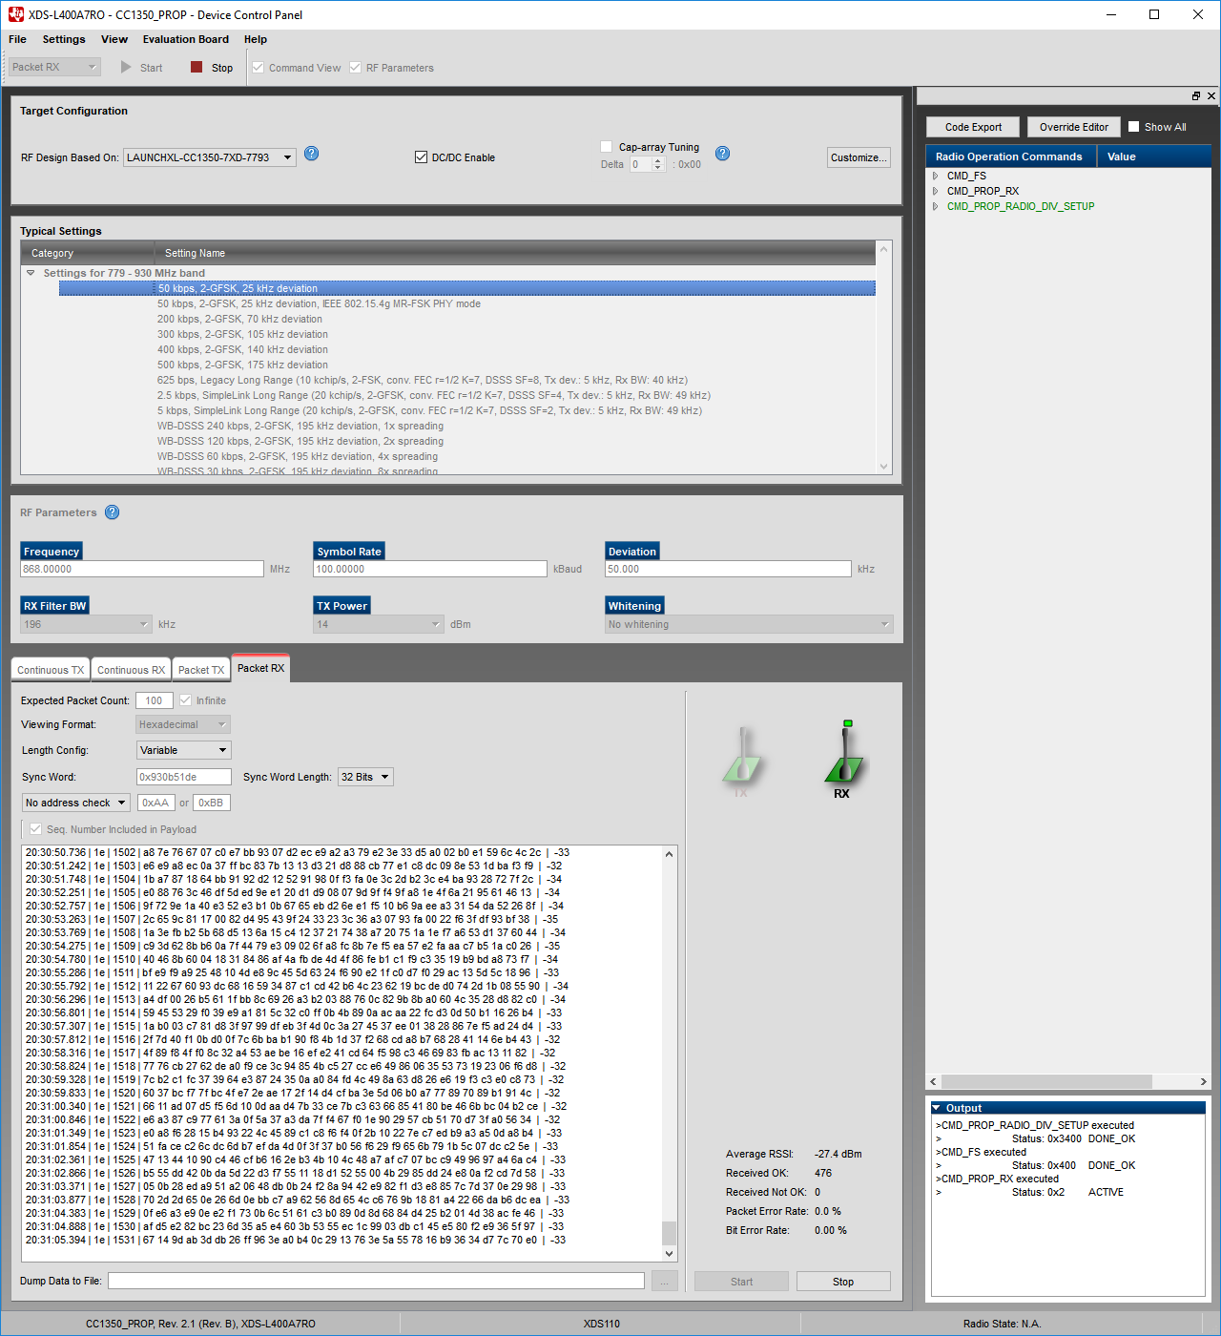

**Youtube Link:**

Task1: <https://youtu.be/iSsy_OFmcgs>

Task2: <https://youtu.be/CT4vHgrhcwc>

Task3: no video needed, was just export/import settings

Task4: <https://youtu.be/3xWLXjsSSJc>

Task5: <https://youtu.be/nJ-1TycrqA8>

Task6: <https://youtu.be/jCdIBnljou8>

Task7: <https://youtu.be/owYPJcRu5Uw>