**DATE SUBMITTED: 12/2/18**

**Part 1 Task 1**

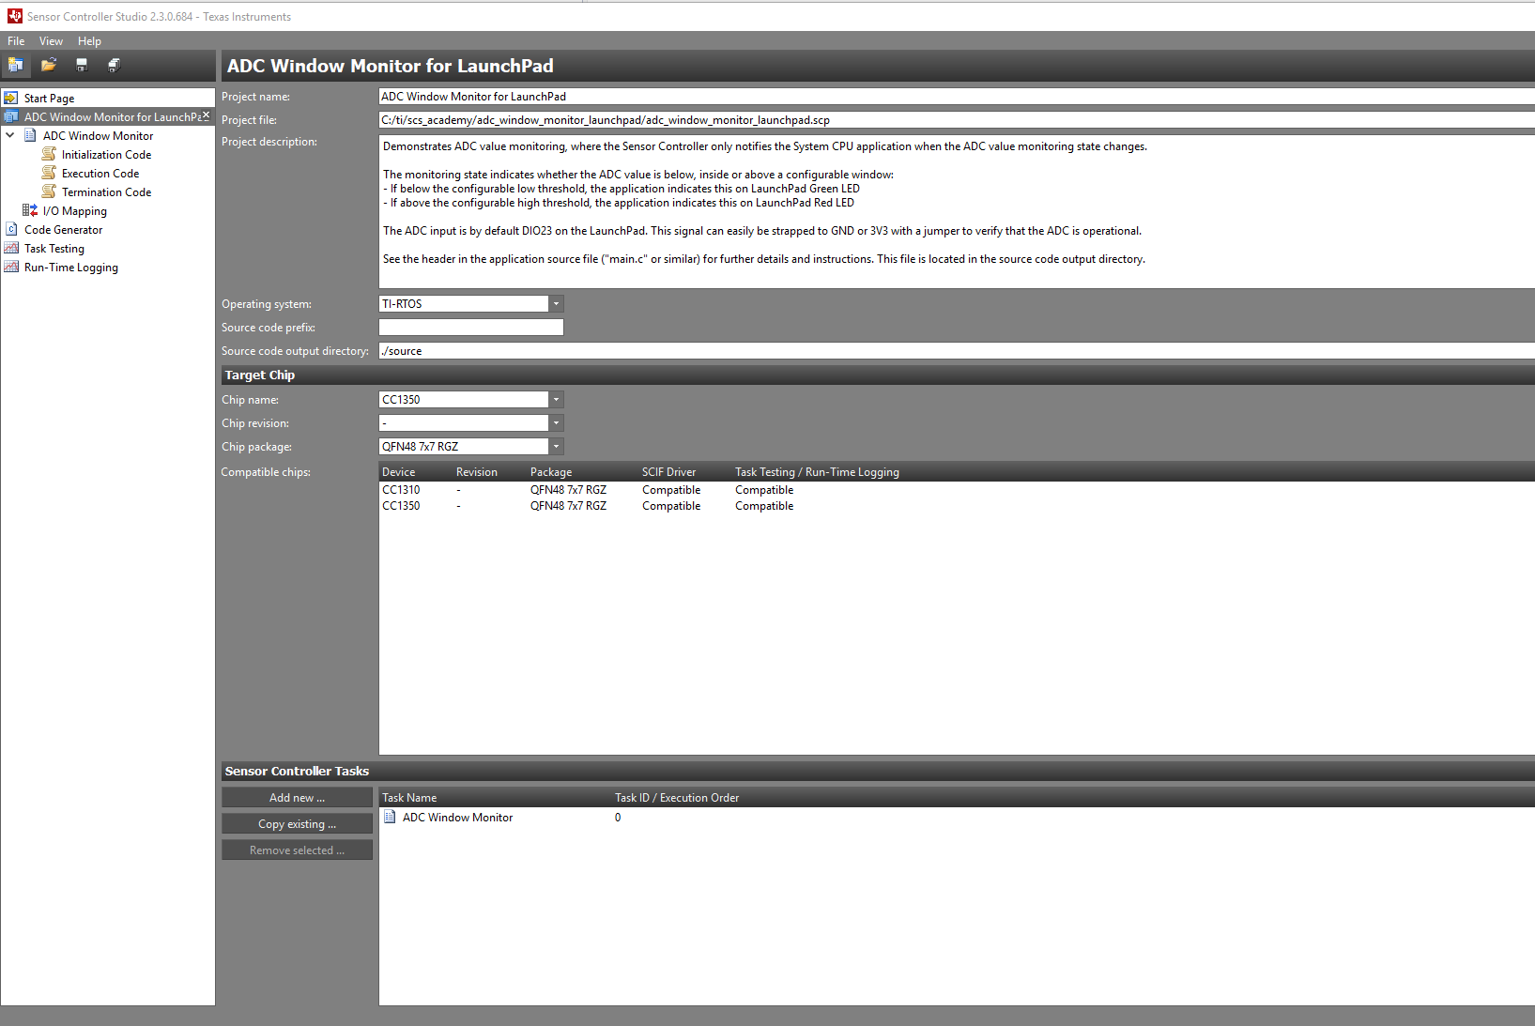

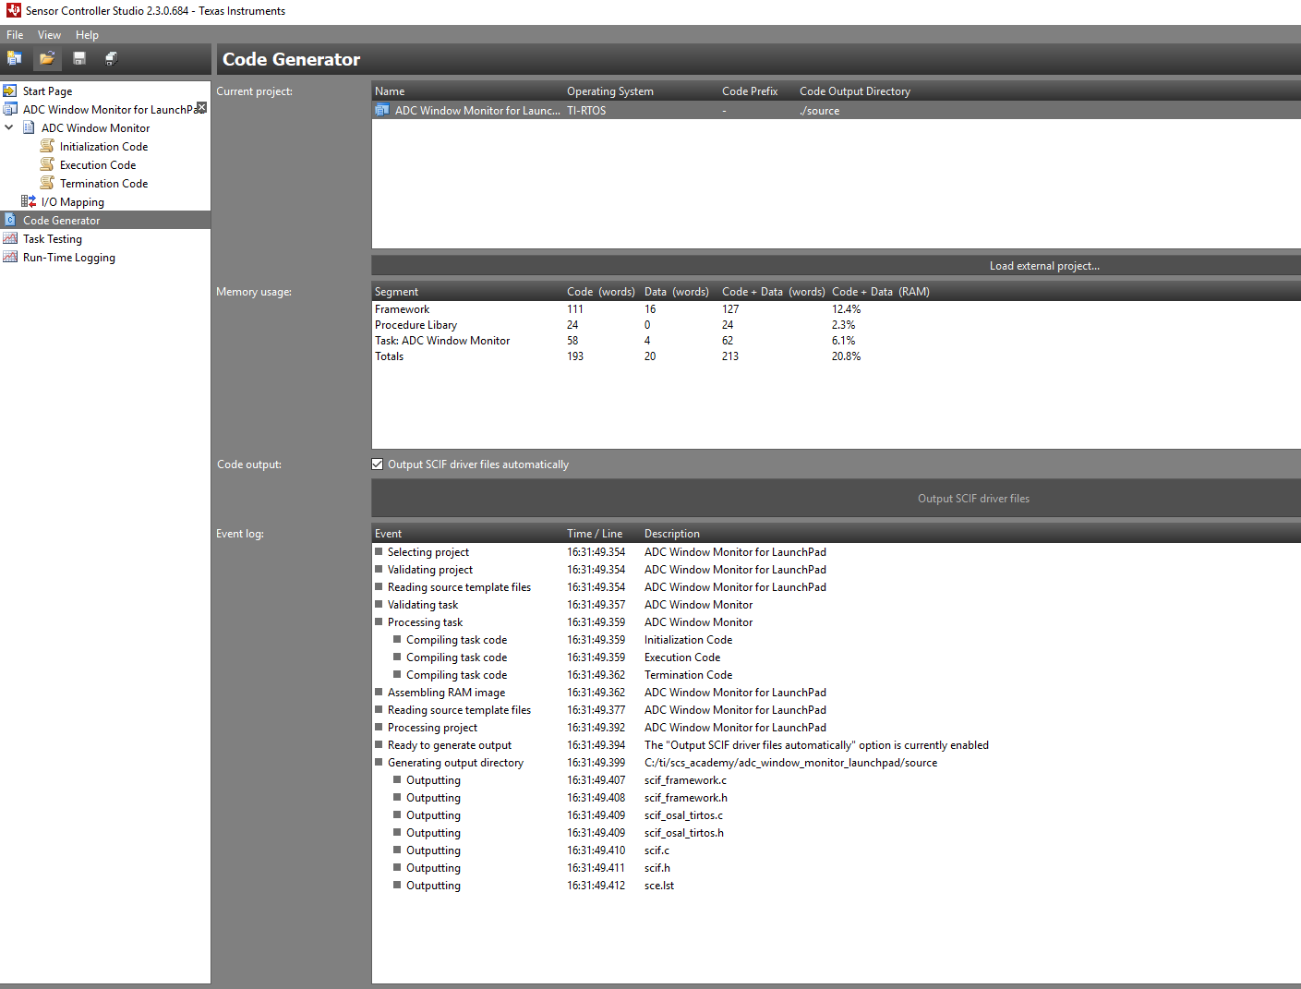

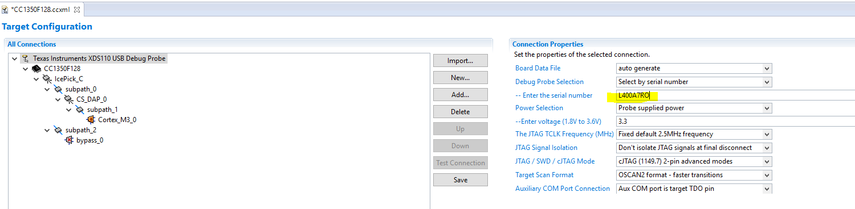

**Part 1 Task 2**

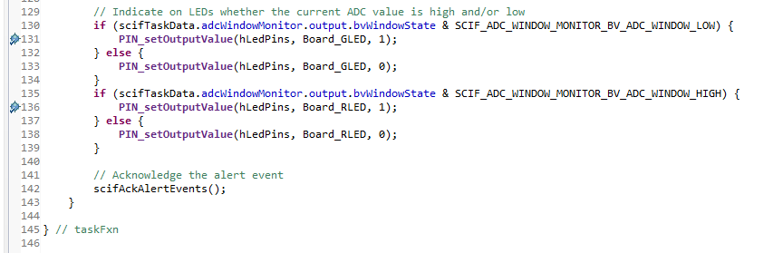

**Part 1 Task 3**

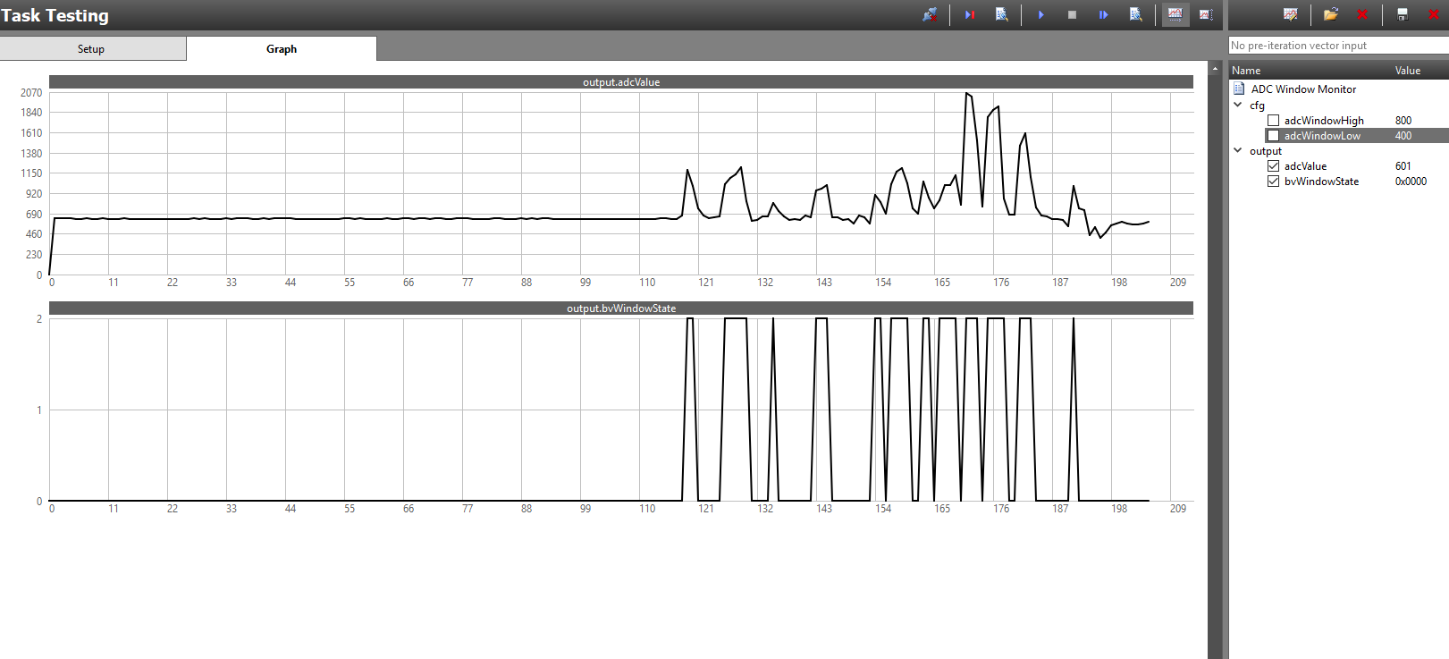

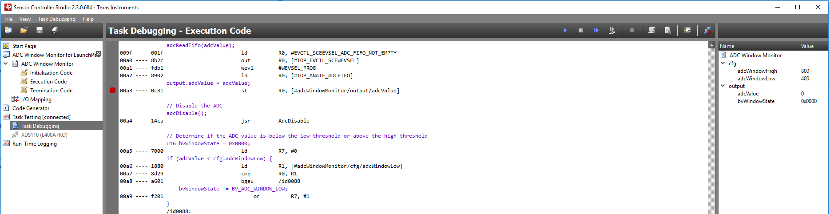

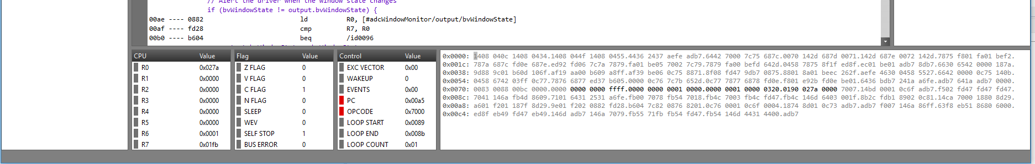

**Part 2 Task 1&2**

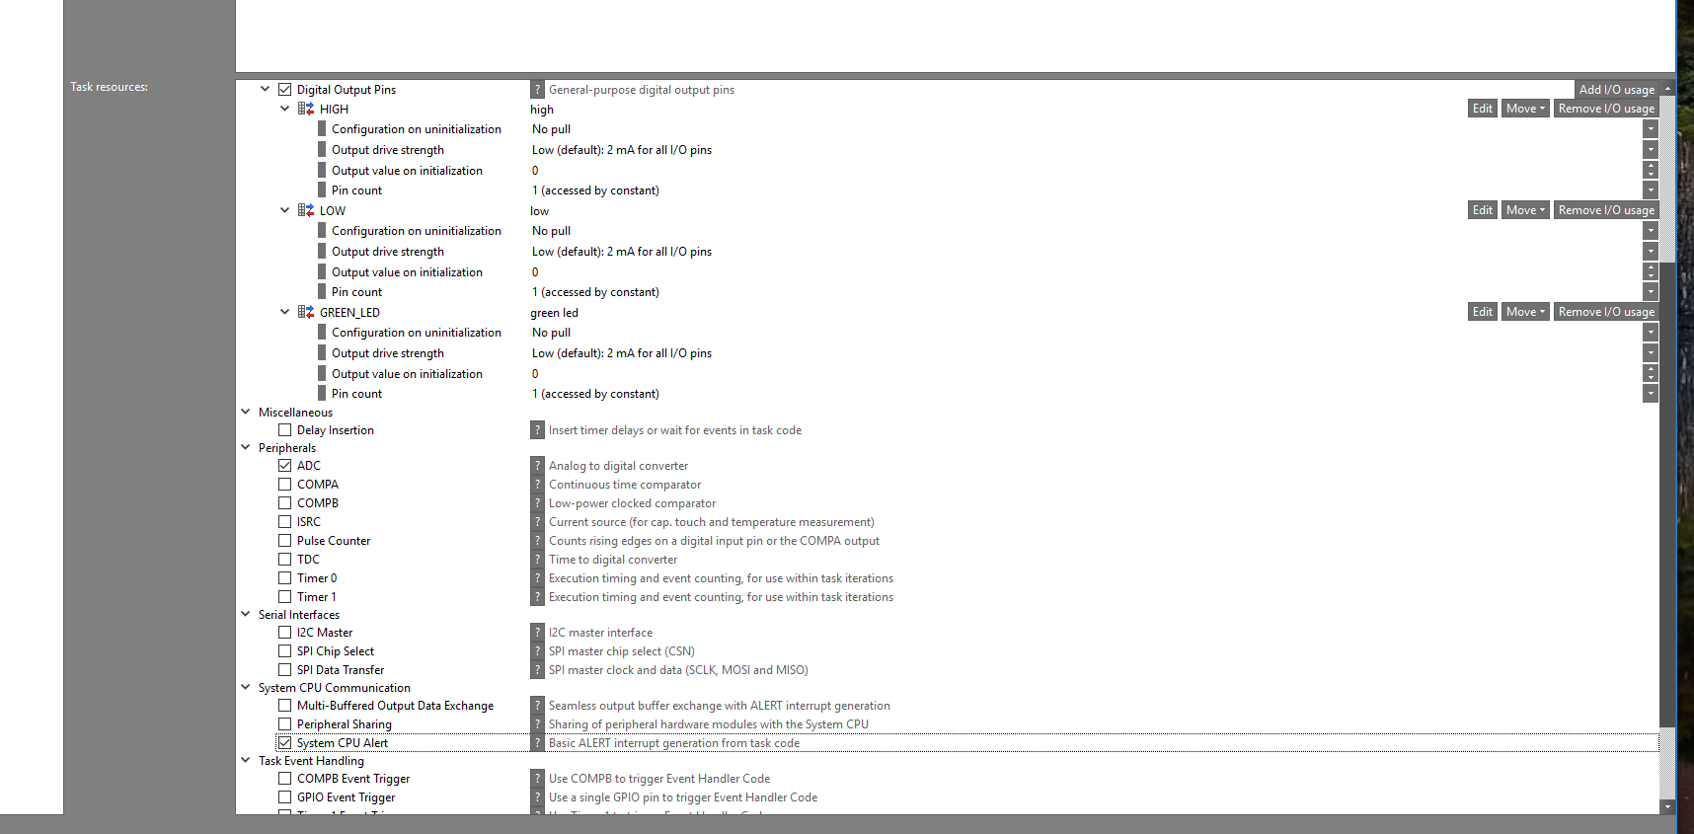

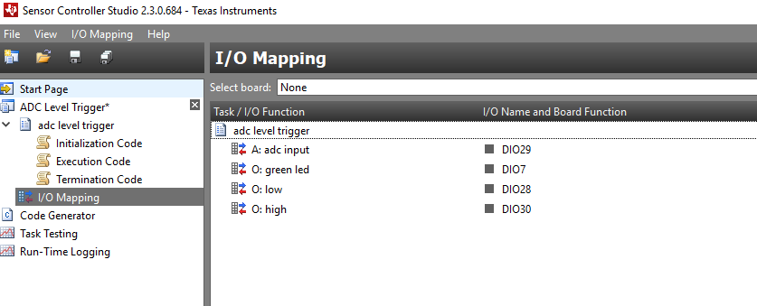

**Part 2 Task 3**

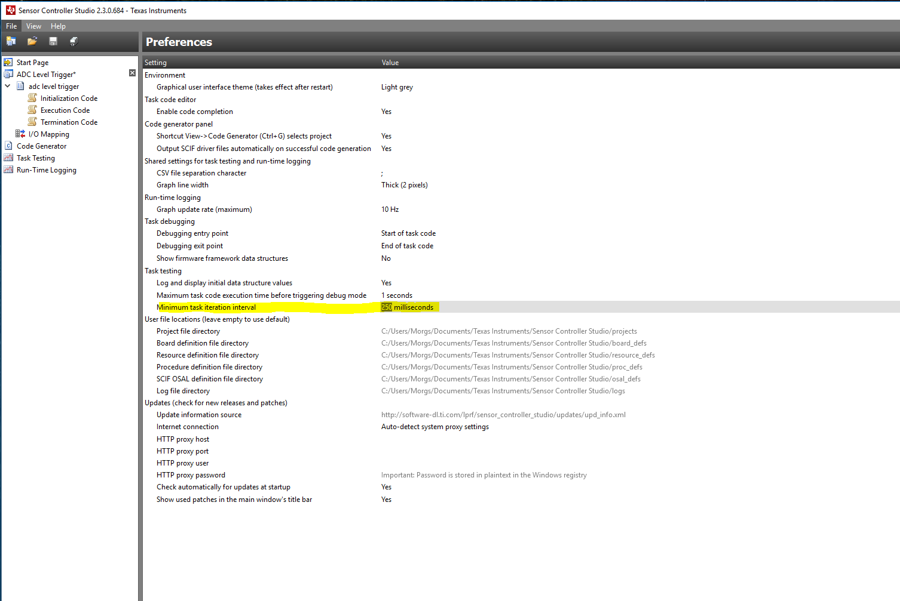

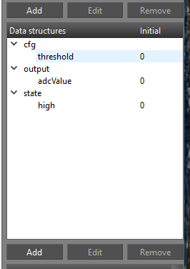

**Part 2 Task 4**

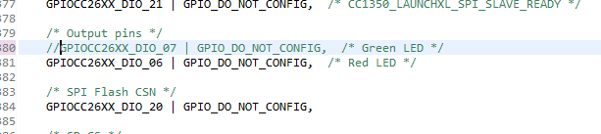

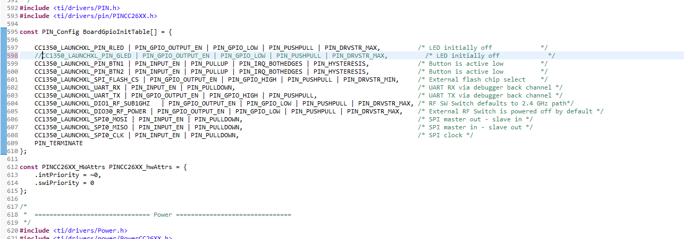

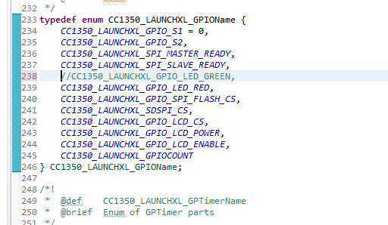

**Youtube Link:**

Part1

Task1&2: <https://youtu.be/g-mcfwIvpaA>

Part2

Task1: <https://youtu.be/s69uhwwtjwI>

Task2&3: <https://youtu.be/6X8Lba_PjT8>

Task4: <https://youtu.be/oYSi4hru1Zk>