**DATE SUBMITTED: 12/2/18**

**Part 1 Task 1&2**

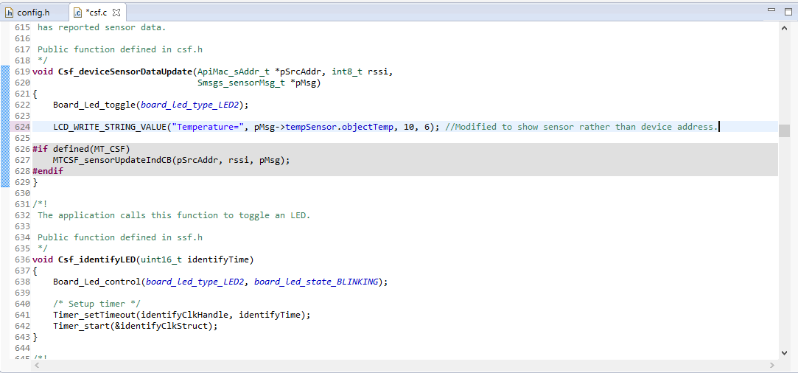

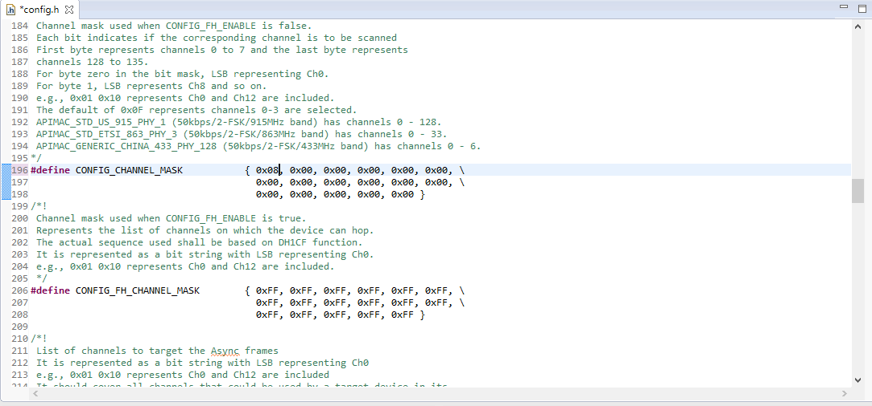

**Part 1 Task 3**

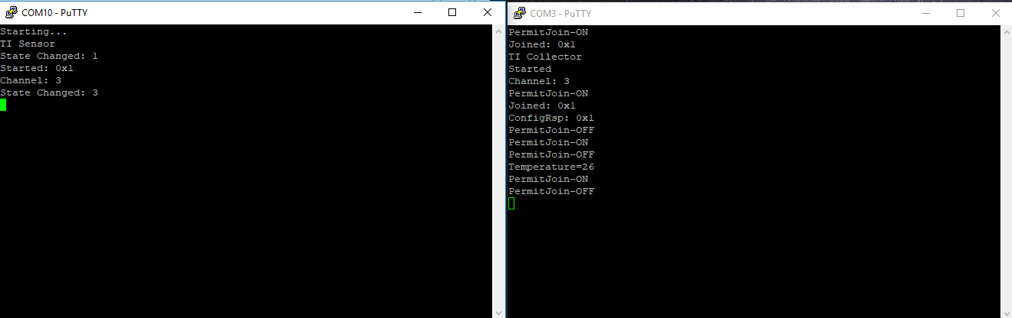

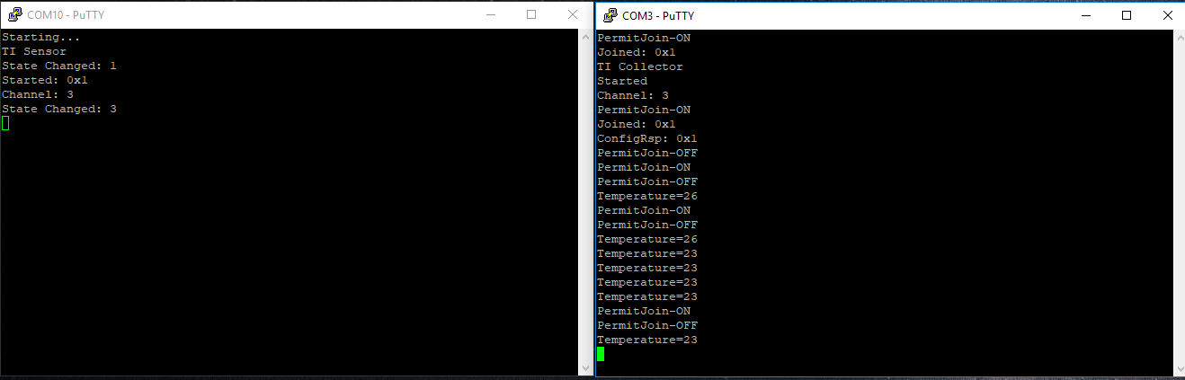

**Part 1 Task 4**

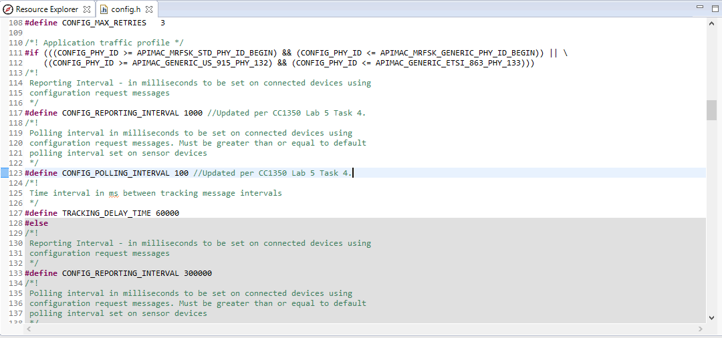

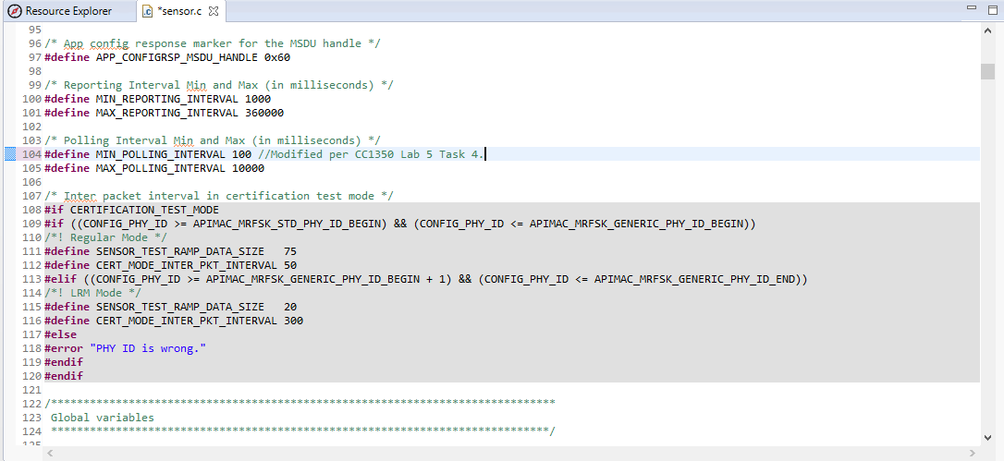

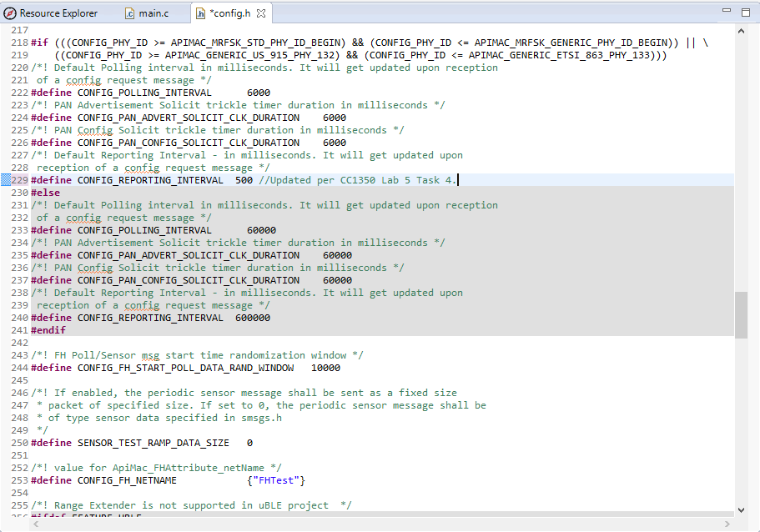

**Part 2 Task 1&2&3**

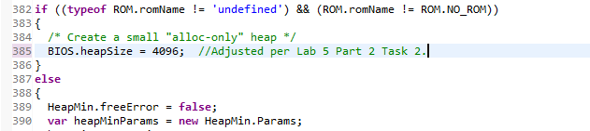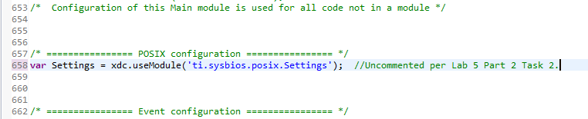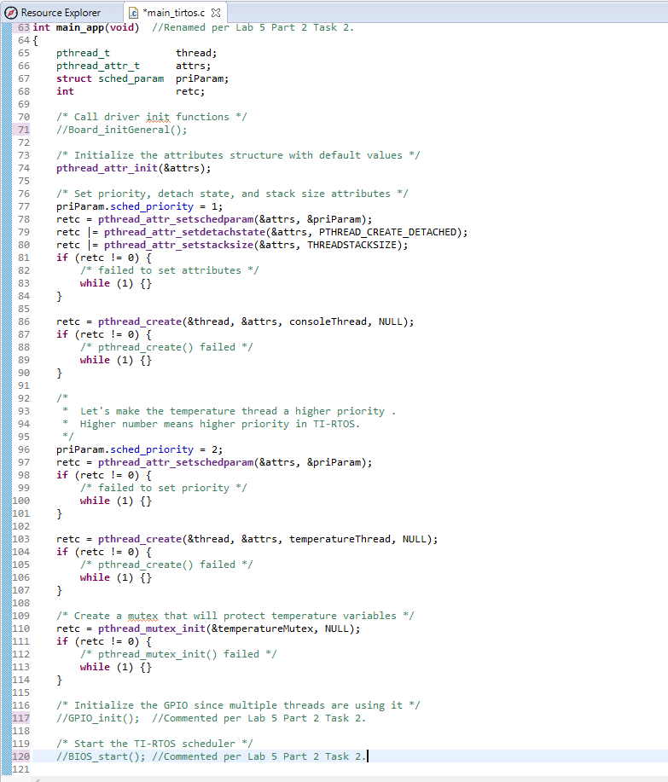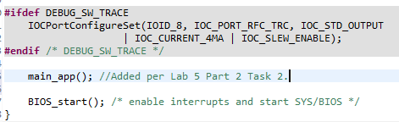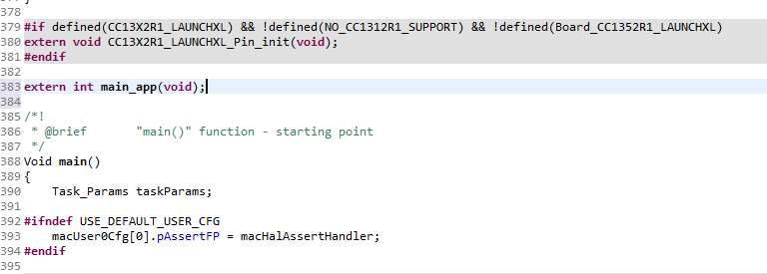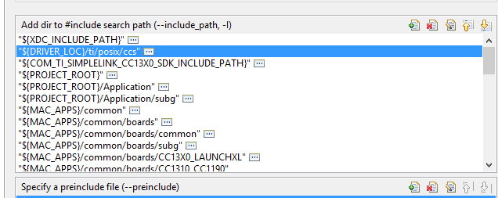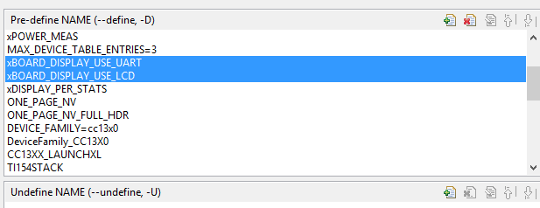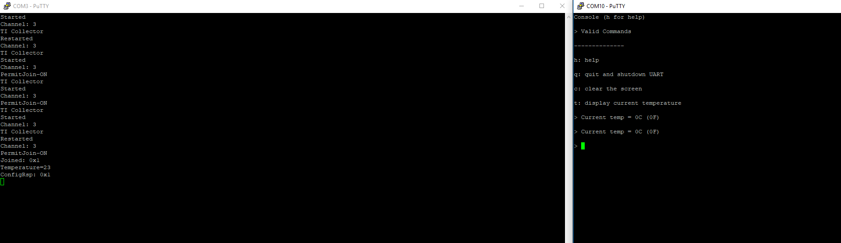

**Youtube Link:**

Part1

Task1: <https://youtu.be/4rbpwo9cVSI>

Task2: <https://youtu.be/Xfa2XMnB7L8>

Task3: <https://youtu.be/WLfKgE60r2g>

Task4: <https://youtu.be/7rKCdlpYYe4>

Part2

Task1&2: <https://youtu.be/Tq3FC4WAB7Q>

Task3: <https://youtu.be/enrPBd0bdHo>