**DATE SUBMITTED: 11/5/18**

**Task 1**

|  |
| --- |
| //--------------------------------------------------------------------------- // Project: Blink TM4C - CCS Lab - STARTER // // Author: Eric Wilbur // // Date: June 2014 // //---------------------------------------------------------------------------   //------------------------------------------ // TivaWare Header Files //------------------------------------------ #include <stdint.h> #include <stdbool.h>  #include "inc/hw_types.h" #include "inc/hw_memmap.h" #include "driverlib/sysctl.h" #include "driverlib/gpio.h" #include "inc/hw_ints.h" #include "driverlib/interrupt.h" #include "driverlib/timer.h" #include <time.h>   //---------------------------------------- // Prototypes //---------------------------------------- void hardware_init(void); void ledToggle(void); void delay(void);   //--------------------------------------- // Globals //--------------------------------------- volatile int16_t i16ToggleCount = 0;   //--------------------------------------------------------------------------- // main() //--------------------------------------------------------------------------- void main(void) {   hardware_init(); // init hardware via Xware   while(1) // forever loop  {  ledToggle(); // toggle LED   delay(); // create a delay of ~1/2sec (changed to 1 sec)   i16ToggleCount += 1; // keep track of #toggles  }  }   //--------------------------------------------------------------------------- // hardware_init() // // inits GPIO pins for toggling the LED //--------------------------------------------------------------------------- void hardware_init(void) {  //Set CPU Clock to 40MHz. 400MHz PLL/2 = 200 DIV 5 = 40MHz  SysCtlClockSet(SYSCTL_SYSDIV_5|SYSCTL_USE_PLL|SYSCTL_XTAL_16MHZ|SYSCTL_OSC_MAIN);   // ADD Tiva-C GPIO setup - enables port, sets pins 1-3 (RGB) pins for output  SysCtlPeripheralEnable(SYSCTL_PERIPH_GPIOF);  GPIOPinTypeGPIOOutput(GPIO_PORTF_BASE, GPIO_PIN_1|GPIO_PIN_2|GPIO_PIN_3);   // Turn on the LED  GPIOPinWrite(GPIO_PORTF_BASE, GPIO_PIN_1|GPIO_PIN_2|GPIO_PIN_3, 4);  }   //--------------------------------------------------------------------------- // ledToggle() // // toggles LED on Tiva-C LaunchPad //--------------------------------------------------------------------------- void ledToggle(void) {  // LED values - 2=RED, 4=BLUE, 8=GREEN  if(GPIOPinRead(GPIO_PORTF_BASE, GPIO_PIN_2))  {  GPIOPinWrite(GPIO_PORTF_BASE, GPIO_PIN_1|GPIO_PIN_2|GPIO_PIN_3, 0);  }  else  {  GPIOPinWrite(GPIO_PORTF_BASE, GPIO_PIN_2, 4);  } }    //--------------------------------------------------------------------------- // delay() // // Creates a 500ms delay via TivaWare fxn //--------------------------------------------------------------------------- void delay(void) {  SysCtlDelay(6700000*2); // creates ~500ms delay - TivaWare fxn  } |

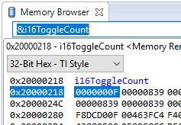

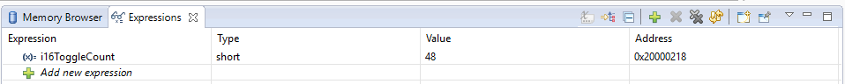

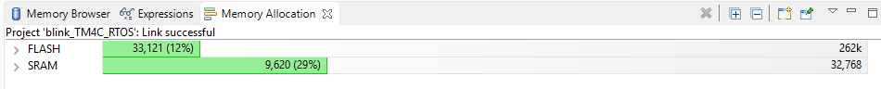

**Youtube Link:** <https://youtu.be/0gMlfp4Qw9I>