**DATE SUBMITTED: 11/7/18**

**Task 1**

|  |
| --- |
| //--------------------------------------------------------------------------------- // Project: Blink TM4C BIOS Using Swi (STARTER) // Author: Eric Wilbur // Date: June 2014 // // Note: The function call TimerIntClear(TIMER2_BASE, TIMER_TIMA_TIMEOUT) HAS // to be in the ISR. This fxn clears the TIMER's interrupt flag coming // from the peripheral - it does NOT clear the CPU interrupt flag - that // is done by hardware. The author struggled figuring this part out - hence // the note. And, in the Swi lab, this fxn must be placed in the // Timer_ISR fxn because it will be the new ISR. // // Follow these steps to create this project in CCSv6.0: // 1. Project -> New CCS Project // 2. Select Template: // - TI-RTOS for Tiva-C -> Driver Examples -> EK-TM4C123 LP -> Example Projects -> // Empty Project // - Empty Project contains full instrumentation (UIA, RTOS Analyzer) and // paths set up for the TI-RTOS version of MSP430Ware // 3. Delete the following files: // - Board.h, empty.c, EK_TM4C123GXL.c/h, empty_readme.txt // 4. Add main.c from TI-RTOS Workshop Solution file for this lab // 5. Edit empty.cfg as needed (to add/subtract) BIOS services, delete given Task // 6. Build, load, run... //----------------------------------------------------------------------------------   //---------------------------------------- // BIOS header files //---------------------------------------- #include <xdc/std.h> //mandatory - have to include first, for BIOS types #include <ti/sysbios/BIOS.h> //mandatory - if you call APIs like BIOS_start() #include <xdc/runtime/Log.h> //needed for any Log_info() call #include <xdc/cfg/global.h> //header file for statically defined objects/handles   //------------------------------------------ // TivaWare Header Files //------------------------------------------ #include <stdint.h> #include <stdbool.h>  #include "inc/hw_types.h" #include "inc/hw_memmap.h" #include "driverlib/sysctl.h" #include "driverlib/gpio.h" #include "inc/hw_ints.h" #include "driverlib/interrupt.h" #include "driverlib/timer.h"   //---------------------------------------- // Prototypes //---------------------------------------- void hardware_init(void); void ledToggle(void); void Timer_ISR(void);  //--------------------------------------- // Globals //--------------------------------------- volatile int16_t i16ToggleCount = 0;   //--------------------------------------------------------------------------- // main() //--------------------------------------------------------------------------- void main(void) {   hardware_init(); // init hardware via Xware   BIOS_start();  }   //--------------------------------------------------------------------------- // hardware_init() // // inits GPIO pins for toggling the LED //--------------------------------------------------------------------------- void hardware_init(void) {  uint32_t ui32Period;   //Set CPU Clock to 40MHz. 400MHz PLL/2 = 200 DIV 5 = 40MHz  SysCtlClockSet(SYSCTL_SYSDIV_5|SYSCTL_USE_PLL|SYSCTL_XTAL_16MHZ|SYSCTL_OSC_MAIN);   // ADD Tiva-C GPIO setup - enables port, sets pins 1-3 (RGB) pins for output  SysCtlPeripheralEnable(SYSCTL_PERIPH_GPIOF);  GPIOPinTypeGPIOOutput(GPIO_PORTF_BASE, GPIO_PIN_1|GPIO_PIN_2|GPIO_PIN_3);   // Turn on the LED  GPIOPinWrite(GPIO_PORTF_BASE, GPIO_PIN_1|GPIO_PIN_2|GPIO_PIN_3, 4);   // Timer 2 setup code  SysCtlPeripheralEnable(SYSCTL_PERIPH_TIMER2); // enable Timer 2 periph clks  TimerConfigure(TIMER2_BASE, TIMER_CFG_PERIODIC); // cfg Timer 2 mode - periodic   ui32Period = (SysCtlClockGet() /2); // period = CPU clk div 2 (500ms)  TimerLoadSet(TIMER2_BASE, TIMER_A, ui32Period); // set Timer 2 period   TimerIntEnable(TIMER2_BASE, TIMER_TIMA_TIMEOUT); // enables Timer 2 to interrupt CPU   TimerEnable(TIMER2_BASE, TIMER_A); // enable Timer 2  }   //--------------------------------------------------------------------------- // ledToggle() // // toggles LED on Tiva-C LaunchPad //--------------------------------------------------------------------------- void ledToggle(void) {  TimerIntClear(TIMER2_BASE, TIMER_TIMA_TIMEOUT); // must clear timer flag FROM timer   // LED values - 2=RED, 4=BLUE, 8=GREEN  if(GPIOPinRead(GPIO_PORTF_BASE, GPIO_PIN_2))  {  GPIOPinWrite(GPIO_PORTF_BASE, GPIO_PIN_1|GPIO_PIN_2|GPIO_PIN_3, 0);  }  else  {  GPIOPinWrite(GPIO_PORTF_BASE, GPIO_PIN_2, 4);  }   i16ToggleCount += 1; // keep track of #toggles   Log_info1("LED TOGGLED [%u] TIMES",i16ToggleCount); // send toggle count to UIA  }  void Timer_ISR(void) {  TimerIntClear(TIMER2_BASE, TIMER_TIMA_TIMEOUT);  Swi_post(LEDSwi); } |

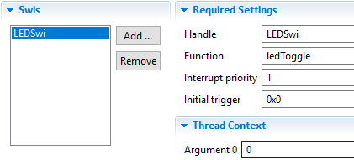

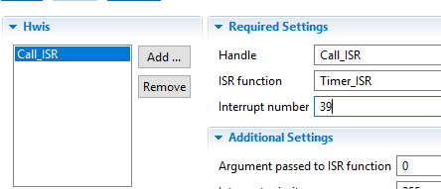

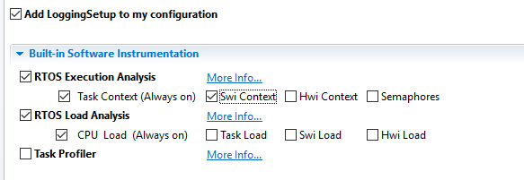

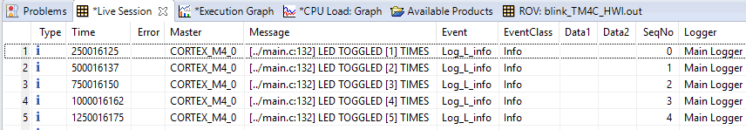

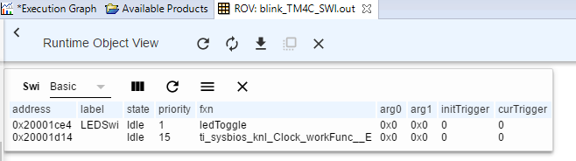

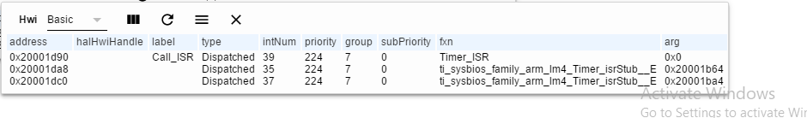

**Youtube Link:** <https://youtu.be/YRKfqkyaRis>