**DATE SUBMITTED:** 10/3/2018

**Task 0**

No submission required, run supplied code

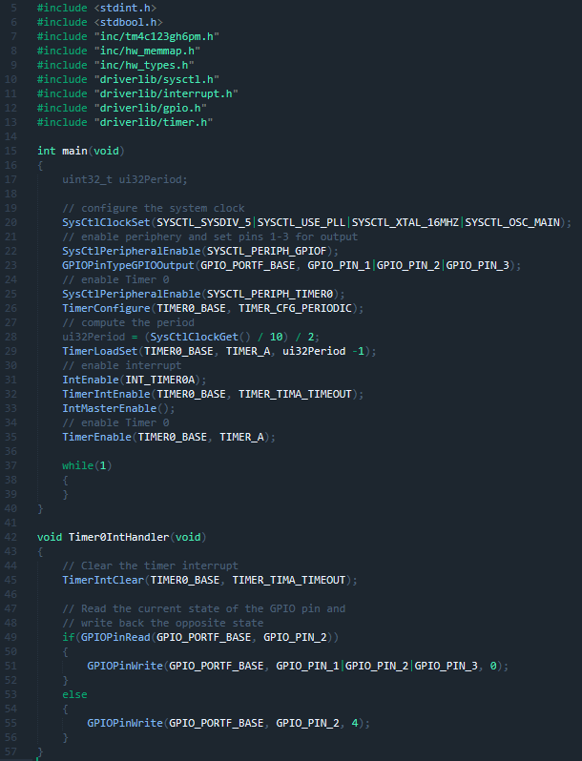

**Youtube Link:** <https://youtu.be/HhNF_2h36Dc>

**Task 1:**

Change duty cycle to 75% and verify the waveform

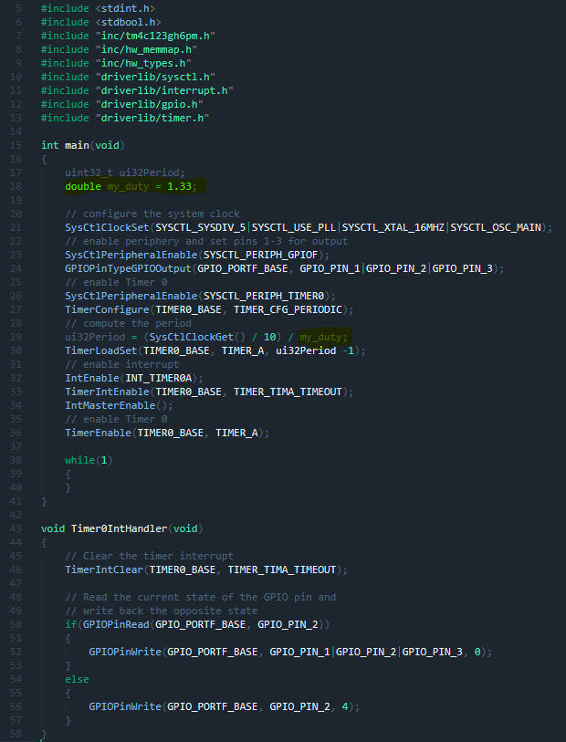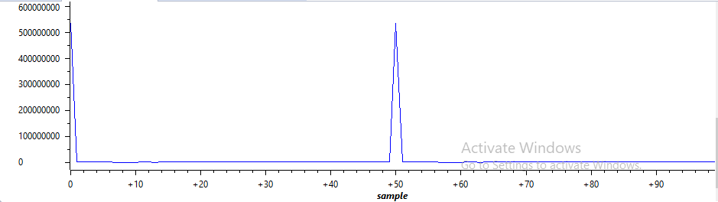

**Youtube Link:** <https://youtu.be/0aPIt9n1ZNw>

**Task 2:**

Include a GPIO interrupt to task 02 from switch SW2 to turn on the LED for 1.5 seconds.

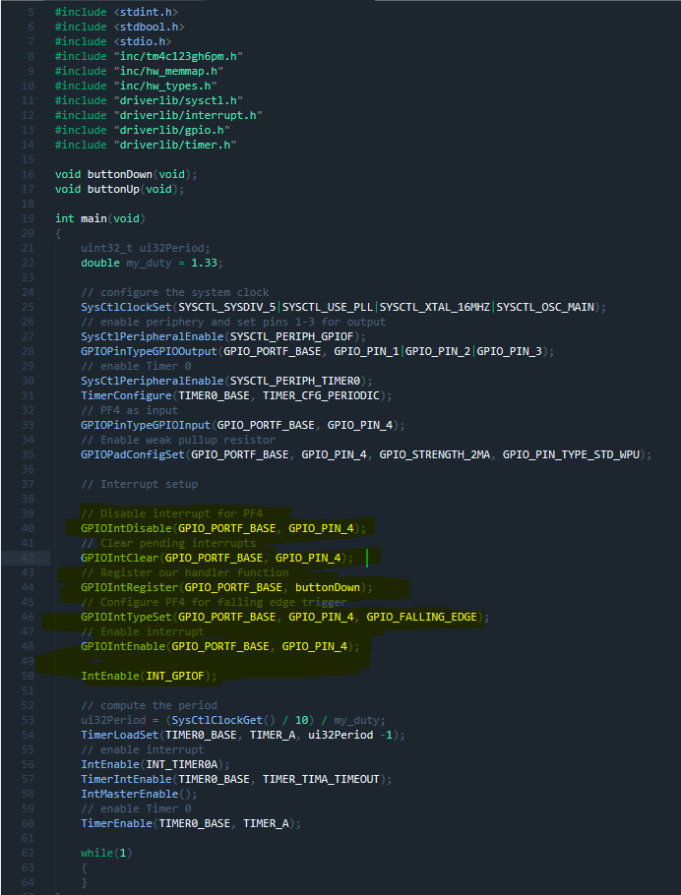

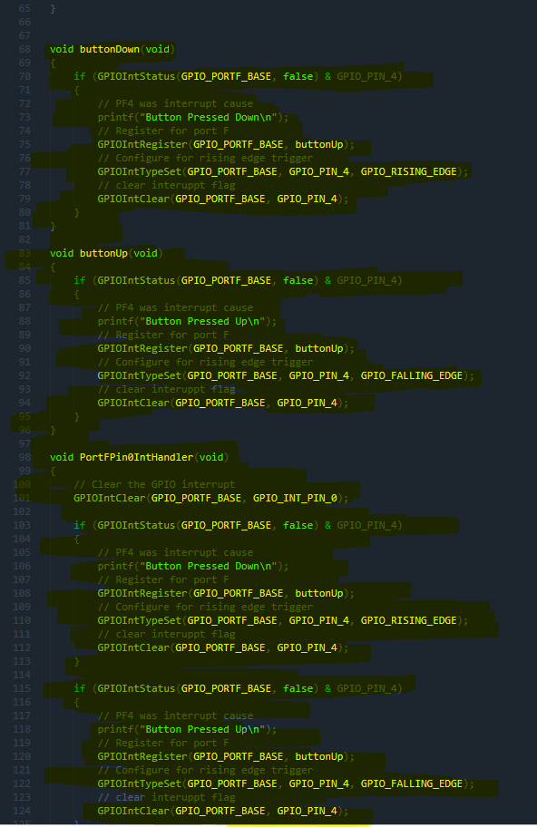

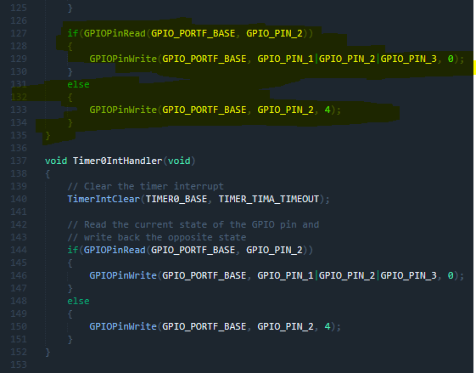

**Youtube Link:** <https://youtu.be/F1nTgg5kom0>