**Task 0**

No submission required - ran the given code - code submitted on github

**Task 1**

#include <stdint.h>

#include <stdbool.h>

#include "inc/hw_memmap.h"

#include "inc/hw_types.h"

#include "driverlib/debug.h"

#include "driverlib/sysctl.h"

#include "driverlib/adc.h"

#define TARGET_IS_BLIZZARD_RB1

#include "driverlib/rom.h"

#include "driverlib/gpio.h"

/*

#ifdef DEBUG

void__error__(char *pcFilename, uint32_t ui321Line){}

#endif

*/

int main(void)

{

// my variables

uint32_t ui32ADC0Value[4];

volatile uint32_t ui32TempAvg;

volatile uint32_t ui32TempValueC;

volatile uint32_t ui32TempValueF;

// set the clock

ROM_SysCtlClockSet(SYSCTL_SYSDIV_5|SYSCTL_USE_PLL|SYSCTL_OSC_MAIN|SYSCTL_XTAL_16MHZ);

// enable periphery

SysCtlPeripheralEnable(SYSCTL_PERIPH_GPIOF);

// GPIO output enable for LEDs

GPIOPinTypeGPIOOutput(GPIO_PORTF_BASE, GPIO_PIN_1|GPIO_PIN_2|GPIO_PIN_3);

// enable ADC0, set to 64

ROM_SysCtlPeripheralEnable(SYSCTL_PERIPH_ADC0);

ROM_ADCHardwareOversampleConfigure(ADC0_BASE, 64);

// configure ADC sequencer to 3 and assign the ADC value types

ROM_ADCSequenceConfigure(ADC0_BASE, 2, ADC_TRIGGER_PROCESSOR, 0);

ROM_ADCSequenceStepConfigure(ADC0_BASE, 2, 0, ADC_CTL_TS);

ROM_ADCSequenceStepConfigure(ADC0_BASE, 2, 1, ADC_CTL_TS);

ROM_ADCSequenceStepConfigure(ADC0_BASE, 2, 2, ADC_CTL_TS);

ROM_ADCSequenceStepConfigure(ADC0_BASE, 2, 3, ADC_CTL_TS|ADC_CTL_IE|ADC_CTL_END);

ROM_ADCSequenceEnable(ADC0_BASE, 2);

//ROM_ADCIntEnable(ADC0_BASE, 3);

while(1)

{

// used SS2 for internal temperature sensor

// clear ADC interrupt and set processor trigger

ROM_ADCIntClear(ADC0_BASE, 2);

ROM_ADCProcessorTrigger(ADC0_BASE, 2);

// continue to loop while calculations are taking place

while(!ROM_ADCIntStatus(ADC0_BASE, 2, false)){}

// here we grab all the adc data and calculate the C and F

ROM_ADCSequenceDataGet(ADC0_BASE, 2, ui32ADC0Value);

ui32TempAvg = (ui32ADC0Value[0] + ui32ADC0Value[1] + ui32ADC0Value[2] + ui32ADC0Value[3] + 2)/4;

ui32TempValueC = (1475 - ((2475 * ui32TempAvg)) / 4096)/10;

ui32TempValueF = ((ui32TempValueC * 9) + 160) / 5;

// i picked 62 because I could only get the temp up to 64 but

// still wanted to show LED turn on and it always initialized at 62

if(ui32TempValueF > 62){GPIOPinWrite(GPIO_PORTF_BASE, GPIO_PIN_2, 0x04);}

else{GPIOPinWrite(GPIO_PORTF_BASE, GPIO_PIN_2, 0x00);}

}

}

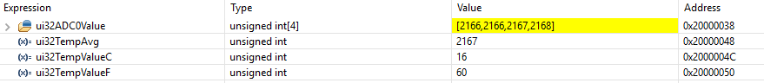

Average ADC Values

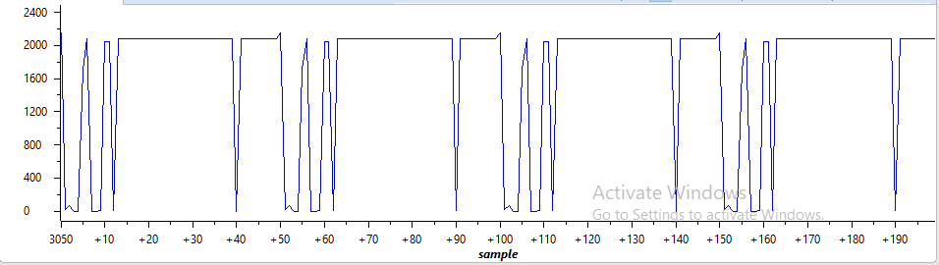

**Youtube Link:** <https://youtu.be/O9LgRkr2wvU>

**Task 2**

#include <stdint.h>

#include <stdbool.h>

#include "inc/hw_memmap.h"

#include "inc/hw_types.h"

#include "inc/tm4c123gh6pm.h"

#include "driverlib/debug.h"

#include "driverlib/sysctl.h"

#include "driverlib/adc.h"

#define TARGET_IS_BLIZZARD_RB1

#include "driverlib/rom.h"

#include "driverlib/gpio.h"

#include "driverlib/timer.h"

#include "driverlib/interrupt.h"

/*

#ifdef DEBUG

void_error_(char *pcFilename, uint32_t ui32Line){}

#endif

*/

//my variables

uint32_t ui32ADC0Value[4];

volatile uint32_t ui32TempAvg;

volatile uint32_t ui32TempValueC;

volatile uint32_t ui32TempValueF;

int main(void)

{

ROM_SysCtlClockSet(SYSCTL_SYSDIV_5|SYSCTL_USE_PLL|SYSCTL_XTAL_16MHZ|SYSCTL_OSC_MAIN);

ROM_SysCtlPeripheralEnable(SYSCTL_PERIPH_ADC0);

ROM_SysCtlPeripheralEnable(SYSCTL_PERIPH_GPIOF);

ROM_GPIOPinTypeGPIOOutput(GPIO_PORTF_BASE, GPIO_PIN_1|GPIO_PIN_2|GPIO_PIN_3);

ROM_ADCHardwareOversampleConfigure(ADC0_BASE, 32);

//step up adc sequencer 2

ROM_ADCSequenceConfigure(ADC0_BASE, 1, ADC_TRIGGER_PROCESSOR, 0);

ROM_ADCSequenceStepConfigure(ADC0_BASE, 1, 0, ADC_CTL_TS);

ROM_ADCSequenceStepConfigure(ADC0_BASE, 1, 1, ADC_CTL_TS);

ROM_ADCSequenceStepConfigure(ADC0_BASE, 1, 2, ADC_CTL_TS);

ROM_ADCSequenceStepConfigure(ADC0_BASE, 1, 3, ADC_CTL_TS|ADC_CTL_IE|ADC_CTL_END);

ROM_ADCSequenceEnable(ADC0_BASE, 1);

//enable timer1

ROM_SysCtlPeripheralEnable(SYSCTL_PERIPH_TIMER1);

//config timer 1 for overflow every half second

ROM_TimerConfigure(TIMER1_BASE, TIMER_CFG_PERIODIC);

ROM_TimerLoadSet(TIMER1_BASE, TIMER_A, (SysCtlClockGet()/2)-1);

//enable interrupt and timer 1

ROM_TimerEnable(TIMER1_BASE, TIMER_A);

ROM_IntEnable(INT_TIMER1A);

ROM_TimerIntEnable(TIMER1_BASE, TIMER_TIMA_TIMEOUT);

//enable masters

IntMasterEnable();

while(1){}

}

void Timer1IntHandler(void)

{

//clear timer interrupt

ROM_TimerIntClear(TIMER1_BASE, TIMER_TIMA_TIMEOUT);

//clear adc interrupt and set processor trig to 2

ROM_ADCIntClear(ADC0_BASE, 1);

ROM_ADCProcessorTrigger(ADC0_BASE, 1);

// continue to loop while calculations are taking place

while(!ROM_ADCIntStatus(ADC0_BASE, 1, false)){}

// here we grab all the adc data and calculate the C and F

ROM_ADCSequenceDataGet(ADC0_BASE, 1, ui32ADC0Value);

ui32TempAvg = (ui32ADC0Value[0]+ui32ADC0Value[1]+ui32ADC0Value[2]+ui32ADC0Value[3] + 2)/4;

ui32TempValueC = (1475 - ((2475 * ui32TempAvg)) / 4096) / 10;

ui32TempValueF = ((ui32TempValueC * 9) + 160) / 5;

// i picked 62 because I could only get the temp up to 64 but

// still wanted to show LED turn on and it always initialized at 62

if(ui32TempValueF > 64){GPIOPinWrite(GPIO_PORTF_BASE, GPIO_PIN_1|GPIO_PIN_2|GPIO_PIN_3, 4);}

else{GPIOPinWrite(GPIO_PORTF_BASE, GPIO_PIN_1|GPIO_PIN_2|GPIO_PIN_3, 0);}

}

**Youtube Link:** <https://youtu.be/7NS4VPf-Lxc>