**DATE SUBMITTED 10/14/2018**

**Task 0**

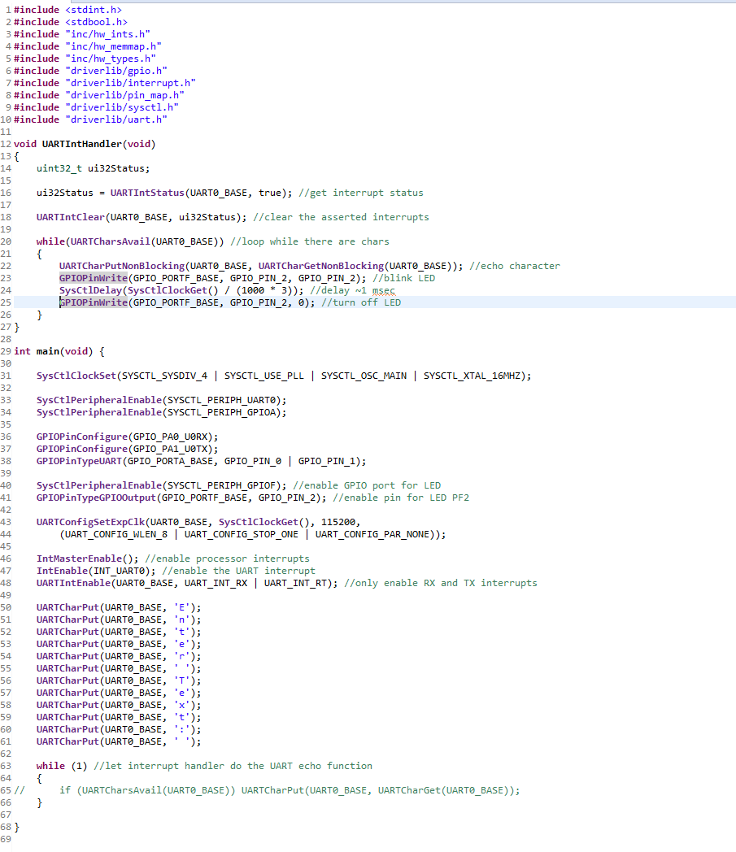

**Youtube Link:** <https://youtu.be/mvGyq8zxUBw>

**Task 1**

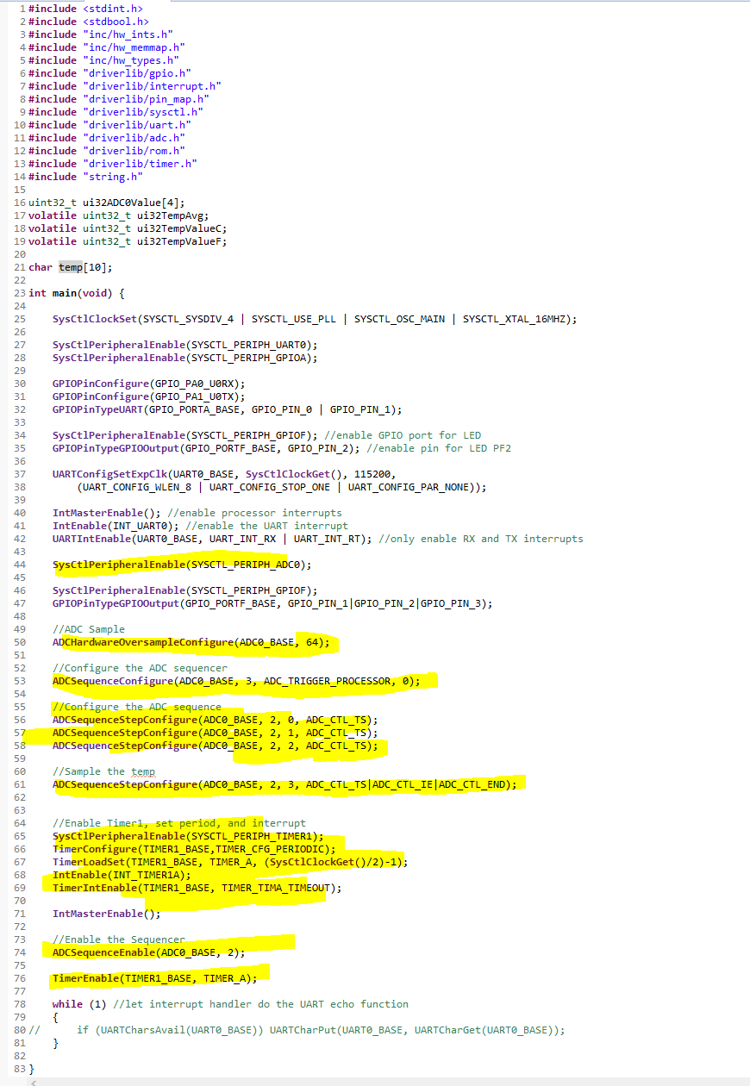

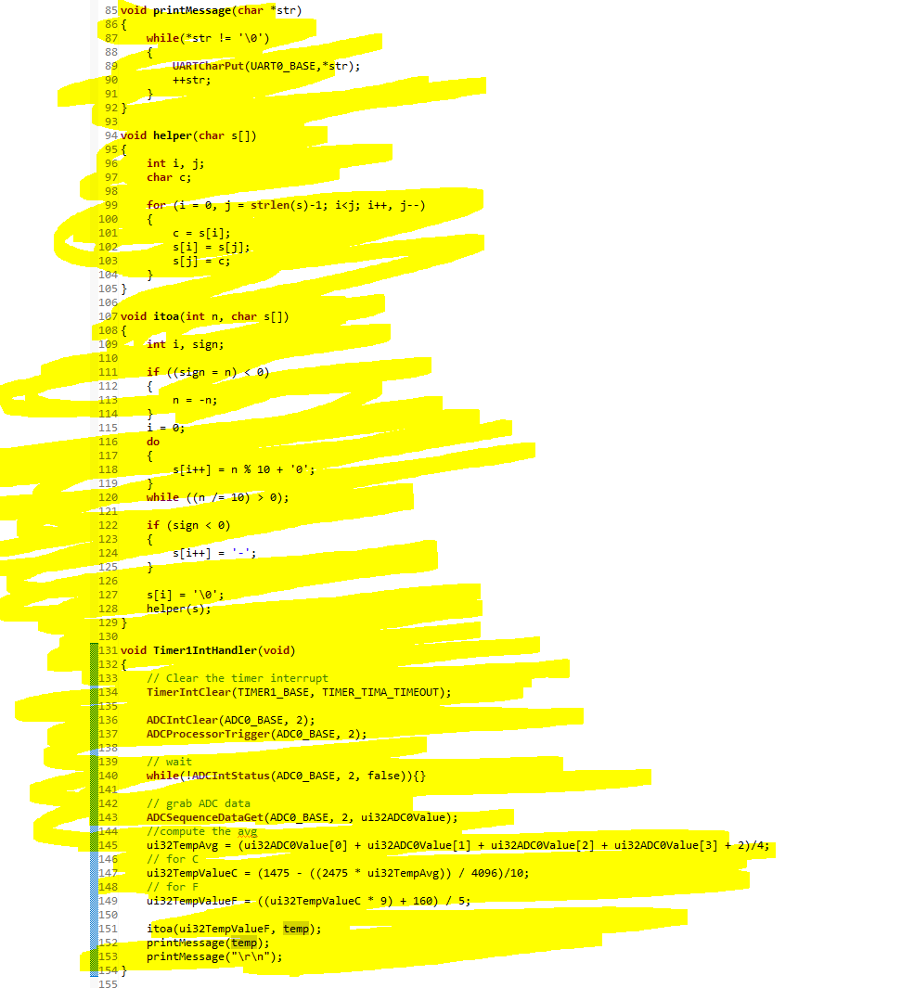

**Youtube Link:** <https://youtu.be/8-CcHeUYB5s>

**Task 2**

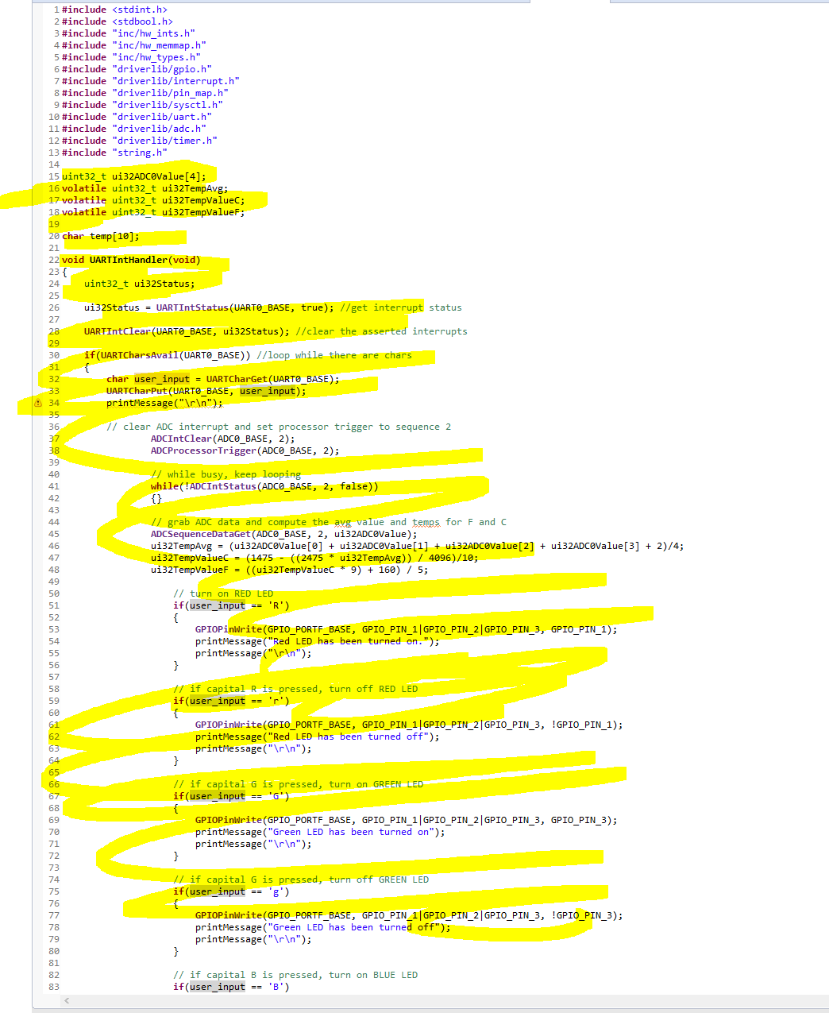

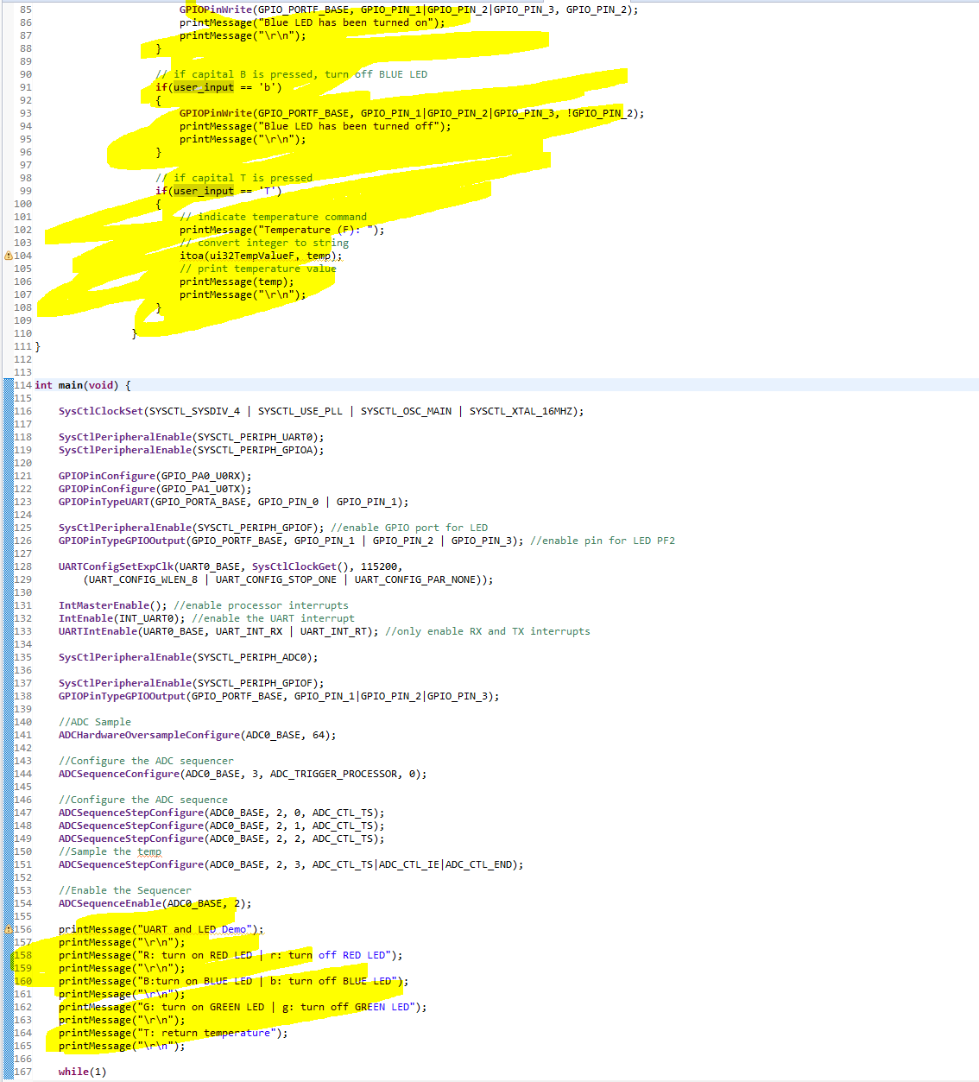

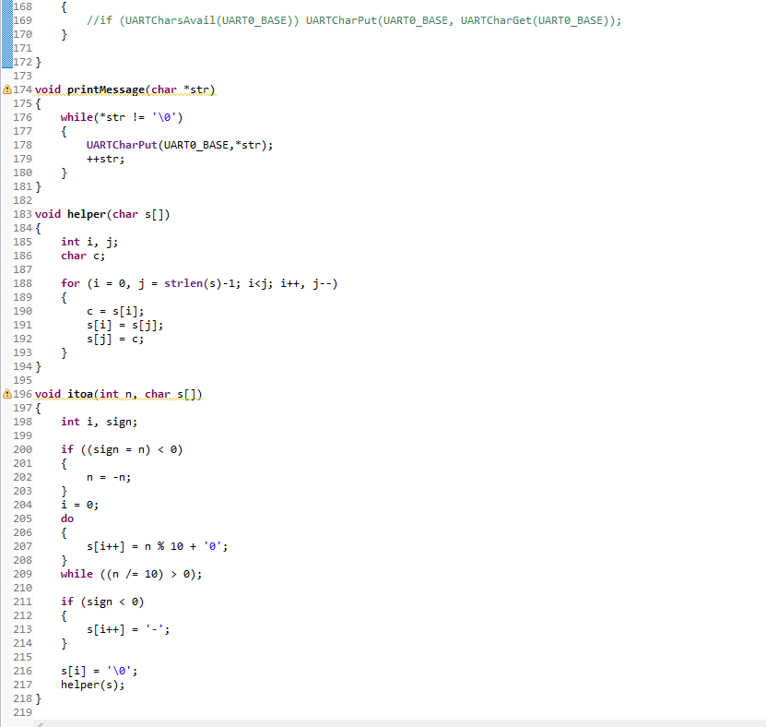

**Youtube Link:** <https://youtu.be/Eb9TEYreuxA>