**DATE SUBMITTED: 10/16/18**

**Task 1**

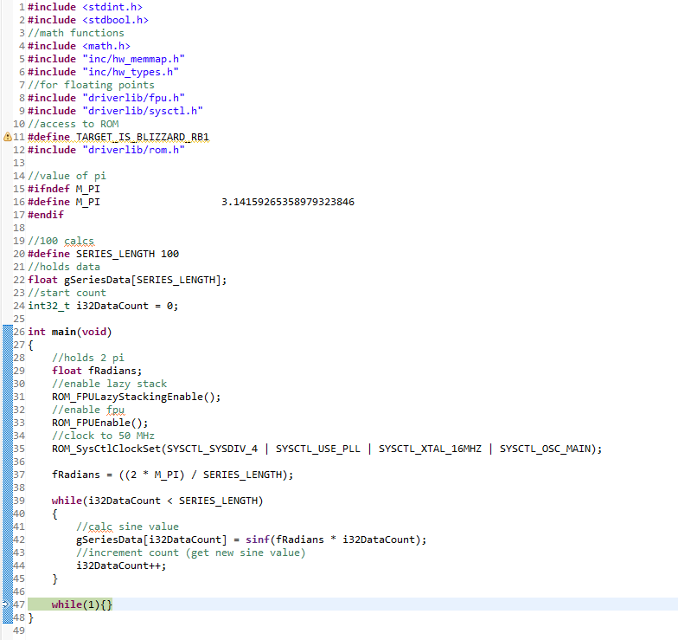

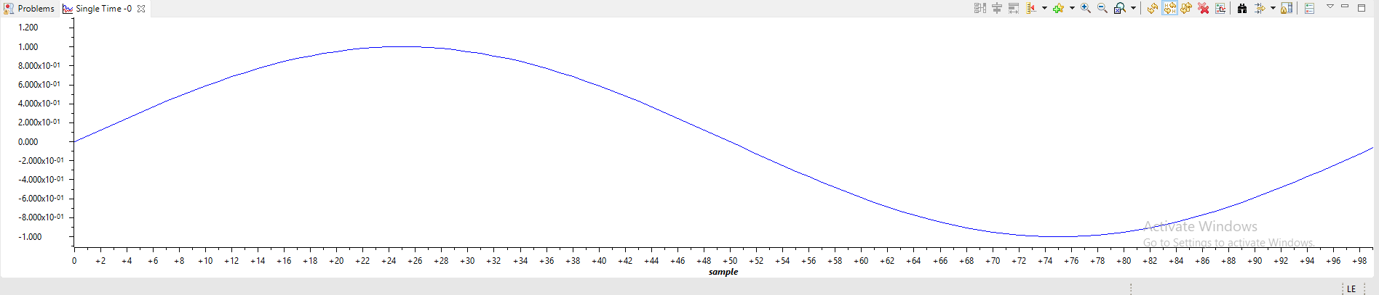

**Youtube Link:** <https://youtu.be/WVjFbsnUlPE>

**Task 2**

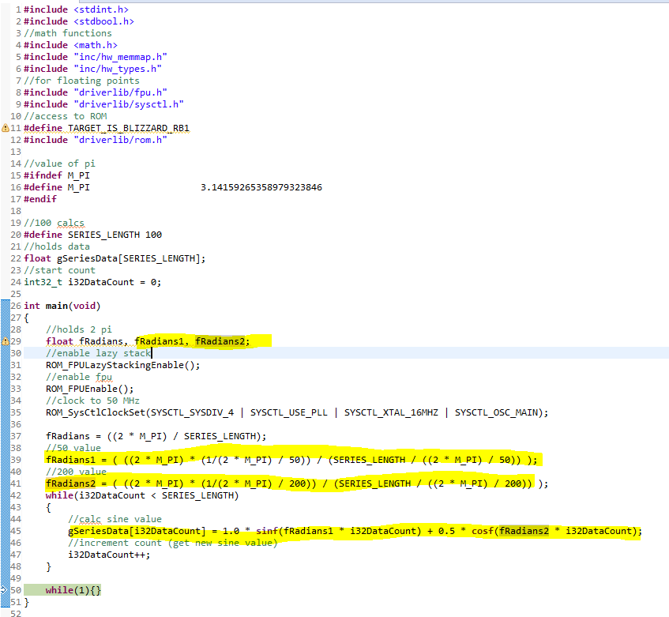

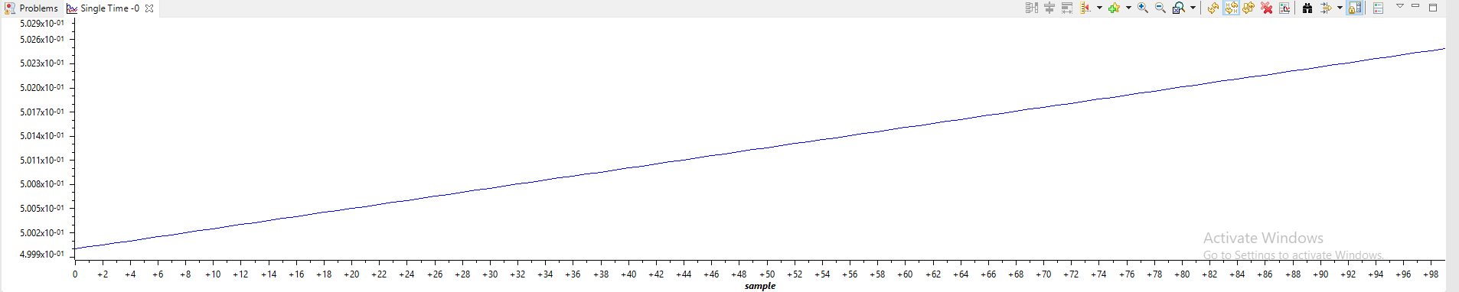

**Youtube Link:** <https://youtu.be/BkB8DXXkfmI>