# Homework 2

Your Name: Minguk Kim

Student ID: A20437179

**1. (20 points) Use your own language/text to answer the following questions:**

1). What is the difference between one-tailed test and a two-tailed test? How to determine it and why it is important to determine that?

If alternative hypothesis is “some value is greater(or less) than certain value”, we conduct one-tailed test. However, if alternative hypothesis is “some value is not equal to certain value”, we conduct two-tailed test. So the factor to determine whether to choose both tests is alternative hypothesis.

The reason why it is important to determine between those two tests is that if you choose wrong decision in hypothesis test, it makes statistically useless result.

2). What is meant by a p-value? Interpret p-value in an one-tailed one-sample hypothesis testing.

P-value is a probability that how much the given statistic support the null hypothesis, assuming the null hypothesis is true. in an one-tailed one-sample hypothesis testing environment, If value of level of significance is 0.05, we can reject H0 and accept Ha if P-value is less than 0.05. On the other hand, we can’t reject H0 if P-value is greater than or equal to 0.05.

**2. (80 points) Manually solve the problem below:**

A bank branch located in a commercial district of a city has the business objective of improving the process for serving customer during the noon to 1 PM (lunch period). The waiting time (defined as the time the customer enters the line until he or she reaches the teller window) of a random sample of 15 customers is collected, and the results are organized and stored as below:

4.21, 5.55, 3.02, 5.13, 4.77, 2.34, 3.54, 3.20  
4.50, 6.10, 0.38, 5.12, 6.46, 6.19, 3.79

1. Calculate the mean and standard deviation, and find q1, q3 from the values above. Is the distribution symmetric? Why? [10]

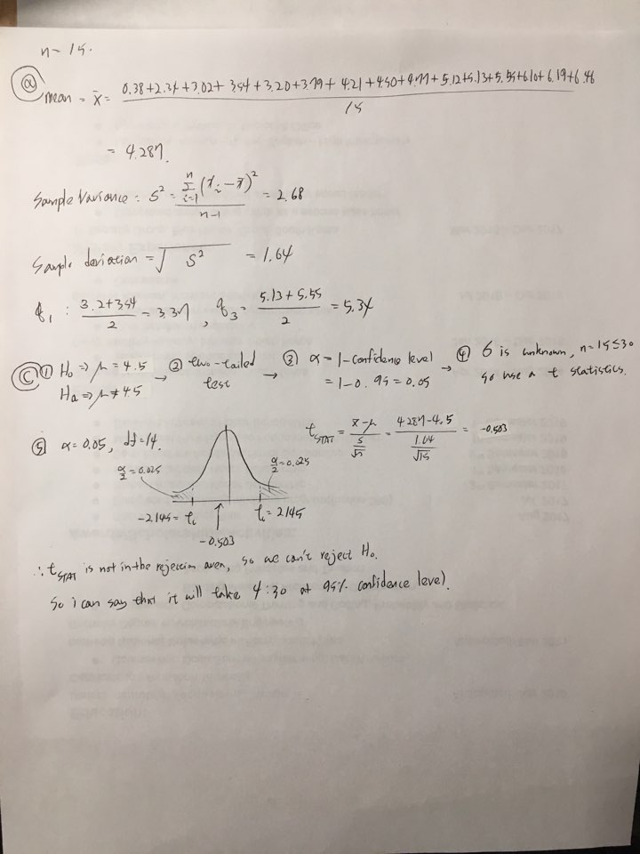

It is asymmetric. This is because the smaller the value of n, the more difficult it is to represent the normal distribution.

1. Are there any assumptions about the population distribution is needed in order to use sample statistics to estimate the population statistics? Why? [10]

1) an average of n guests will visit during the lunch period

2) There will be a correlation between waiting time and number of guests

the business objective is improving the process for serving customer during the lunch period. Therefore, the bank can improve the process by finding and improving the correlation between each factors.

1. As a customer walks into the branch office during the lunch period. She asks the branch manager how long she can expect to wait. If you are the manager, answer this question by 95% confidence. [20]



1. We were told the average waiting minute will be 5 minutes. But we think it is true. By using 5% as the level of significance, validate the hypothesis through as least three approaches. Show your steps one by one [30]

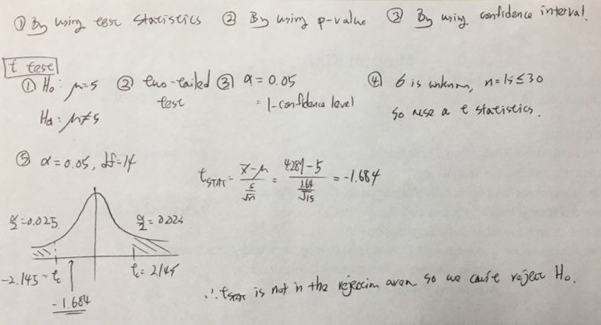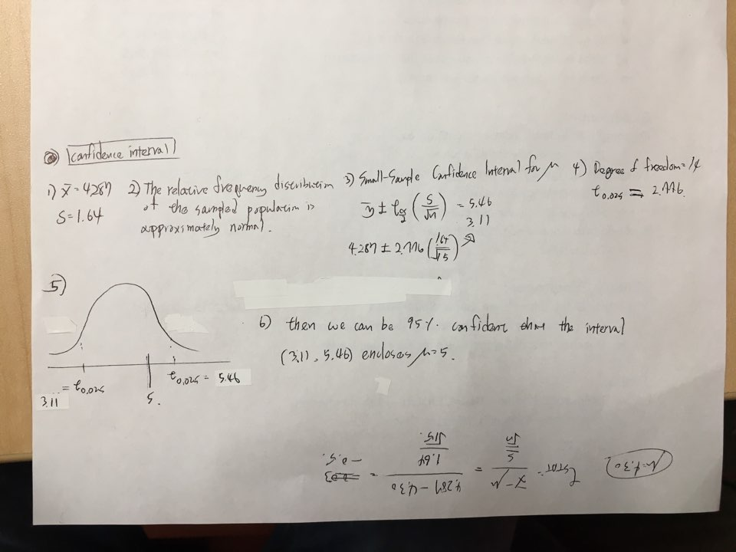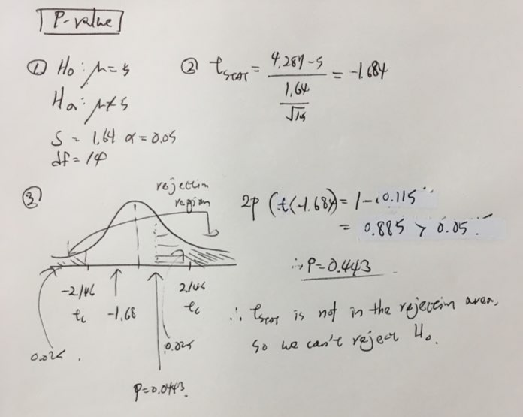

1. e). Use just one method to solve the problem in part d) but use the 99% as the confidence level. Did you get different results? What are the reasons if you get different results. [10]

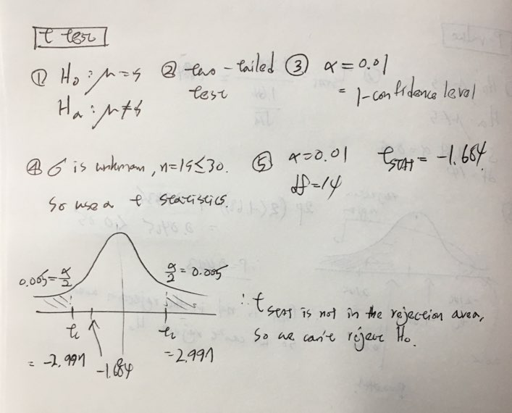

I got the same result

Note, if you need either z value or t value, you can find them by using this tool:   
<http://www.mathcracker.com/z_critical_values.php>

<http://www.mathcracker.com/t_critical_values.php>