**HW4 Simple Linear Regression Analysis**

**Jet Fuel Spot prices and prices of Airline index (XAL).**

In normal times the Airline Index (XAL) stock price that is a weighted index of the stocks for large American airlines companies has strongly ties with jet fuel prices. Based on historical data, financial investors know that if jet fuel increases, the XAL index price will decrease, and viceversa. The two variables have a strong linear association as clearly displayed by the scatterplot below. So investors can use this knowledge to buy XAL index if jet fuel price goes down, and sell XAL index if jet fuel price goes up.

정상적인시기에 대형 미국 항공사의 주식 지수를 가중시킨 XAL (Airline Index) 주가는 제트 유가와 밀접한 관련이 있습니다. 역사적 데이터를 토대로 재무 투자자들은 제트 연료가 증가하면 XAL 지수가 하락하고 부채가 줄어든다는 사실을 알고 있습니다. 두 변수는 아래의 산점도에 의해 명확하게 표시되는 강한 선형 연관성을가집니다. 따라서 투자자들은이 지식을 바탕으로 제트 연료 가격이 하락하면 XAL 지수를 구입하고 제트 유가가 오르면 XAL 지수를 판매 할 수 있습니다.

The data to be analyzed in this problem are XAL stock and jet fuel weekly prices from **January 5th, 2007 to August 31st, 2008**

**이 문제에서 분석 할 데이터는 2007 년 1 월 5 일부터 2008 년 8 월 31 일까지 XAL 재고 및 제트 연료 주간 가격입니다**

* **The Airline Index** is designed to measure the performance of highly capitalized companies in the airline industry. The Index tracks the aggregate performance of major U.S. and overseas airlines, including Alaska Air Group Inc. (ALK); America West Holding Corporation CLB (AWA); AMR Corporation (AMR); Continental Airlines Inc. (CAL); Delta Air Lines Inc. (DAL); KLM Royal Dutch Airlines NV (KLM); Norwest Airlines Corp. (NWAC); Southwest Airlines Co. (LUV); UAL Corp. (UAL); US Airways Group Inc. (U).

• 항공사 지수는 항공 업계에서 고도로 자본가가 많은 회사의 실적을 측정하도록 설계되었습니다. 이 지수는 알래스카 항공 그룹 (ALK)을 포함한 주요 미국 및 해외 항공사의 총 실적을 추적합니다. 미국 서부 지주 회사 CLB (AWA); AMR Corporation (AMR); 콘티넨탈 항공 Inc. (CAL); 델타 항공 (DAL); KLM 네덜란드 항공 NV (KLM); Norwest Airlines Corp. (NWAC); Southwest Airlines Co. (LUV); UAL Corp. (UAL); US Airways Group Inc. (U).

* 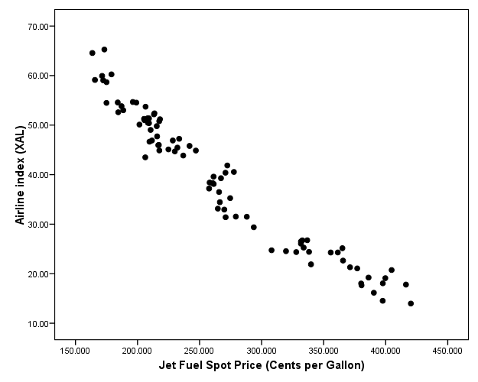**Jet Fuel Spot Prices** are in cents per gallon.

• 제트 연료 스팟 가격은 갤런 당 센트입니다.

Use the computer output attached below to find the fitted regression line to predict XAL index price from jet fuel price.

**아래 첨부 된 컴퓨터 출력을 사용하여 제트 연료 가격에서 XAL 지수 가격을 예측하는 회귀선을 찾으십시오.**

**Answer the following questions:**

1. Interpret the correlation between the two variables, and write down the regression model. [10]
2. What’s the adjusted R2 value for the regression line? Explain it. Why we prefer to use adjusted R2 rather than the raw R2 value? [15]
3. Use the regression line to predict the index price: [10]
   1. Predict the XAL price on Sept. 7th, knowing that the fuel price was 224.885 cents.
   2. Predict the XAL price for Oct. 5th, knowing that the fuel price was 301.928 cents.

**Computer output**

The CORR Procedure

2 Variables: fuel xal

Simple Statistics

Variable N Mean Std Dev Sum Minimum Maximum

fuel 86 267.24903 72.53431 22983 163.60200 420.25000

xal 86 39.01081 13.53587 3355 13.98000 64.56000

Simple Statistics

Variable Label

fuel Weekly jet fuel spot price

xal Airline index weekly price

Pearson Correlation Coefficients, N = 86

Prob > |r| under H0: Rho=0

fuel xal

fuel 1.00000 -0.97331

Weekly jet fuel spot price <.0001

xal -0.97331 1.00000

Airline index weekly price <.0001

The REG Procedure

Model: MODEL1

Dependent Variable: xal Airline index weekly price

Number of Observations Read 86

Number of Observations Used 86

Analysis of Variance

Sum of Mean

Source DF Squares Square F Value Pr > F

Model 1 14754 14754 1511.05 <.0001

Error 84 820.15556 9.76376

Corrected Total 85 15574

Root MSE 3.12470 R-Square 0.9473

Dependent Mean 39.01081 Adj R-Sq 0.9467

Coeff Var 8.00983

Parameter Estimates

Parameter Standard

Variable Label DF Estimate Error t Value Pr > |t|

Intercept Intercept 1 87.55209 1.29340 67.69 <.0001

fuel Weekly jet fuel spot price 1 -0.18163 0.00467 -38.87 <.0001

1. Here are the observed XAL weekly prices on Sept. 7th is $45.1, and on Oct. 5th was $46.9. What are the prediction errors for the two observations? If you were an investor, which of the two predictions would you trust more? Explain your answer. [10]
2. As we all know so well, financial markets were in turmoil last year, caused by a severe crisis of the banking industry. The graphs below shows the data for XAL stock price and fuel price until March 2010. Examine what the graphs show. Does the association between the two variables change after August 2008? [15]

*Data collected from* ***Jan. 2007 to March 2010****.*

***Data from January 2007 to August 2008 Data from Sept 2008 to March 2010***

*Dual axis Plot that shows the changes in XAL index price and jet fuel price over time*

1. If you were an investor, would you still use information about jet fuel price to make a buy or sell decision for the XAL index? [10]
2. What are the steps in residual analysis. And further state how you can identify the problems in each step, and how to solve these issues accordingly. [30]